Supplementary file 2.
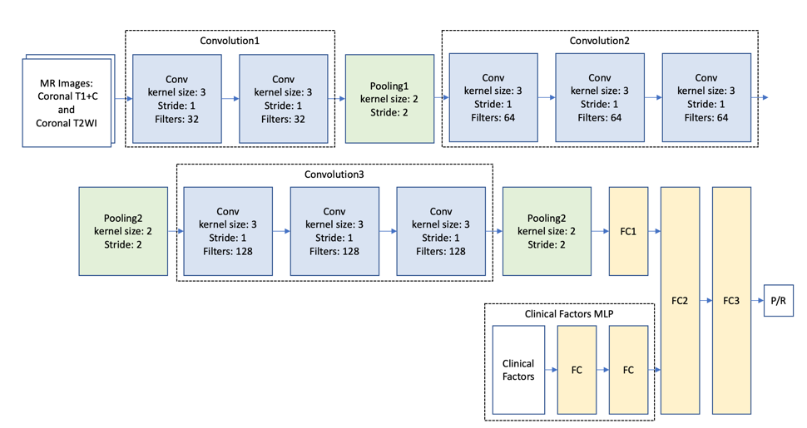
Figure S1. Another hybrid CNN_v2-MLP architecture for prediction of progression/recurrence (P/R) in NFMAs.

