Supplementary Table 1. Primer sequences used for qRT-PCR

Gene | Forward primers | Reverse primers
LANA | 5'-TCCCTCTACACTAAACCCAATA-3' | 5'-TTGCTAATCTCGTTGTCCC-3'
RTA | 5’-CACAAAAATGGCGCAAGATGA-3’ | 5’-TGGTAGAGTTGGGCCTTCAGTT-3’
ORF26 | 5’-GCTCGAATCCAACGGATTTG -3’ | 5’- AATAGCGTGCCCCAGTTGC-3’
β-actin | 5’-ATCGTGCGTGACATTAAGGAG-3’ | 5’-GGAAGGAAGGCTGGAAGAGT-3’

Supplementary figure legends
Supplementary Figure 1. The heatmap of Top 30 abundance species in 3 groups of HIV patients with or without KSHV coinfection.
Supplementary Figure 2. Functional gene families altered in the group of HIV patients with KSHV oral shedding. The heatmap of functional gene families associated with microbiome was predicted by PICRUSt.
Supplementary Figure 3. Transfection with control vectors cannot block KSHV lytic reactivation by conditioned medium from Streptococcus species. PDLF cells were infected with purified KSHV virions (MOI~5), then transfected with control empty vectors (pcDNA) for 48 h, and treated with filtered conditioned medium from Streptococcus species culture (diluted as 1:50) for additional 48 h. Viral gene expression was quantified using qRT-PCR. Error bars represent the S.D. for 3 independent experiments. * = p<0.05; ** = p<0.01 (two-tailed Student's t-test).

Supplementary Figure 1
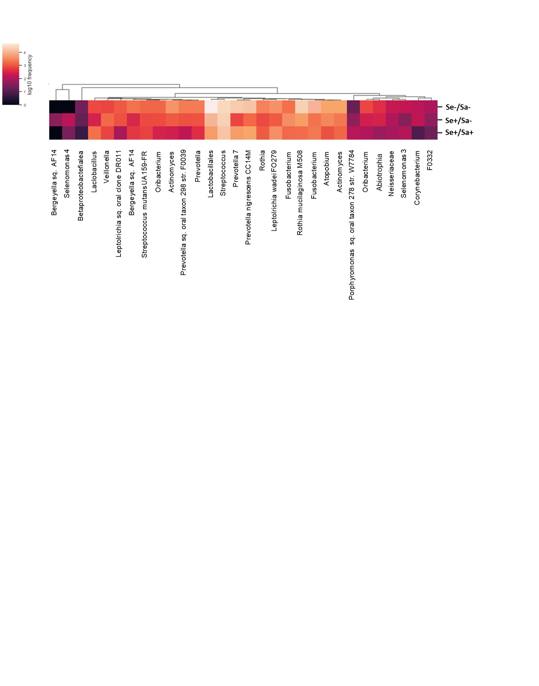

Supplementary Figure 2
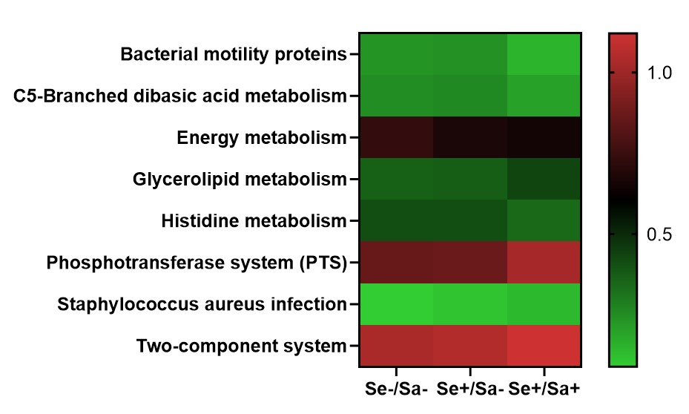
Supplementary Figure 3
