Fabrication of Guided Tissue Regeneration Membrane Using Lignin Mediated ZnO Nanoparticles in Biopolymer Matrix for Antimicrobial Activity
Bushra Bilal^{a‡}, Rimsha Niazi^{b‡}, Sohail Nadeem^{b}, Muhammad Asim Farid^{c}, Muhammad Shahid Nazirª, Toheed Akhtar^{b}, Mohsin Javaid^{b}, Aysha Mohyuddin^{b}, Zulfiqar Ali^{d}, Syed Ali Raza Naqvi^{e}*, Nawshad Muhammad^{f*}, Sadaf Ul Hassan^{ab}*
Bushra Bilal^{a‡}, Rimsha Niazi^{b‡}, Sohail Nadeem^{b}, Muhammad Asim Farid^{c}, Muhammad Shahid Nazirª, Toheed Akhtar^{b}, Mohsin Javaid^{b}, Aysha Mohyuddin^{b}, Zulfiqar Ali^{d}, Syed Ali Raza Naqvi^{e}*, Nawshad Muhammad^{f*}, Sadaf Ul Hassan^{ab}*, Eslam B. Elkaeed^{g}, Hala A. Ibrahium^{h, i} Nasser S. Awwad^{j}
ªDepartment of Chemistry, COMSATS University Islamabad, Lahore Campus, 54000, Pakistan.
^{b}Department of Chemistry, School of Sciences, University of Management and Technology, Lahore Campus, Pakistan.
^{c}Department of Chemistry, Division of Science and Technology, University of Education, Vehari campuse, Pakistan.
^{d}Department of Chemical Engineering, COMSATS University Islamabad, Lahore Campus, 54000, Pakistan.
^{e}Department of Chemistry, Government College University, Faisalabad, Pakistan.
^{f}Department of Dental Materials, Institute of Basic Medical Sciences, Khyber Medical University, Peshawar, Pakistan
^{g}Department of Pharmaceutical Sciences, College of Pharmacy, Almaarefa University, Ad Diriyah 13713, Riyadh, Saudi Arabia.
^{h}Biology Department, Faculty of Science, King Khalid University, P.O. Box 9004, Abha 61413, Saudi Arabia.
^{i}Department of Semi Pilot Plant, Nuclear Materials Authority, P.O. Box 530, El Maadi, Egypt.
^{j}Chemistry Department, Faculty of Science, King Khalid University, P.O. Box 9004, Abha 61413, Saudi Arabia.
*Corresponding Authors: drarnaqvi@gmail.com (Syed Ali Raza Naqvi); sadaf.hassan@umt.edu.pk (Sadaf Ul Hassan); nawshad.ibms@kmu.edu.pk (Nawshad Muhammad)
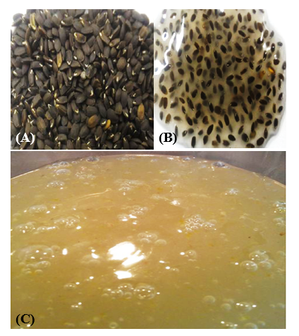
Figure S1. Chia seeds (A) before swelling in water (B) swelling in water (C) after extraction.
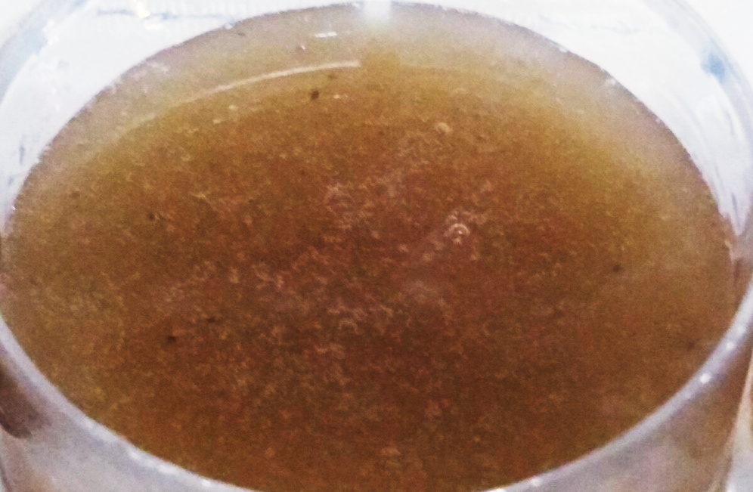
Figure S2. Membrane before drying.
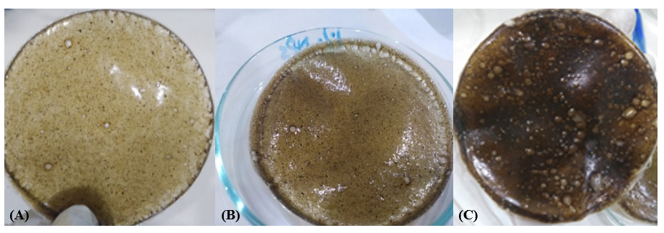
Figure S3. Prepared membranes after drying (A) membrane having 1% of lignin mediated zinc oxide nanoparticles (B) membrane having 2.5% nanoparticles (C) membrane having 5% of lignin mediated zinc oxide nanoparticles
Figure S4. EDX of ZnO NP.

Figure S5. EDX of 1% lignin mediated ZnO NPs GTR membrane.

