Supplementary Material

Supplementary Table
Supplementary Table 1. Details of varicose vein instrumental variables and possible associations with other traits
SNP | Other traits
rs11121615 | Impedance of leg, leg fat-free mass, whole body fat-free mass, leg predicted mass, whole body water mass
rs72787716 | NA
rs6546368 | NA
rs2734045 | Monocyte percentage of white cells, monocyte count, basophil count, impedance of leg left, sum eosinophil basophil counts
rs28558138 | Self-reported hypertension, diastolic blood pressure
rs2250127 | Red cell distribution width, impedance of leg, leg predicted mass, impedance of whole body, leg fat percentage, whole body fat-free mass, whole body water mass, basal metabolic rate, trunk fat-free mass, cellulitis, lymphocyte count, forced vital capacity, body fat percentage, immature fraction of reticulocytes
rs11135046 | Breast cancer, systolic blood pressure
rs1155207 | Mean corpuscular hemoglobin, mean corpuscular volume, height, red cell distribution width, hemoglobin concentration, disorders of mineral metabolism, trunk fat mass, hematocrit, weight, whole body fat mass, basal metabolic rate, hip circumference adjusted for BMI, leg predicted mass, body fat percentage, whole body water mass, whole body fat-free mass, waist circumference, arm fat-free mass, diastolic blood pressure, forced vital capacity, primary sclerosing cholangitis
rs62401797 | NA
rs2800709 | Heel bone mineral density, hemoglobin concentration, red blood cell count, hematocrit, hip circumference, reticulocyte count
rs75731123 | Vascular or heart problems diagnosed by doctor
rs10817784 | NA
rs2083714 | Diastolic blood pressure, systolic blood pressure, trunk predicted mass, trunk fat-free mass, red blood cell count, impedance of whole body, impedance of left, hemoglobin concentration, hematocrit
rs55726902 | Allergic disease asthma hay fever or eczema, platelet count, plateletcrit, allergic disease, self-reported hypertension
rs41286076 | Height
rs4772697 | NA
rs437564 | Mean corpuscular volume, red blood cell count
rs34457921 | NA
rs2911463 | Mean corpuscular hemoglobin concentration, hemoglobin concentration, reticulocyte count, red blood cell count, reticulocyte fraction of red cells
rs236548 | Sitting height
rs2241173 | NA
rs6021277 | NA
rs6062619 | NA
Abbreviations: BMI, body mass index; NA, not available; SNP, single-nucleotide polymorphism.
Supplementary Table 2. Details of the all datasets included in the studies.
Phenotype | Source | Dataset | Unit | No. cases | No. controls | Definition | Purpose
Varicose veins | Pan-UK Biobank | I83 European | log OR | 12059 | 408472 | ICD-10: I83 | Main exposure dataset
Lower extremity DVT | FinnGen | I9_PHLETHROMBDVTLOW | log OR | 4576 | 190028 | ICD-10: I80.20, I80.29, I80.3  ICD-9: 4511, 4510, 4512  ICD-8: 4510 | Main outcome dataset
PE | FinnGen | I9_PULMEMB | log OR | 4185 | 214228 | ICD-10: I26  ICD-9: 415  ICD-8: 450 | Main outcome dataset
VTE | FinnGen | I9_VTE | log OR | 9176 | 209616 | ICD-10: I26, I80, O87.1, O88.2  ICD-9: 415, 451, 6713, 6714, 6732  ICD-8: 450, 451, 671, 6739 | Main outcome dataset
Varicose veins | FinnGen | I9_VARICVE | log OR | 17027 | 190028 | ICD-10: I83  ICD-9: 454  ICD-8: 454 | Exposure dataset for validation
DVT | MRC-IEU analysis of UK Biobank | ukb-b-12040 | Transformed log OR | 9241 | 453692 | Self-reported | Outcome dataset for validation
Phenotype | Source | Dataset | No. variants | No. participants |  | Definition | Purpose
Standing height | MRC-IEU analysis of UK Biobank Consortium | ukb-b-10787 | SD | 461460 |  | - | Multivariable MR
BMI | MRC-IEU analysis of UK Biobank | ukb-b-19953 | SD | 461460 |  | - | Multivariable MR
Height | GAINT consortium | ieu-a-89 | SD | 253288 |  | - | Two-step MR
BMI | GAINT consortium | ieu-b-40 | SD | 681275 |  | - | Two-step MR

Supplementary Table 3. Strength of selected genetic instrumental variables.
SNP | Beta | SE | EAF | R² | F statistic
rs11121615 | -0.284 | 0.015 | 0.690 | 0.035 | 653.390
rs72787716 | -0.098 | 0.017 | 0.209 | 0.003 | 58.241
rs6546368 | 0.155 | 0.014 | 0.657 | 0.011 | 200.136
rs2734045 | 0.100 | 0.014 | 0.482 | 0.005 | 91.754
rs28558138 | -0.131 | 0.014 | 0.420 | 0.008 | 154.149
rs2250127 | 0.144 | 0.016 | 0.247 | 0.008 | 142.120
rs11135046 | -0.121 | 0.014 | 0.543 | 0.007 | 133.822
rs1155207 | -0.106 | 0.014 | 0.487 | 0.006 | 103.223
rs62401797 | -0.146 | 0.026 | 0.079 | 0.003 | 56.887
rs2800709 | -0.078 | 0.014 | 0.519 | 0.003 | 55.705
rs75731123 | -0.108 | 0.019 | 0.149 | 0.003 | 54.241
rs10817784 | 0.094 | 0.016 | 0.738 | 0.003 | 62.687
rs2083714 | 0.081 | 0.014 | 0.499 | 0.003 | 60.174
rs55726902 | 0.100 | 0.016 | 0.242 | 0.004 | 67.322
rs41286076 | 0.092 | 0.015 | 0.256 | 0.003 | 59.138
rs4772697 | 0.083 | 0.014 | 0.361 | 0.003 | 58.294
rs437564 | 0.085 | 0.014 | 0.377 | 0.003 | 62.261
rs34457921 | -0.088 | 0.015 | 0.298 | 0.003 | 59.430
rs2911463 | -0.190 | 0.015 | 0.687 | 0.016 | 288.323
rs236548 | -0.119 | 0.016 | 0.745 | 0.005 | 98.903
rs2241173 | -0.091 | 0.014 | 0.575 | 0.004 | 74.298
rs6021277 | 0.102 | 0.014 | 0.460 | 0.005 | 94.990
rs6062619 | -0.113 | 0.016 | 0.268 | 0.005 | 92.057
Total |  |  |  | 0.150 | 2781.546

Supplementary Table 4. Missing SNPs and proxies.
SNP | Proxy | Chr | Position | Distance (kb) | r² | Qualified?
rs2734045 | rs2713587 | 3 | 128290848 | 1212 | 1 | Yes
rs6546368 | rs7579440 | 2 | 68498508 | 324 | 0.987 | Yes
rs10817784 | rs7033287 | 9 | 118287525 | 2582 | 0.975 | Yes
rs34457921 | rs28703652 | 16 | 88620640 | 6354 | 0.886 | No
Abbreviations: Chr, chromosome; SNP, single-nucleotide polymorphism.
URL: https://analysistools.cancer.gov/LDlink/?tab=ldproxy

Supplementary Table 5. Supporting statistics of basic MR and MR-PRESSO.
Sensitive parameter | DVT | PE | VTE
MR-Egger Q | 22.502 | 18.309 | 19.634
MR-Egger p | 0.260 | 0.502 | 0.417
IVW Q | 24.24 | 18.421 | 22.552
IVW p | 0.232 | 0.560 | 0.311
Egger-intercept | 0.018 | -0.005 | 0.017
Egger-intercept p | 0.241 | 0.741 | 0.109
MR-PRESSO outlier | None | None | None
Abbreviations: DVT, deep vein thrombosis; PE, pulmonary embolism; VTE, venous thromboembolism.

Supplementary Table 6. Supporting statistics of CAUSE.
Comparison | Model 1 | Model 2 | Delta_elpd | Se_delta_elpd | Z
1 | Null | Sharing | -5.311 | 2.360 | -2.250
2 | Null | Causal | -9.401 | 4.217 | -2.229
3 | Sharing | Causal | -4.090 | 1.945 | -2.103

Supplementary Figures
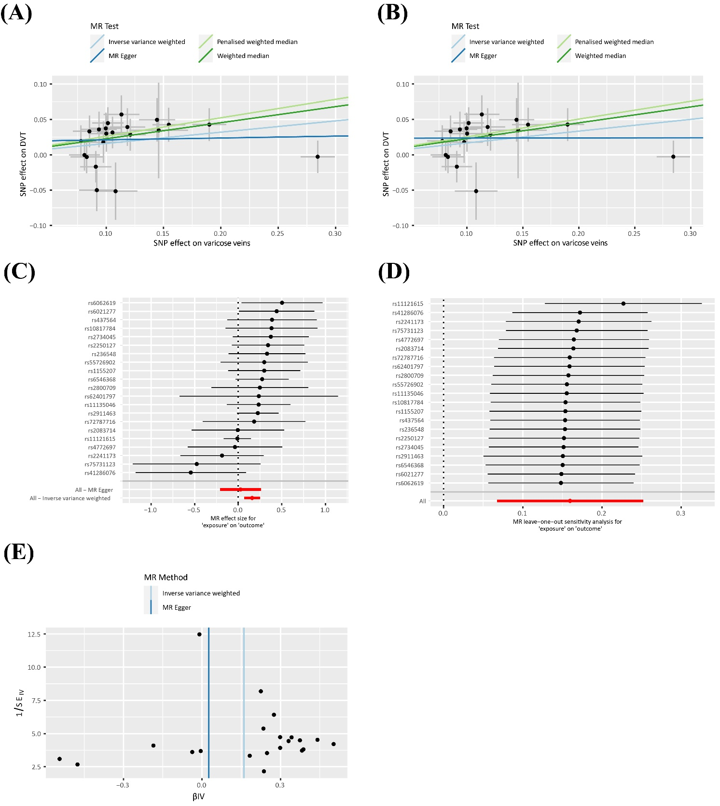
Supplementary Figure 1. Scatter plots, forest plot, leave-one-out plot and funnel plot of causal effect of varicose veins on DVT. (A) Scatter plot using all 21 SNPs. (B) Scatter plot using 19 SNPs that have no association with confounders. (C) Forest plot of effect SNPs on DVT. (D) Leave-one-out plot. (E) Funnel plot for IVW method and MR-Egger.

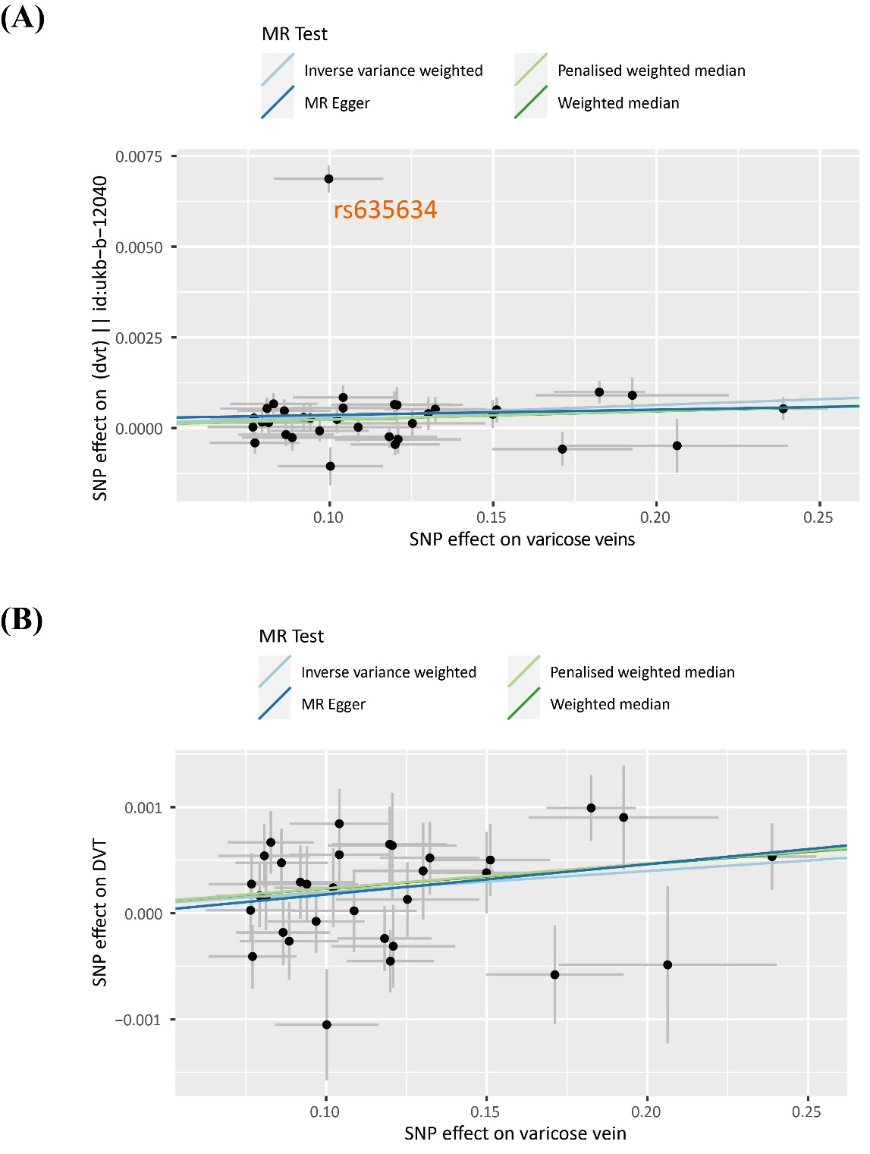
Supplementary Figure 2. Scatter plot of causal effect of varicose veins on DVT using validation cohorts. (A) When the outlier rs635634 was not excluded. (B) When the outlier was excluded.

