Supplementary Information for:

The effect of manipulated prenatal conditions on growth, survival, and reproduction throughout the complete life course of a precocial bird

Oscar Vedder, Coraline Bichet and Barbara Tschirren

Breakpoint models testing the age-specific effect of the incubation treatment on adult body mass and individual egg mass.

To determine the age at which changes in adult body mass and egg mass occurred, we constructed Linear Mixed Models (LMM). For both dependent variables, individual age was categorized to the average age of the 8 sampling periods (see main text), and a breakpoint was set for all but the last age category. We subsequently ranked these “breakpoint models” using Akaike Information Criterion for small sample size (AICc).
Adult body mass and individual egg mass were used as the dependent variable, and the incubation treatment and each age category, set as breakpoint, were included as explanatory variables. The age at last sampling and the interaction between the age category (breakpoint) and the incubation treatment were also included as explanatory variables. These models included parent pair identity, and individual identity (nested within parents) as random effects. All age variables were standardized (by subtracting the mean of the variable from each value and dividing it by the squared variance of the variable).
These models were run using the function “lmer” in the package “lme4” (Bates et al., 2015) and the breakpoints were set using the function “bs” from the package “splines” implemented in R 3.6.1 (R Core Team, 2014).

For adult body mass, the best model was given by a breakpoint set at an age of 404 days. For individual egg mass, the best model was given by a breakpoint set at an age of 243 days.
The estimates of these two models are presented in Table S1. The association between adult body mass, and individual egg mass, with age (set as breakpoints) per incubation treatment are presented in Figure S1A and S1B, respectively.
Dependent variable | A. Adult body mass  (n = 740 measurements of 178 females from 84 parent pairs)  Breakpoint at 404 days |  |  | B. Egg mass  (n = 2968 measurements of 176 females from 83 parent pairs)  Breakpoint at 243 days
Parameter | Estimate ± SE | t value | p-value | Estimate ± SE | t value | p-value
Intercept | 253.35 ± 3.00 | 84.43 | <0.001 | 10.42 ± 0.11 | 93.77 | <0.001
Incubation treatment (ref = 37.7°C) | -4.45 ± 3.56 | -1.25 | 0.212 | 0.11 ± 0.12 | 0.91 | 0.367
Age before breakpoint | 16.40 ± 2.69 | 6.11 | <0.001 | 1.82 ± 0.05 | 40.31 | <0.001
Age after breakpoint | 2.14 ± 4.37 | 0.49 | 0.625 | 1.68 ± 0.09 | 18.25 | <0.001
Age at last sampling | -0.19 ± 1.54 | -0.12 | 0.904 | 0.04 ± 0.07 | 0.67 | 0.507
Incubation treatment:Age before breakpoint | 1.16 ± 4.05 | 0.29 | 0.776 | -0.02 ± 0.07 | -0.34 | 0.732
Incubation treatment:Age after breakpoint | -10.53 ± 6.40 | 1.64 | 0.101 | 0.20 ± 0.15 | 1.34 | 0.180
Random female ID nested in parent pair ID  (variance ± SD) | 124.8 ± 11.17 |  |  | 0.31 ± 0.55
Random parent pair ID  (variance ± SD) | 283.5 ± 16.84 |  |  | 0.52 ± 0.72
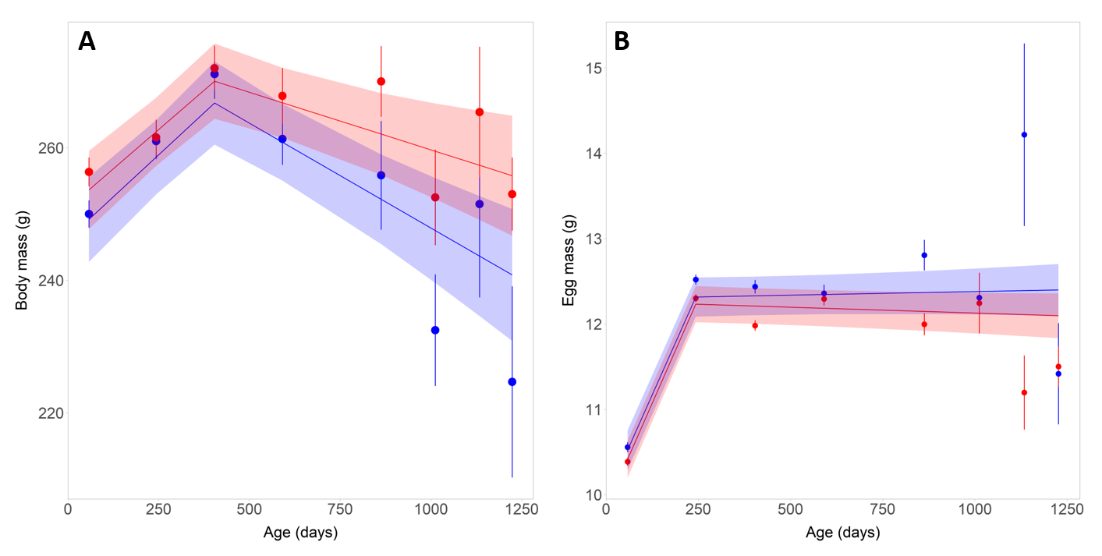
Table S1: Parameter estimates of the LMM, with age categories set as breakpoint, testing for incubation treatment effects on age-specific (A) adult body mass, and (B) individual egg mass.
SE, standard error; SD, standard deviation

Figure S1: Age-specific variation in (A) body mass and (B) individual egg mass per incubation treatment (red for 37.7 ºC and blue for 36.0 ºC). Circles represent the mean adult body mass and individual egg mass for each age category, with standard errors. Solid lines represent the prediction of the best breakpoint models, with their 95% confidence intervals.
References
Bates, D., Maechler, M., Bolker, B. M., & Walker, S. C. (2015). Fitting Linear Mixed-Effects Models Using lme4. Journal of Statistical Software, 67, 1–48.
R Core Team. (2014). R: A language and environment for statistical computing. R Foundation for Statistical Computing. http://www.R-project.org/

