Supplementary Material
1 Supplementary Figures
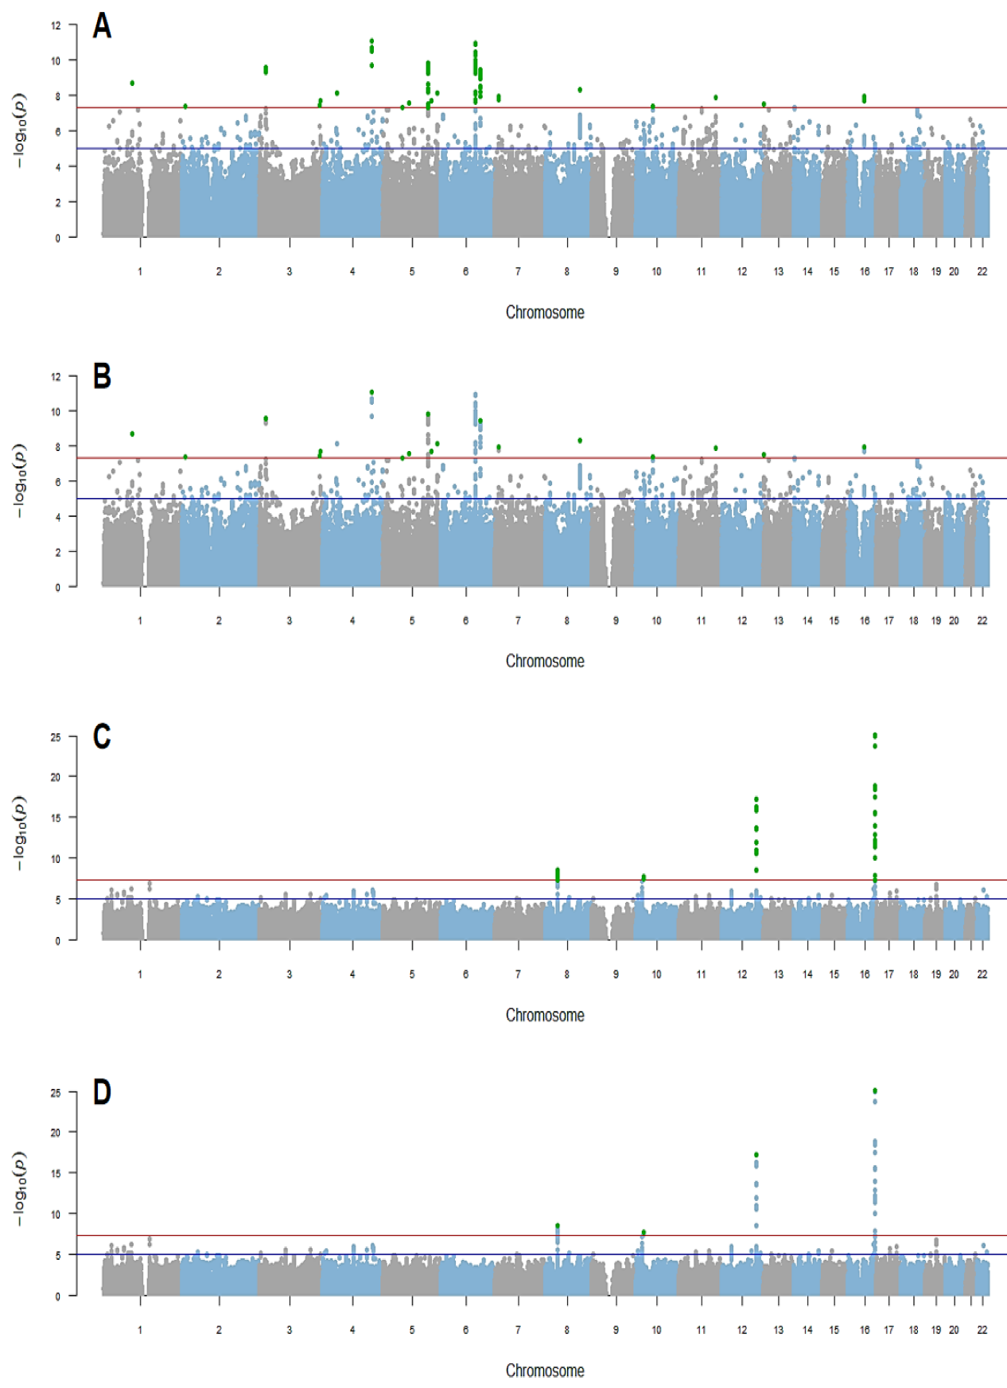
Figure S1. Manhattan plots of the SNPs strongly associated (P < 5 × 10⁻⁸) with circulating tryptophan/kynurenine levels. A. Filter results of the SNPs strongly associated with circulating tryptophan levels before pairwise-linkage disequilibrium clumping. B. Filter results of the SNPs strongly associated with circulating tryptophan levels after pairwise-linkage disequilibrium clumping. C. Filter results of the SNPs strongly associated with circulating kynurenine levels before pairwise-linkage disequilibrium clumping. D. Filter results of the SNPs strongly associated with circulating kynurenine levels after pairwise-linkage disequilibrium clumping. Each point in the figures represents a SNP. The red solid line is at a P value of 5 × 10⁻⁸. The blue solid line is at a P value of 1 × 10⁻⁵.

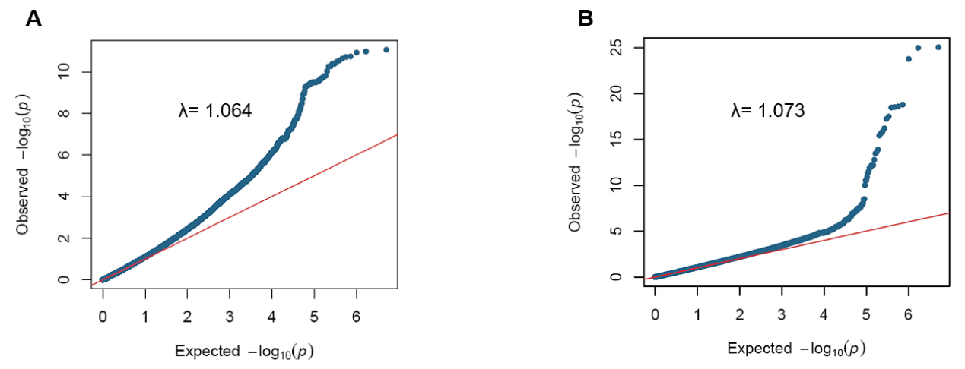
Figure S2. Quantile-quantile (Q-Q) plots for the genome-wide meta-analysis results of the SNPs strongly associated with circulating tryptophan (A)/kynurenine (B) levels. Each point in the figures represents a SNP.
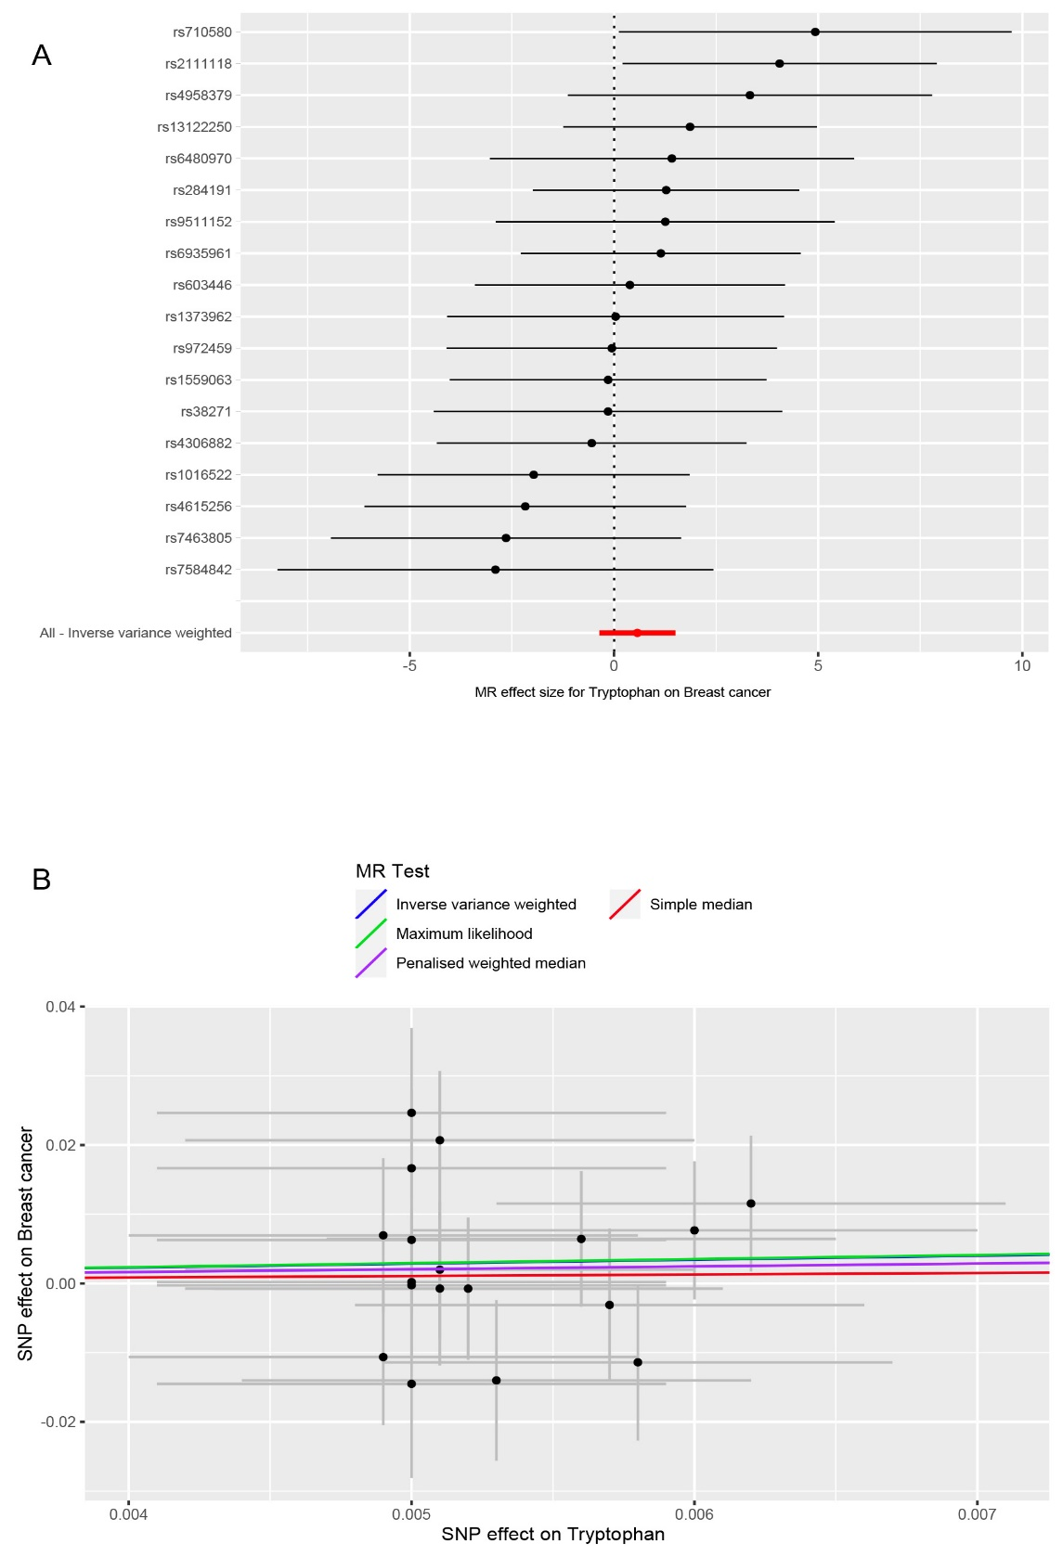
Figure S3. Genetically predicted associations between circulating tryptophan levels and the risk of breast cancer. A. Forest plot for the causal effects of circulating tryptophan levels on the risk of breast cancer. B. Scatter plot of different analysis methods for the causal associations between circulating tryptophan levels and the risk of breast cancer. Each approach has a different line. The slope of each line shows the causal association.
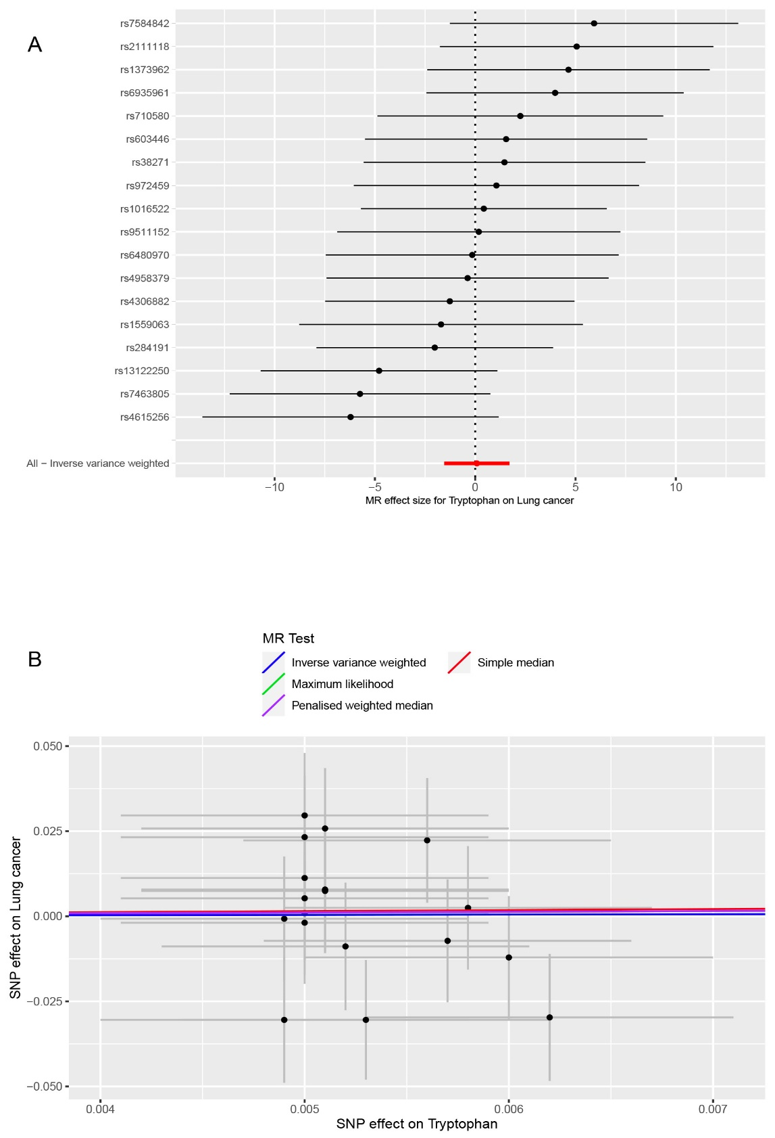
Figure S4. Genetically predicted associations between circulating tryptophan levels and the risk of lung cancer. A. Forest plot for the causal effects of circulating tryptophan levels on the risk of lung cancer. B. Scatter plot of different analysis methods for the causal associations between circulating tryptophan levels and the risk of lung cancer. Each approach has a different line. The slope of each line represents the causal association.
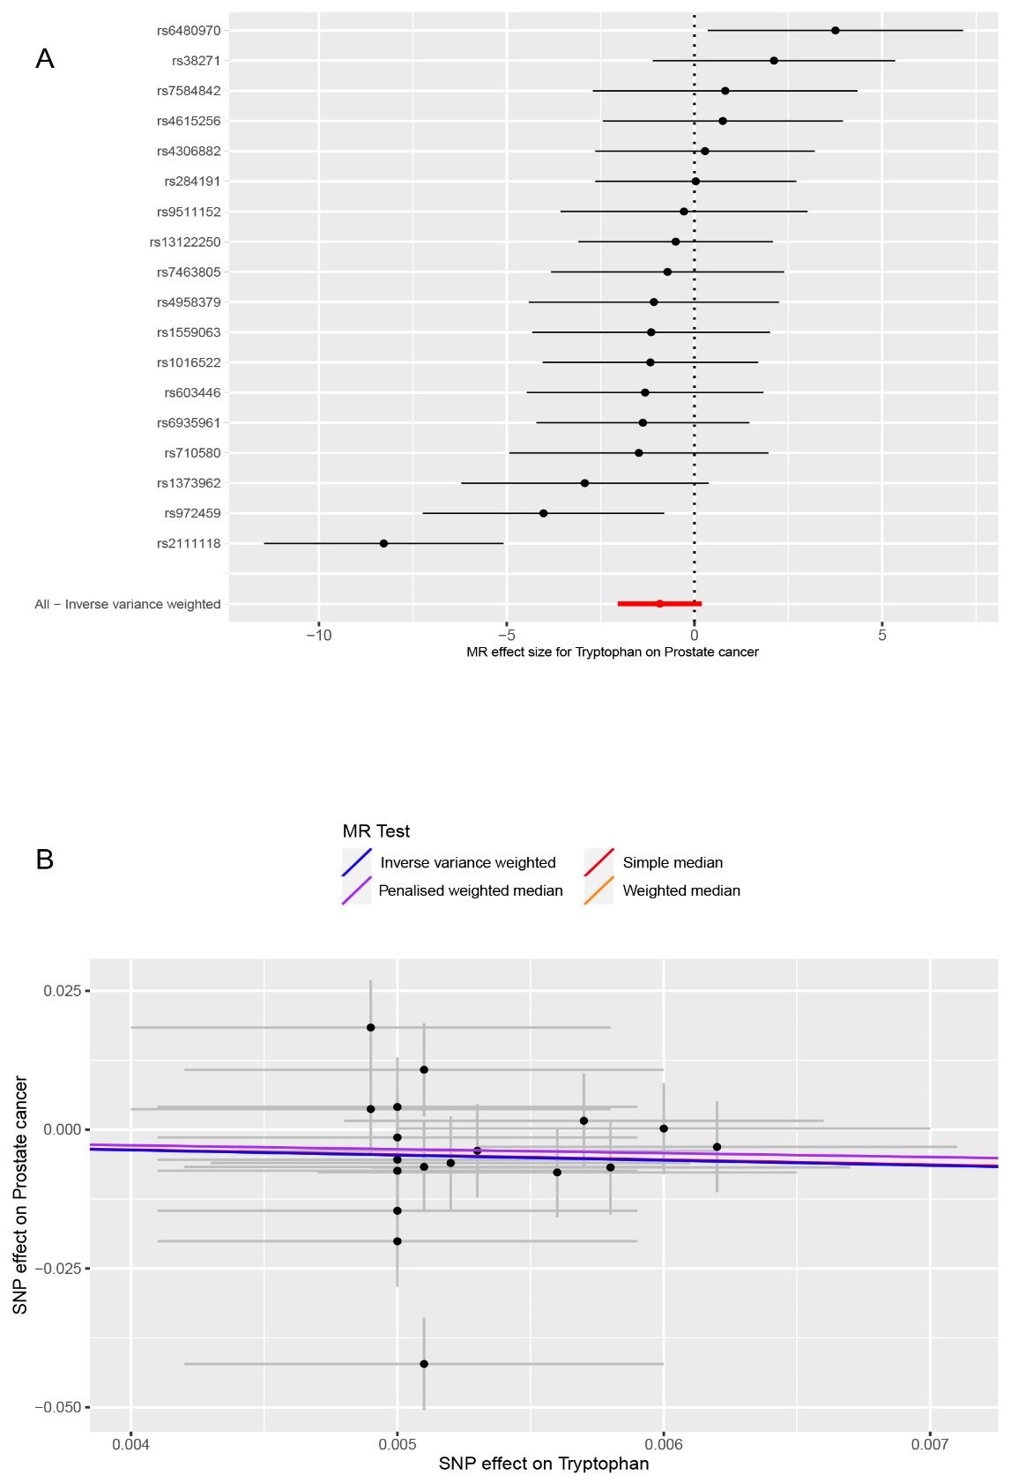
Figure S5. Genetically predicted associations between circulating tryptophan levels and the risk of prostate cancer. A. Forest plot for the causal effects of circulating tryptophan levels on the risk of prostate cancer. B. Scatter plot of different analysis methods for the causal associations between circulating tryptophan levels and the risk of prostate cancer. Each approach has a different line. The slope of each line represents the causal association.
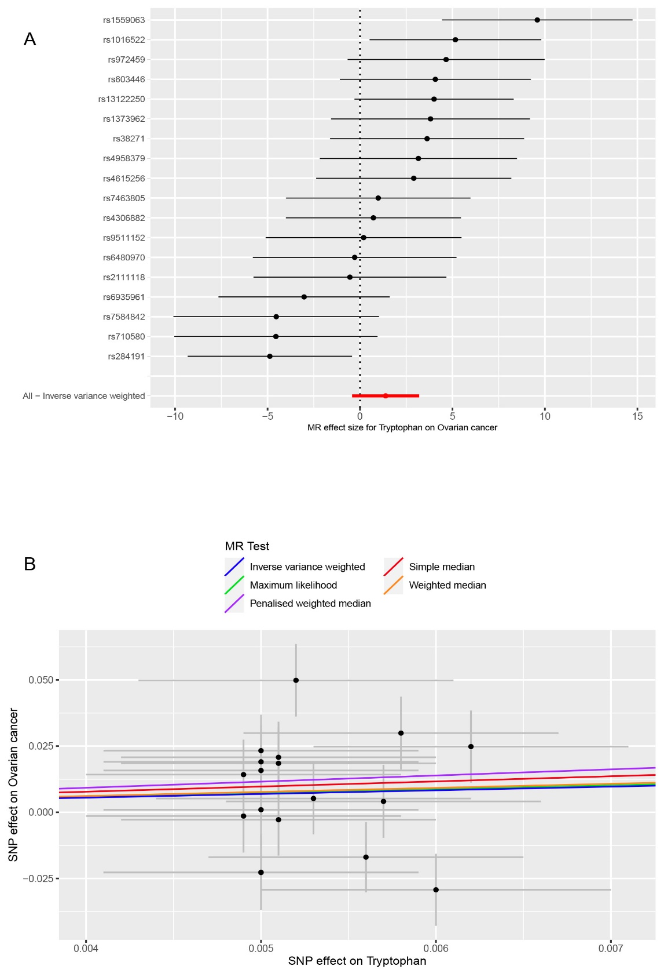
Figure S6. Genetically predicted associations between circulating tryptophan levels and the risk of ovarian cancer. A. Forest plot for the causal effects of circulating tryptophan levels on the risk of ovarian cancer. B. Scatter plot of different analysis methods for the causal associations between circulating tryptophan levels and the risk of ovarian cancer. Each approach has a different line. The slope of each line represents the causal association.
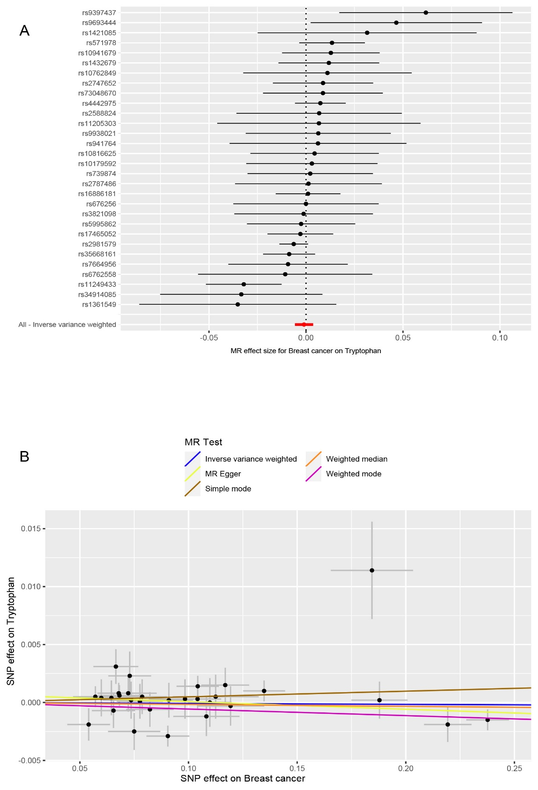
Figure S7. Genetically predicted associations between breast cancer and circulating tryptophan levels. A. Forest plot for the causal effects of breast cancer on circulating tryptophan levels. B. Scatter plot of different analysis methods for the causal associations between breast cancer and circulating tryptophan levels. Each approach has a different line. The slope of each line represents the causal association.
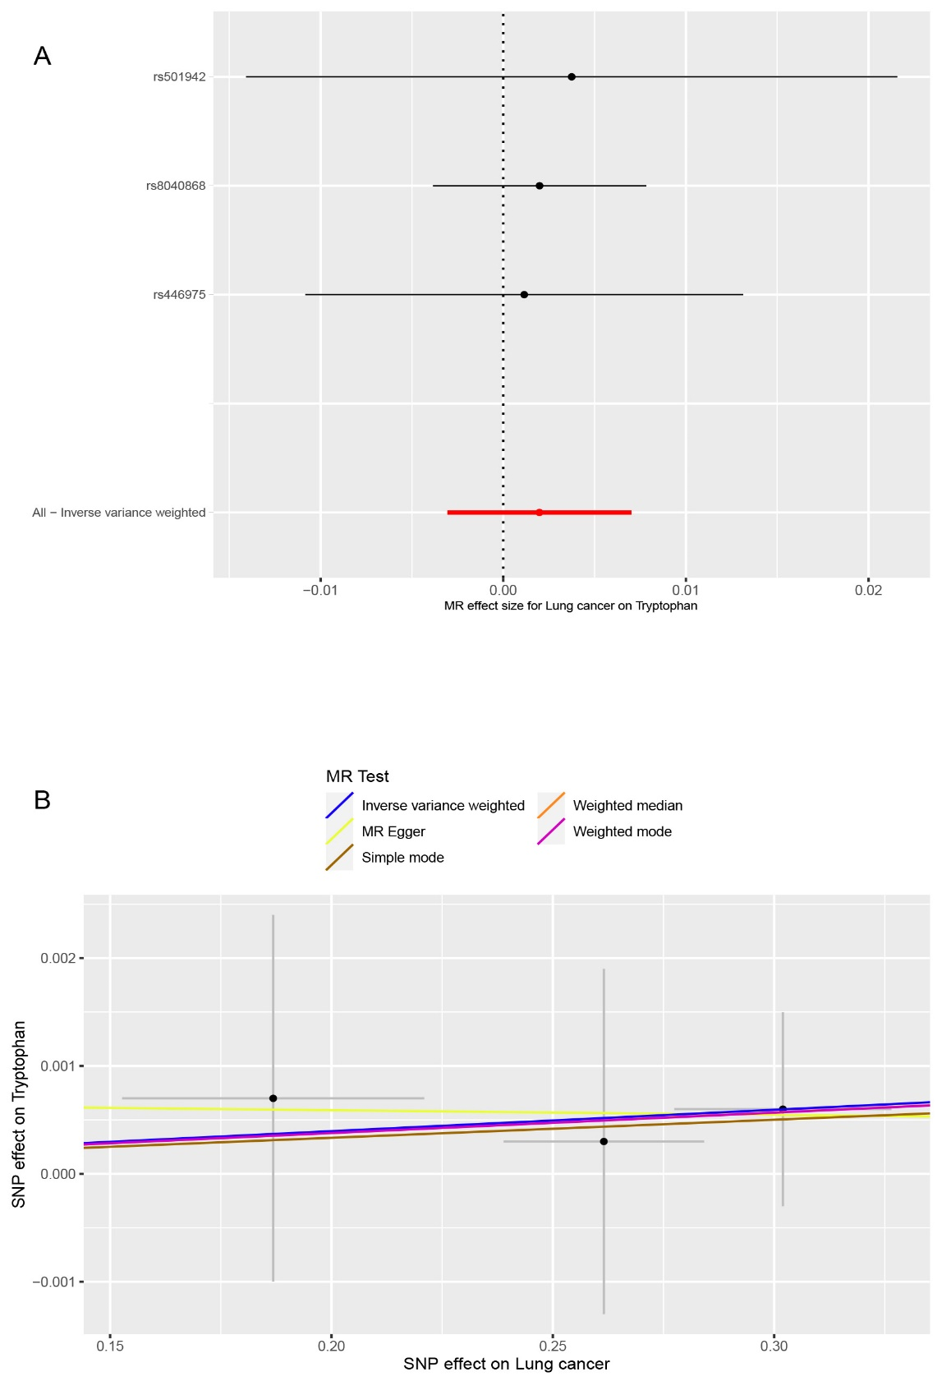
Figure S8. Genetically predicted associations between lung cancer and circulating tryptophan levels. A. Forest plot for the causal effects of lung cancer on circulating tryptophan levels. B. Scatter plot of different analysis methods for the causal associations between lung cancer and circulating tryptophan levels. Each approach has a different line. The slope of each line represents the causal association.
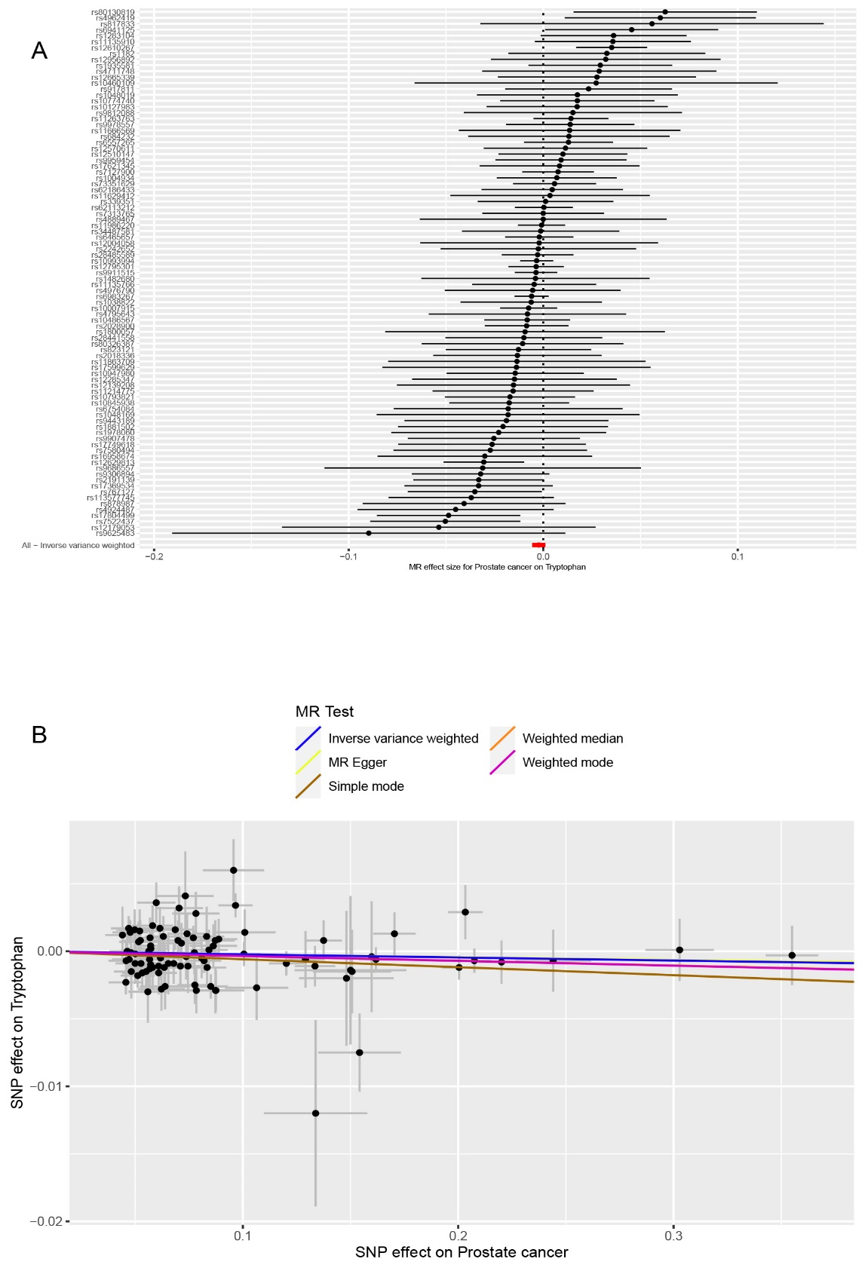
Figure S9. Genetically predicted associations between prostate cancer and circulating tryptophan levels. A. Forest plot for the causal effects of prostate cancer on circulating tryptophan levels. B. Scatter plot of different analysis methods for the causal associations between prostate cancer and circulating tryptophan levels. Each approach has a different line. The slope of each line represents the causal association.
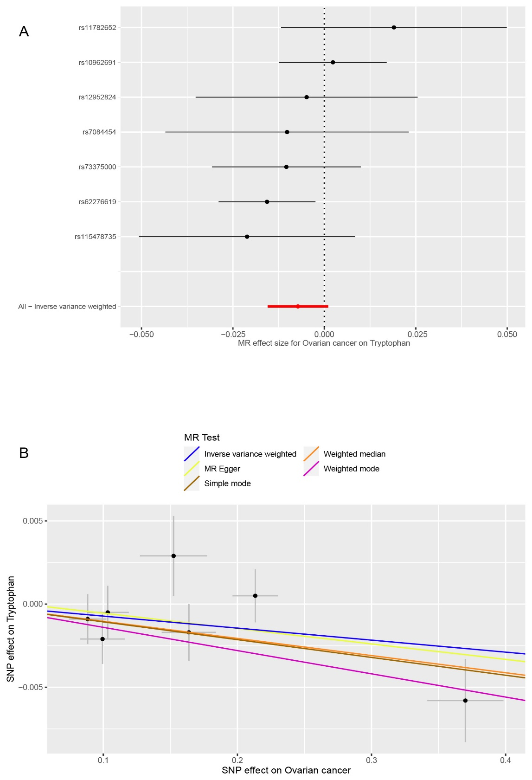
Figure S10. Genetically predicted associations between ovarian cancer and circulating tryptophan levels. A. Forest plot for the causal effects of ovarian cancer on circulating tryptophan levels. B. Scatter plot of different analysis methods for the causal associations between ovarian cancer and circulating tryptophan levels. Each approach has a different line. The slope of each line represents the causal association.
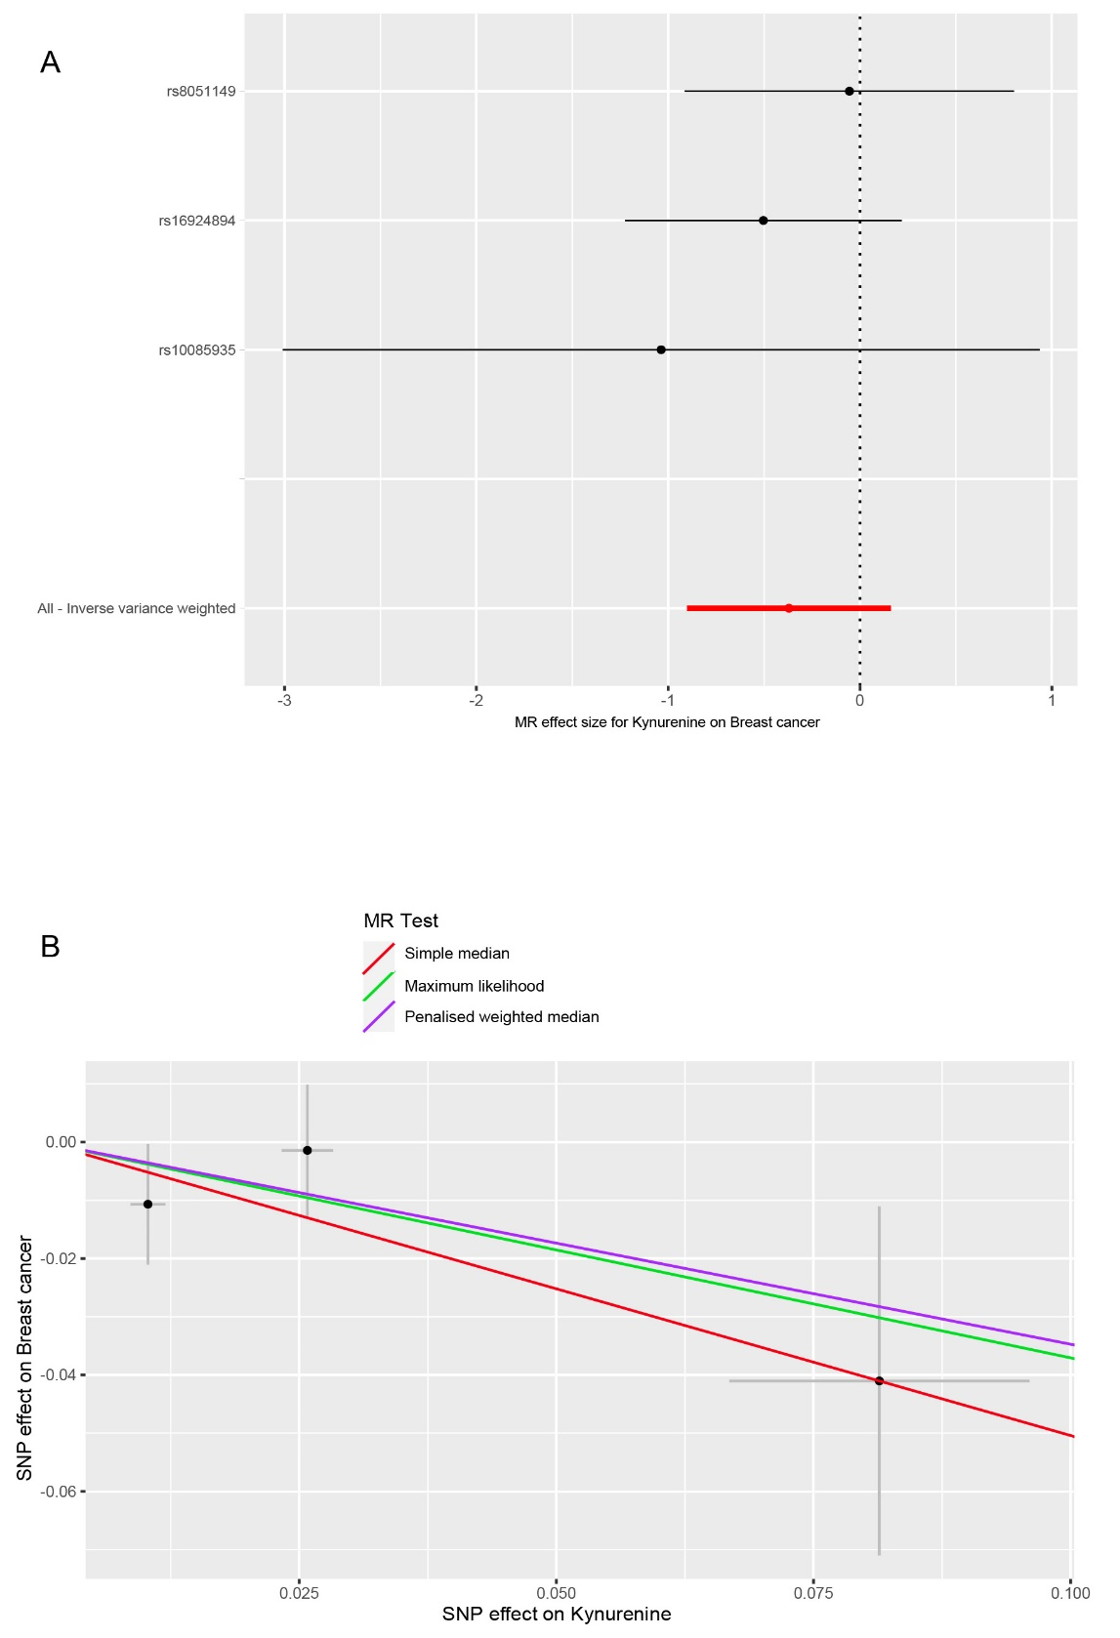
Figure S11. Genetically predicted associations between circulating kynurenine levels and the risk of breast cancer. A. Forest plot for the causal effects of circulating kynurenine levels on the risk of breast cancer. B. Scatter plot of different analysis methods for the causal associations between circulating kynurenine levels and the risk of breast cancer. Each approach has a different line. The slope of each line represents the causal association.
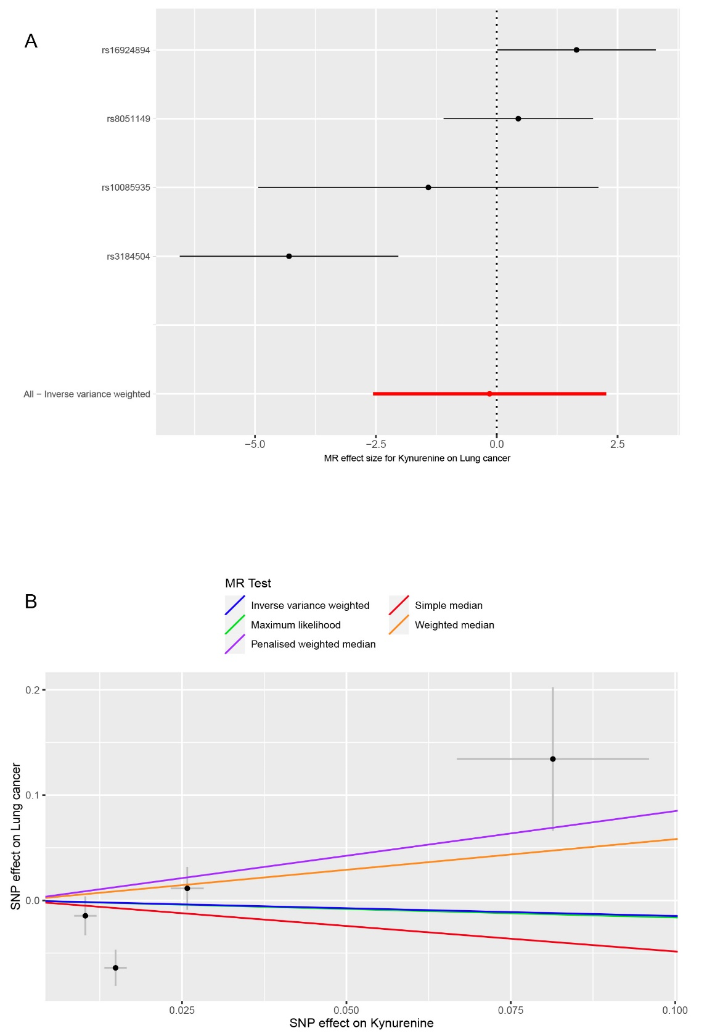
Figure S12. Genetically predicted associations between circulating kynurenine levels and the risk of lung cancer. A. Forest plot for the causal effects of circulating kynurenine levels on the risk of lung cancer. B. Scatter plot of different analysis methods for the causal associations between circulating kynurenine levels and the risk of lung cancer. Each approach has a different line. The slope of each line represents the causal association.
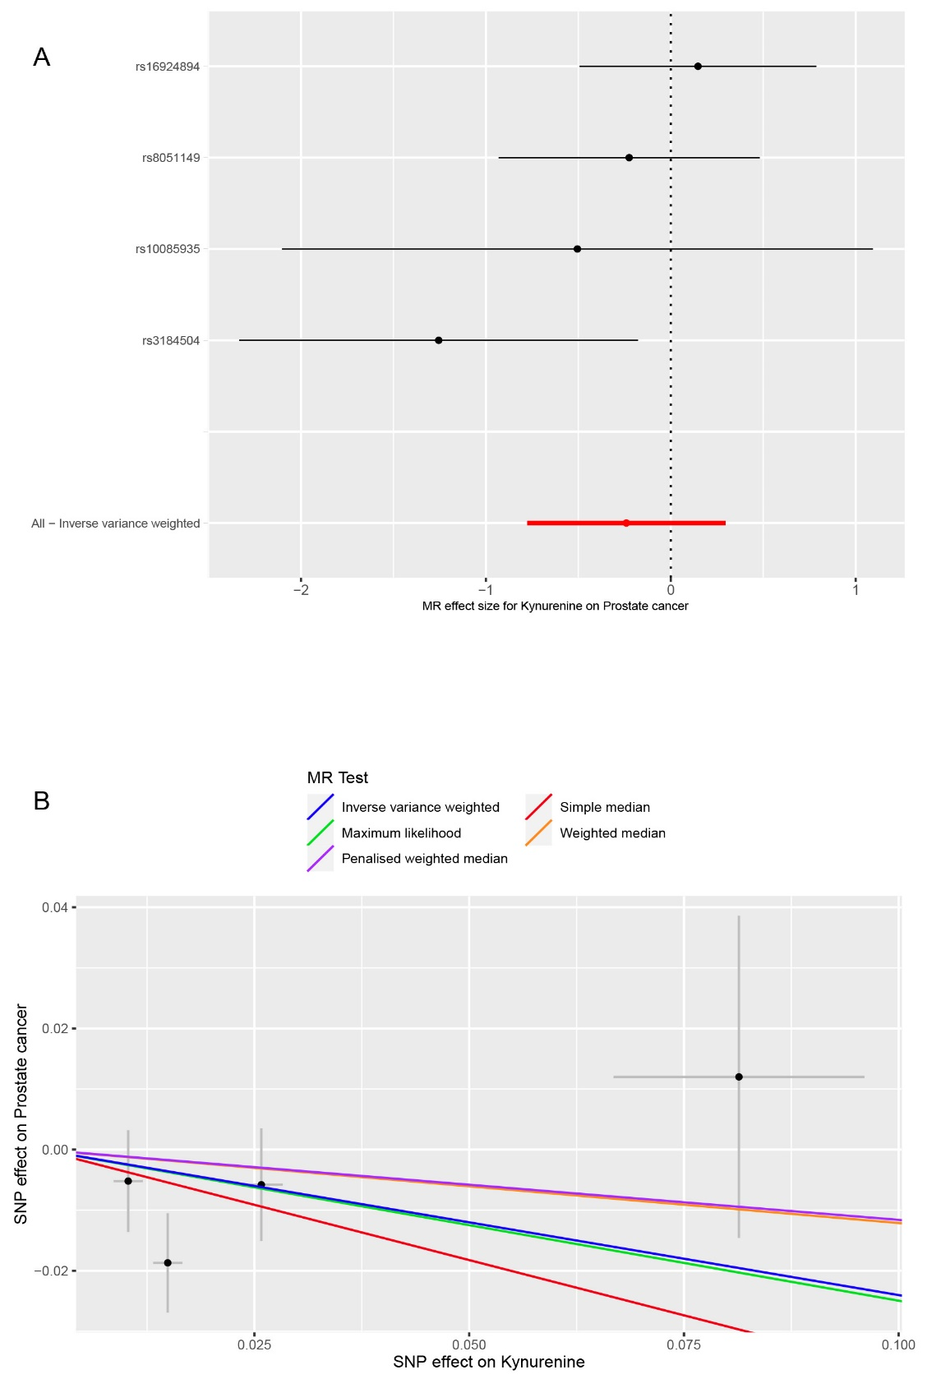
Figure S13. Genetically predicted associations between circulating kynurenine levels and the risk of prostate cancer. A. Forest plot for the causal effects of circulating kynurenine levels on the risk of prostate cancer. B. Scatter plot of different analysis methods for the causal associations between circulating kynurenine levels and the risk of prostate cancer. Each approach has a different line. The slope of each line represents the causal association.
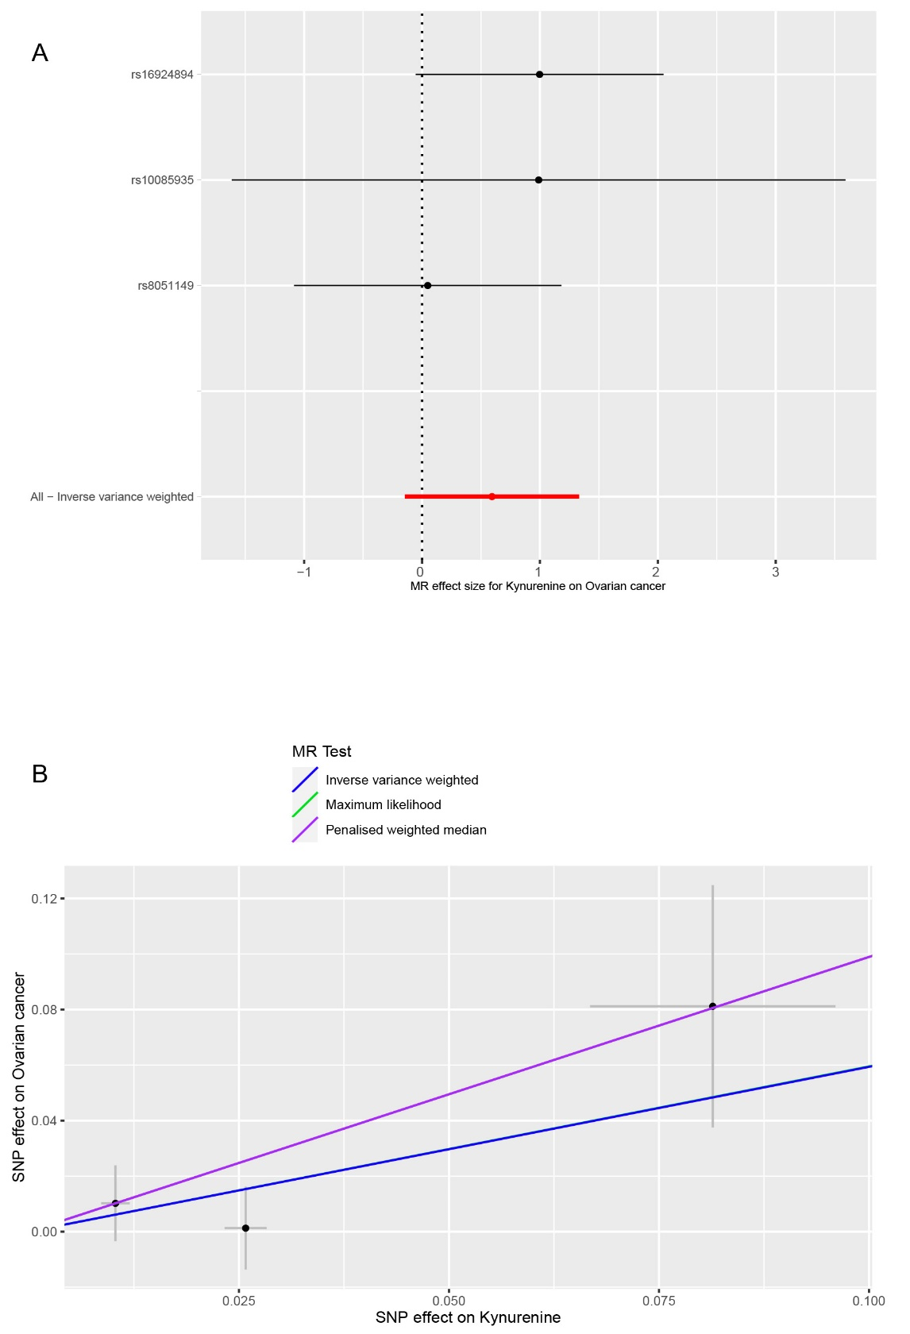
Figure S14. Genetically predicted associations between circulating kynurenine levels and the risk of ovarian cancer. A. Forest plot for the causal effects of circulating kynurenine levels on the risk of ovarian cancer. B. Scatter plot of different analysis methods for the causal associations between circulating kynurenine levels and the risk of ovarian cancer. Each approach has a different line. The slope of each line represents the causal association.
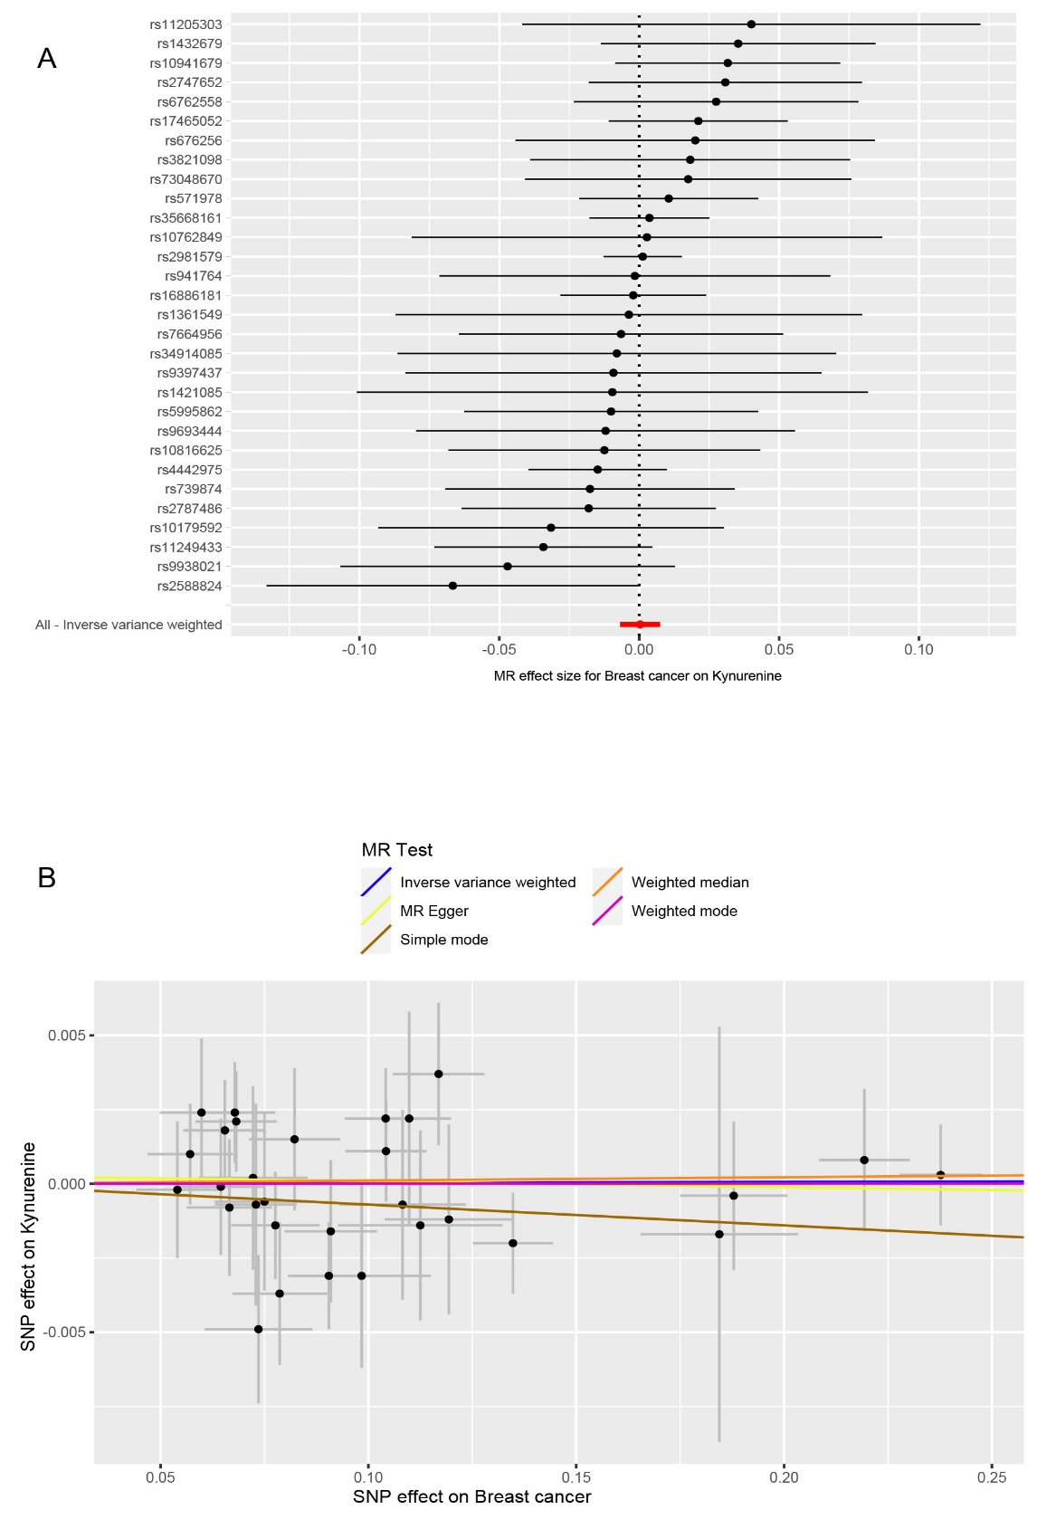
Figure S15. Genetically predicted associations between breast cancer and circulating kynurenine levels. A. Forest plot for the causal effects of breast cancer on circulating kynurenine levels. B. Scatter plot of different analysis methods for the causal associations between breast cancer and circulating kynurenine levels. Each approach has a different line. The slope of each line represents the causal association.
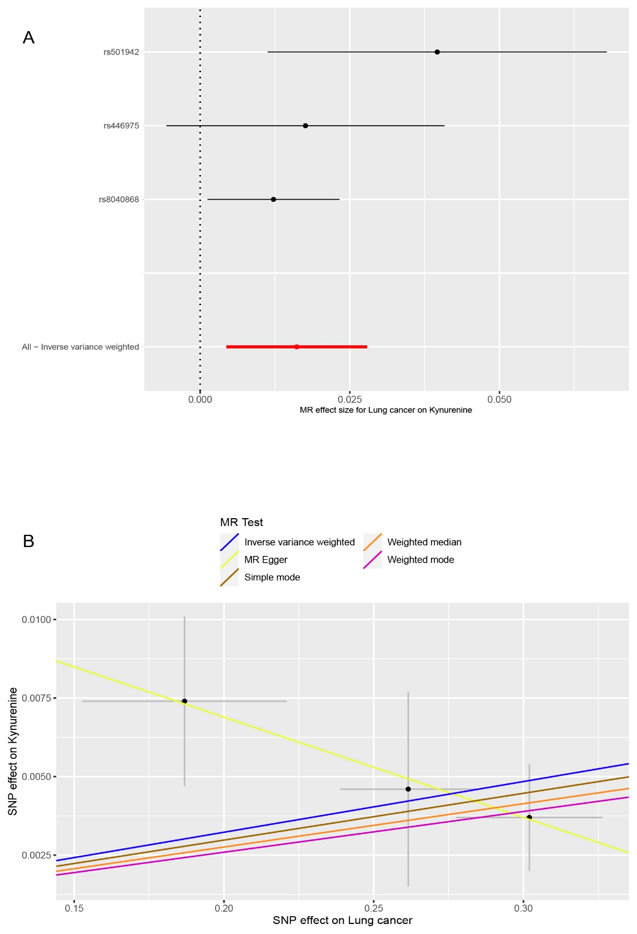
Figure S16. Genetically predicted associations between lung cancer and circulating kynurenine levels. A. Forest plot for the causal effects of lung cancer on circulating kynurenine levels. B. Scatter plot of different analysis methods for the causal associations between lung cancer and circulating kynurenine levels. Each approach has a different line. The slope of each line represents the causal association.
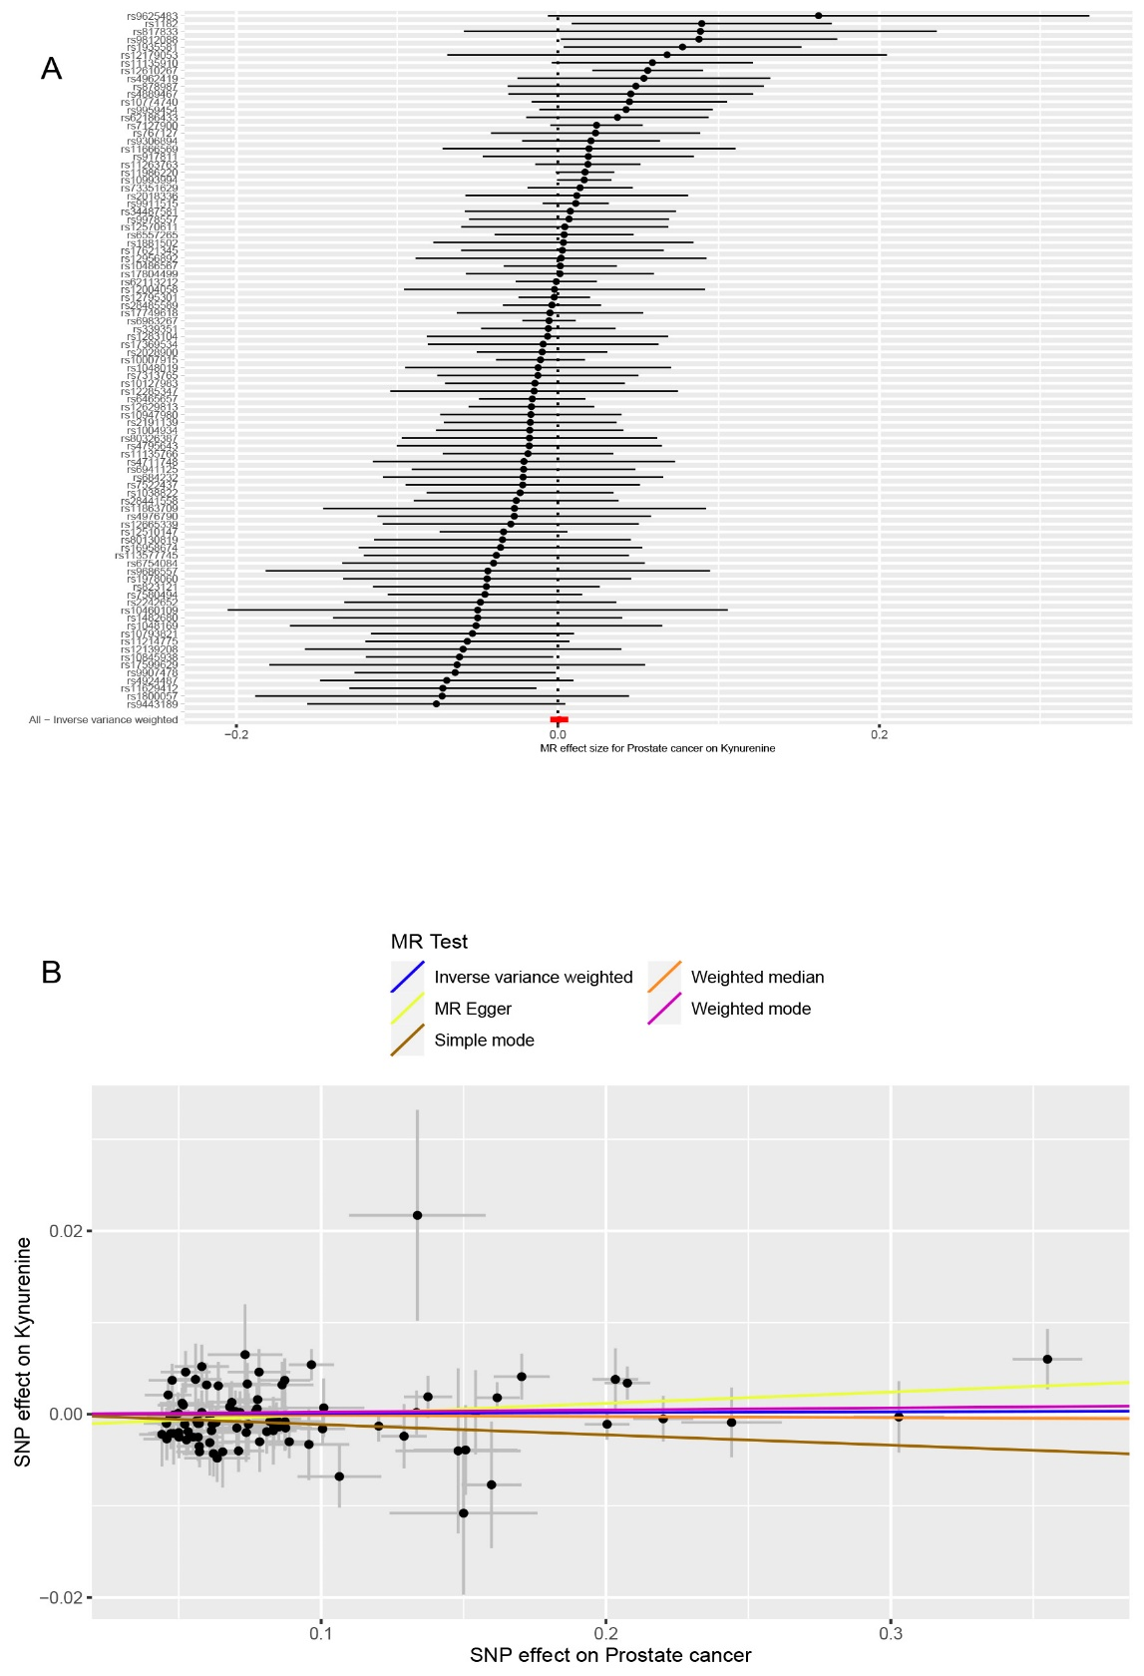
Figure S17. Genetically predicted associations between prostate cancer and circulating kynurenine levels. A. Forest plot for the causal effects of prostate cancer on circulating kynurenine levels. B. Scatter plot of different analysis methods for the causal associations between prostate cancer and circulating kynurenine levels. Each approach has a different line. The slope of each line represents the causal association.
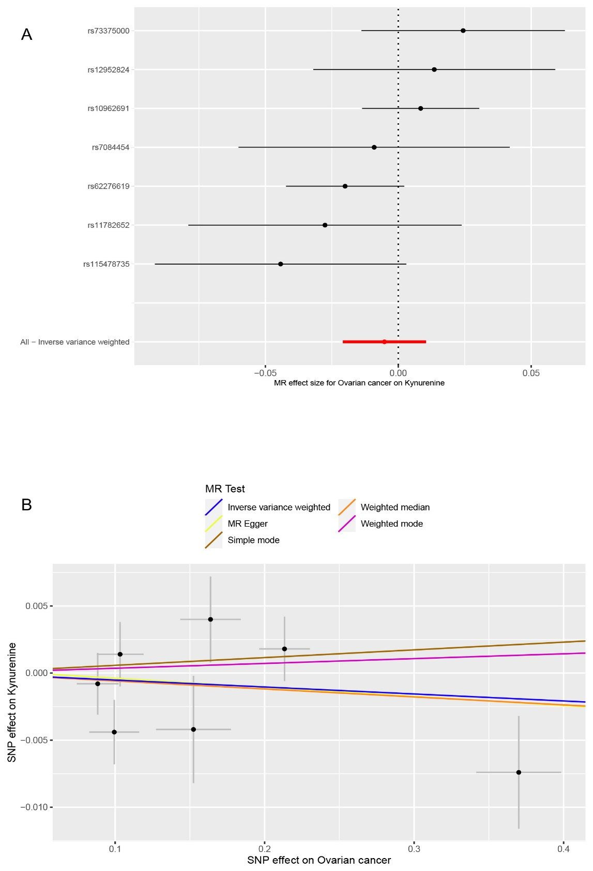
Figure S18. Genetically predicted associations between ovarian cancer and circulating kynurenine levels. A. Forest plot for the causal effects of ovarian cancer on circulating kynurenine levels. B. Scatter plot of different analysis methods for the causal associations between ovarian cancer and circulating kynurenine levels. Each approach has a different line. The slope of each line represents the causal association.
2 Supplementary Tables
Table S1. The tryptophan-related and kynurenine-related genetic variants used for the MR analysesª
Exposure | SNP | Chr | Position | Effect allel | Alternative allele | EAF | Beta | SE | P value | Nearby gene | R² | F-statistic
Tryptophan | rs13122250 | 4 | 157027738 | T | C | 0.5542 | 0.0062 | 0.0009 | 8.949E-12 | NA | 0.003005 | 47.46
Tryptophan | rs1016522 | 5 | 143173519 | A | G | 0.5803 | 0.0058 | 0.0009 | 1.589E-10 | HMHB1 | 0.002592 | 41.53
Tryptophan | rs4306882 | 3 | 21037588 | T | G | 0.6153 | -0.0057 | 0.0009 | 2.52E-10 | NA | 0.002433 | 40.11
Tryptophan | rs6935961 | 6 | 125678049 | A | G | 0.5578 | -0.0056 | 0.0009 | 3.753E-10 | NA | 0.002447 | 38.72
Tryptophan | rs284191 | 1 | 92008636 | A | G | 0.6150 | -0.0060 | 0.0010 | 1.973E-09 | TGFBR3 | 0.002184 | 36.00
Tryptophan | rs7463805 | 8 | 110822848 | T | C | 0.5213 | -0.0053 | 0.0009 | 4.596E-09 | NA | 0.002218 | 34.68
Tryptophan | rs1559063 | 5 | 172281200 | C | G | 0.6209 | 0.0052 | 0.0009 | 7.818E-09 | ERGIC1 | 0.002014 | 33.38
Tryptophan | rs38271 | 7 | 14273556 | A | G | 0.5925 | -0.0051 | 0.0009 | 1.185E-08 | DGKB | 0.001987 | 32.11
Tryptophan | rs2111118 | 16 | 52606654 | T | C | 0.6207 | 0.0051 | 0.0009 | 1.212E-08 | FTO | 0.001937 | 32.11
Tryptophan | rs603446 | 11 | 116159645 | T | C | 0.4448 | 0.0051 | 0.0009 | 1.383E-08 | ZPR1 | 0.002032 | 32.11
Tryptophan | rs972459 | 3 | 193338191 | T | C | 0.5787 | 0.0050 | 0.0009 | 1.969E-08 | NA | 0.001928 | 30.86
Tryptophan | rs4958379 | 5 | 153990234 | A | G | 0.4330 | -0.0050 | 0.0009 | 2.176E-08 | NA | 0.001942 | 30.86
Tryptophan | rs1373962 | 5 | 83563618 | T | C | 0.5973 | 0.0050 | 0.0009 | 2.707E-08 | EDIL3 | 0.001903 | 30.86
Tryptophan | rs9511152 | 13 | 18494767 | A | G | 0.5590 | -0.0050 | 0.0009 | 2.985E-08 | NA | 0.001950 | 30.86
Tryptophan | rs710580 | 3 | 191291857 | A | C | 0.3566 | -0.0050 | 0.0009 | 3.574E-08 | P3H2 | 0.001815 | 30.86
Tryptophan | rs7584842 | 2 | 11673711 | T | C | 0.5377 | -0.0050 | 0.0009 | 4.15E-08 | GREB1 | 0.001966 | 30.86
Tryptophan | rs6480970 | 10 | 54238670 | A | G | 0.6159 | -0.0049 | 0.0009 | 4.287E-08 | LOC105378306/7 | 0.001797 | 29.64
Tryptophan | rs4615256 | 5 | 62736623 | A | G | 0.5327 | 0.0049 | 0.0009 | 4.988E-08 | LOC107986418 | 0.001891 | 29.64
Kynurenine | rs8051149 | 16 | 86436323 | A | G | 0.2127 | 0.0258 | 0.0025 | 9.073E-26 | SLC7A5 | 0.004564 | 106.50
Kynurenine | rs3184504 | 12 | 110368991 | T | C | 0.4851 | 0.0149 | 0.0017 | 6.046E-18 | SH2B3 | 0.004910 | 76.82
Kynurenine | rs10085935 | 8 | 39925424 | T | C | 0.3782 | -0.0103 | 0.0017 | 3.326E-09 | IDO2 | 0.002209 | 36.71
Kynurenine | rs16924894 | 10 | 24885531 | A | T | 0.0240 | 0.0814 | 0.0146 | 2.329E-08 | NA | 0.000186 | 31.08
Abbreviations: SNP, single-nucleotide polymorphism; Chr, chromosome; EAF, effect allel frequency; SE, standard error.
Source: ªShin SY, Fauman EB, Petersen AK et al. An atlas of genetic influences on human blood metabolites. Nat Genet 2014; 46: 543-550.

Table S2. The site-specific cancers-related instrumental variables used for the MR analyses
Exposure | SNP | Chr | Position | Reference allel | Alternative allel | EAF | Beta | SE | P value | R² | F-statistic
Breast cancer | rs9938021 | 16 | 80648048 | C | G | 0.2285 | 0.0787 | 0.0114 | 5.35E-12 | 0.000187 | 47.53
Breast cancer | rs9693444 | 8 | 29509616 | A | C | 0.6761 | -0.0666 | 0.0103 | 1.09E-10 | 0.000203 | 41.61
Breast cancer | rs941764 | 14 | 91841069 | A | G | 0.3399 | 0.0645 | 0.0102 | 2.37E-10 | 0.000201 | 40.14
Breast cancer | rs9397437 | 6 | 151952332 | G | A | 0.0654 | 0.1844 | 0.0189 | 1.98E-22 | 0.000129 | 94.92
Breast cancer | rs7664956 | 4 | 175832937 | G | T | 0.1201 | -0.1082 | 0.0152 | 1.24E-12 | 0.000119 | 50.42
Breast cancer | rs739874 | 14 | 68974410 | A | G | 0.2670 | -0.0910 | 0.0111 | 2.67E-16 | 0.000293 | 67.02
Breast cancer | rs73048670 | 19 | 44284531 | C | T | 0.3993 | 0.0571 | 0.0103 | 2.88E-08 | 0.000165 | 30.81
Breast cancer | rs676256 | 9 | 110895353 | C | T | 0.6166 | 0.1098 | 0.0101 | 1.00E-27 | 0.000628 | 119.15
Breast cancer | rs6762558 | 3 | 4742251 | A | G | 0.3959 | 0.0655 | 0.0099 | 4.44E-11 | 0.000231 | 43.38
Breast cancer | rs5995862 | 22 | 40857793 | A | C | 0.1045 | 0.1194 | 0.0155 | 1.31E-14 | 0.000124 | 59.38
Breast cancer | rs571978 | 3 | 27344193 | A | G | 0.5223 | 0.1043 | 0.0097 | 9.55E-27 | 0.000637 | 114.56
Breast cancer | rs4442975 | 2 | 217920769 | G | T | 0.5061 | -0.1348 | 0.0097 | 2.91E-44 | 0.001085 | 194.67
Breast cancer | rs3821098 | 2 | 218292141 | T | C | 0.7370 | -0.0822 | 0.0109 | 5.63E-14 | 0.000244 | 56.51
Breast cancer | rs35668161 | 16 | 52538825 | C | A | 0.2492 | 0.2193 | 0.0109 | 1.71E-89 | 0.001680 | 402.60
Breast cancer | rs34914085 | 14 | 37128564 | C | A | 0.2098 | -0.0750 | 0.0120 | 4.23E-10 | 0.000144 | 38.99
Breast cancer | rs2981579 | 10 | 123337335 | A | G | 0.5956 | -0.2377 | 0.0099 | 1.29E-128 | 0.003127 | 582.21
Breast cancer | rs2787486 | 17 | 53209774 | A | C | 0.3008 | -0.0776 | 0.0107 | 3.09E-13 | 0.000249 | 53.12
Breast cancer | rs2747652 | 6 | 152437016 | T | C | 0.5324 | 0.0682 | 0.0098 | 2.97E-12 | 0.000271 | 48.74
Breast cancer | rs2588824 | 14 | 68619461 | T | C | 0.8354 | -0.0736 | 0.0130 | 1.33E-08 | 0.000099 | 32.27
Breast cancer | rs17465052 | 8 | 128354080 | G | A | 0.4246 | -0.1042 | 0.0099 | 6.31E-26 | 0.000604 | 110.92
Breast cancer | rs16886181 | 5 | 56029243 | T | C | 0.1586 | 0.1879 | 0.0129 | 6.32E-48 | 0.000629 | 211.49
Breast cancer | rs1432679 | 5 | 158244083 | C | T | 0.5679 | -0.0679 | 0.0098 | 3.60E-12 | 0.000265 | 48.36
Breast cancer | rs1421085 | 16 | 53800954 | T | C | 0.4131 | -0.0729 | 0.0099 | 1.39E-13 | 0.000296 | 54.72
Breast cancer | rs1361549 | 6 | 82287685 | G | A | 0.4250 | -0.0541 | 0.0098 | 3.80E-08 | 0.000165 | 30.23
Breast cancer | rs11249433 | 1 | 121280613 | A | G | 0.4018 | 0.0905 | 0.0099 | 4.43E-20 | 0.000451 | 84.23
Breast cancer | rs11205303 | 1 | 149906413 | T | C | 0.3984 | 0.0599 | 0.0100 | 2.36E-09 | 0.000190 | 35.62
Breast cancer | rs10941679 | 5 | 44706498 | A | G | 0.2543 | 0.1169 | 0.0110 | 3.20E-26 | 0.000475 | 112.33
Breast cancer | rs10816625 | 9 | 110837073 | A | G | 0.0610 | 0.1125 | 0.0198 | 1.32E-08 | 0.000041 | 32.32
Breast cancer | rs10762849 | 10 | 80886061 | C | T | 0.1621 | 0.0723 | 0.0131 | 3.77E-08 | 0.000092 | 30.28
Breast cancer | rs10179592 | 2 | 121246568 | T | C | 0.9015 | 0.0984 | 0.0166 | 3.35E-09 | 0.000069 | 34.95
Lung cancer | rs8040868 | 15 | 78911181 | T | C | 0.424371 | 0.301974 | 0.024535 | 4.97E-60 | 0.002720 | 151.48
Lung cancer | rs446975 | 3 | 9217383 | G | T | 0.115137 | -0.261532 | 0.022649 | 6.42E-18 | 0.000999 | 133.34
Lung cancer | rs501942 | 6 | 31840477 | C | T | 0.108859 | 0.186841 | 0.034137 | 1.47E-10 | 0.000214 | 29.96
Prostate cancer | rs9978557 | 21 | 42882462 | C | T | 0.098 | -0.1009 | 0.0143 | 2.02E-12 | 0.000063 | 49.79
Prostate cancer | rs9959454 | 18 | 76770820 | A | G | 0.2672 | -0.0872 | 0.009 | 5.34E-22 | 0.000262 | 93.87
Prostate cancer | rs9911515 | 17 | 69115358 | A | G | 0.5197 | -0.1618 | 0.0079 | 6.47E-93 | 0.001493 | 419.47
Prostate cancer | rs9907478 | 17 | 47395729 | C | T | 0.0757 | 0.1064 | 0.0147 | 4.52E-13 | 0.000052 | 52.39
Prostate cancer | rs9812088 | 3 | 128263668 | G | A | 0.3 | -0.0524 | 0.0088 | 2.99E-09 | 0.000106 | 35.46
Prostate cancer | rs9686557 | 5 | 172959030 | A | C | 0.444 | 0.0482 | 0.008 | 1.94E-09 | 0.000128 | 36.30
Prostate cancer | rs9625483 | 22 | 28888939 | G | A | 0.0288 | 0.1338 | 0.024 | 2.43E-08 | 0.000012 | 31.08
Prostate cancer | rs9443189 | 6 | 76495882 | A | G | 0.1429 | -0.0635 | 0.0116 | 4.68E-08 | 0.000052 | 29.97
Prostate cancer | rs9306894 | 2 | 20878105 | A | G | 0.3633 | 0.0777 | 0.0082 | 1.92E-21 | 0.000296 | 89.79
Prostate cancer | rs917811 | 7 | 21059022 | C | T | 0.6856 | -0.0686 | 0.0085 | 5.51E-16 | 0.000200 | 65.13
Prostate cancer | rs878987 | 11 | 134266372 | A | G | 0.1459 | 0.0639 | 0.0117 | 4.77E-08 | 0.000053 | 29.83
Prostate cancer | rs823121 | 1 | 205724302 | G | A | 0.4322 | -0.0472 | 0.008 | 3.38E-09 | 0.000122 | 34.81
Prostate cancer | rs817833 | 9 | 110152977 | G | T | 0.8914 | -0.0733 | 0.0131 | 2.14E-08 | 0.000043 | 31.31
Prostate cancer | rs80326387 | 15 | 66705043 | G | A | 0.2583 | 0.0567 | 0.0091 | 4.64E-10 | 0.000106 | 38.82
Prostate cancer | rs80130819 | 12 | 48419618 | A | C | 0.0916 | -0.0957 | 0.0142 | 1.89E-11 | 0.000054 | 45.42
Prostate cancer | rs767127 | 14 | 69134264 | A | G | 0.4989 | 0.0512 | 0.0079 | 1.00E-10 | 0.000150 | 42.00
Prostate cancer | rs7580494 | 2 | 62781499 | C | T | 0.3878 | 0.0551 | 0.0081 | 1.17E-11 | 0.000157 | 46.27
Prostate cancer | rs7522437 | 1 | 204029890 | G | A | 0.4609 | -0.0457 | 0.008 | 1.21E-08 | 0.000116 | 32.63
Prostate cancer | rs73351629 | 8 | 128018466 | C | G | 0.3334 | -0.1375 | 0.0085 | 5.15E-59 | 0.000829 | 261.68
Prostate cancer | rs7313765 | 12 | 65011980 | G | A | 0.4218 | -0.0563 | 0.0082 | 5.72E-12 | 0.000164 | 47.14
Prostate cancer | rs7127900 | 11 | 2233574 | A | G | 0.8015 | -0.1704 | 0.0098 | 4.94E-68 | 0.000686 | 302.33
Prostate cancer | rs6983267 | 8 | 128413305 | G | T | 0.4892 | -0.2004 | 0.0079 | 2.81E-141 | 0.002293 | 643.49
Prostate cancer | rs6941125 | 6 | 109287209 | T | A | 0.1457 | 0.0704 | 0.0111 | 1.99E-10 | 0.000071 | 40.23
Prostate cancer | rs684232 | 17 | 618965 | T | C | 0.3534 | 0.0832 | 0.0082 | 4.34E-24 | 0.000335 | 102.95
Prostate cancer | rs6754084 | 2 | 202124997 | T | C | 0.7324 | 0.05 | 0.0091 | 3.53E-08 | 0.000084 | 30.19
Prostate cancer | rs6557265 | 6 | 153433402 | T | C | 0.4226 | -0.077 | 0.008 | 1.04E-21 | 0.000322 | 92.64
Prostate cancer | rs6465657 | 7 | 97816327 | C | T | 0.5365 | -0.1005 | 0.0079 | 6.96E-37 | 0.000574 | 161.84
Prostate cancer | rs62186433 | 2 | 242257835 | A | G | 0.1486 | 0.0863 | 0.011 | 3.21E-15 | 0.000111 | 61.55
Prostate cancer | rs62113212 | 19 | 51360840 | C | T | 0.0775 | -0.3028 | 0.0159 | 4.26E-81 | 0.000370 | 362.67
Prostate cancer | rs4976790 | 5 | 177968915 | G | T | 0.1131 | 0.0737 | 0.0127 | 6.73E-09 | 0.000048 | 33.68
Prostate cancer | rs4962419 | 10 | 126697114 | G | A | 0.2664 | 0.0598 | 0.0089 | 1.62E-11 | 0.000126 | 45.15
Prostate cancer | rs4924487 | 15 | 40922915 | G | C | 0.8359 | 0.0622 | 0.0109 | 1.32E-08 | 0.000064 | 32.56
Prostate cancer | rs4889467 | 16 | 82169385 | C | T | 0.6506 | -0.0463 | 0.0082 | 1.91E-08 | 0.000103 | 31.88
Prostate cancer | rs4795643 | 17 | 30092614 | C | A | 0.2287 | -0.0618 | 0.0103 | 1.64E-09 | 0.000091 | 36.00
Prostate cancer | rs4711748 | 6 | 43694598 | T | C | 0.7746 | -0.0521 | 0.0094 | 3.36E-08 | 0.000076 | 30.72
Prostate cancer | rs34487581 | 10 | 897201 | G | A | 0.1585 | 0.0775 | 0.0109 | 9.34E-13 | 0.000096 | 50.55
Prostate cancer | rs339351 | 6 | 117200434 | C | A | 0.3052 | -0.0843 | 0.0087 | 2.90E-22 | 0.000284 | 93.89
Prostate cancer | rs28485589 | 2 | 173303031 | A | G | 0.0608 | -0.2441 | 0.0176 | 1.11E-43 | 0.000157 | 192.36
Prostate cancer | rs28441558 | 17 | 7803118 | T | C | 0.0548 | 0.1507 | 0.0182 | 1.02E-16 | 0.000051 | 68.56
Prostate cancer | rs2242652 | 5 | 1280028 | G | A | 0.2054 | -0.1598 | 0.0105 | 3.46E-52 | 0.000539 | 231.62
Prostate cancer | rs2191139 | 19 | 42001210 | T | C | 0.7474 | 0.0875 | 0.0093 | 3.25E-21 | 0.000238 | 88.52
Prostate cancer | rs2028900 | 2 | 85767735 | C | T | 0.4418 | -0.082 | 0.008 | 6.67E-25 | 0.000369 | 105.06
Prostate cancer | rs2018336 | 6 | 11217897 | T | C | 0.2206 | -0.0679 | 0.0096 | 1.91E-12 | 0.000123 | 50.03
Prostate cancer | rs1978060 | 22 | 19749525 | A | G | 0.6127 | 0.0568 | 0.0083 | 8.54E-12 | 0.000158 | 46.83
Prostate cancer | rs1935581 | 10 | 90195149 | C | T | 0.3728 | -0.0477 | 0.0082 | 6.55E-09 | 0.000113 | 33.84
Prostate cancer | rs1881502 | 11 | 1507512 | T | C | 0.8097 | -0.0581 | 0.0101 | 7.42E-09 | 0.000073 | 33.09
Prostate cancer | rs1800057 | 11 | 108143456 | C | G | 0.0234 | 0.15 | 0.026 | 8.15E-09 | 0.000011 | 33.28
Prostate cancer | rs17804499 | 4 | 74442349 | G | C | 0.0534 | -0.1542 | 0.0192 | 9.15E-16 | 0.000046 | 64.50
Prostate cancer | rs17749618 | 11 | 76251818 | A | G | 0.324 | -0.0609 | 0.0085 | 7.48E-13 | 0.000160 | 51.33
Prostate cancer | rs17621345 | 7 | 40875192 | A | C | 0.2587 | -0.0715 | 0.0095 | 6.72E-14 | 0.000155 | 56.65
Prostate cancer | rs17599629 | 1 | 150658287 | A | G | 0.2181 | 0.0654 | 0.0096 | 9.87E-12 | 0.000113 | 46.41
Prostate cancer | rs17369534 | 3 | 152064639 | G | C | 0.1047 | -0.0873 | 0.0134 | 6.51E-11 | 0.000057 | 42.44
Prostate cancer | rs16958674 | 16 | 57693055 | C | T | 0.2385 | -0.0533 | 0.0094 | 1.27E-08 | 0.000083 | 32.15
Prostate cancer | rs1482680 | 5 | 44392142 | G | A | 0.6667 | -0.0501 | 0.0085 | 3.58E-09 | 0.000110 | 34.74
Prostate cancer | rs12956892 | 18 | 56746315 | G | T | 0.3021 | 0.0498 | 0.0086 | 7.68E-09 | 0.000101 | 33.53
Prostate cancer | rs1283104 | 3 | 106962521 | C | G | 0.3788 | 0.047 | 0.0082 | 8.81E-09 | 0.000110 | 32.85
Prostate cancer | rs12795301 | 11 | 68992285 | C | A | 0.1586 | 0.2201 | 0.0105 | 3.07E-98 | 0.000836 | 439.40
Prostate cancer | rs12665339 | 6 | 30601232 | A | G | 0.1674 | 0.0615 | 0.0106 | 5.56E-09 | 0.000067 | 33.66
Prostate cancer | rs12629813 | 3 | 113284149 | C | T | 0.4371 | -0.0851 | 0.008 | 1.98E-26 | 0.000397 | 113.16
Prostate cancer | rs12610267 | 19 | 38744733 | A | G | 0.5103 | -0.0966 | 0.0079 | 4.87E-34 | 0.000533 | 149.52
Prostate cancer | rs12570611 | 10 | 104421679 | G | C | 0.3242 | -0.0699 | 0.0085 | 2.54E-16 | 0.000211 | 67.63
Prostate cancer | rs12510147 | 4 | 95521863 | G | A | 0.3115 | -0.0888 | 0.0086 | 4.34E-25 | 0.000326 | 106.62
Prostate cancer | rs12285347 | 11 | 102396607 | T | C | 0.4507 | -0.0745 | 0.0082 | 1.17E-19 | 0.000291 | 82.54
Prostate cancer | rs12179053 | 6 | 160711566 | C | T | 0.2603 | -0.0559 | 0.0091 | 6.50E-10 | 0.000104 | 37.73
Prostate cancer | rs12139208 | 1 | 88213014 | T | C | 0.6286 | -0.0458 | 0.0082 | 2.58E-08 | 0.000104 | 31.20
Prostate cancer | rs12004058 | 9 | 18564470 | C | G | 0.312 | -0.0481 | 0.0086 | 2.36E-08 | 0.000096 | 31.28
Prostate cancer | rs11986220 | 8 | 128531689 | A | T | 0.8953 | -0.355 | 0.0122 | 1.10E-187 | 0.001132 | 846.71
Prostate cancer | rs11863709 | 16 | 57654576 | C | T | 0.0403 | -0.1481 | 0.022 | 1.78E-11 | 0.000025 | 45.32
Prostate cancer | rs1182 | 9 | 132576060 | C | A | 0.2198 | 0.0581 | 0.0095 | 1.10E-09 | 0.000091 | 37.40
Prostate cancer | rs11666569 | 19 | 17214073 | C | T | 0.2867 | -0.0516 | 0.009 | 8.17E-09 | 0.000096 | 32.87
Prostate cancer | rs11629412 | 14 | 37138294 | G | C | 0.5821 | 0.0573 | 0.0082 | 2.34E-12 | 0.000169 | 48.83
Prostate cancer | rs113577745 | 2 | 10135681 | C | G | 0.098 | 0.0784 | 0.0131 | 2.09E-09 | 0.000045 | 35.82
Prostate cancer | rs11263763 | 17 | 36103565 | G | A | 0.5292 | 0.2033 | 0.008 | 3.06E-141 | 0.002294 | 645.80
Prostate cancer | rs11214775 | 11 | 113807181 | G | A | 0.2915 | -0.071 | 0.009 | 3.93E-15 | 0.000183 | 62.23
Prostate cancer | rs11135910 | 8 | 25892142 | C | T | 0.1529 | 0.0782 | 0.011 | 9.19E-13 | 0.000093 | 50.54
Prostate cancer | rs11135766 | 8 | 23533623 | C | T | 0.5736 | -0.1291 | 0.008 | 5.09E-59 | 0.000908 | 260.42
Prostate cancer | rs10993994 | 10 | 51549496 | T | C | 0.617 | -0.2075 | 0.008 | 2.29E-147 | 0.002267 | 672.75
Prostate cancer | rs10947980 | 6 | 41525739 | A | G | 0.2634 | 0.0834 | 0.0089 | 8.78E-21 | 0.000243 | 87.81
Prostate cancer | rs10845938 | 12 | 14416918 | A | G | 0.5541 | 0.0572 | 0.008 | 9.80E-13 | 0.000180 | 51.12
Prostate cancer | rs10793821 | 5 | 133836209 | C | T | 0.5795 | 0.0527 | 0.008 | 5.43E-11 | 0.000151 | 43.40
Prostate cancer | rs10774740 | 12 | 114666202 | G | T | 0.3844 | -0.0741 | 0.0082 | 1.63E-19 | 0.000276 | 81.66
Prostate cancer | rs10486567 | 7 | 27976563 | G | A | 0.2373 | -0.1335 | 0.0094 | 2.04E-45 | 0.000521 | 201.70
Prostate cancer | rs1048169 | 9 | 19055965 | T | C | 0.379 | 0.0609 | 0.0081 | 6.53E-14 | 0.000190 | 56.53
Prostate cancer | rs1048019 | 6 | 160147630 | A | G | 0.2849 | -0.0569 | 0.0091 | 3.22E-10 | 0.000114 | 39.10
Prostate cancer | rs10460109 | 18 | 73036165 | T | C | 0.5857 | -0.0441 | 0.008 | 3.48E-08 | 0.000105 | 30.39
Prostate cancer | rs1038822 | 2 | 43738173 | T | C | 0.6877 | -0.0809 | 0.0085 | 1.48E-21 | 0.000277 | 90.59
Prostate cancer | rs10127983 | 1 | 153923276 | C | T | 0.3117 | 0.0631 | 0.0085 | 1.02E-13 | 0.000169 | 55.11
Prostate cancer | rs1004934 | 10 | 122796182 | G | C | 0.3874 | 0.0572 | 0.0081 | 1.39E-12 | 0.000169 | 49.87
Prostate cancer | rs10007915 | 4 | 106065308 | C | G | 0.4093 | -0.1202 | 0.0081 | 8.27E-50 | 0.000759 | 220.21
Ovarian cancer | rs10962691 | 9 | 16915105 | C | G | 0.2026 | -0.2133 | 0.01698 | 1.73E-36 | 0.000767 | 157.80
Ovarian cancer | rs115478735 | 9 | 136149711 | A | T | 0.1936 | 0.09941 | 0.01672 | 2.80E-09 | 0.000166 | 35.35
Ovarian cancer | rs11782652 | 8 | 82653644 | A | G | 0.06811 | 0.1524 | 0.02508 | 1.25E-09 | 0.000071 | 36.92
Ovarian cancer | rs12952824 | 17 | 46478195 | C | A | 0.2171 | 0.1033 | 0.0157 | 4.91E-11 | 0.000221 | 43.29
Ovarian cancer | rs62276619 | 3 | 156397692 | C | T | 0.04882 | 0.37 | 0.0284 | 5.53E-39 | 0.000237 | 169.73
Ovarian cancer | rs7084454 | 10 | 21821274 | G | A | 0.3279 | 0.08833 | 0.01395 | 2.41E-10 | 0.000266 | 40.09
Ovarian cancer | rs73375000 | 8 | 129561866 | C | T | 0.1324 | -0.1638 | 0.02023 | 4.58E-16 | 0.000227 | 65.56

Table S3. Summary-level descriptives for tryptophan and kynurenine of the KORA-TwinsUK studiesª
Metabolite | Pathway | Super-pathway | Platform | CV(%) | Included in GWAS meta-analysis | Total N | TwinsUK |  |  |  |  | KORA |  |  |  |  | First author (year) | Web URL
 |  |  |  |  |  |  | N | Min | Max | Mean | SD | N | Min | Max | Mean | SD
Tryptophan | Tryptophan metabolism | Amino acid | LC/MS pos | 6.4 | Yes | 7,804 | 6,041 | -0.285 | 0.279 | 0 | 0.07 | 1,763 | -0.257 | 0.219 | -0.002 | 0.062 | Shin (2014) | http://metabolomics.helmholtz-muenchen.de/gwas/index.php?task=download
Kynurenine | Tryptophan metabolism | Amino acid | LC/MS pos | 7.3 | Yes | 7,816 | 6,052 | -0.412 | 0.429 | 0.003 | 0.113 | 1,764 | -0.42 | 0.418 | 0.002 | 0.105 | Shin (2014) | http://metabolomics.helmholtz-muenchen.de/gwas/index.php?task=download
Source: ªShin SY, Fauman EB, Petersen AK et al. An atlas of genetic influences on human blood metabolites. Nat Genet 2014; 46: 543-550.

Table S4. Characteristics of population in the KORA-TwinsUK studiesª
Cohort | TwinsUK | KORA
Country | UK | Germany
Gender(M/F) | 6,056 (433/5,623) | 1,768 (858/910)
Age (years, mean (SD)) | 53.4 (14.0) | 60.8 (8.8)
BMI (kg/m2, mean (SD)) | 26.1 (4.9) | 28.2 (4.8)
Source: ªShin SY, Fauman EB, Petersen AK et al. An atlas of genetic influences on human blood metabolites. Nat Genet 2014; 46: 543-550.

Table S5. Characteristics of population related to the site-specific cancers
Study/Consortium | Exposure/Outcome | Cases | Controls | Sample size | Population | First author (year) | PMID
BCAC | Breast cancer | 46785 | 42892 | 89677 | European | Michailidou et al., 2017 | 29059683
ILCCO | Lung cancer | 11348 | 15861 | 27209 | European | Wang et al., 2014 | 24880342
PRACTICAL | Prostate cancer | 79148 | 61106 | 140254 | European | Schumacher et al., 2018 | 29892016
OCAC | Ovarian cancer | 25509 | 40941 | 66450 | European | Phelan et al., 2017 | 28346442

Table S6. Previous studies verifing the instrumental variables strongly associated with tryptophan/kynurenine
Exposure | SNP | Chr | Position | Effect allel | Other allel | EAF | Beta | SE | P value | Nearby gene | Study
Tryptophan | rs13122250 | 4 | 157027738 | T | C | 0.5542 | 0.0062 | 0.0009 | 8.949E-12 | NA | Li et al., 2019, Cheng et al., 2020
Tryptophan | rs4306882 | 3 | 21037588 | T | G | 0.6153 | -0.0057 | 0.0009 | 2.52E-10 | NA | Li et al., 2019, Cheng et al., 2020
Tryptophan | rs6935961 | 6 | 125678049 | A | G | 0.5578 | -0.0056 | 0.0009 | 3.753E-10 | NA | Li et al., 2019, Cheng et al., 2020
Tryptophan | rs284191 | 1 | 92008636 | A | G | 0.6150 | -0.0060 | 0.0010 | 1.973E-09 | TGFBR3 | Li et al., 2019, Cheng et al., 2020
Tryptophan | rs7463805 | 8 | 110822848 | T | C | 0.5213 | -0.0053 | 0.0009 | 4.596E-09 | NA | Li et al., 2019, Cheng et al., 2020
Tryptophan | rs1559063 | 5 | 172281200 | C | G | 0.6209 | 0.0052 | 0.0009 | 7.818E-09 | ERGIC1 | Li et al., 2019, Cheng et al., 2020
Tryptophan | rs38271 | 7 | 14273556 | A | G | 0.5925 | -0.0051 | 0.0009 | 1.185E-08 | DGKB | Li et al., 2019, Cheng et al., 2020
Tryptophan | rs2111118 | 16 | 52606654 | T | C | 0.6207 | 0.0051 | 0.0009 | 1.212E-08 | FTO | Li et al., 2019, Cheng et al., 2020
Tryptophan | rs603446 | 11 | 116159645 | T | C | 0.4448 | 0.0051 | 0.0009 | 1.383E-08 | ZPR1 | Li et al., 2019, Cheng et al., 2020
Tryptophan | rs972459 | 3 | 193338191 | T | C | 0.5787 | 0.0050 | 0.0009 | 1.969E-08 | NA | Li et al., 2019, Cheng et al., 2020
Tryptophan | rs4958379 | 5 | 153990234 | A | G | 0.4330 | -0.0050 | 0.0009 | 2.176E-08 | NA | Li et al., 2019, Cheng et al., 2020
Tryptophan | rs1373962 | 5 | 83563618 | T | C | 0.5973 | 0.0050 | 0.0009 | 2.707E-08 | EDIL3 | Li et al., 2019, Cheng et al., 2020
Tryptophan | rs9511152 | 13 | 18494767 | A | G | 0.5590 | -0.0050 | 0.0009 | 2.985E-08 | NA | Li et al., 2019, Cheng et al., 2020
Tryptophan | rs710580 | 3 | 191291857 | A | C | 0.3566 | -0.0050 | 0.0009 | 3.574E-08 | P3H2 | Li et al., 2019, Cheng et al., 2020
Tryptophan | rs7584842 | 2 | 11673711 | T | C | 0.5377 | -0.0050 | 0.0009 | 4.15E-08 | GREB1 | Li et al., 2019, Cheng et al., 2020
Tryptophan | rs6480970 | 10 | 54238670 | A | G | 0.6159 | -0.0049 | 0.0009 | 4.287E-08 | LOC105378306/7 | Li et al., 2019, Cheng et al., 2020
Tryptophan | rs4615256 | 5 | 62736623 | A | G | 0.5327 | 0.0049 | 0.0009 | 4.988E-08 | LOC107986418 | Li et al., 2019, Cheng et al., 2020
Kynurenine | rs8051149 | 16 | 86436323 | A | G | 0.2127 | 0.0258 | 0.0025 | 9.073E-26 | SLC7A5 | Li et al., 2019, Cheng et al., 2020
Kynurenine | rs3184504 | 12 | 110368991 | T | C | 0.4851 | 0.0149 | 0.0017 | 6.046E-18 | SH2B3 | Li et al., 2019, Cheng et al., 2020
Kynurenine | rs10085935 | 8 | 39925424 | T | C | 0.3782 | -0.0103 | 0.0017 | 3.326E-09 | IDO2 | Li et al., 2019, Cheng et al., 2020
Kynurenine | rs16924894 | 10 | 24885531 | A | T | 0.0240 | 0.0814 | 0.0146 | 2.329E-08 | NA | Li et al., 2019, Cheng et al., 2020
Abbreviations: SNP, single-nucleotide polymorphism; Chr, chromosome; EAF, effect allel frequency; SE, standard error.

Table S7. Baseline characteristics by quintiles of daily dietary tryptophan intake for participants from the NHANES Ⅲª
 | Dietary tryptophan intake levels (g/d)
 | Quintile 1 | Quintile 2 | Quintile 3 | Quintile 4 | Quintile 5 | P^{c} _{trend}
 | (≤0.5) | (0.6-07) | (0.8-0.9) | (1.0-1.2) | (≥1.3)
Number | 3917 | 3352 | 3080 | 3075 | 3254 | -
Age (y) | 46.06(44.76-47.35) | 46.30(45.11-47.49) | 44.19(42.81-45.57) | 42.36(41.32-43.40) | 37.86(37.01-38.72) | <0.001
Body mass index^{b} (kg/m²) | 26.30(25.97-26.63) | 26.42(26.10-26.73) | 26.32(26.02-26.62) | 26.60(26.29-26.92) | 26.36(25.96-26.75) | 0.56
Education (y) | 11.66(11.46-11.86) | 12.18(11.96-12.40) | 12.51(12.30-12.73) | 12.67(12.40-12.93) | 12.63(12.43-12.83) | <0.001
Poverty Income Ratio | 2.71(2.55-2.87) | 3.02(2.88-3.17) | 3.26(3.05-3.46) | 3.26(3.12-3.40) | 3.09(2.89-3.29) | <0.001
C-reactive protein (mg/dL) | 0.48(0.44-0.52) | 0.42(0.39-0.46) | 0.41(0.37-0.45) | 0.39(0.36-0.42) | 0.34(0.32-0.36) | <0.001
Healthy Eating Index score | 58.66(57.95-59.36) | 64.96(64.24-65.67) | 66.60(65.76-67.44) | 65.80(64.96-66.64) | 61.96(61.16-62.77) | <0.001
Gender |  |  |  |  |  | <0.001
Male (%) | 223.8(21.9-25.9) | 36.1(33.9-38.4) | 43.0(39.9-46.2) | 55.4(52.9-57.9) | 76.6(74.3-78.8)
Female (%) | 76.2(74.1-78.1) | 63.9(61.6-66.1) | 57.0(53.8-60.1) | 44.6(42.1-47.1) | 23.4(21.2-25.7)
Race (%) |  |  |  |  |  | 0.003
Non-Hispanic White | 73.7(70.1-76.9) | 76.6(73.2-79.6) | 77.8(74.7-80.7) | 77.9(75.0-80.6) | 73.8(70.9-76.5)
Non-Hispanic Black | 14.0(12.3-15.8) | 11.4(9.8-13.2) | 9.8(8.4-11.5) | 9.2(7.9-10.7) | 11.2(9.9-12.6)
Mexican-American | 5.0(4.1-6.0) | 4.5(3.7-5.5) | 5.5(4.6-6.6) | 5.2(4.3-6.1) | 6.0(5.0-7.2)
Other Race | 7.4(4.6-11.8) | 7.6(5.2-10.8) | 6.8(4.5-10.3) | 7.7(5.5-10.7) | 9.1(6.6-12.3)
Smoker (%) | 48.5(45.5-51.1) | 52.9(50.0-55.8) | 54.5(50.5-58.5) | 54.5(52.0-56.9) | 55.3(52.5-58.1) | 0.008
Drinker (%) | 52.4(49.5-55.3) | 58.9(55.3-62.4) | 62.3(57.8-66.7) | 64.0(60.5-67.4) | 69.2(65.2-72.9) | <0.001
Regular exercise (%) | 70.6(67.3-73.7) | 75.4(72.6-78.1) | 82.6(80.3-84.7) | 81.3(78.9-83.4) | 82.0(79.6-84.2) | <0.001
Diabetes (%) | 5.6(4.8-6.6) | 5.9(5.1-6.9) | 5.2(4.2-6.4) | 5.2(4.2-6.4) | 4.1(2.9-5.6) | 0.134
Hypertension (%) | 25.8(23.6-28.1) | 24.8(222.1-27.8) | 22.2(220.0-24.6) | 22.5(20.0-25.3) | 19.5(17.3-22.0) | 0.006
Hypercholesterolemia (%) | 10.7(9.4-12.1) | 10.3(8.6-12.4) | 10.8(8.9-13.1) | 12.1(10.3-14.1) | 12.0(10.1-14.2) | 0.522
Cancer (%) | 7.8(6.6-9.1) | 9.9(8.6-11.3) | 8.6(6.9-10.8) | 6.2(5.1-7.6) | 4.7(3.9-5.7) | <0.001
Cancer mortality (%) | 7.2(6.0-8.5) | 7.5(6.2-9.1) | 6.5(5.2-8.1) | 6.1(5.1-7.3) | 4.9(4.0-6.0) | 0.033
ªValues were weighted means(95% CI) or weighted percentages(95% CI).
^{b}Body mass index was calculated as weight in kilograms divided by height in meters squared.
^{c}P_{trend} was calculated by General linear models (continuous variables) or Pearson χ² tests (bivariate relationships).

Table S8. Hazard ratios and 95% CIs for all-cancer mortalityª by quintiles of daily dietary tryptophan intake
 | Cance mortality | Hazard ratio (95% CI)
Participants | (No./total No.) | Model 1^{b} | Model 2^{c} | Model 3^{d}
All participants (16678)
Quintile 1(3254) | 199/3254 | 1(Ref.) | 1(Ref.) | 1(Ref.)
Quintile 2(3075) | 219/3075 | 1.004(0.739-1.365) | 1.066(0.788-1.442) | 1.151(0.847-1.563)
Quintile 3(3080) | 243/3080 | 0.997(0.703-1.413) | 0.994(0.703-1.406) | 1.078(0.757-1.533)
Quintile 4(3352) | 320/3352 | 1.137(0.825-1.567) | 1.163(0.856-1.581) | 1.205(0.881-1.648)
Quintile 5(3917) | 320/3917 | 1.154(0.834-1.597) | 1.233(0.942-1.612) | 1.160(0.872-1.545)
P _{trend} | - | 0.746 | 0.573 | 0.8
Participants with cancer (1198)
Quintile 1(152) | 26/152 | 1(Ref.) | 1(Ref.) | 1(Ref.)
Quintile 2(194) | 40/194 | 1.087(0.572-2.068) | 1.175(0.610-2.263) | 1.632(0.827-3.222)
Quintile 3(254) | 53/254 | 1.080(0.610-1.913) | 1.017(0.572-1.807) | 1.475(0.782-2.782)
Quintile 4(308) | 68/308 | 1.390(0.652-2.966) | 1.567(0.718-3.421) | 1.956(0.924-4.144)
Quintile 5(290) | 50/290 | 1.122(0.537-2.344) | 1.344(0.619-2.916) | 1.455(0.667-3.174)
P _{trend} | - | 0.803 | 0.576 | 0.448
Non-cancer participants (15477)
Quintile 1(3101) | 173/3101 | 1(Ref.) | 1(Ref.) | 1(Ref.)
Quintile 2(2881) | 179/2881 | 1.000(0.740-1.352) | 1.052(0.779-1.419) | 1.092(0.808-1.475)
Quintile 3(2826) | 190/2826 | 0.973(0.663-1.428) | 0.974(0.652-1.455) | 1.015(0.684-1.504)
Quintile 4(3043) | 252/3043 | 1.083(0.765-1.532) | 1.074(0.780-1.479) | 1.084(0.787-1.492)
Quintile 5(3626) | 270/3626 | 1.193(0.841-1.694) | 1.235(0.934-1.632) | 1.154(0.860-1.549)
P _{trend} | - | 0.68 | 0.63 | 0.908
Kaplan-Meier test P | 0.085
ªCance mortality was ascertained by the National Death Index(NDI).
^{b}Model 1 adjusted for age (continuous), gender (male, female) and race (Non-Hispanic White, Non-Hispanic Black, Mexican-American, Other race).
^{c}Model 2 adjusted for age (continuous), gender (male, female), race (Non-Hispanic White, Non-Hispanic Black, Mexican-American, Other race), education (continuous), poverty income ratio (continuous), smoker (yes, no), drinker (yes, no), regular exercise (yes, no).
^{d}Model 3 adjusted for age (continuous), gender (male, female), race (Non-Hispanic White, Non-Hispanic Black, Mexican-American, Other race), education (continuous), poverty income ratio (continuous), smoker (yes, no), drinker (yes, no), regular exercise (yes, no), healthy eating index score (continuous), C-reactive protein (continuous), diabetes (non-diabetic, diabetic).
Abbreviations: CI, confidence interval; No., number of events; ref., reference group.

