Supplementary Material

Supplementary Table 1. Measurement invariance
Model | χ² | Df | Δ χ² | Δdf | p | CFI | ΔCFI | RMSEA | ΔRMSEA
Sex (male vs. female)
Configural | 23.836 | 16 |  |  |  | 0.994 |  | 0.042
Metric | 36.220 | 21 | 12.384 | 5 | 0.030 | 0.988 | 0.006 | 0.051 | 0.009
Scalar | 65.332 | 26 | 29.112 | 5 | <.001 | 0.968 | 0.020 | 0.074 | 0.023
Having depression (PHQ-9 ≥ 10 vs. PHQ-9 <10)
Configural | 24.219 | 16 |  |  |  | 0.993 |  | 0.043
Metric | 37.679 | 21 | 13.46 | 5 | 0.019 | 0.986 | 0.007 | 0.053 | 0.010
Scalar | 128.500 | 26 | 90.821 | 5 | <.001 | 0.911 | 0.075 | 0.119 | 0.066
State of complete remission (yes vs. no)
Configural | 25.023 | 16 |  |  |  | 0.993 |  | 0.045
Metric | 32.794 | 21 | 7.771 | 5 | 0.169 | 0.990 | 0.003 | 0.045 | 0
Scalar | 164.856 | 26 | 132.062 | 5 | <.001 | 0.885 | 0.105 | 0.139 | 0.094
Current undergoing cancer treatment (yes vs. no)
Configural | 25.258 | 16 |  |  |  | 0.992 |  | 0.046
Metric | 27.803 | 21 | 2.545 | 5 | 0.770 | 0.994 | -0.002 | 0.034 | -0.012
Scalar | 34.712 | 26 | 6.909 | 5 | 0.227 | 0.993 | 0.001 | 0.035 | 0.001

Supplementary Table 2. Loevinger’s H coefficient, monotonicity, and G² p values of the
items
 | H coefficients | Monotonicity |  |  |  | Local dependence G² p values
 |  | #ac | #vi | #zsig | Crit | Item 1 | Item 2 | Item 3 | Item 4 | Item 5
Item 1 | .71 | 68 | 0 | 0 | 0
Item 2 | .71 | 71 | 2 | 0 | 17 | .274
Item 3 | .60 | 99 | 5 | 0 | 14 | .274 | .274
Item 4 | .58 | 69 | 3 | 0 | 10 | .274 | .274 | .274
Item 5 | .52 | 74 | 3 | 0 | 10 | .274 | .274 | .274 | .274
Item 6 | .49 | 84 | 1 | 0 | 11 | .274 | .274 | .274 | .274 | .289
ac = active comparison, vi = violation, zsig = significant violation
Notes: p-values adjusted for false discovery rate (FDR)

Supplementary Table 3. Item fit, slope, and threshold parameters
Items | Slope parameter (a) | Threshold parameter (b)
 |  | b₁ | b₂ | b₃ | b₄
Item 1 | 1.845 | -2.734 | -1.667 | -.832 | 1.105
Item 2 | 2.555 | -2.008 | -1.170 | -.456 | 1.177
Item 3 | 2.654 | -1.719 | -.875 | -.170 | 1.438
Item 4 | 2.251 | -1.710 | -.858 | -.029 | 1.911
Item 5 | 1.393 | -1.303 | .172 | .957 | 2.834
Item 6 | 1.360 | -1.892 | -797 | -.029 | 2.283
Notes: p-values adjusted for false discovery rate (FDR)

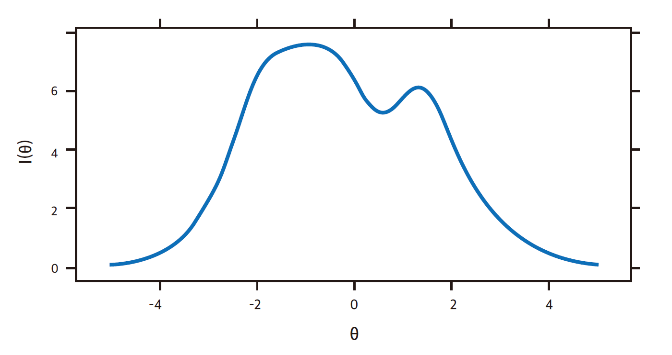Supplementary Figure 1. Scale information curve of the SAVE-6 among cancer patients

