Table S1 Primer information
Gene | Primer（5'-3'）
TCHH | F:TTGGGCCGATTACCTGTGAG
 | R:ACCTCTTTCCTGCATTGCCT
LPL | F:GCGATTCCTACTTCAGCTGGT
 | R:TCCCGGGAACAGAAGATAACC
EEA1 | F:TGACCTTGGAACGTGAGAGAG
 | R:GTTCACTCCTCAGCTGGCTT
LOC443015 | F:TACGGAGACCTGAACCACCT
 | R:ATGAAGAAGTGGAGGCGTGG
LOC101118514 | F:AGATGCTGAGTGGTGTTGGG
 | R:CGCACAAGCCCCTTCTGG
HSPA6 | F:TAAATGGCCCCTCTGAACGG
 | R:CCACCCCTGAAGTTAGGCAG
LOC101107641 | F:GGATCTGAACACGCGGAGAA
 | R:CGCTCTGGTTGTAGTAGCCG
CD14 | F:CCCTCAGTCTCCGTAACGTG
 | R:GTGTGCTTGGGCAATGTTCA

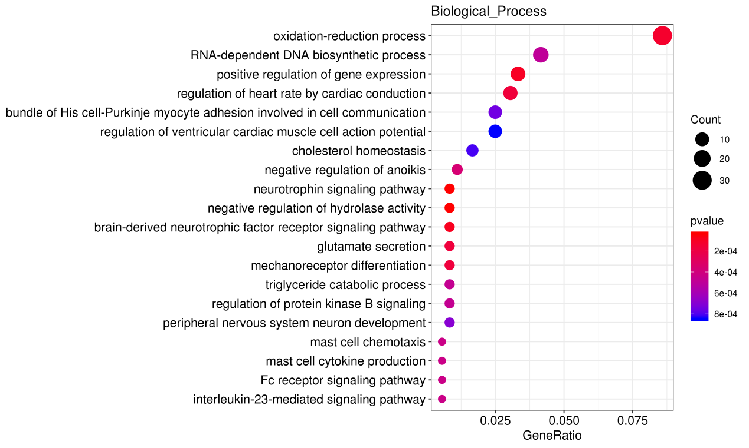
Fig. S1 BP enrichment bubble chart

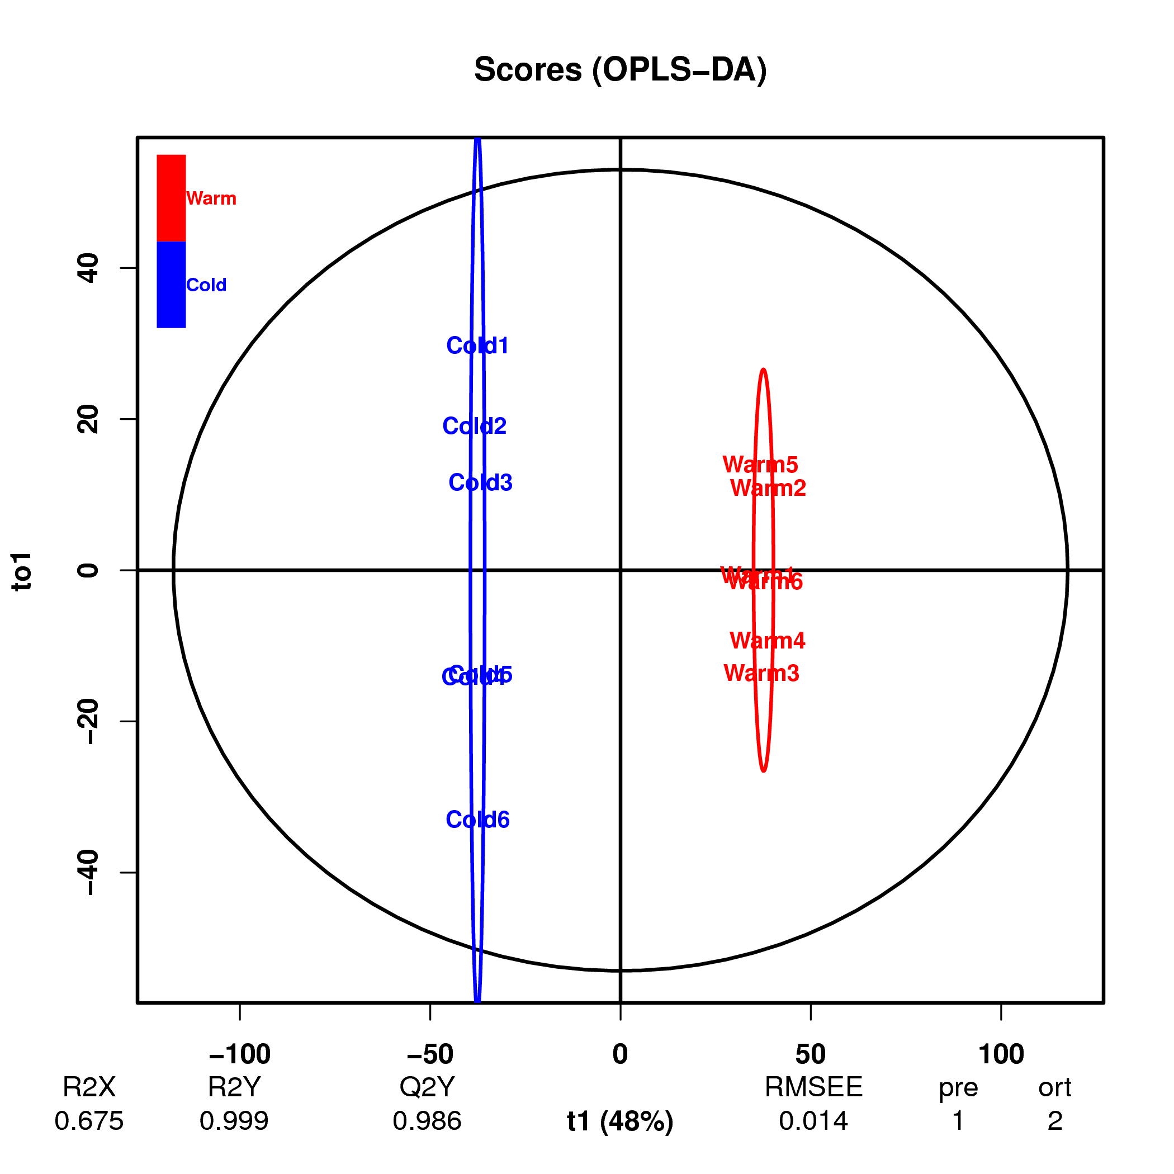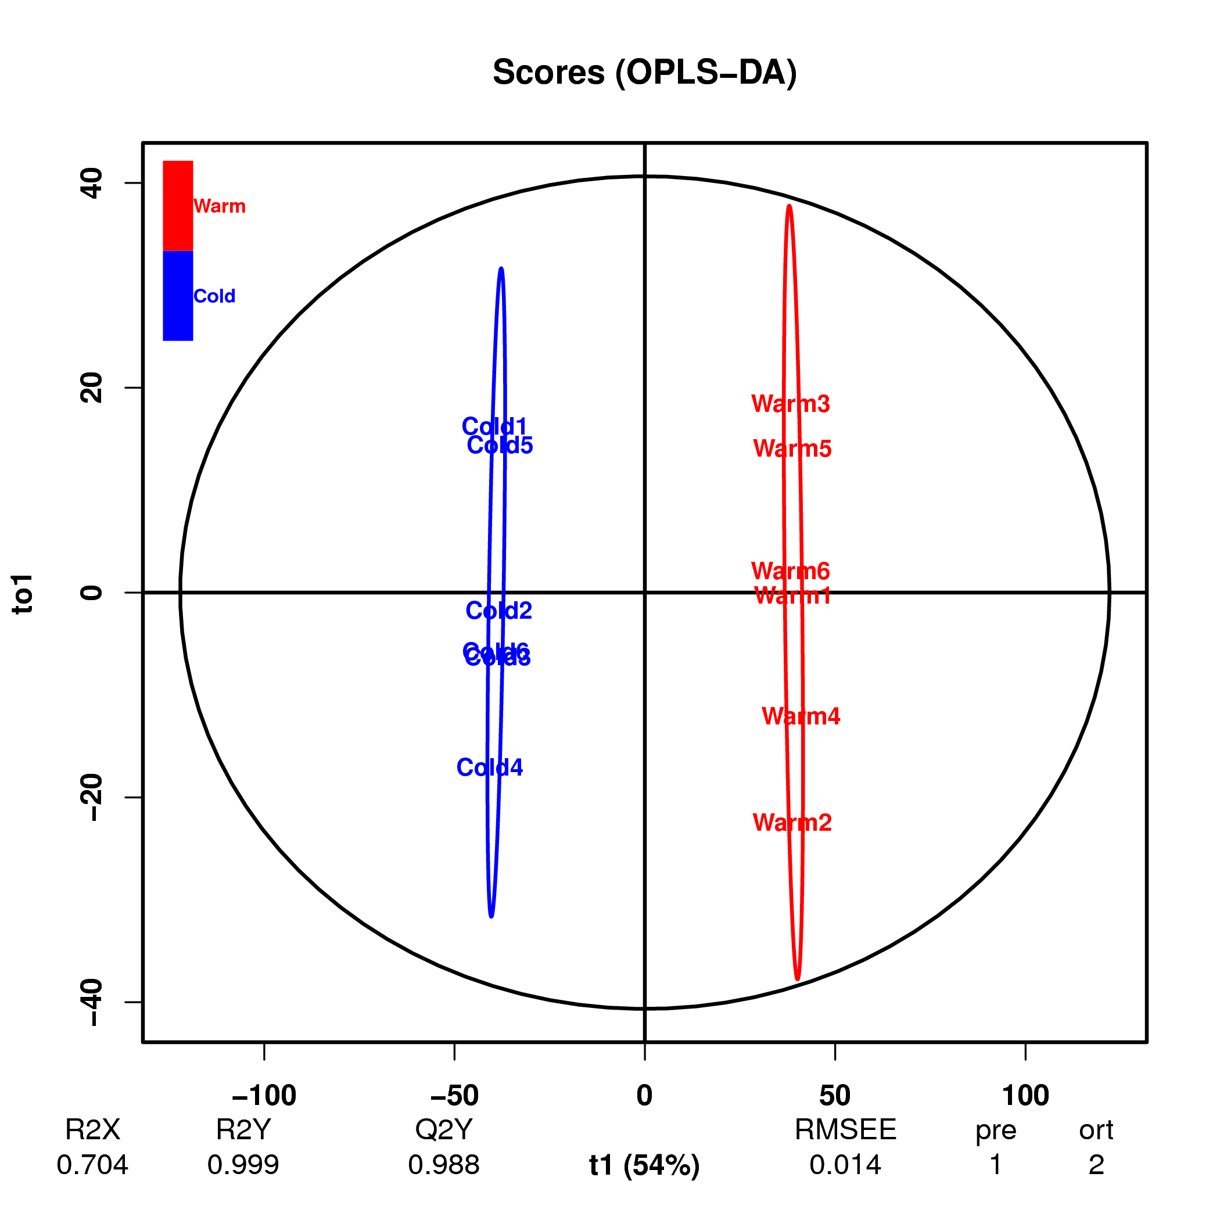

Fig S2

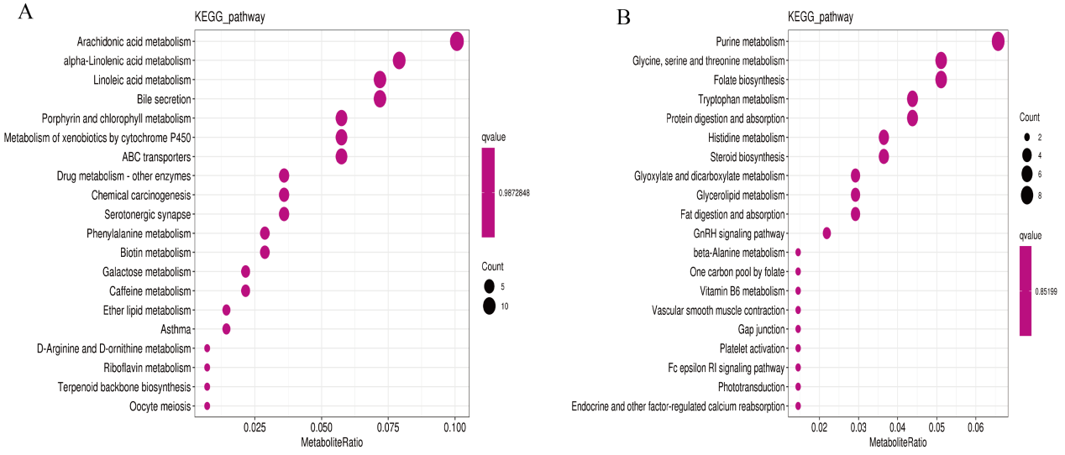
Fig S3 a KEGG pathway in positive model. b KEGG pathway in b negative model

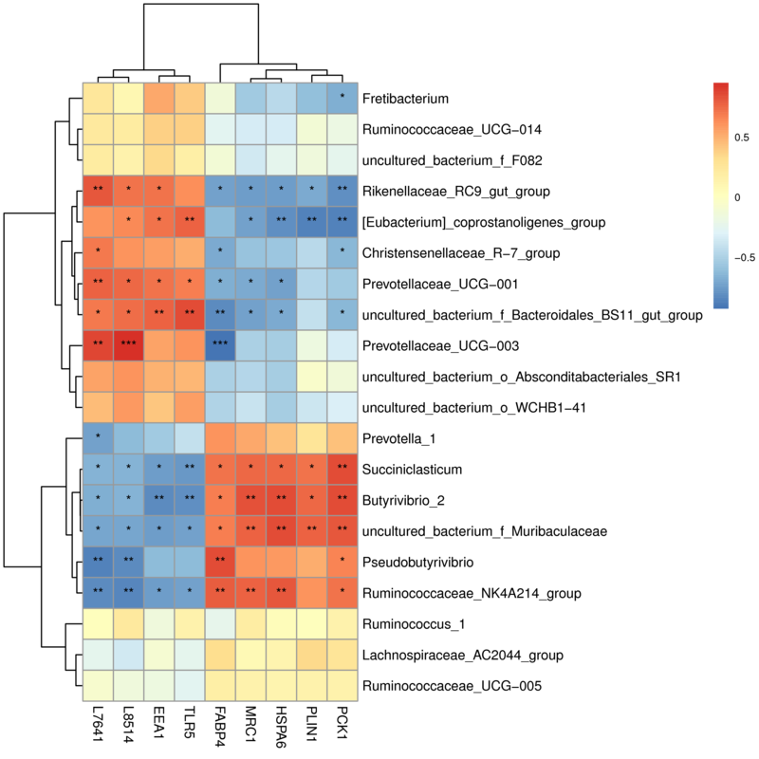
Fig. S4 Correlation analysis between rumen microbes and host genes

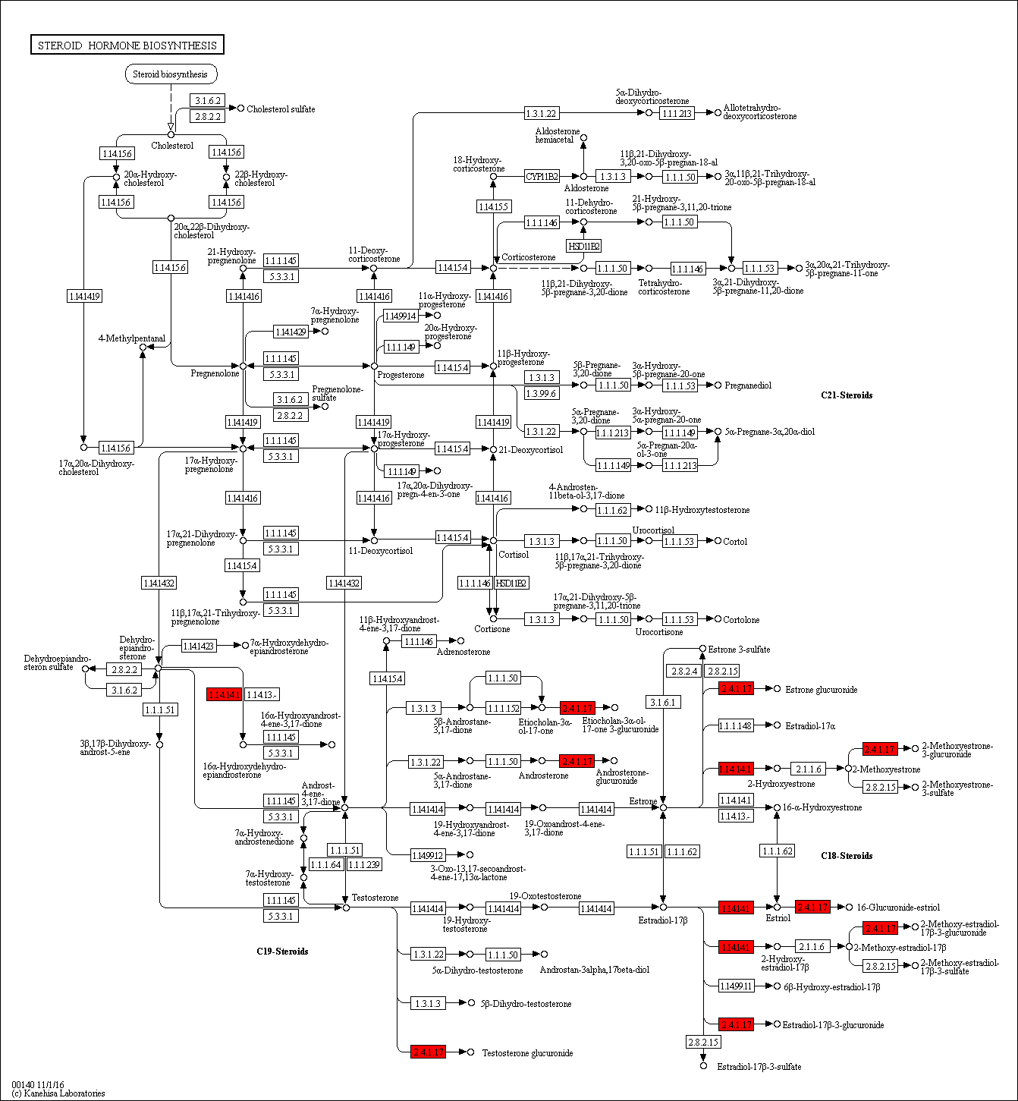
Fig S5 Ko00140 pathway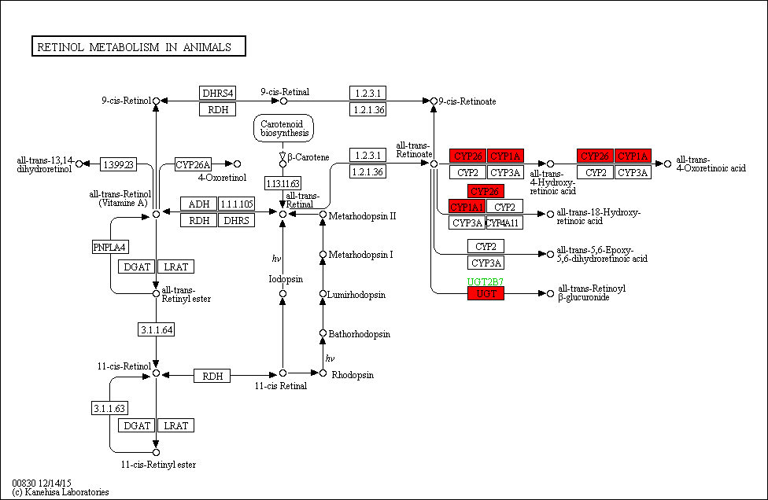
Fig S6 ko00830 pathway

