Supplementary Material
R code for Figure S2
Table S1 Sensitivity analyses of association between demographic characteristics and ΔCDI-S score using complete data.
Table S2 Sensitivity analyses of association between demographic characteristics and ΔSCARED score using complete data.
Figure S1 The distribution of ΔCDI-S and ΔSCARED score.
Figure S2 CDI-S and SCARED score distribution in elementary students. (A) Distribution of CDI-S and SCARED score at two waves in Grades 3–6. The vertical line in each distribution represents the mean. Blue represents March and red represents November. (B) Distribution of ΔCDI-S and ΔSCARED score in Wuhan and Huangshi and in Grades 3–6. The vertical line in each distribution represents the mean. Blue represents Wuhan and red represents Huangshi.

R code for Figure S2
p <- ggplot(data = data, mapping = aes(
x = score,
y = Time,
fill = Time))
p + geom_density_ridges(alpha = 0.5,
quantile_lines=TRUE,
quantile_fun=function(x,...)mean(x)) +
guides(fill = FALSE) +
labs(x = "Scale score",
y = "Time")+facet_grid(grade~group,scales="free_x")+
theme(axis.title.x=element_text(size=30),
axis.title.y=element_text(size=30),
axis.text.x=element_text(size=30),
axis.text.y=element_text(size=30),
strip.text = element_text( size = 30),
text=element_text(family="Arial"),
panel.grid=element_blank()
)

p <- ggplot(data = data1, mapping = aes(
x = score,
y = location,
fill = location))
p + geom_density_ridges(alpha = 0.5,
quantile_lines=TRUE,
quantile_fun=function(x,...)mean(x)) +
guides(fill = FALSE) +
labs(x = "Δ Score",
y = "Location")+facet_grid(grade~group,scales="free_x")+
theme(axis.title.x=element_text(size=30),
axis.title.y=element_text(size=30),
axis.text.x=element_text(size=30),
axis.text.y=element_text(size=30),
strip.text = element_text( size = 30),
panel.grid=element_blank()
)

Table S1 Sensitivity analyses of association between demographic characteristics and ΔCDI-S score using complete data.
Characteristics |  | 2nd tertile (≥1, < 3) | 3rd tertile (≥ 3) | Linear model
 |  | OR (95%CI) | OR (95%CI) | β (95%CI)
Gender
 | Female vs. Male | 0.81 (0.59,1.11) | 0.87 (0.64,1.19) | 0.01 (-0.44,0.46)
School location
 | Wuhan vs. Huangshi | 1.52 (1.05,2.19) | 1.14 (0.78,1.67) | 0.06 (-0.48,0.60)
Grade
 | Grade 4 vs. 3 | 0.87 (0.56,1.34) | 0.80 (0.52,1.23) | -0.69 (-1.31,-0.07)
 | Grade 5 vs. 3 | 1.05 (0.70,1.59) | 0.85 (0.56,1.29) | -0.59 (-1.19,0.01)
 | Grade 6 vs. 3 | 0.91 (0.56,1.46) | 1.10 (0.70,1.73) | -0.04 (-0.71,0.63)
Protective measures during COVID-19 (Wave 1)
 | Yes vs. No | 0.90 (0.65,1.23) | 1.02 (0.75,1.40) | 0.19 (-0.26,0.65)
Knowing the host of SARS-CoV-2 (Wave 1)
 | Yes vs. No | 0.85 (0.61,1.20) | 1.03 (0.73,1.46) | 0.05 (-0.45,0.54)
Daily sleep time (Wave 2)
 | < 8 hours vs. ≥ 8 hours | 1.21 (0.86,1.70) | 1.22 (0.87,1.71) | 0.34 (-0.15,0.82)
Neglect (Wave 2)
 | Yes vs. No | 1.35 (0.96,1.89) | 2.77 (1.91,4.00) | 1.14 (0.66,1.63)
Ref: Reference; OR: odds ratios; CI: confidence intervals; CDI-S: Children’s Depression Inventory-Short Form
ΔCDI-S score was the change of scale scores from Wave 1 to Wave 2.
OR (95% CI) were derived from the multinomial logistic regression model and the first tertile was the reference group (score < 1).
β (95% CI) were derived from generalized linear regression.
Table S2 Sensitivity analyses of association between demographic characteristics and ΔSCARED score using complete data.
Characteristics |  | 2nd tertile (≥0, < 11) | 3rd tertile (≥ 11) | Linear model
 |  | OR (95%CI) | OR (95%CI) | β (95%CI)
Gender
 | Female vs. Male | 1.05 (0.77,1.42) | 1.26 (0.91,1.74) | 1.58 (-0.19,3.34)
School location
 | Wuhan vs. Huangshi | 1.51 (1.04,2.21) | 1.69 (1.14,2.51) | 4.20 (2.09,6.32)
Grade
 | Grade 4 vs. 3 | 0.99 (0.65,1.53) | 1.16 (0.75,1.81) | 1.29 (-1.15,3.73)
 | Grade 5 vs. 3 | 1.09 (0.73,1.62) | 0.79 (0.51,1.22) | -0.87 (-3.21,1.48)
 | Grade 6 vs. 3 | 1.12 (0.71,1.76) | 1.11 (0.68,1.80) | 0.87 (-1.77,3.50)
Protective measures during COVID-19 (Wave 1)
 | Yes vs. No | 0.96 (0.71,1.31) | 0.91 (0.66,1.26) | -0.28 (-2.05,1.50)
Knowing the host of SARS-CoV-2(Wave 1)
 | Yes vs. No | 0.90 (0.64,1.26) | 0.96 (0.67,1.38) | -0.04 (-1.99,1.91)
Daily sleep time (Wave 2)
 | < 8 hours vs. ≥ 8 hours | 1.29 (0.93,1.80) | 1.29 (0.91,1.83) | 0.97 (-0.94,2.87)
Neglect (Wave 2)
 | Yes vs. No | 1.42 (1.03,1.96) | 3.51 (2.39,5.16) | 6.29 (4.37,8.21)
Ref: Reference; OR: odds ratios; CI: confidence intervals; SCARED: Screen for Child Anxiety Related Emotional Disorders.
ΔSCARED score was the change of scale scores from Wave 1 to Wave 2.
OR (95% CI) were derived from the multinomial logistic regression model and the first tertile was the reference group (score < 0).
β (95% CI) were derived from the generalized linear regression.
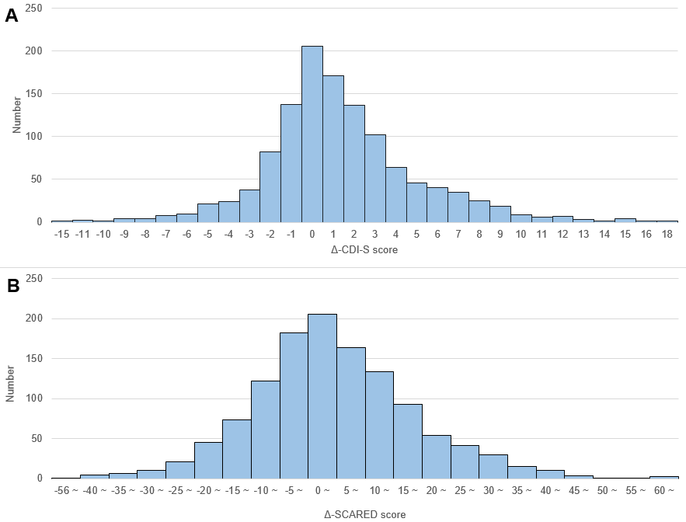
Figure S1 The distribution of ΔCDI-S and ΔSCARED score.
Figure S2 CDI-S and SCARED score distribution in elementary students. (A) Distribution of CDI-S and SCARED score at two waves in Grades 3–6. The vertical line in each distribution represents the mean. Blue represents March and red represents November. (B) Distribution of ΔCDI-S and ΔSCARED score in Wuhan and Huangshi and in Grades 3–6. The vertical line in each distribution represents the mean. Blue represents Wuhan and red represents Huangshi.

