Supplementary Material

Supplementary Tables

Supplementary Table 1 TTTS and FLC related clinical characteristics of FLC treated or Untreated groups.
Characteristics and pregnancy outcomes | FLC Treated group(n=14) | Untreated group(n=11) | P-Value
Gestational age at diagnosis of TTTS (days) ª | 156.1±24.2 | 221.6±23.7 | ＜0.001
Quintero Stage at diagnosis ^{b} |  |  | 0.183
I | 7/14 | 1/11
II | 2/14 | 1/11
III | 4/14 | 6/11
IV | 1/14 | 2/11
V | 0/14 | 1/11
Gestational age when receiving FLC procedures (days) | 159.4±24.1 | -- | --
Quintero Stage when receiving FLC |  |  | --
I | 7/14 | -- | --
II | 1/14 | -- | --
III | 5/14 | -- | --
IV | 1/14 | -- | --
V | 0/14 | -- | --
Quintero Stage at delivery |  |  | --
I | -- | 1/11 | --
II | -- | 1/11 | --
III | -- | 6/11 | --
IV | -- | 2/11 | --
V | -- | 1/11 | --
Gestational age at delivery(days) ª | 237.9±16.6 | 224.8±23.9 | 0.131
Survival at delivery ^{b} |  |  | 0.420
None fetus | 1/14 | 1/11
Only 1 fetus | 0/14 | 2/11
Both fetuses | 13/14 | 8/11
a Student’s T-test
b Fisher exact probability

Supplementary Table 2 Amniotic deepest vertical pool (median (75-25th centile)) of the recipients and donors in the FLC and Un group at the diagnosis of TTTS.
Cotwin Group | FLC treated group  (n=14) | Untreated group  (n=11) |  | P value
Recipients | 117.0(140.0-91.0) mm | 157.0(163.0-144.0)mm |  | 0.276ª
Donors | 8.5(16.0-2.0)mm | 7.0 (35.0-3.5)mm | 0.717ª

a Mann-Whitney U test

Supplementary Table 3 Amniotic deepest vertical pool (median (75-25th centile)) of larger and smaller cotwins in Con and PTB twins at last ultrasound monitoring.

Cotwin Group | Control group(n=15) | Preterm birth group (n=7) | P value
Larger | 59.0(69.5-48.5)mm | 60.0(69.5-50.5)mm | 0.834ª
Smaller | 49.5(54.5-49.5)mm | 53.0 (56.5-49.0)mm | 0.367ª
Total | 54.0(60.0-45.5)mm | 54.0 (60.5-51.5)mm | 0.912ª

a Mann-Whitney U test
Characteristics and pregnancy outcomes | Control group  (n=15) | Preterm birth group  (n=7) | FLC Treated group  (n=13) | Untreated group  (n=8) | P-Value
 |  |  |  |  | C5 | C6 | C7 | C8 | C9 | C10
Maternal age (years)ª | 27.9±4.5 | 28.3±4.2 | 27.2±4.6 | 26.6±3.5 | 0.687 | 0.482 | 0.623 | 0.120ª | 0.754ª | 0.863
Gestational age(weeks) ª | 37.3±0.5 | 34.3±1.6 | 33.9±2.3 | 33.4±2.1 | ＜0.001 | ＜0.001 | 0.744 | 0.400^{b} | 0.595^{b} | ＜0.001
Education  (below high school) ^{b} | 2/15(86.7%) | 1/7(14.3%) | 1/13(7.7%) | 0/8（0%） | 1.000 | 0.526 | 1.000 | 0.467 | 1.000 | 000^{c}
Employed outside the home ^{b} |  |  |  |  | 1.000 | 0.405 | 1.000 | 0.421^{d} | 1.000^{c} | 1.000^{c}
Yes | 13/15(86.7%) | 6/7(85.7%） | 12/1392.3%） | 8/8（100%）
No | 2/15(13.3%) | 1/7（14.3%） | 1/13（7.7%） | 0/8（0%）
Pregestational Body mass index (kg/m²) ª | 21.0±2.7 | 20.5±2.9 | 20.3±3.5 | 20.3±2.2 | 0.572 | 0.540 | 0.911 | 0.888ª | 0.990ª | 0.699
Prenatal Body mass index (kg/m²) ª | 27.6±2.4 | 26.6±1.9 | 26.7±3.5 | 27.9±2.1 | 0.426 | 0.782 | 0.964 | 0.246 | 0.389 | 0.355
Primigravida ^{b} | 9/15(60.0%) | 5/7（71.4%） | 7/13（53.8%） | 4/8（50.0%） | 1.000 | 0.780 | 0.642 | 0.864^{c} | 1.000^{c} | 0.671
Smoking before or during pregnancy ^{b} | 0/15(0%) | 0/7 (0%) | 0/13 (0%) | 0/8(0%) | 1.000^{d} | 1.000^{d} | 1.000^{d} | 1.000^{d} | 1.000^{d} | 1.000^{d}
Mode of conception ^{b} |  |  |  |  | 1.000 | 1.000 | 0.589 | 0.421^{d} | 1.000^{c} | 0.545
IVF-ET | 1/15(6.7%) | 1/7（14.3%） | 1/13（7.7%） | 0/8(0%)
Natural conception | 14/15(93.3%) | 6/7（85.7%） | 12/13（92.3%） | 8/8(100%)
Delivery ^{b} |  |  |  |  | 0.206 | 1.000 | 1.000 | 0.243^{d} | 0.505^{c} | 0.318
Cesarean | 15（100%） | 6/7（85.7%） | 11/13(84.6%) | 8/8（100%）
Vaginal | 0（0%） | 1/7（14.3%） | 2/13(15.4%) | 0/8（0%）
Supplementary Table 4 Maternal clinical characteristics.
aStudent’s T-test
bMann-Whitney U test
cChi-square test.
dFisher’s exact test;
eIVF-ET, In vitro fertilization & embryo transfer.
*p < 0.001.
Supplementary Table 5 Neonatal clinical characteristics.
 | Control group  (n=15) |  |  | Preterm birth group  (n=7) |  |  | FLC treated group  (n=13) |  |  | Untreated group  (n=8) |  |  | P-Value
 | L | S | T | L | S | T | R | D | T | R | D | T | C1 | C2 | C3 | C4 | C5 | C6 | C7 | C8 | C9 | C10
Birthweight(g)ª | 2721±245.9 | 2586±221.4 | 2653±239.9 | 2079±455.5 | 1991±450.5 | 2035±437.6 | 1998±420.6 | 1571±493.1 | 1785±499.2 | 1816±334.2 | 1396±402.5 | 1606±418.1 | 0.1262 | 0.7252 | 0.0256 | 0.0395 | <0.0001 | <0.0001 | 0.1231 | 0.0105 | 0.2398 | <0.0001
Birthweight discordance(g) ª | 212.0±81.35 |  |  | 87.14±64.73 |  |  | 427.7±419.5 |  |  | 420.0±231.5 |  |  | -- |  |  |  | 0.0614 | 0.0045 | 0.0493 | 0.0029 | 0.9628 | 0.0020
Birthweight discordant ratio(%)ª | 7.748±3.058 |  |  | 4.226±3.130 |  |  | 20.93±19.12 |  |  | 23.72±14.44 |  |  | -- |  |  |  | 0.0139 | 0.0004 | 0.0359 | 0.0040 | 0.7272 | 0.0213
Body length(cm) ª | 46.87  ±1.60 | 46.40  ±1.35 | 46.63±1.47 | 44.83±1.94 | 43.83±1.94 | 44.33±1.92 | 42.45±3.503 | 40.20±5.051 | 41.38±4.35 | 42.25±4.301 | 39.38±4.809 | 40.81±4.65 | 0.3952 | 0.3931 | 0.2456 | 0.2281 | <0.0001 | <0.0001 | 0.0341 | 0.0208 | 0.705 | 0.0002
Head circumference(mm) ª | 318.2±8.748 | 313.3±8.290 | 315.8±8.719 | 310.4±10.45 | 306.4±12.84 | 308.4±11.24 | 298.9±17.79 | 283.3±24.73 | 291.5±22.30 | 293.8±14.27 | 280.3±20.77 | 287.0±18.57 | 0.1538 | 0.6037 | 0.1108 | 0.1520 | <0.0001 | <0.0001 | 0.0320 | 0.0032 | 0.5205 | 0.0437
Abdominal circumference(mm) ª | 313.2±26.92 | 311.0±16.29 | 312.1±21.87 | 292.0±18.37 | 277.2±50.74 | 284.6±36.81 | 286.7±32.96 | 254.5±32.36 | 270.6±35.90 | 279.5±18.85 | 248.8±27.29 | 264.1±27.66 | 0.7944 | 0.5567 | 0.0312 | 0.0201 | <0.0001 | <0.0001 | 0.3180 | 0.1189 | 0.5513 | 0.0076
Placenta weight(g) ª | 661.4±95.66 |  |  | 738.0±133.10 |  |  | 678.5±91.46 |  |  | 635.0±55.55 |  |  | -- |  |  |  | 0.6409 | 0.4851 | 0.2903 | 0.0745 | 0.2422 | 0.1822
Amniotic fluid volume(ml) ª | 580.0±227.4 | 493.3±171.0 | 536.7±202.5 | 480.0±83.67 | 360.0±230.2 | 420.0±175.1 | 525.5±96.06 | 409.1±122.1 | 467.3±122.6 | 2838±1632 | 193.8±221.1 | 1516±1769 | 0.2480 | 0.3052 | 0.0220 | 0.0005 | 0.1604 | 0.0042 | 0.3845 | 0.0085 | 0.0085 | 0.1120
Neonatal sex^{b} |  |  |  |  |  |  |  |  |  |  |  |  |  |  |  |  | 0.295 | 0.364 | 1.000 | 1.000 | 1.000 | 0.747
male | 16/30(53.3%) |  |  | 6/14(42.9%) |  |  | 10/26(38.5%) |  |  | 6/16(37.5%)
female | 14/30(46.7%) |  |  | 8/14(57.1%) |  |  | 16/26(64.5%) |  |  | 10/16(61.9%)
Apgar Score
at 1 min | 10 (9, 10) | 10 (9, 10) | 10 (9, 10) | 9 (8, 10) | 9 (8, 10) | 9 (8, 10) | 9 (8, 9) | 8 (4, 9) | 8 (6, 9) | 8 (6, 9) | 8 (4, 9) | 8 (5, 9) | 0.935 | 0.935
at 5 min | 10 (10, 10) | 10 (10, 10) | 10 (10, 10) | 10 (10, 10) | 10 (9, 10) | 10 (9, 10) | 10 (9, 10) | 9(8, 10) | 10 (9, 10) | 9(8, 10) | 9(7, 10) | 9(8, 10) | 1.000 | 1.000
at 10 min | 10 (10, 10) | 10 (10, 10) | 10 (10, 10) | 10 (10, 10) | 10 (10, 10) | 10 (10, 10) | 10 (9, 10) | 9(8, 10) | 10 (9, 10) | 9 (9, 10) | 9 (8, 10) | 9 (8, 10) | 1.000 | 1.000
aStudent’s T-test
bMann-Whitney U test
cChi-square test.

Supplementary Figures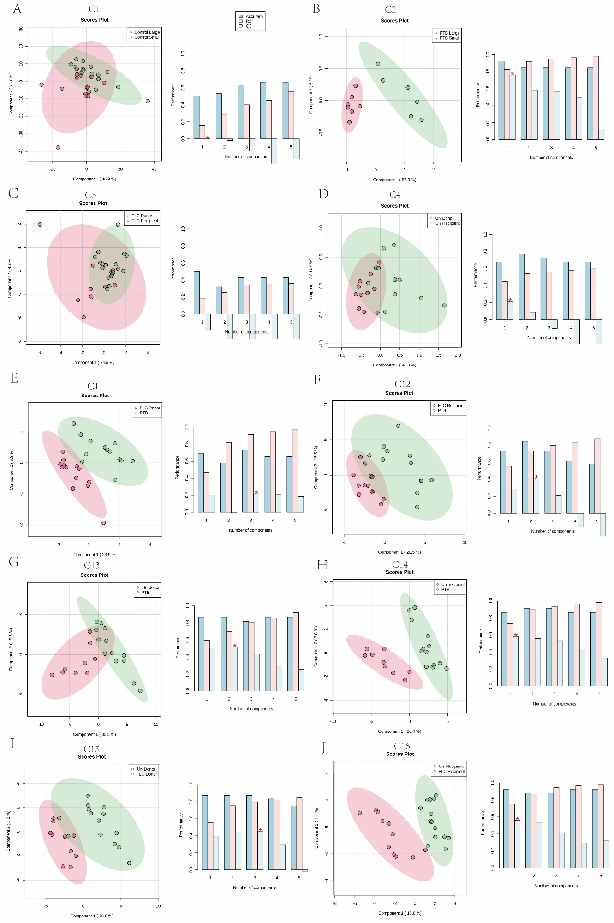
Supplementary Figure 1. The partial least squares discriminant analysis (PLS-DA) of placental metabolome in comparison 1-4 and 11-16
Left plots in A-J are the PLS-DA scores plots of corresponding comparisons. Histograms on the right display the evaluation of prediction model performance via leave-one-out cross validations (LOOCV) in which R2 represents the model’s explaining ability of data and Q2 reflexes the predictive ability of corresponding PLS-DA model.
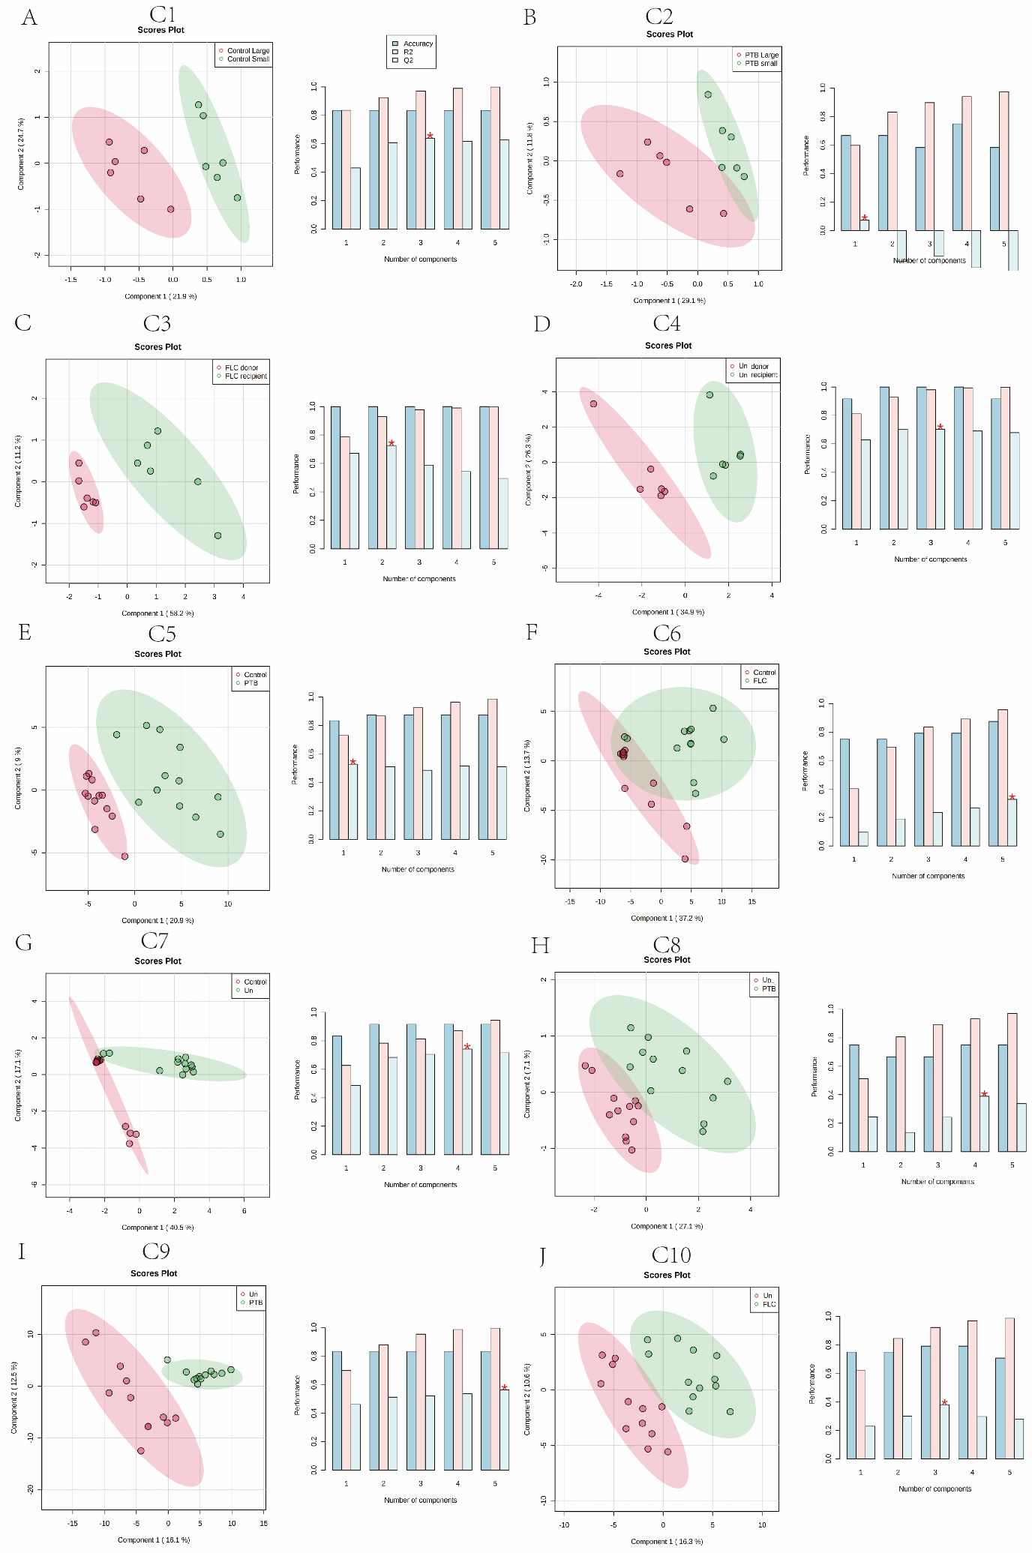
Supplementary Figure 2. The partial least squares discriminant analysis (PLS-DA) of umbilical cord plasma metabolome in comparison 1 to 10
Left plots in A-J are the PLS-DA scores plots of corresponding comparisons. Histograms on the right display the evaluation of prediction model performance via leave-one-out cross validations (LOOCV) in which R2 represents the model’s explaining ability of data and Q2 reflexes the predictive ability of corresponding PLS-DA model.

Supplementary Figure 3. Pie chart demonstrates the ratio of different compound sets of discriminating metabolites in 16 comparisons of placental metabolomes (A) and umbilical cord plasma metabolome (B) according to the SPMDB database.

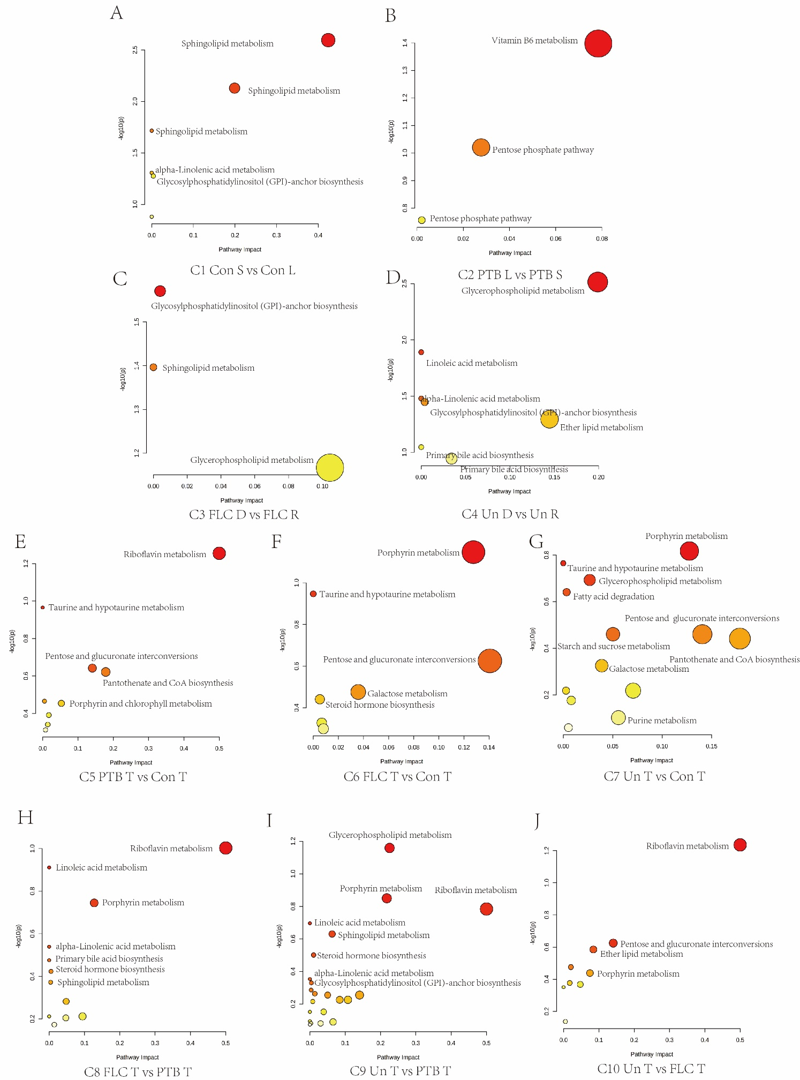
Supplementary Figure 4. Bubble plots demonstrate the result of quantitative enrichment analysis of comparison 1 to 10 in umbilical cord plasma metabolome. The metabolic pathways with most significance in corresponding comparisons are shown as bubbles in each plot. Bubbles with redder color and bigger size indicates they are more significant according to their p-value and pathway impact.

