**SUPPORTING INFORMATION**

**Thermodynamics and kinetics of pH-dependent dissolution of sparingly soluble alkaline earth hydroxides in source-separated human urine collected in decentralised sanitation systems**

**Prithvi Simhaa,*, Chinmoy Kanti Deba, Dyllon G. Randallb, Björn Vinneråsa**

**a** *Department of Energy and Technology, Swedish University of Agricultural Sciences, Box 7032, SE-750 07 Uppsala, Sweden*

**b** *Civil Engineering Department & the Future Water Institute, University of Cape Town, 7700, Cape Town, South Africa*

**\***Corresponding Author: Department of Energy and Technology, Swedish University of Agricultural Sciences, P.O. Box 7032, SE-75007, Uppsala, Sweden.

Phone: +46(0)790544594; *E-mail*: [Prithvi.Simha@slu.se](mailto:Prithvi.Simha@slu.se); [prithvi.simha@mespom.eu](mailto:prithvi.simha@mespom.eu)

# **Fig. S1**. Relative increase in Mg(OH)2 solubility in fresh human urine at 25 °C at various concentration factors values.



# **Fig. S2**. Mass balance calculations show concentration of different elements in fresh human urine, filtered fresh human urine saturated with Mg(OH)2, and precipitated solids. Also shown is the % recovery of the elements from fresh urine as precipitated solids. Four different urine compositions are used: FU1, FU2, FU3 and FU4. See Table 1 for composition.

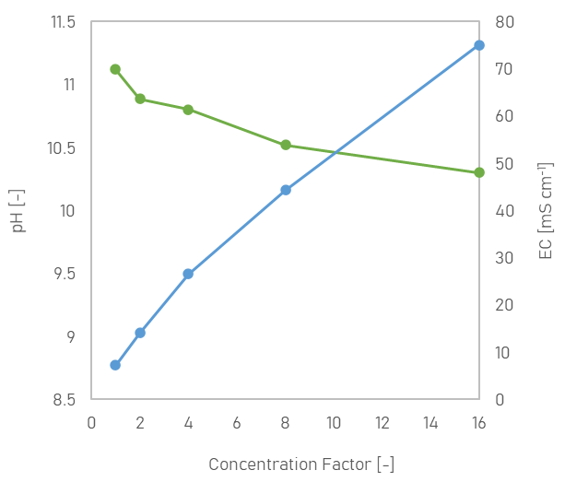

# **Fig. S3**. Change in pH (green; primary y-axis) and electrical conductivity (EC) (blue; secondary y-axis) of synthetic fresh urine saturated with Mg(OH)2 at 25 °C and at various concentration factors values.

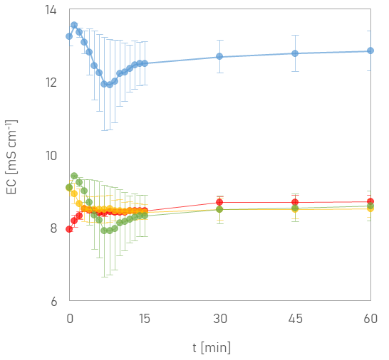

# **Fig. S4.** Change in Electrical Conductivity (EC) of fresh urine as function of time when urine is dosed with 2 g MgO L-1. Legend: FU1 (⬤), FU2 (⬤), FU3 (⬤) and FU4 (⬤). Compositions shown in Table 1. Data points are average values of three replicates and error bars indicate standard deviation.

|  |  |  |  |
| --- | --- | --- | --- |
| Variable | Dim.1 | Dim.2 | Dim.3 |
| solubility | 0.99 | -0.0237 | 0.04731 |
| ammonia | 0.94244 | -0.1887 | 0.25095 |
| nitrogen | 0.95712 | -0.0172 | 0.2441 |
| phosphorus | 0.97856 | 0.17774 | 0.01415 |
| magnesium | 0.98892 | 0.10379 | 0.03588 |
| calcium | 0.97073 | 0.12311 | -0.132 |
| potassium | 0.73706 | -0.6283 | -0.2475 |
| sulphur | 0.88604 | 0.3214 | -0.2887 |

# **Fig. S5**. Graphical representation and summary of results of the principal component analysis depicting the relationships between different variables and percentage of variance explained by the two main principal components (Dim1 and Dim2).

# **Fig. S6**. Increase in temperature of fresh human urine when it is dosed with 2 g MgO L-1.

# **Fig. S7**. The simulated temperature of urine saturated with Mg(OH)2 at which pH is ≥10 (to prevent enzymatic urea hydrolysis) is shown for different urine concentration factors (CF).

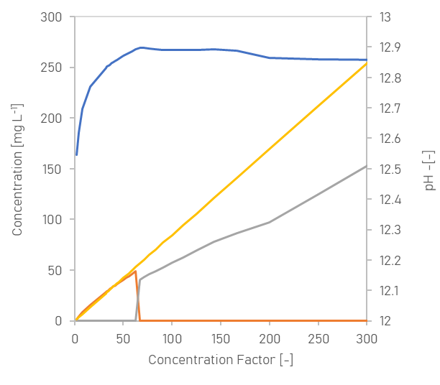

# **Fig. S8.** Simulated change in amount of major solids formed as function of concentration factor (CF) when fresh urine is saturated with Ca(OH)2. Legend: hydroxyapatite (**—**), gypsum (**—**) and anhydrite (**—**). Change in pH (**—**) of urine is shown on secondary y-axis.

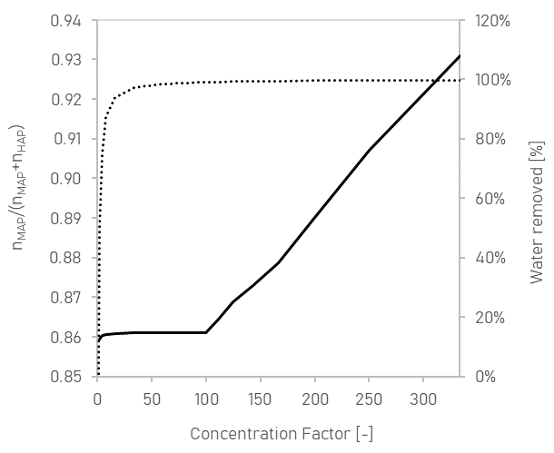

# **Fig. S9.** Distribution (mole fraction) of soluble phosphate (⋯) excreted in fresh urine as precipitated struvite (MAP) and hydroxyapatite (HAP) when fresh human urine is saturated at 25 °C with Mg(OH)2 at various concentration factors. The water removed (%) from urine at different concentration factors is shown on secondary y-axis (—).