Supplemental Table 1. Stimulation Use
Day | No. of stimulation sessions per day, mean (SD) | Participants with 3 stimulation sessions per day, %
1 | 2.93 (0.9) | 86
2 | 2.77 (0.7) | 89
3 | 2.68 (0.7) | 82
4 | 2.68 (0.9) | 86
5 | 2.83 (0.7) | 94

Supplemental Table 2. Overall Change From Baseline for Additional Efficacy Assessments
Assessment | nVNS |  |  | SoC |  |  | Treatment  difference | p value
 | n | Obs | LSM change from BL (95% CI) | n | Obs | LSM change from BL (95% CI) | LSM (95% CI)
FiO₂ | 47 | 168 | 0.04  (–0.01 to 0.09) | 50 | 224 | 0.03  (–0.02 to 0.07) | 0.01  (–0.05 to 0.08) | 0.650
Oxygen saturation, % | 47 | 168 | 0.41  (0.06-0.75) | 50 | 224 | 0.28  (–0.02 to 0.57) | 0.13  (–0.32 to 0.59) | 0.568
Lymphocytes, no./µL | 27 | 39 | 689.56  (459.09-920.03) | 35 | 52 | 472.19  (273.05-  671.33) | 217.37  (–93.30 to 528.05) | 0.166
Platelets, no./µL | 27 | 39 | 83191.27  (53475.70-112906.80) | 35 | 52 | 66150.90 (40576.65-91725.16) | 17040.37  (–22152.80 to 56233.57) | 0.387
TNF-α, pg/mL | 23 | 29 | –1.66  (–6.36 to 3.04) | 28 | 39 | –2.26  (–6.06 to 1.55) | 0.60  (–5.48 to 6.67) | 0.849
IL-6, pg/mL | 24 | 32 | 25.07  (–80.60 to 130.73) | 31 | 44 | 57.70  (–34.35 to 149.75) | –32.64  (–172.81 to 107.53) | 0.642
Ferritin, ng/mL | 24 | 30 | –343.68  (–485.18 to  –202.17) | 30 | 41 | –214.93  (–339.39 to  –90.48) | –128.74  (–317.20 to 59.71) | 0.176
Haptoglobin, mg/dL | 22 | 28 | –104.31  (–141.69 to  –66.92) | 29 | 40 | –66.63  (–99.05 to  –34.22) | –37.67  (–87.54 to 12.20) | 0.135
 | n | Mean (SD) |  | n | Mean (SD)
Length of hospital stay, mean (SD), d | 47 | 11.0 (8.0) |  | 49 | 10.1 (6.7) |  | NA | 0.840ª
Length of ICU stay, mean (SD), d | 8 | 8.0 (6.1) |  | 2 | 7.0 (1.4) |  | NA | 0.933ª
p values are from F tests comparing the change from baseline overall (ie, for all postbaseline observations) for the nVNS and SoC groups unless otherwise indicated.
ªFrom Wilcoxon rank sum test.
Abbreviations: BL, baseline; FiO₂, fraction of inspired oxygen; IL, interleukin; LSM, least squares mean; NA, not applicable; nVNS, non-invasive vagus nerve stimulation; obs, observations; SoC, standard of care; TNF, tumor necrosis factor.

Supplemental Figure 1. Individual CRP levels on study days 1, 3 and 5 among hospitalized patients with COVID-19 (A). Changes from baseline in levels of CRP among hospitalized patients with COVID-19 (B).
A
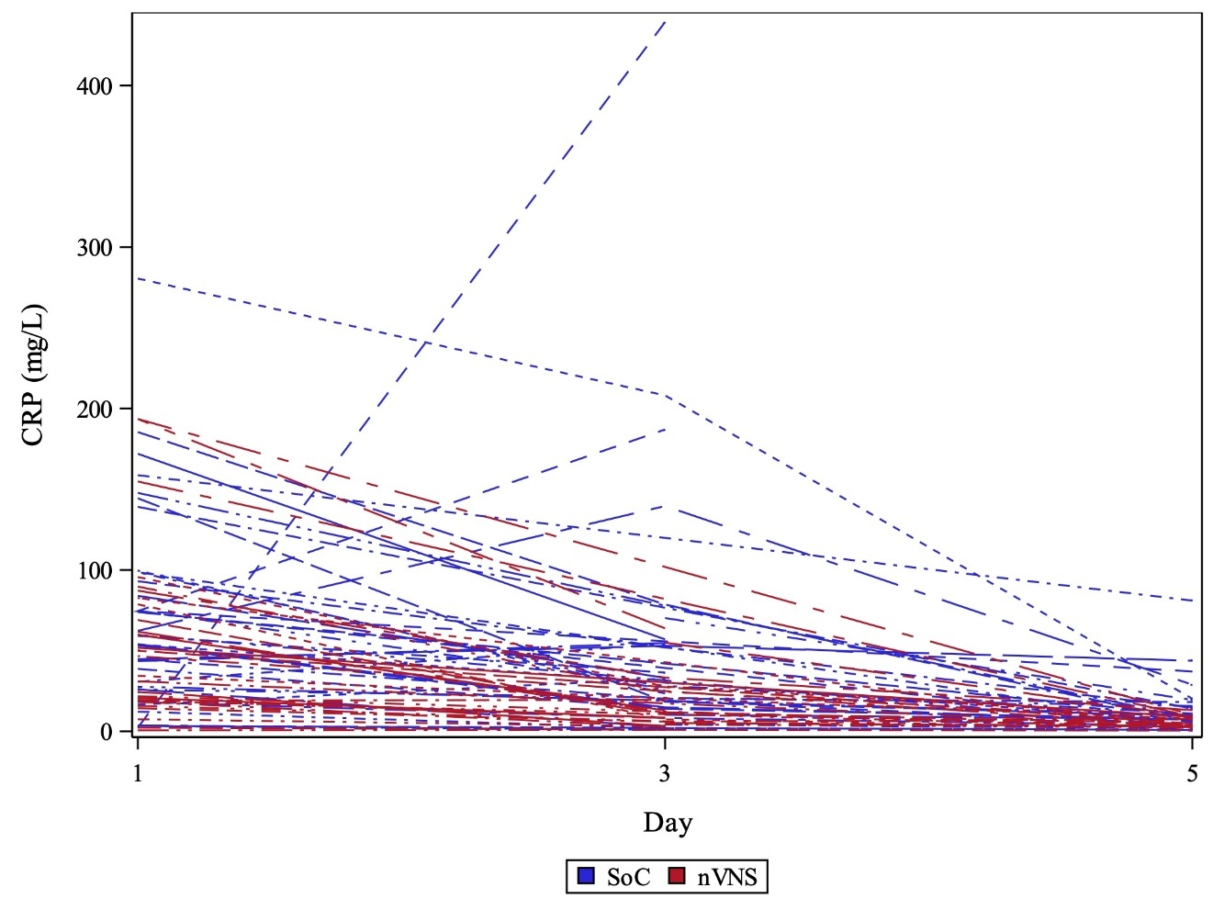
B
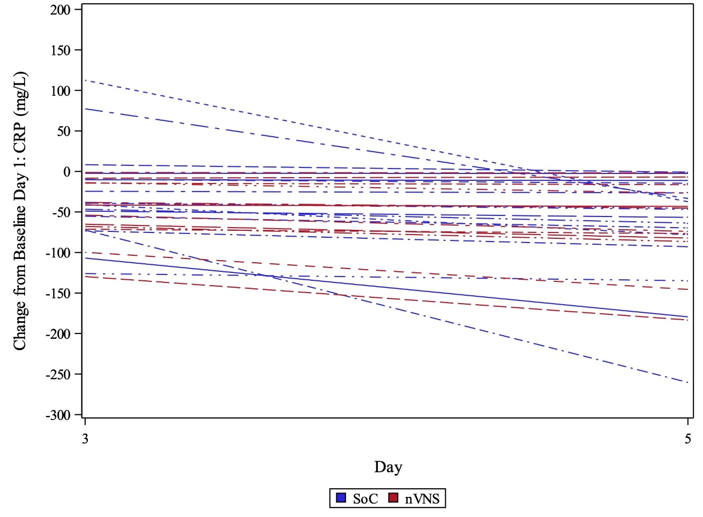
Abbreviations: COVID-19, coronavirus disease 2019; CRP, c-reactive protein; nVNS, non-invasive vagus nerve stimulation; SoC, standard of care.

Supplemental Figure 2. Individual procalcitonin levels on study days 1, 3 and 5 among hospitalized patients with COVID-19 (A). Changes from baseline in levels of procalcitonin among hospitalized patients with COVID-19 (B).
A
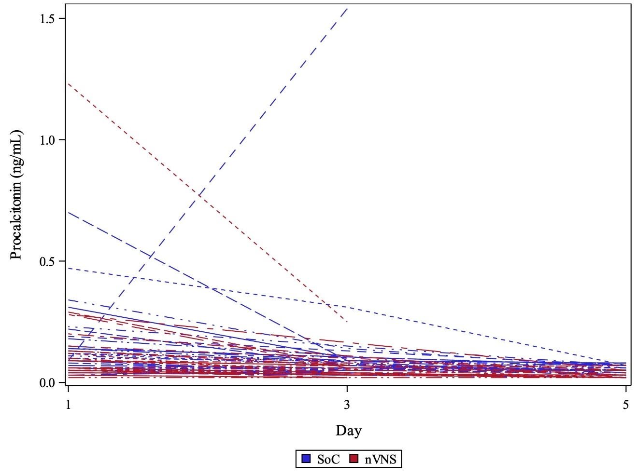
B
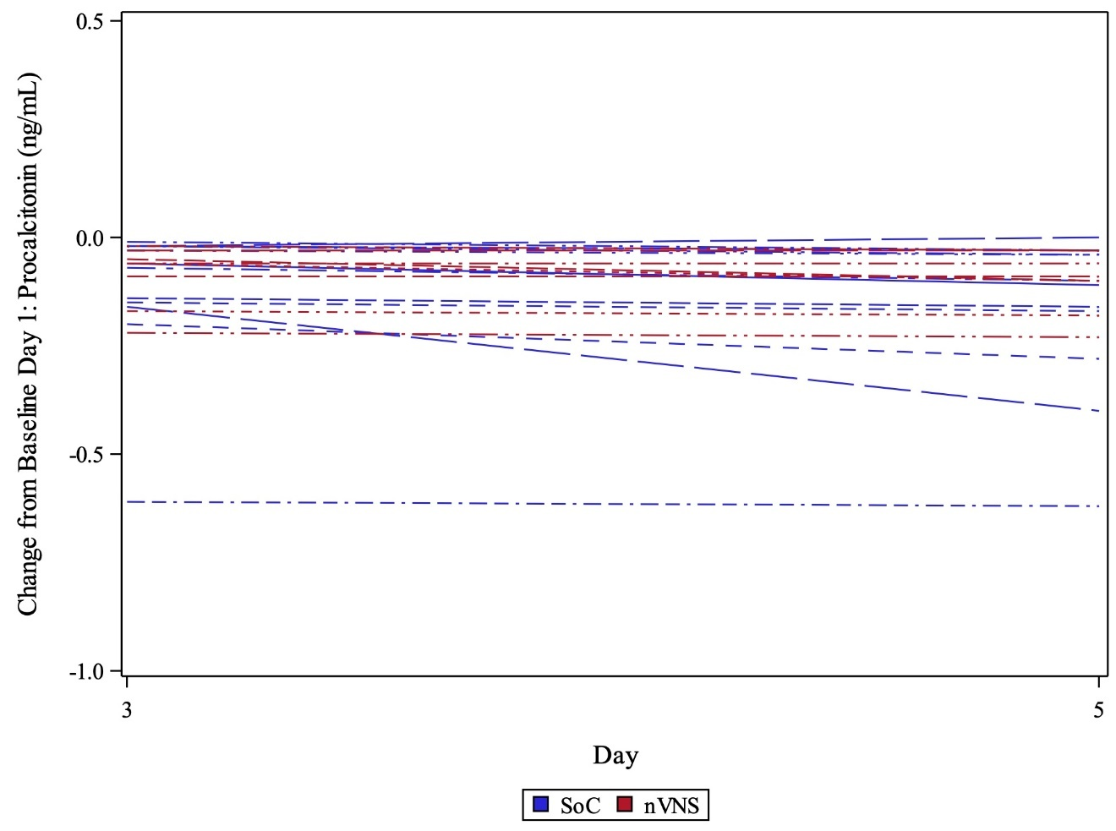
Abbreviations: COVID-19, coronavirus disease 2019; nVNS, non-invasive vagus nerve stimulation; SoC, standard of care.

Supplemental Figure 3. Individual D-dimer levels on study days 1, 3 and 5 among hospitalized patients with COVID-19 (A). Changes from baseline in levels of D-dimer among hospitalized patients with COVID-19 (B).
A
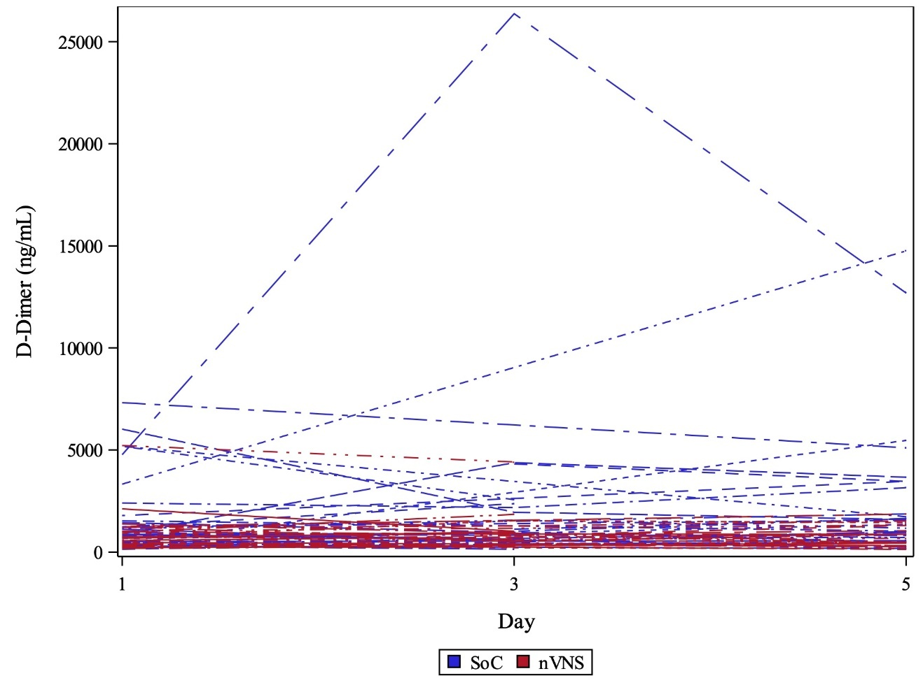
B
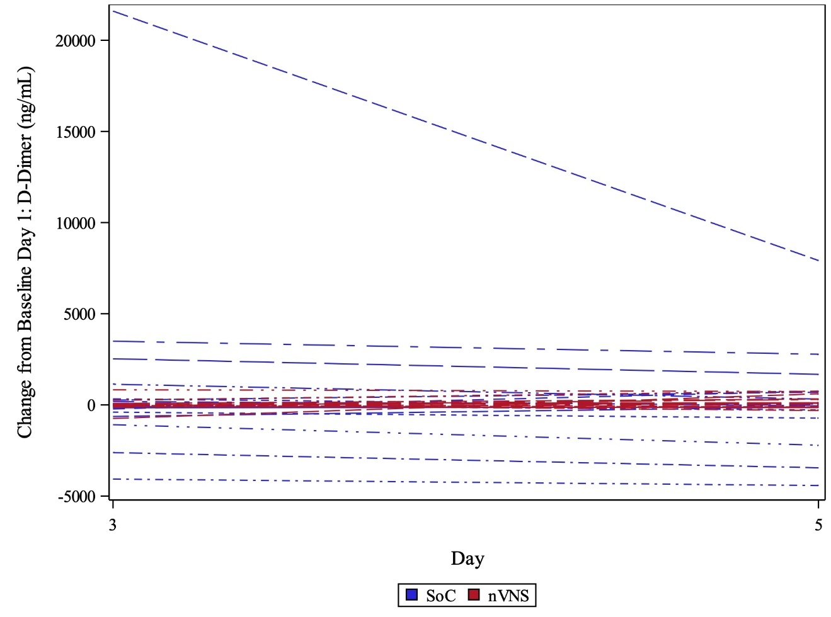
Abbreviations: COVID-19, coronavirus disease 2019; nVNS, non-invasive vagus nerve stimulation; SoC, standard of care.

