Appendix A
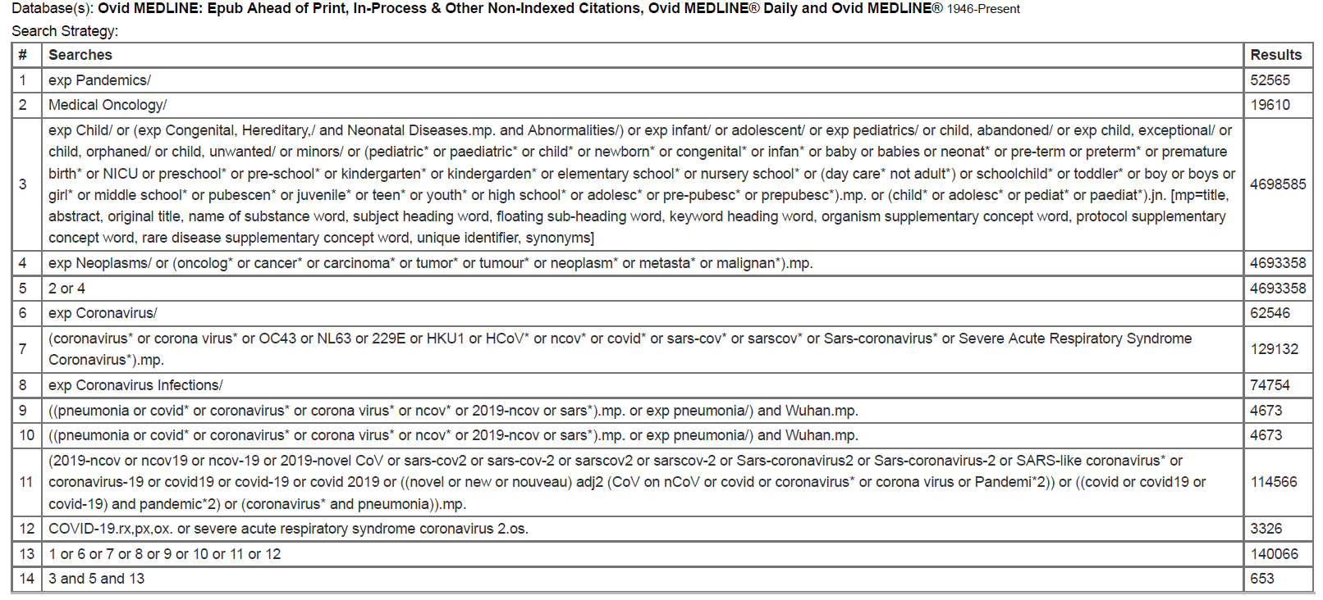
Database: OVID Medline: Epub Ahead of Print, In-Process & Other Non-indexed Citations, OVID MEDLINE Daily and OVID MEDLINE (1947-Present)

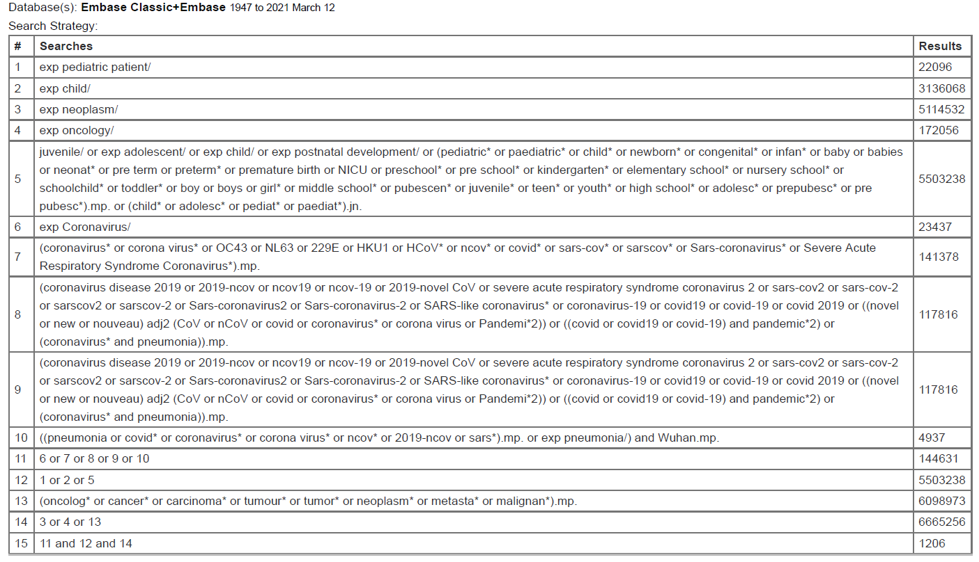
Database: Embase Classic, Embase (1947-2021)

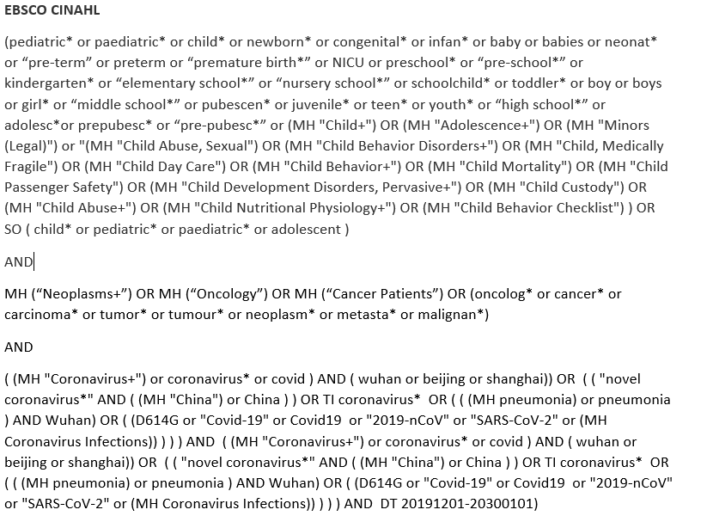
Database: EBSCO CINAHL (1947-Present)

