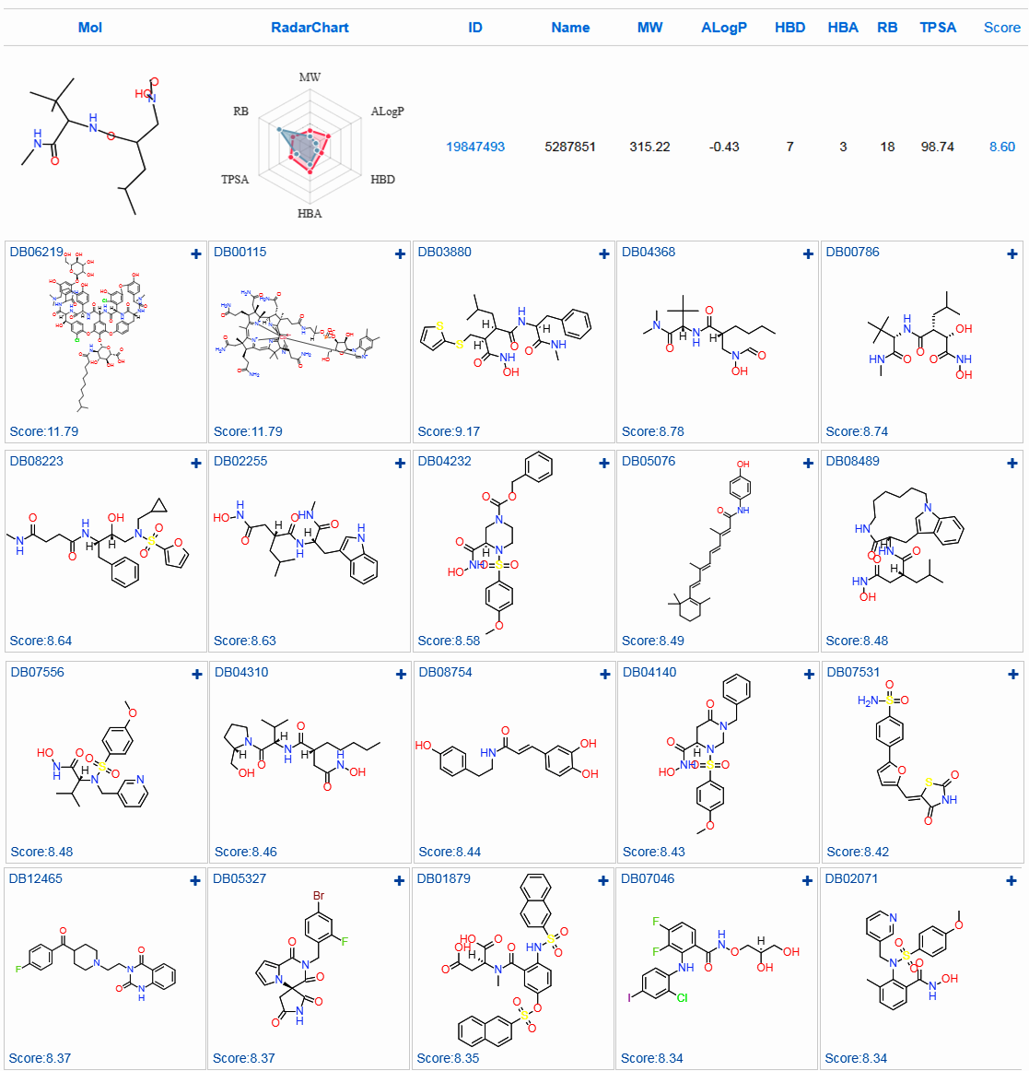
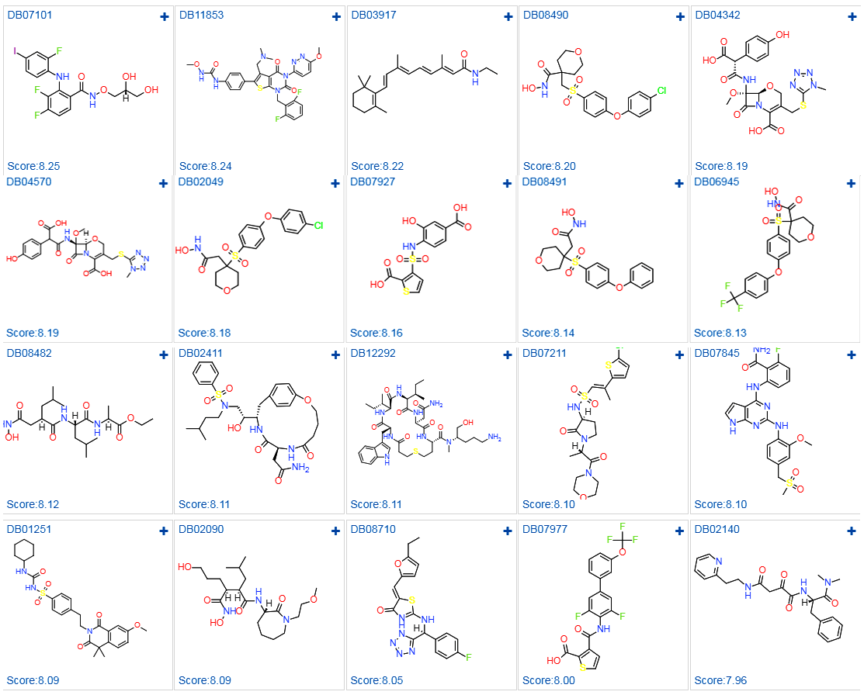

Supplementary figure 1- Total hit compounds screened by deeplearning method

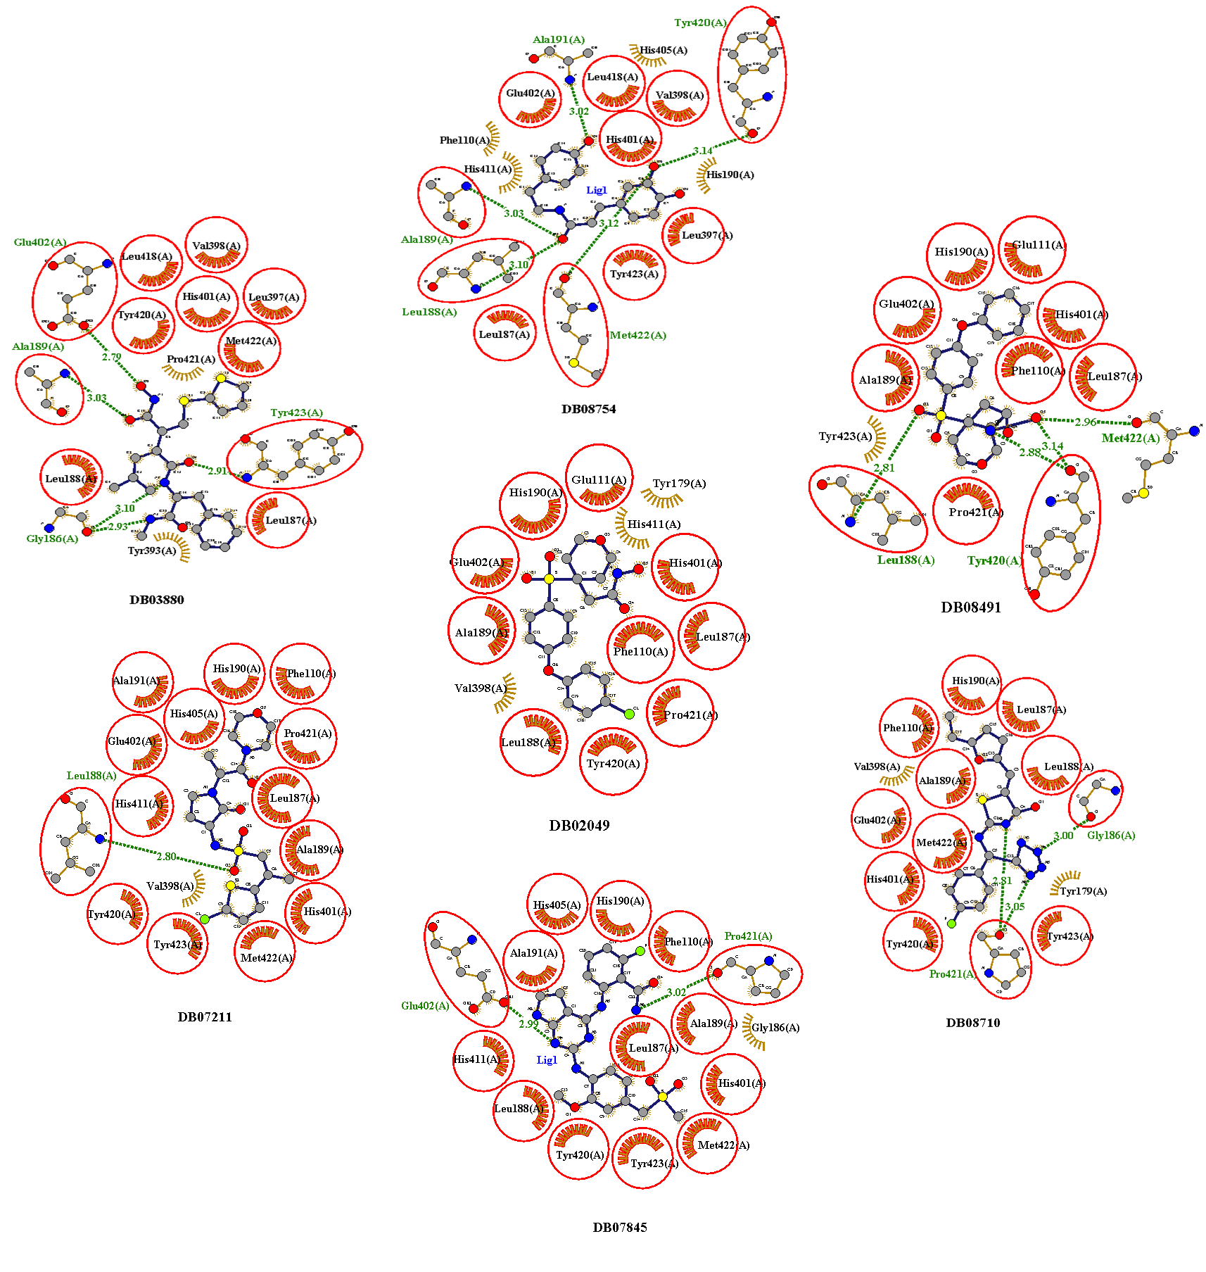

Supplementary figure 2- 2D plots of top docked compounds not showing interaction with zinc

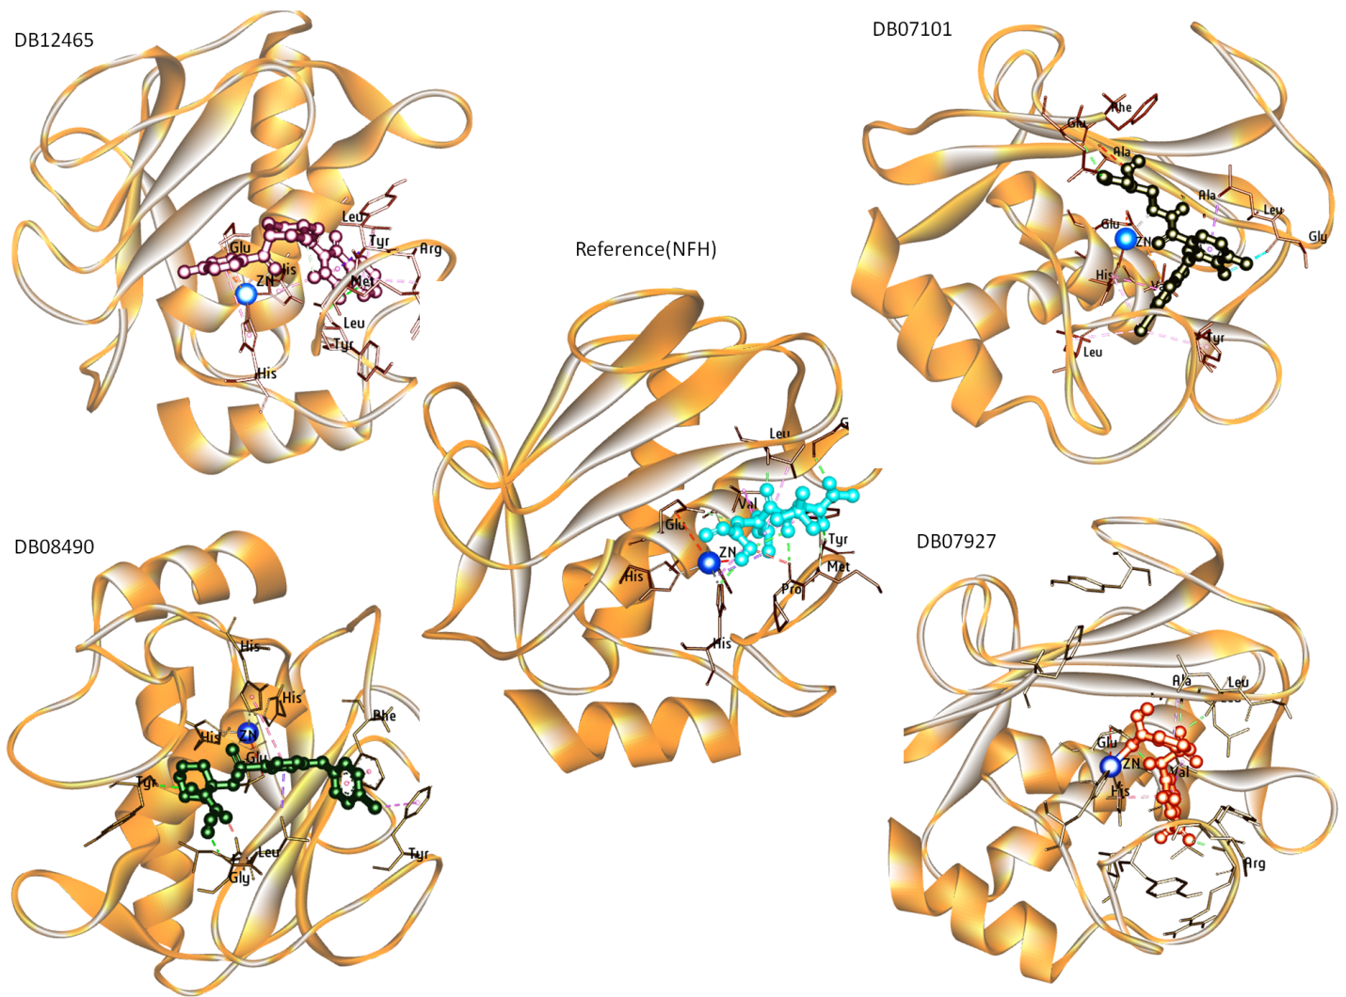

Supplementary figure 3- 3D plots of best four compounds and reference molecule after the 100 ns MD simulation

