Associations of Changes in Religiosity and Flourishing During the COVID-19 Pandemic: A Study of Faith Communities in the U.S.

[DOI: 10.3389/fpsyg.2022.805785]

Supplementary Material 1: Graph of changes in the four dimensions of religiosity from before to during the COVID-19 pandemic
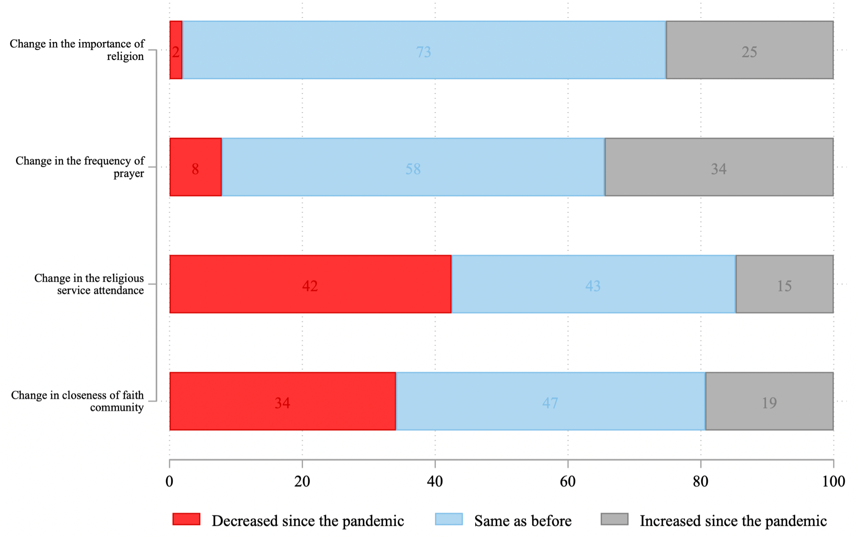
Note: Mental Health in Congregations Study (2020). N=1,480.

