Figure S1. AURK, PLK, and Tubulin inhibitors do not synergize with vemurafenib in UACC62P/R cells. UACC62P/R cells were seeded into 384-well plates at a density of 1,000 cells/well. The next day the cells were treated in a concentration response matrix with a top concentration of 10 µM for all compounds and a ½ dilution series. Viability was analyzed as described in the Materials and Methods section. Data is expressed as relative viability wherein a value of 1 (blue) indicates 100% viability and a value of 0 (red) indicates 0% viability. A. UACC62P/R cells were treated with a GSK461364 x Vemurafenib concentration response matrix. B. UACC62P/R cells were treated with a MLN8237 x Vemurafenib concentration response matrix. C. UACC62P/R cells were treated with a Mebendazole x Vemurafenib concentration response matrix. This experiment was repeated with n = 3 biological replicates. The data in these matrices represent the average compound response across all experimental replicates.

Figure S2. Identification of compound classes which are selective for BRAFi-resistant cells. A) Overall compound representation in the MIPE library. AURKi, PLKi, Tubulin inhibitors, Kinesin inhibitors, and Chk1/2 inhibitors are highlighted. Compound class enrichment for the top 25 most selective compounds in B) UACC62P/R cells, C) M238P/R cells, D) M229P/R cells, and E) M249P/R cells.

Figure S3. ROS production is not altered in BRAFi-resistant cells. A) UACC62P/R and B) M229P/R cells were seeded into 96-well plates. The next day the cells were treated with H₂O₂ and the ROS assay was performed as described in the Materials and Methods with cells treated with H₂O₂ serving as a positive control. Relative ROS production is normalized to ROS levels in UACC62P (panel A) or M229P (panel B). This experiment was repeated with n = 3 technical replicates and n = 3 biological replicates.

Figure S4. p-γH2AX staining is not altered in compound-treated UACC62P/R cells. A) UACC62P/R cells were treated with 1 µM GSK461364, MLN8237, or Mebendazole for 24 h. The cells were fixed and stained with a p-γH2AX antibody and quantified as described Materials and Methods. B) Representative immunofluorescence images. This experiment was repeated with n = 3 biological replicates.

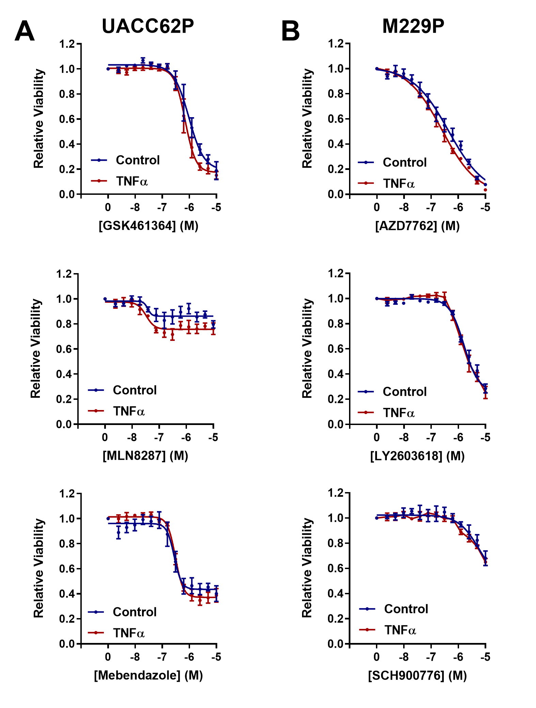
Figure S5. TNFα does not alter AURK, PLK, Tubulin, or Chk1/2 inhibitor sensitivity. A) UACC62P or B) M229P cells were seeded into 384-well plates at a density of 1,000 cells/well. The next day the cells were treated -/+ 10 ng/mL TNFα and a concentration gradient of the indicated compound. Viability was measured and quantified as described in the Materials and Methods section. This experiment was repeated with n = 3 technical replicates and n = 3 biological replicates.

Figure S6. Cyclin B1, Cyclin A1, and PARP levels in MLN8237-treated UACC62P/R cells. UACC62P and UACC62R cells were engineered to express EGFP-Cyclin B1 as described in the Materials and Methods section. The cells were treated with 1 µM MLN8237 for 24 h before cellular lysates were collected. Immunoblots were performed to measure levels of (A) Cyclin A1, (B) Cyclin B1, and (C) PARP. GAPDH was using as a loading control.

Figure S7. Chk1/2 inhibitors do not synergize with vemurafenib in M229P/R cells. M229P/R cells were seeded into 384-well plates at a density of 1,000 cells/well. The next day the cells were treated in a concentration response matrix with a top concentration of 10 µM for all compounds and a ½ dilution series. Viability was analyzed as described in the Materials and Methods section. Data is expressed as relative viability wherein a value of 1 (blue) indicates 100% viability and a value of 0 (red) indicates 0% viability. A. M229P/R cells were treated with a AZD7762 x Vemurafenib concentration response matrix. B. M229P/R cells were treated with a LY2603618 x Vemurafenib concentration response matrix. C. M229P/R cells were treated with a SCH900776 x Vemurafenib concentration response matrix. This experiment was repeated with n = 3 biological replicates. The data in these matrices represent the average compound response across all experimental replicates.

Figure S8: Chk1/2 inhibitors increase γH2AX staining in M229P/R cells. M229P/R cells were treated with 100 nM AZD7762, 1 µM LY2603618, or 1 µM SCH900776 for 24 h. The cells were subsequently fixed and stained with an antibody raised against p-γH2AX. Scale bar = 10 µM. These images are color versions of the images in Fig. 4C. Scale bar = 10 µM.

