Supplementary Table 1, The quality control of HCC cancer report in Shanghai
Year Diagnosis | DCO |  | D/C |  | HV
 | N | ％ | N | ％ | N | ％
1973 | 386 | 29.58 | 1305/1282 | 0.97 | 179 | 13.72
1974 | 571 | 38.32 | 1490/1391 | 0.93 | 139 | 9.33
1975 | 649 | 42.61 | 1523/1500 | 0.98 | 88 | 5.78
1976 | 688 | 46.11 | 1492/1492 | 0.99 | 181 | 12.13
1977 | 649 | 46.09 | 1408/1405 | 0.99 | 140 | 9.94
1978 | 740 | 43.81 | 1689/1688 | 1.01 | 167 | 9.89
1979 | 503 | 33.56 | 1499/1595 | 1.04 | 146 | 9.74
1980 | 578 | 41.67 | 1387/1526 | 1.08 | 134 | 9.66
1981 | 627 | 42.97 | 1459/1463 | 1.00 | 117 | 8.02
1982 | 717 | 46.26 | 1550/1489 | 0.97 | 117 | 7.55
1983 | 730 | 47.22 | 1546/1578 | 1.02 | 125 | 8.09
1984 | 725 | 44.78 | 1619/1589 | 0.96 | 130 | 8.03
1985 | 800 | 46.14 | 1734/1675 | 0.95 | 133 | 7.67
1986 | 840 | 47.57 | 1766/1713 | 0.96 | 145 | 8.21
1987 | 890 | 49.67 | 1792/1804 | 1.00 | 150 | 8.37
1988 | 204 | 11.54 | 1767/1666 | 0.93 | 344 | 19.47
1989 | 72 | 4.14 | 1740/1739 | 0.97 | 199 | 11.44
1990 | 77 | 4.20 | 1834/1746 | 0.92 | 239 | 13.04
1991 | 14 | 0.82 | 1703/1794 | 1.07 | 225 | 13.21
1992 | 1 | 0.06 | 1762/1832 | 1.00 | 262 | 14.87
1993 | 0 | 0.00 | 1613/1657 | 1.00 | 213 | 13.21
1994 | 0 | 0.00 | 1677/1599 | 0.96 | 211 | 12.58
1995 | 0 | 0.00 | 1582/1568 | 1.00 | 191 | 12.09
1996 | 0 | 0.00 | 1606/1613 | 1.00 | 215 | 13.42
1997 | 0 | 0.00 | 1570/1518 | 0.95 | 211 | 13.44
1998 | 6 | 0.35 | 1710/1571 | 0.90 | 249 | 14.56
1999 | 0 | 0.00 | 1677/1519 | 0.89 | 252 | 15.03
2000 | 0 | 0.00 | 1631/1522 | 0.94 | 235 | 14.41
2001 | 1 | 0.06 | 1586/1521 | 0.93 | 283 | 17.84
2002 | 1 | 0.05 | 1838/1601 | 0.87 | 346 | 18.82
2003 | 1 | 0.06 | 1682/1466 | 0.85 | 344 | 20.45
2004 | 3 | 0.16 | 1832/1422 | 0.77 | 398 | 21.72
2005 | 2 | 0.11 | 1832/1417 | 0.78 | 394 | 21.51
2006 | 2 | 0.11 | 1804/1508 | 0.83 | 407 | 22.56
2007 | 2 | 0.11 | 1769/1537 | 0.84 | 425 | 24.02
2008 | 2 | 0.11 | 1821/1565 | 0.85 | 452 | 24.82
2009 | 0 | 0.00 | 1748/1566 | 0.91 | 469 | 26.83
2010 | 0 | 0.00 | 1757/1442 | 0.82 | 528 | 30.05
2011 | 1 | 0.06 | 1679/1458 | 0.85 | 491 | 29.24
2012 | 0 | 0.00 | 1557/1402 | 0.90 | 465 | 29.87
2013 | 138 | 0.08 | 1426/1705 | 0.84 | 642 | 37.65
Supplementary Figure 1
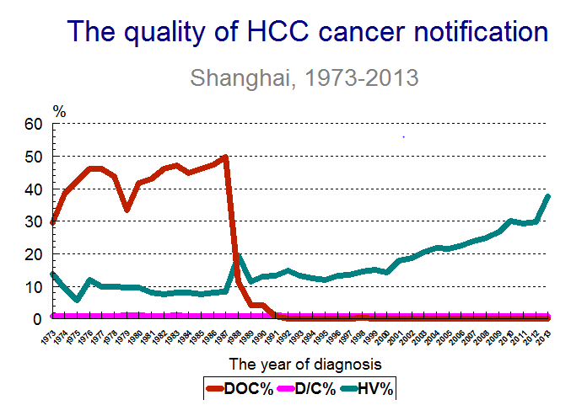

Year | HCC
 | Male |  | Female
1973 | 33.38 |  |  | 11.65
1974 | 35.28 |  |  | 13.22
1975 | 37.07 |  |  | 11.72
1976 | 35.06 |  |  | 12.47
1977 | 33.36 |  |  | 10.60
1978 | 38.55 |  |  | 13.54
1979 | 33.45 |  |  | 10.75
1980 | 29.25 |  |  | 9.56
1981 | 29.96 |  |  | 10.80
1982 | 30.56 |  |  | 10.98
1983 | 29.54 |  |  | 10.58
1984 | 30.24 |  |  | 10.96
1985 | 30.21 |  |  | 10.45
1986 | 29.85 |  |  | 10.11
1987 | 29.57 |  |  | 10.30
1988 | 27.56 |  |  | 10.57
1989 | 29.21 |  |  | 9.87
1990 | 29.04 |  |  | 9.89
1991 | 25.23 |  |  | 8.86
1992 | 24.91 |  |  | 8.72
1993 | 23.48 |  |  | 8.48
1994 | 25.59 |  |  | 9.02
1995 | 24.06 |  |  | 8.24
1996 | 23.63 |  |  | 8.40
1997 | 23.12 |  |  | 8.63
1998 | 26.43 |  |  | 8.70
1999 | 26.46 |  |  |  | 7.93
2000 | 25.26 | 8.25
2001 | 24.02 | 7.99
2002 | 27.62 | 8.91
2003 | 21.40 | 6.53
2004 | 23.47 | 7.61
2005 | 22.04 | 7.89
2006 | 22.18 | 7.29
2007 | 20.44 | 6.76
2008 | 22.44 | 6.89
2009 | 21.34 | 6.93
2010 | 18.51 | 5.93
2011 | 17.53 |  | 5.27
2012 | 16.63 |  | 5.99
2013 | 18.39 |  |  |  | 6.14
2014 | 17.34 |  |  |  | 5.60
Supplementary Table 2, incidences (ASRs, 1/100, 000) of HCC from 1973 to 2014 in Shanghai

Supplementary Table 3, incidences (1/100,000) of different types of hepatitis from 1973 to 2014 in Shanghai
Year | Hepatitis in total | HAV | HBV | HCV | HEV | unclassified
2000 | 83.41 | 9.03 | 23.09 | 1.13 | 5.48 | 44.67
2001 | 81.83 | 10.95 | 20.33 | 1.65 | 5.21 | 43.68
2002 | 48.43 | 5.78 | 19.83 | 0.83 | 3.58 | 19.41
2003 | 70.09 | 7.29 | 25.73 | 1.21 | 4.11 | 31.76
2004 | 69.06 | 3.7 | 26.53 | 1.02 | 3.88 | 33.92
2005 | 42.37 | 2.45 | 16.85 | 0.99 | 4.24 | 17.84
2006 | 37.92 | 2.41 | 16.22 | 1.42 | 3.12 | 14.75
2007 | 26.99 | 2.1 | 14.03 | 1.42 | 2.54 | 6.91
2008 | 22.02 | 1.69 | 12.74 | 1.8 | 2.49 | 3.3
2009 | 19.21 | 1.31 | 11.08 | 1.81 | 2.71 | 2.3
2010 | 15.52 | 0.92 | 7.88 | 1.89 | 3.05 | 1.79
2011 | 11.39 | 0.83 | 5.93 | 0.63 | 2.71 | 1.29
2012 | 9.66 | 0.66 | 4.96 | 0.66 | 2.1 | 1.28
2013 | 8.39 | 0.55 | 4.2 | 0.51 | 1.9 | 1.23
2014 | 7.11 | 0.83 | 3.24 | 0.22 | 1.96 | 0.87

