SUPPLEMENTARY MATERIAL

Supplementary Figures

Supplementary Figure 1. Gr-1+ cells from N3-tg mice display features of MDSCs. (A) RT-qPCR assay, in duplicates, of relative Arginase-1 (Arg-1) mRNA expression in CD11b⁺Gr-1⁺ cells sorted from the bone-marrow (BM) or spleen (Spl) of N3-tg versus wt mice at 12 wks of age. The expression levels of Arg-1 mRNA in wt CD11b⁺Gr-1⁺ cells are set as 1. (B) FACS analysis of intracellular Arginase-1 protein expression reported as fluorescence intensity in CD11b⁺Gr-1⁺ gated cells from the bone-marrow (BM) or spleen (Spl) of N3-tg versus wt mice at 12 wks of age. Numbers inside cytograms indicate percentages of Arg-1⁺ cells (black line=anti-Arg-1; grey line=isotype ctr). Results are representative of three independent experiments (n=3 mice per group). (C) Percentages of MitoSOXRed⁺ cells inside Gr-1⁺ subset from BM or Spl of N3-tg at 12 wks of age, compared to wt littermates, as assessed by FACS analysis. In (A) and (B) the values are presented as mean±SD from three independent experiments (n=3 mice per group); *, P≤0.05 and **, P≤0.01 represent significant differences between the indicated groups. (D) Representative FACS analysis of pSTAT3 protein expression reported as fluorescence intensity in Gr-1⁺ gated cells from BM of N3-tg at 12 wks of age, compared to wt controls. Numbers inside cytograms indicate percentages of pSTAT3⁺ cells (red line=anti-pSTAT3; gray line=isotype ctr). (E) Percentages of pSTAT3⁺ cells in Gr-1⁺ gated cells from BM of N3-tg mice at 12 wks of age, compared to wt controls, as measured by the FACS analysis, as in (C). The values are presented as mean±SD from three independent experiments (n=3 mice per group); *, P≤0.05 represents significant differences between the indicated groups.

Supplementary Figure 2. N3-tg T-ALL cells are required to generate functional MDSCs in vitro (A) The graph represents the results of a suppression assay, indicating the percentages of proliferating wt CD4⁻CD8⁺ T 'responder' cells, assessed as CFSE dilution by FACS analysis, at 72 hrs of culturing, either alone (Ctr, dark grey bar), as a control, or in combination with Gr-1⁺ cells that were magnetically selected from five-days cultures of total wt BM cells, in the presence of anti-IL6 neutralizing antibodies (light grey bars) or isotype controls (white bars), at the indicated wt Gr-1⁺/responders ratio. (B) The same suppression test, as in (A), was conducted with wt Gr-1⁺ cells that were magnetically selected from five-days co-cultures, in the presence of transwells, of total wt BM cells with splenic N3-tg DP T cells, as a positive control (red bar); or with N3-tg non-DP T cells (blue bar); or with N3-tg CD4⁻CD8⁺ T cells (yellow bar); or with sorted wt DP thymocytes, either alone (black bar) or in the presence of mouse recombinant IL-6 (at a final concentration of 50 pg/mL, light grey bar); or, finally, cultured in the presence of IL-6 in the culture medium (white bar). In (A) and (B) the results in the graphs are calculated as the ratio between the percentages of proliferating CD4⁻CD8⁺ T ‘responder’ cells in Gr-1⁺ cells-containing cultures and in control cultures, set up in the absence of Gr-1⁺ cells, and are expressed as % of control. The results represent the mean values±SD from three independent experiments (n=3 mice per group), with two technical replicates per experiment. ns=not significant, P>0.05; **, P≤0.01 and ***, P≤ 0.001 represent significant differences with respect to the relative controls (Ctr). The NS symbol over the line represent not significant (P>0.05) differences between the indicated groups.

Supplementary Figure 3. CD4⁺CD8⁺ (DP) T cells from N3-tg mice engraft the BM of NSG hosts. The analysis presented in this figure were performed on the same NSG recipient groups, as in the Figure 4. (A) Representative FACS analysis of CD4 versus CD8 marker distributions in the BM of NSG mice, recipients of DPtg cells or DPwt control cells, at 3-5 wks post-transplantation. Numbers inside cytograms indicate the percentages of CD4⁺CD8⁺ cells. (B) Percentages and (C) absolute numbers of DPtg cells or DPwt control cells in the BM of their respective NSG hosts, at 3-5 wks and 9-11 wks post-transplantation, assessed by the same FACS analysis, as in (A). In panel (B-C) data are presented as the mean values±SD of three independent experiments (n=3 mice per group); ns=not significant, P>0.05; *, P≤0.05 represents a significant difference between the indicated groups.

Supplementary Figure 4. Treatment with RB6-8C5 antibodies impairs Gr-1⁺ subset of N3-tg mice. N3-tg mice at 8 wks of age were injected i.p. with anti-Gr-1 (RB6-8C5 clone) depleting antibodies (RB6-8C5) or isotype controls (Ctr), twice a week and sacrificed and analyzed after 4 wks of treatment. (A) Percentages of CD11b⁺Gr-1⁺ cells are shown, as measured by FACS analysis of CD11b versus Gr-1 marker distributions in the spleen (SPL, left panel) and peripheral blood (PB, right panel) of N3-tg mice, treated as above. Numbers inside cytograms indicate the mean percentages±SD of CD11b⁺Gr-1⁺ cells. (B) The graphs show the CD11b⁺Gr-1⁺ absolute numbers in the spleen (SPL, left panel) and peripheral blood (PB, right panel) of N3-tg mice, treated as above, assessed by the same FACS analysis, as in (A). In (A) and (B) the values are presented as mean±SD of three independent experiments (n=4 mice per group). *, P≤0.05 and ***, P≤0.001 represent significant differences between the indicated groups. (C) The graph represents the results of a suppression assay, indicating the percentages of proliferating wt CD4-CD8+ T 'responder' cells, assessed as CFSE dilution by FACS analysis, at 72 hrs of culturing, either alone (Responders alone, white bar), or in combination with N3-tg Gr-1⁺ cells that were magnetically selected from BM of N3-tg mice, treated with RB6-8C5 antibodies (grey bar) or relative control antibodies (Ctr, black bar), as above. The indicated N3-tg Gr-1⁺/responders ratio (0:1, 1:2) were used. The results are calculated as the ratio between the percentages of proliferating CD4⁻CD8⁺ T ‘responder’ cells in Gr-1⁺ cells-containing cultures and in control cultures, set up in the absence of Gr-1⁺ cells, and are expressed as % of control. (D) IL-6 protein concentration assessed by ELISA in blood serum (PB serum), from N3-tg mice treated with RB6-8C5 versus relative controls (Ctr). In (C) and (D) the results are presented as the mean value±SD from two independent experiments (n=3 mice per group), and with two technical replicates per experiment. *, P≤0.05 and ***, P≤0.001 represents significant differences between the indicated groups.

Supplementary Figure 5. The human Notch3-dependent T-ALL cell line, TALL-1 drives the expansion of MDSCs from healthy PBMCs. (A) FACS analysis of intracellular IL-6 staining in the indicated human T-ALL cell lines (red lines). Black lines=ligand blocking controls (see Materials and methods). The human multiple myeloma U266 cell line was used as a positive control. Data are representative of three independent experiments. PBMCs from healthy donors were co-cultured with the human Notch3-dependent T-ALL cell line, TALL-1, by using transwell inserts, or were cultured in medium alone, as a control, for six days. The data shown are relative to the end of culturing. (B) Representative dot plot of CD14⁺HLA-DR^{low/neg} cells inside CD11b⁺CD33⁺ subset, as measured by FACS analysis in harvested PBMCs/TALL-1 co-culture samples (+TALL-1), versus samples of autologous PBMCs cultured alone (PBMCs alone). Numbers inside cytograms indicate the percentages of CD11b⁺CD33⁺CD14⁺HLA-DR^{low/neg} cells. (C) Percentages (left panel) and absolute numbers (right panel) of CD11b⁺CD33⁺CD14⁺HLA-DR^{low/neg} cells, as measured by the same FACS analysis, as in (B). The values are presented as mean±SD from six independent experiments (n=8 samples per group, donors n=8), each in triplicates. **, P≤0.01 and ****, P ≤ 0.0001 represent significant differences between the indicated groups. (D) At the end of the co-culture assay above, the CD33⁺ fractions were magnetically selected from harvested samples and used as 'putative' suppressors (CD33⁺) in a suppression test on proliferating CD4⁻CD8⁺ gated cells ('responders'), from CFSE-labelled and activated autologous PBMCs, at the indicated CD33⁺:responders ratios (0:1, 1:16, 1:8). CD33⁺ cells were selected from PBMCs cultured either in medium alone (CD33⁺/PBMCs alone, blue bars) or with TALL-1 cells (CD33⁺/+TALL-1, red bars). The results are illustrated as the ratio between the percentages of proliferating CD4⁻CD8⁺ gated cells in cultures containing CD33⁺ and in control cultures set up in the absence of CD33⁺ (no CD33⁺, black bar), expressed as % of control, and assessed as CFSE dilution by FACS analysis at 72 h of culturing. The values are presented as the mean±SD from three independent experiments (n=3 samples per group, donors n=3), with three technical replicates per experiment. **, P≤0.01 and ***, P≤ 0.001 represent significant differences between the indicated groups. (E) Percentages (left panel) and cell count proportions (middle panel) of CD11b⁺CD33⁺CD14⁺HLA-DR^{low/neg} cells in harvested PBMCs/TALL-1 co-culture samples, in the absence (CTR, white bars) or presence of GSI (+GSI, black bars), as measured by the same FACS analysis, as in (B). The right panel shows the absolute numbers of TALL-1 cells from the same co-cultures, as counted at the end of the co-culturing time. (F) Percentages (left panel) and cell count proportions (right panel) of CD11b⁺CD33⁺CD14⁺HLA-DR^{low/neg} cells in harvested PBMCs/TALL-1 co-culture samples, in the absence (CTR, white bars) or presence of anti-IL-6 neutralizing antibodies (+anti-IL6, black bars), as measured by the same FACS analysis, as in (B). (G) Cell count proportions of CD11b⁺CD33⁺CD14⁺HLA-DR^{low/neg} cells in harvested PBMCs/TALL-1 co-culture samples, in the absence (CTR, white bar) or presence of GSI (+GSI, black bar) or presence of both GSI and anti-IL6 antibodies (+GSI/anti-IL6, grey bar), as measured by the same FACS analysis, as in (B). In (E-G) the cell count proportions were calculated as the ratio between the CD11b⁺CD33⁺CD14⁺HLA-DR^{low/neg} absolute numbers in PBMCs/TALL-1 treated co-culture samples and in relative untreated controls, and expressed as % of control. The values represent the mean±SD from four independent experiments (n=4 samples per group, donors n=4), each in triplicates. ns=not significant, P>0.05; *, P≤0.05; **, P≤0.01 and ***, P≤0.001 represent significant differences between the indicated groups.

Supplementary Figure 6. During the co-cultures with healthy PBMCs, KE-37 cells express IL-6 and down-modulate Notch1-active protein upon GSI treatment (A) Western blot analysis of cleaved Notch1 intracellular domain (N1ic) expression in KE-37 cells, at the day six of co-culturing with PBMCs in the presence of GSI 10 μm or DMSO, as a control. Molecular weights in kDa are indicated in the left part. The results are representative of three independent experiments (n=3 samples per group, donors n=3), each in triplicates. (B) FACS analysis of IL-6 expression in KE-37 cells (left panel), as well as in CD3⁺ T cell subset (middle panel) and CD33⁺ myeloid cells (right panel) from healthy PBMCs, as measured at day six of culturing alone (black lines) or in PBMCs/KE37 co-cultures (red lines). The grey lines represent staining controls (see methods). Data are representative of three independent experiments (n=3 samples per group, donors n=3), each in duplicates.

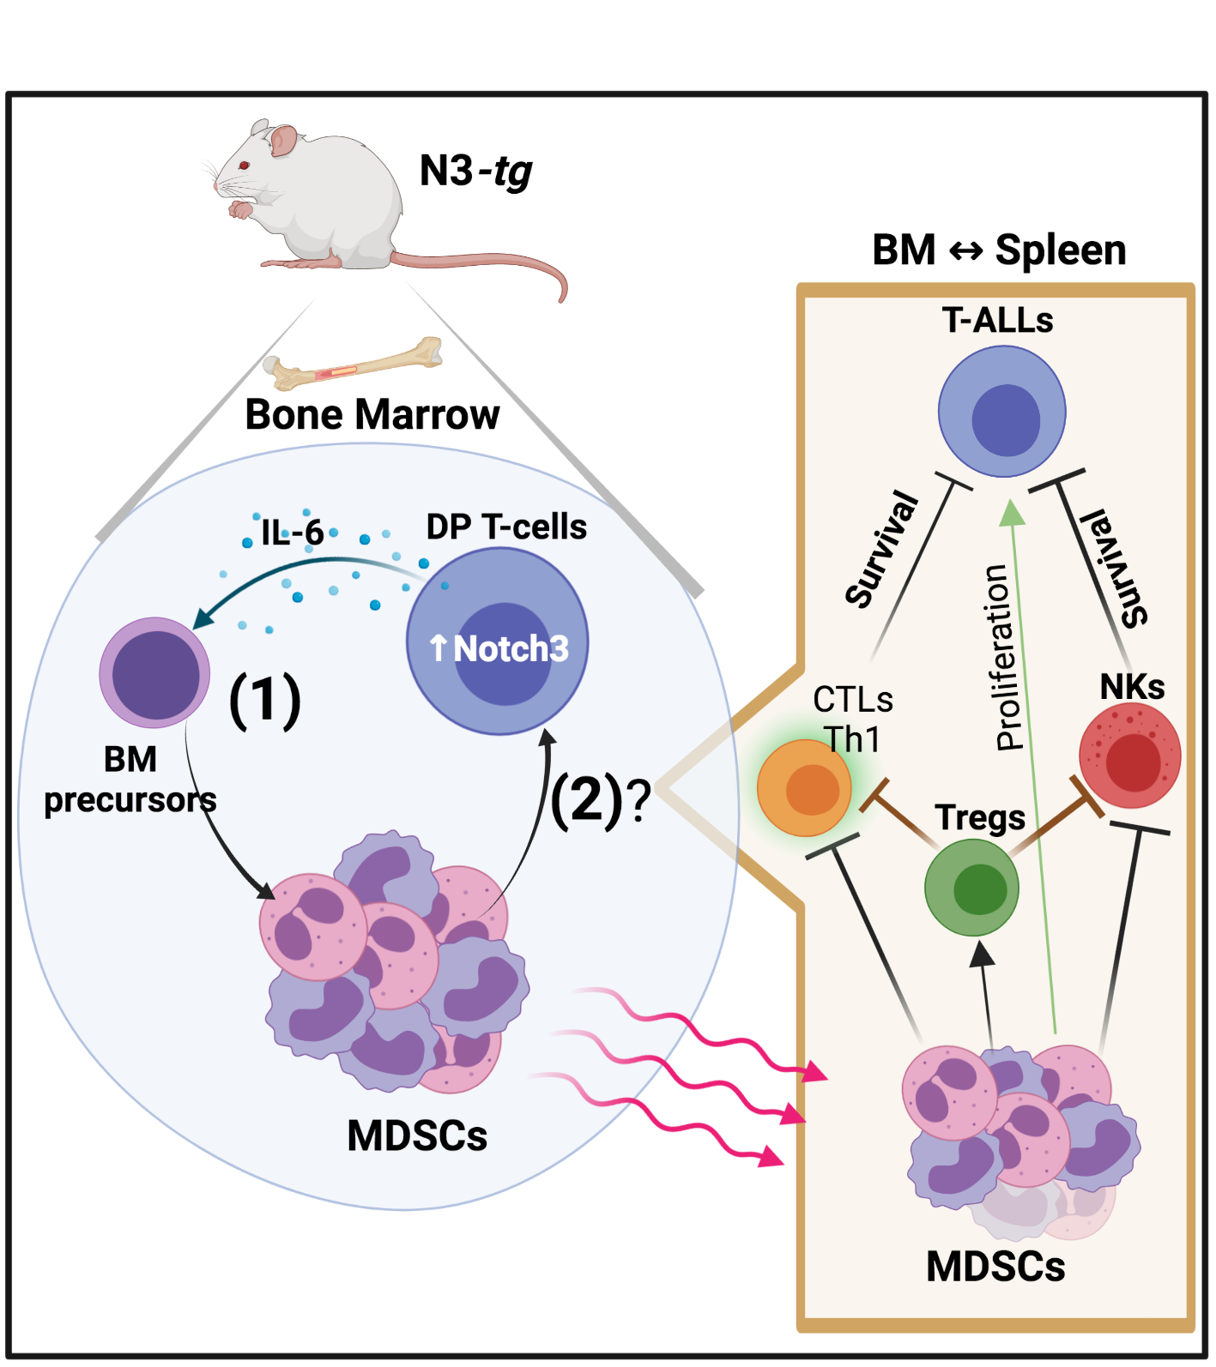

Supplementary Figure 7. The Notch3 dependent-induction of MDSCs and their possible role in T-ALL progression. On the left part, the figure summarizes the in vivo results on our Notch3-dependent model of T-ALL (N3-tg mice). Inside the Bone-Marrow aberrant T cells, mainly represented by CD4⁺CD8⁺ DP T cells (DP T-cells) induce functional MDSCs (MDSCs) from BM precursors, through a mechanism influenced by Notch-signaling deregulation inside DP T cells (↑Notch3) and the presence/release of IL-6 in the TME (1). In turn, MDSCs sustain DP T cell proliferation and/or survival (2), and eventually T-ALL progression, through mechanisms that we have hypothesized (?) on the right part of the figure (see the rectangle box), and that are likely active in BM of transgenic mice, but also in the spleen (BM⇔Spleen), where MDSCs migrate (see the red curve arrows). In particular, MDSC may improve T-ALL cell (T-ALLs) survival/proliferation, either directly (green arrow) and, more likely, indirectly by blocking anti-tumor immune responses of NKs, besides that of CTL/Th1 subsets, as well as through the generation of immuno-suppressive Tregs. Created with BioRender.com

