SUPPLEMENTARY DATA

Short-chain Alcohols Upregulate GILZ Gene Expression and Attenuate LPS-induced Septic Immune Response
Hang Pong Ng, Scott Jennings, Steve Nelson, Guoshun Wang

- Gating strategy to evaluate GILZ expression levels
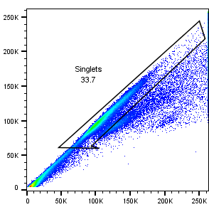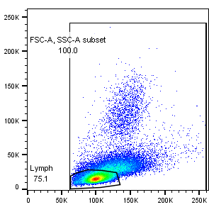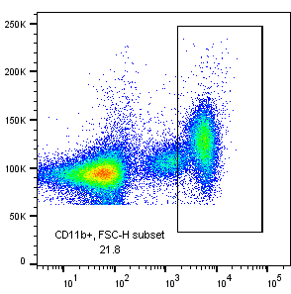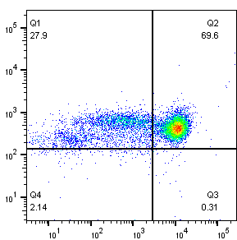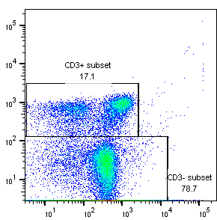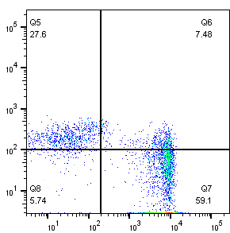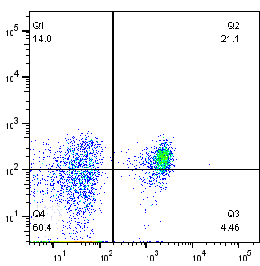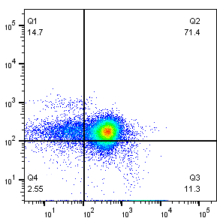

FSC
-
A
FSC
-
H
Small Gate (Lymph subset)
Large Gate (FSC
-
A, SSC
-
A Subset)
PerCP
-
Cy5.5 :: CD19
Comp
-
FITC
-
A :: CD11b
Comp
-
APC
-
A :: Ly6G
FSC
-
A
SSC
-
A
Comp
-
Alexa
-
700
-
A::CD3
Comp
-
PE
-
Cy5
-
A :: CD4
FSC
-
A
Comp
-
Pacific Blue
-
A :: CD8
Upper Gate (CD3+ Subset)
Lower Gate (CD3
-
Subset)
Comp
-
PE
-
A :: GILZ
Comp
-
PE
-
A :: GILZ
Comp
-
PE
-
A :: GILZ
Comp
-
PE
-
A :: GILZ
FSC
-
A
FSC
-
H
Fig. S1. Gating Strategy to Evaluate GILZ Expression. Nucleated cells from peripheral blood were blocked with TruStain FcTMXPLUS (2.5 µg/ml; BioLegend), and subjected to immunostaining with the following antibodies: CD11b-FITC (5 µg/ml; Invitrogen), Ly6G-APC (4 µg/ml; BD Pharmingen), CD3e-Alexa 700 (10 µg/ml; BD Pharmingen), CD8-Pacific Blue (5 µg/ml; BioLegend), CD4-PE-Cy5 (10 µg/ml; BD Pharmingen), and CD19-PerCP Cy5.5 (10 µg/ml; BD Pharmingen), Next, the cells were permeabilized and fixed using BD
Cytofix/Cytoperm™ Fixation/Permeabilization Kit. Then, the cells were intracellularly stained with GILZ-PE antibody (5 µg/ml; Invitrogen), followed by flow cytometry analysis.

- Gating strategy to evaluate phospho-IκB levels
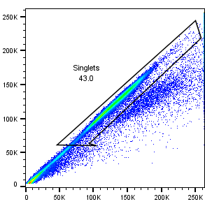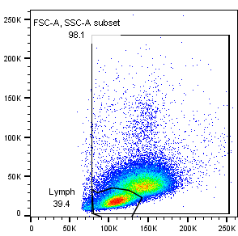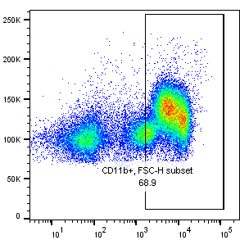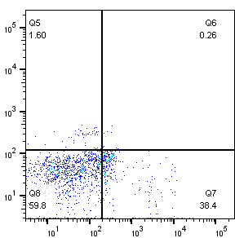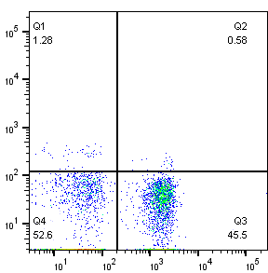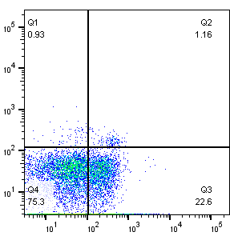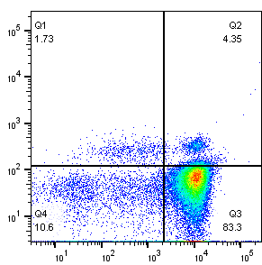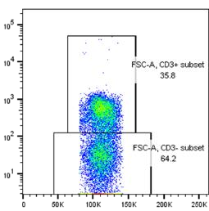

FSC
-
A
FSC
-
H
Small Gate (Lymph subset)
Large Gate (FSC
-
A, SSC
-
A Subset)
PerCP
-
Cy5.5 :: CD19
Comp
-
FITC
-
A :: CD11b
Comp
-
APC
-
A :: Ly6G
Comp
-
PE
-
A ::
Phospho
-
I
κ
B
FSC
-
A
SSC
-
A
Comp
-
Alexa 700
-
A::CD3
Comp
-
PE
-
Cy5
-
A :: CD4
FSC
-
A
Comp
-
PE
-
A ::
Phospho
-
I
κ
B
Comp
-
Pacific Blue
-
A :: CD8
Comp
-
PE
-
A ::
Phospho
-
I
κ
B
Comp
-
PE
-
A ::
Phospho
-
I
κ
B
Upper Gate (CD3+ Subset)
Lower Gate (CD3
-
Subset)
FSC
-
H
Fig. S2. Gating Strategy to Evaluate Phosphor-IκB Levels. Nucleated cells from peripheral blood were blocked with TruStain FcTMXPLUS (2.5 µg/ml; BioLegend), and subjected to immunostaining with the following antibodies against surface markers: CD11b-FITC (5 µg/ml; Invitrogen), Ly6G-APC (4 µg/ml; BD Pharmingen), CD3e-PE-Cy7 (10 µg/ml; BD Pharmingen), CD8-Pacific Blue (5 µg/ml; BioLegend), CD4-Alexa-700 (10 µg/ml; BD Pharmingen), and CD19-PerCP Cy5.5 (10 µg/ml; BD Pharmingen). Next, the cells were permeabilized and fixed using BD Cytofix/Cytoperm™ Fixation/Permeabilization Kit. Then, the cells were intracellularly stained with phospho-IκB-PE antibody (1.25 µg/ml; Invitrogen), followed by flow cytometry analysis.

