Supplementary table 1. Physico-chemical properties of the soils in different treatments

Treatment | TOC (g kg⁻¹) |  | TN (g kg⁻¹) | AN (mg kg⁻¹) | TP (g kg⁻¹) | AP (mg kg⁻¹) | TK ( g kg⁻¹) | AK (mg kg⁻¹) | pH
CTS | 13.88±0.06ª | 0.95±0.06ª |  | 76.14±1.55ª | 0.68±0.01^{d} | 17.65±1.14ª | 21.54±0.34ª | 147.05±8.14ª | 7.89±0.18ª
NTS | 14.61±0.42ª | 0.97±0.01ª |  | 75.59±1.34ª | 0.89±0.01^{b} | 14.99±0.40ª | 21.99±0.71ª | 160.35±16.95ª | 8.11±0.03ª
CT | 12.81±0.63ª | 0.85±0.08^{ab} |  | 60.80±2.32^{b} | 0.79±0.01^{c} | 15.36±1.84ª | 21.65±0.75ª | 77.22±0.00^{b} | 8.01±0.12ª
NT | 13.11±0.87ª | 0.81±0.01^{b} |  | 65.18±2.05^{c} | 0.93±0.01ª | 13.93±1.29ª | 21.75±0.42ª | 77.22±0.00^{b} | 8.07±0.04ª

Note: Total organic carbon, TOC; Total nitrogen, TN; Alkaline nitrogen, AN; Total phosphorus, TP; Available phosphorus, AP; Total potassium, TK; Available potassium, AK; Values in the same column followed by different letters differ significantly (P < 0.05).
Supplementary table 2. Topological properties of the fungal sub-community networks

 | Tillage (CT and CTS) |  |  | No-tillage (NT and NTS)
 | Abundant | Intermediate | Rare | Abundant | Intermediate | Rare
Number of nodesª | 39 | 250 | 372 | 38 | 222 | 376
Number of edges^{b} | 144 | 4523 | 5334 | 75 | 1751 | 5136
Positive edges^{c} | 88 | 2431 | 4866 | 34 | 944 | 4879
Negative edges^{d} | 56 | 2092 | 468 | 41 | 807 | 437
Modularity^{e} | 1.135 | 3.49 | 0.867 | -12.2 | 4.14 | 0.684
Number of community^{f} | 11 | 12 | 14 | 13 | 10 | 14
Network diameter^{g} | 7 | 6 | 9 | 6 | 5 | 6
Average path length^{h} | 2.525 | 2.497 | 2.8 | 2.685 | 2.859 | 2.795
Average degree^{i} | 7.385 | 36.184 | 28.677 | 3.974 | 15.775 | 28.227
Average clustering coefficient^{j} | 0.659 | 0.617 | 0.861 | 0.503 | 0.518 | 0.82
Density^{k} | 0.194 | 0.145 | 0.077 | 0.107 | 0.071 | 0.075
 | No straw mulching (CT and NT) |  |  | Straw mulching (CTS and NTS)
 | Abundant | Intermediate | Rare | Abundant | Intermediate | Rare
Number of nodesª | 39 | 241 | 340 | 38 | 224 | 372
Number of edges^{b} | 130 | 2794 | 4101 | 80 | 1814 | 4203
Positive edges^{c} | 76 | 1529 | 3810 | 35 | 950 | 3783
Negative edges^{d} | 54 | 1265 | 291 | 45 | 864 | 420
Modularity^{e} | 1.91 | 3.149 | 0.843 | -10.063 | 7.748 | 0.868
Number of community^{f} | 11 | 9 | 14 | 16 | 9 | 14
Network diameter^{g} | 6 | 7 | 8 | 5 | 6 | 6
Average path length^{h} | 2.349 | 2.726 | 2.847 | 2.243 | 2.912 | 3.026
Average degree^{i} | 6.667 | 23.187 | 24.124 | 4.211 | 16.196 | 22.597
Average clustering coefficient^{j} | 0.582 | 0.592 | 0.855 | 0.749 | 0.541 | 0.795
Density^{k} | 0.175 | 0.097 | 0.071 | 0.114 | 0.073 | 0.061
Note: CT, soil sampled from convention tillage field. CTS, soil sampled from tillage and straw mulching field. NT, soil sampled from the site of no-tillage field. NTS, soil sampled from the site of no-tillage and straw mulching field. Fungal OTUs with significant (p < 0.05) and strong (r >0.6) correlation. Correlation analysis was performed by R language (R 2021, version 4.1.1). The parameters of network were calculated by Gephi 0.9.2.
^{a,b}Number of connection obtained by Gephi.
^{c}Positive correlation between two fungal OTUs.
^{d}Negative correlation between two fungal OTUs.
^{e}Structure with high-density connection between nodes.
^{f}A community is defined as a group of nodes that are densely connected internally.
^{g}The longest distance between nodes in the network.
^{h}Average network distance between all pairs of nodes or the average length of all edges.
^{i}The average number of connections of every node in the network .
^{j}The average clustering coefficient is defined as the mean value of individual coefficients.
^{k}The density used to measure how close the network is to complete. A complete graph has all possible edges and density equal to 1.

Supplementary table 4. α-diversity of fungal sub-communities
Fungal  Sub-communities | Treatment | Shannon | Chao1
Abundant | CTS | 3.94±0.33ª | 36.67±0.58ª
 | NTS | 4.38±0.10ª | 36.67±0.58ª
 | CT | 4.21±0.62ª | 37.00±1.00ª
 | NT | 4.17±0.09ª | 36.33±0.58ª
Intermediate | CTS | 4.06±0.10ª | 196.92±13.25ª
 | NTS | 4.21±0.16ª | 213.89±34.20ª
 | CT | 3.89±0.39ª | 137.00±7.55^{b}
 | NT | 3.95±0.05ª | 173.57±4.74ª
Rare | CTS | 6.05±0.43ª | 218.55±84.27ª
 | NTS | 6.32±0.66ª | 217.30±16.29ª
 | CT | 6.20±0.53ª | 145.86±19.23ª
 | NT | 5.93±0.20ª | 182.88±12.44ª

Note: Values in the same column followed by different letters differ significantly (P < 0.05)

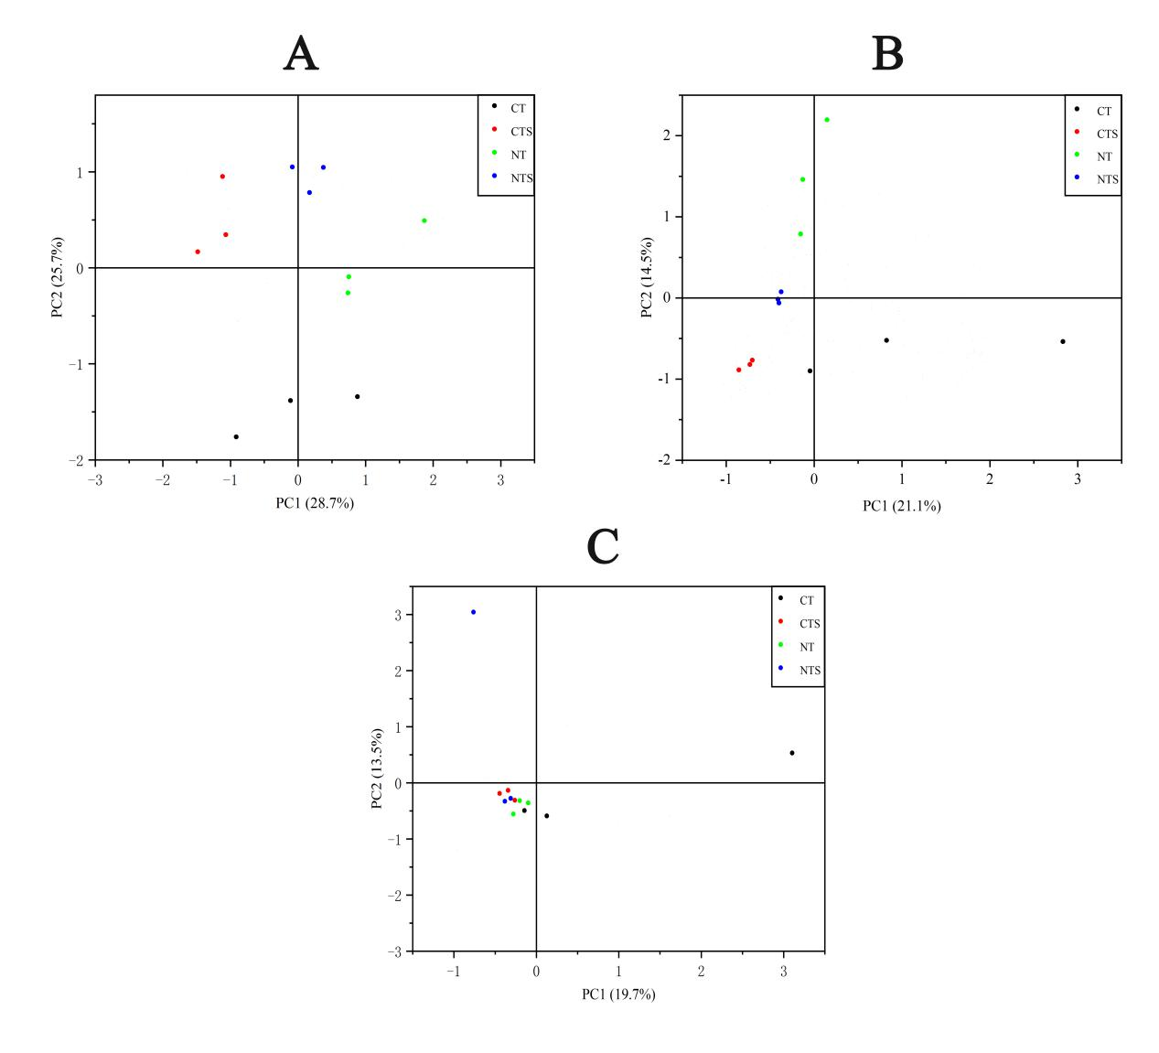
Figure. S1. Principal component analysis of the abundant (A), intermediate (B) and rare (C) sub-communities in four treatments.

