Supplementary Material

Supplementary Table S1. Taxonomy and isolation information of 122 Lactobacillus strains
LAB strain | Taxonomy | Isolation location | Isolation source
JLD65 | L. plantarum | Guangdong | feces of healthy centenarian
JLD66 | L. plantarum | Guangdong | feces of healthy centenarian
JLE15 | L. plantarum | Guangdong | feces of healthy centenarian
JLE50 | L. plantarum | Guangdong | feces of healthy centenarian
JLE53 | L. brevis | Guangdong | feces of healthy centenarian
JLE88 | L. plantarum | Guangdong | feces of healthy centenarian
JLJ14 | L. plantarum | Guangdong | feces of healthy centenarian
JLJ16 | L. fermentum | Guangdong | feces of healthy centenarian
JLJ19 | L. fermentum | Guangdong | feces of healthy centenarian
JLJ21 | L. fermentum | Guangdong | feces of healthy centenarian
JLJ32 | L. pantheris | Guangdong | feces of healthy centenarian
JLJ42 | L. fermentum | Guangdong | feces of healthy centenarian
JLJ46 | L. fermentum | Guangdong | feces of healthy centenarian
JLK69 | L. plantarum | Guangdong | feces of healthy centenarian
JLL10 | L. plantarum | Guangdong | feces of healthy centenarian
JLL2 | L. plantarum | Guangdong | feces of healthy centenarian
JLL28 | L. fermentum | Guangdong | feces of healthy centenarian
JLL29 | L. brevis | Guangdong | feces of healthy centenarian
JLL31 | L. plantarum | Guangdong | feces of healthy centenarian
JLL43 | L. fermentum | Guangdong | feces of healthy centenarian
JLL45 | L. fermentum | Guangdong | feces of healthy centenarian
JLL61 | L. fermentum | Guangdong | feces of healthy centenarian
JLL8 | L. plantarum | Guangdong | feces of healthy centenarian
JLL81 | L. plantarum | Guangdong | feces of healthy centenarian
JLL85 | L. plantarum | Guangdong | feces of healthy centenarian
JLL86 | L. fermentum | Guangdong | feces of healthy centenarian
JLL88 | L. plantarum | Guangdong | feces of healthy centenarian
JLM10 | L. fermentum | Guangdong | feces of healthy centenarian
JLM2 | L. plantarum | Guangdong | feces of healthy centenarian
JLM37 | L. plantarum | Guangdong | feces of healthy centenarian
JLM4 | L. plantarum | Guangdong | feces of healthy centenarian
PV1 | L. plantarum | Guangdong | feces of healthy centenarian
PV11 | L. fermentum | Guangdong | feces of healthy centenarian
PV12 | L. fermentum | Guangdong | feces of healthy centenarian
PV13 | L. fermentum | Guangdong | feces of healthy centenarian
PV14 | L. fermentum | Guangdong | feces of healthy centenarian
PV15 | L. fermentum | Guangdong | feces of healthy centenarian
PV16 | L. equi | Guangdong | feces of healthy centenarian
PV18 | L. fermentum | Guangdong | feces of healthy centenarian
PV19 | L. casei | Guangdong | feces of healthy centenarian
PV2 | L. plantarum | Guangdong | feces of healthy centenarian
PV20 | L. fermentum | Guangdong | feces of healthy centenarian
PV21 | L. fermentum | Guangdong | feces of healthy centenarian
PV22 | L. fermentum | Guangdong | feces of healthy centenarian
PV23 | L. delbrueckii | Guangdong | feces of healthy centenarian
PV27 | L. delbrueckii | Guangdong | feces of healthy centenarian
PV28 | L. reuteri | Guangdong | feces of healthy centenarian
PV3 | L. plantarum | Guangdong | feces of healthy centenarian
PV30 | L. oris | Guangdong | feces of healthy centenarian
PV33 | L. plantarum | Guangdong | feces of healthy centenarian
PV35 | L. salivarius | Guangdong | feces of healthy centenarian
PV37 | L. plantarum | Guangdong | feces of healthy centenarian
PV38 | L. salivarius | Guangdong | feces of healthy centenarian
PV4 | L. plantarum | Guangdong | feces of healthy centenarian
PV44 | L. salivarius | Guangdong | feces of healthy centenarian
PV46 | L. equi | Guangdong | feces of healthy centenarian
PV47 | L. rhamnosus | Guangdong | feces of healthy centenarian
PV49 | L. plantarum | Guangdong | feces of healthy centenarian
PV5 | L. plantarum | Guangdong | feces of healthy centenarian
PV50 | L. rhamnosus | Guangdong | feces of healthy centenarian
PV54 | L. rhamnosus | Guangdong | feces of healthy centenarian
PV55 | L. plantarum | Guangdong | feces of healthy centenarian
PV6 | L. delbrueckii | Guangdong | feces of healthy centenarian
PV63 | L. mucosae | Guangdong | feces of healthy centenarian
PV65 | L. casei | Guangdong | feces of healthy centenarian
PV66 | L. plantarum | Guangdong | feces of healthy centenarian
PV68 | L. mucosae | Guangdong | feces of healthy centenarian
PV7 | L. delbrueckii | Guangdong | feces of healthy centenarian
PV70 | L. helveticus | Guangdong | feces of healthy centenarian
PV74 | L. plantarum | Guangdong | feces of healthy centenarian
PV78 | L. brevis | Guangdong | feces of healthy centenarian
PV8 | L. delbrueckii | Guangdong | feces of healthy centenarian
PV9 | L. fermentum | Guangdong | feces of healthy centenarian
PVE77 | L. plantarum | Guangdong | feces of healthy centenarian
PVE88 | L. plantarum | Guangdong | feces of healthy centenarian
PVH34 | L. plantarum | Guangdong | feces of healthy centenarian
PVH6 | L. plantarum | Guangdong | feces of healthy centenarian
PVH69 | L. fermentum | Guangdong | feces of healthy centenarian
XJA11 | L. equi | Xinjiang | yogurt
XJA12 | L. salivarius | Xinjiang | yogurt
XJA14 | L. equi | Xinjiang | yogurt
XJA2 | L. equi | Xinjiang | yogurt
XJC14 | L. reuteri | Xinjiang | milk granule
XJC2 | L. mucosae | Xinjiang | koumiss
XJC20 | L. delbrueckii | Xinjiang | milk granule
XJC21 | L. fermentum | Xinjiang | milk granule
XJC23 | L. gallinarum | Xinjiang | milk granule
XJC36 | L. helveticus | Xinjiang | milk granule
XJC42 | L. fermentum | Xinjiang | milk granule
XJC5 | L. oris | Xinjiang | koumiss
XJC56 | L. fermentum | Xinjiang | milk granule
XJC59 | L. fermentum | Xinjiang | koumiss
XJC60 | L. fermentum | Xinjiang | milk granule
XJC65 | L. fermentum | Xinjiang | yogurt
XJC67 | L. plantarum | Xinjiang | yogurt
XJC69 | L. plantarum | Xinjiang | milk lump
XJC70 | L. delbrueckii | Xinjiang | milk lump
XJC80 | L. fermentum | Xinjiang | milk lump
XJC9 | L. plantarum | Xinjiang | milk lump
XJC91 | L. plantarum | Xinjiang | milk lump
XJC92 | L. fermentum | Xinjiang | milk lump
XJG17 | L. equi | Xinjiang | yogurt
XJG18 | L. plantarum | Xinjiang | goat's milk
XJG21 | L. equi | Xinjiang | goat's milk
XJG33 | L. reuteri | Xinjiang | goat's milk
XJG49 | L. plantarum | Xinjiang | goat's milk
XJK20 | L. equi | Xinjiang | goat's milk
XJK21 | L. gasseri | Xinjiang | goat's milk
XJK49 | L. plantarum | Xinjiang | goat's milk
XJP1 | L. fermentum | Xinjiang | milk pimple
XJP13 | L. delbrueckii | Xinjiang | yogurt
XJP29 | L. delbrueckii | Xinjiang | milk pimple
XJP30 | L. fermentum | Xinjiang | milk pimple
XJP38 | L. delbrueckii | Xinjiang | milk pimple
XJP44 | L. fermentum | Xinjiang | milk pimple
XJP54 | L. delbrueckii | Xinjiang | milk pimple
XJP61 | L. delbrueckii | Xinjiang | milk pimple
XJP68 | L. crustorum | Xinjiang | mare's milk
XJP69 | L. oris | Xinjiang | mare's milk
XJP70 | L. reuteri | Xinjiang | mare's milk
XJP82 | L. plantarum | Xinjiang | yogurt
XJP87 | L. oris | Xinjiang | yogurt

Supplementary Table S2. Genomic characteristics of 11 strains of L. fermentum in this study
Strain | XJC92 | JLJ21 | JLM10 | JLL86 | JLJ46 | PV18 | JLL28 | PV22 | XJC60 | XJC42 | XJC21
Genome Size (Mb) | 1.91 | 2.07 | 2.05 | 2.04 | 2.08 | 2.07 | 2.08 | 2.19 | 1.97 | 1.97 | 1.97
GC content (%) | 51.73 | 51.63 | 51.69 | 51.85 | 51.51 | 51.61 | 51.5 | 51.22 | 51.65 | 51.64 | 51.66
Number of CDS | 2160 | 2200 | 2171 | 2142 | 2320 | 2214 | 2297 | 2278 | 2003 | 2026 | 2016
Number of tRNA | 58 | 57 | 56 | 58 | 57 | 58 | 58 | 58 | 58 | 58 | 58
Number of Repeat Regions | 12 | 56 | 20 | 9 | 22 | 56 | 30 | 170 | 229 | 232 | 228
Number of rRNA | 7 | 10 | 12 | 13 | 10 | 10 | 9 | 15 | 15 | 15 | 15
Gene Number in Subsystem
Protein Processing | 313 | 368 | 378 | 367 | 392 | 368 | 357 | 365 | 317 | 317 | 315
Stress Response, Defense, Virulence | 194 | 194 | 194 | 194 | 195 | 194 | 194 | 194 | 185 | 185 | 185
DNA processing | 67 | 71 | 73 | 77 | 70 | 70 | 69 | 79 | 75 | 75 | 73
Energy | 80 | 79 | 84 | 78 | 84 | 79 | 78 | 81 | 81 | 81 | 81
RNA processing | 96 | 86 | 92 | 93 | 102 | 92 | 89 | 83 | 98 | 98 | 96
Cellular Processes | 40 | 40 | 40 | 40 | 41 | 40 | 40 | 40 | 40 | 40 | 40
Regulation and Cell Signaling | 55 | 58 | 56 | 56 | 57 | 58 | 54 | 57 | 57 | 57 | 57
Membrane Transport | 7 | 15 | 15 | 15 | 15 | 15 | 15 | 15 | 8 | 8 | 8

Supplementary Table S3. Quantification of γ-aminobutyric acid in the MNTDs of the L. fermentum isolates
Strain | γ-aminobutyric acid (mg/L)
PV22 | 45.757 ± 0.315
PV18 | 1.572 ± 0.672
XJC21 | 2.774 ± 0.149
XJC65 | 2.552 ± 0.096
pH adjusted MRS | 1.141 ± 0.003

Supplementary Figure 1
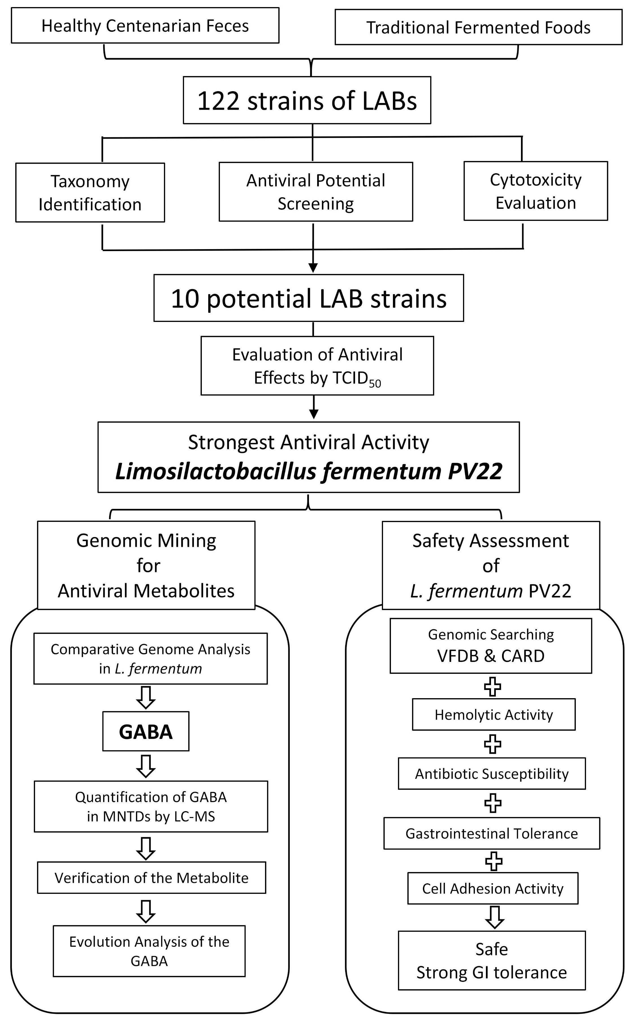
Supplementary Figure 1 The flow diagram for the selection and verification of the lactic acid bacteria (LAB) strains with anti-norovirus activities
LAB: lactic acid bacteria; TCID₅₀: 50% tissue culture infectious dose; GABA: γ-aminobutyric acid; L. fermentum: Limosilactobacillus fermentum; MNTD: Minimum non-toxic dilutions; LC-MS: liquid chromatography-tandem mass spectrometry; VFDB: Virulence Factor Database; CARD: Comprehensive Antibiotic Research Database; GI: gastrointestinal.
Supplementary Figure 2
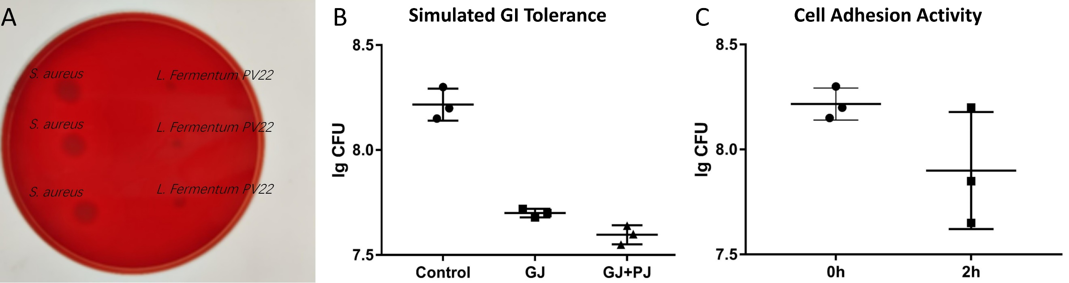
Supplementary Figure 2 Safety and gastrointestinal tract tolerance assessment of L. fermentum PV22
A. Hemolytic activity examination of L. fermentum PV22: compared to the positive control, no hemolytic phenomenon could be observed in L. fermentum PV22. B. Gastrointestinal tract tolerance of L. fermentum PV22: L. fermentum PV22 showed strong gastrointestinal tract tolerance against simulated gastric juice and simulated pancreatic juice. C. Cell adhesion activity of L. fermentum PV22: 50.12% of the bacteria were attached to the Caco-2 cells after 2 hours co-incubation.
L. fermentum: Limosilactobacillus fermentum; GI: gastrointestinal; GJ: gastric juice; PJ: pancreatic juice.

