SUPPLEMENTARY MATERIAL FOR:
A cell wall hydrolase MepH is negatively regulated by proteolysis involving Prc and NlpI in Escherichia coli.

Wook-Jong Jeon¹ and Hongbaek Cho¹*

¹Department of Biological Sciences, College of Natural Sciences, Sungkyunkwan University,

*To whom correspondence should be addressed.
Hongbaek Cho, Ph.D.
Sungkyunkwan University
Department of Biological Sciences
Suwon 16419, Republic of Korea
e-mail: hongbaek@skku.edu
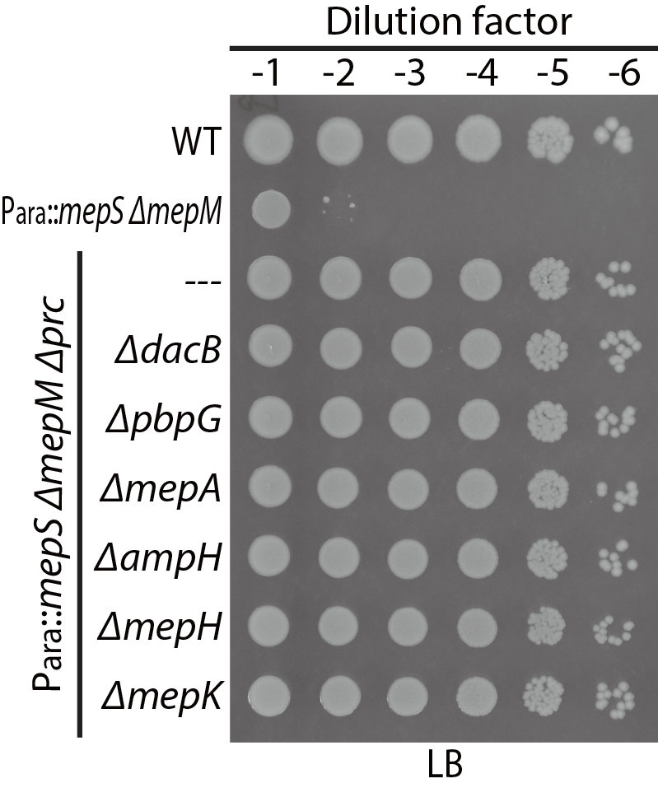
Supplementary Figure 1. Spot dilution assay of DD-endopeptidase mutant derivative strains of HC611 on LB agar. MG1655, HC611 (P_{ara}::mepS, ΔmepM), WJ81 (P_{ara}::mepS, ΔmepM, Δprc), and the DD-endopeptidase mutant derivatives of WJ81 were grown overnight in M9-arabinose medium, serially diluted in LB, and the dilutions spotted on LB-agar as in Fig. 3. The plates were incubated at 30 °C and photographed after 22 hours.
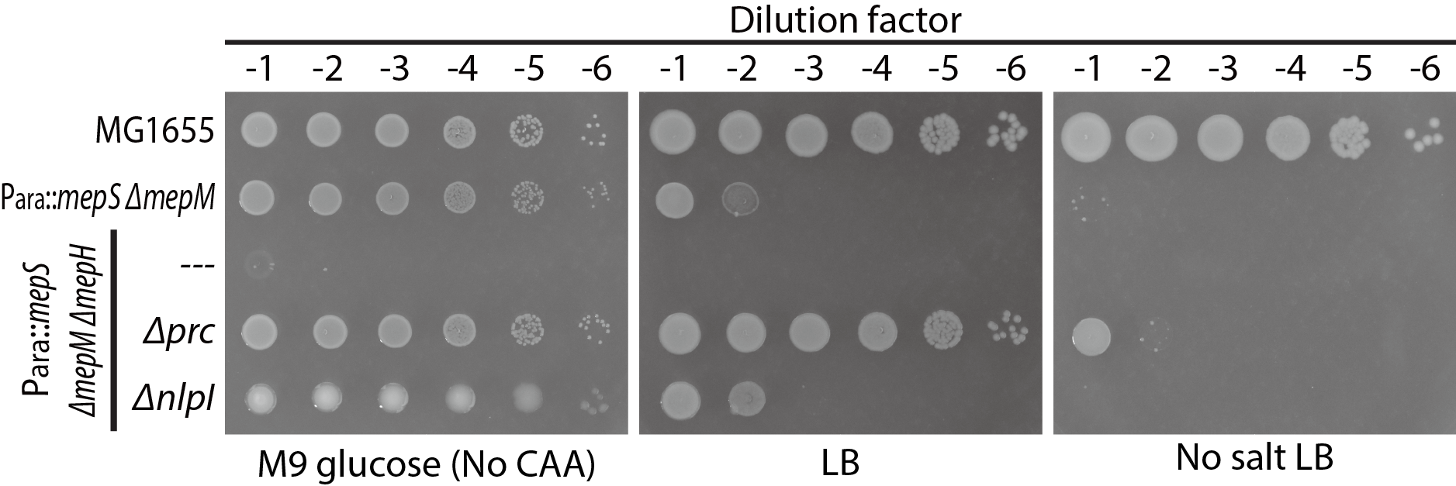
Supplementary Figure 2. Inactivation of Prc or NlpI suppresses the collective essentiality of mepS, mepM, and mepH. To assess suppression of the synthetic lethality between mepS, mepM, and mepH by inactivation of Prc or NlpI, MG1655, HC611 (P_{ara}::mepS ΔmepM), WJ283 (P_{ara}::mepS ΔmepM ΔmepH), WJ89 (P_{ara}::mepS ΔmepM ΔmepH Δprc), and WJ95 (P_{ara}::mepS ΔmepM ΔmepH ΔnlpI) strains were grown overnight in M9-arabinose medium. The overnight cultures were 10-fold serially diluted in M9-glucose medium lacking casamino acids, LB medium, or LB medium lacking NaCl, and spotted on the corresponding solid agar media. Then, the agar plates were incubated at 30 °C. The LB and no salt LB agar plates were photographed after incubation for 22 hours and the M9-glucose agar plate after incubation for 40 hours.

Supplementary Table 1. Strains used in this study
Strain | Genotype | Source/  Reference
MG1655 | rph ilvG rfb-50 | (Guyer et al., 1981)
TB10 | rph1 ilvG rfb-50 λΔcro-bio nad::Tn10 | (Johnson et al., 2004)
TB28 | MG1655 ΔlacIZYA<>frt | (Bernhardt and Boer, 2004)
DH5α(λpir) | F- endA1 hsdR17 (r⁻m⁺) supE44 thi-1 recA1 gyrA relA1 Δ(lacZYA-argF)_{u189} Φ80lacZΔM15 λpir | (Pal et al., 2005)
MFDpir | RP4-2-Tc::[ΔMu1::aac(3)IV-ΔaphA-Δnic35-ΔMu2::zeo] ΔdapA::(erm-pir) ΔrecA | (Ferrières et al., 2010)
BL21(DE3)/pLysS | ompT rB− mB− (P_{lac}UV5::T7gene1)  pLysS[T7p20 ori_{p15A}](Cm^{R}) | Lab collection
HC611 | rph1 ilvG rfb-50 ΔlacIZYA<>frt ΔmepM<>frt P_{ara}::mepS | This study
WJ76 | rph1 ilvG rfb-50 ΔlacIZYA<>frt ΔmepM<>frt P_{ara}::mepS ΔnlpI<>frt | This study
WJ81 | rph1 ilvG rfb-50 ΔlacIZYA<>frt ΔmepM<>frt P_{ara}::mepS Δprc<>frt | This study
WJ85 | rph1 ilvG rfb-50 ΔlacIZYA<>frt ΔmepM<>frt P_{ara}::mepS Δprc<>frt ΔdacB::aph | This study
WJ86 | rph1 ilvG rfb-50 ΔlacIZYA<>frt ΔmepM<>frt P_{ara}::mepS Δprc<>frt ΔpbpG::aph | This study
WJ87 | rph1 ilvG rfb-50 ΔlacIZYA<>frt ΔmepM<>frt P_{ara}::mepS Δprc<>frt ΔmepA::aph | This study
WJ88 | rph1 ilvG rfb-50 ΔlacIZYA<>frt ΔmepM<>frt P_{ara}::mepS Δprc<>frt ΔampH::aph | This study
WJ89 | rph1 ilvG rfb-50 ΔlacIZYA<>frt ΔmepM<>frt P_{ara}::mepS Δprc<>frt ΔmepH::aph | This study
WJ91 | rph1 ilvG rfb-50 ΔlacIZYA<>frt ΔmepM<>frt P_{ara}::mepS ΔnlpI<>frt ΔdacB::aph | This study
WJ92 | rph1 ilvG rfb-50 ΔlacIZYA<>frt ΔmepM<>frt P_{ara}::mepS ΔnlpI<>frt ΔpbpG::aph | This study
WJ93 | rph1 ilvG rfb-50 ΔlacIZYA<>frt ΔmepM<>frt P_{ara}::mepS ΔnlpI<>frt ΔmepA::aph | This study
WJ94 | rph1 ilvG rfb-50 ΔlacIZYA<>frt ΔmepM<>frt P_{ara}::mepS ΔnlpI<>frt ΔampH::aph | This study
WJ95 | rph1 ilvG rfb-50 ΔlacIZYA<>frt ΔmepM<>frt P_{ara}::mepS ΔnlpI<>frt ΔmepH::aph | This study
WJ124 | rph1 ilvG rfb-50 ΔlacIZYA<>frt ΔmepM<>frt P_{ara}::mepS mepH-FLAG::aph | This study
WJ125 | rph1 ilvG rfb-50 ΔlacIZYA<>frt ΔmepM<>frt P_{ara}::mepS Δprc<>frt mepH-FLAG::aph | This study
WJ126 | rph1 ilvG rfb-50 ΔlacIZYA<>frt ΔmepM<>frt P_{ara}::mepS ΔnlpI<>frt mepH-FLAG::aph | This study
WJ199 | rph1 ilvG rfb-50 ΔmepS<>frt Δprc<>frt mepH-FLAG<>frt ΔmepM::aph | This study
WJ200 | rph1 ilvG rfb-50 ΔmepS<>frt ΔnlpI<>frt mepH-FLAG<>frt ΔmepM::aph | This study
WJ203 | rph1 ilvG rfb-50 mepH-FLAG<>frt | This study
WJ283 | rph1 ilvG rfb-50 ΔlacIZYA<>frt ΔmepM<>frt P_{ara}::mepS ΔmepH::aph | This study
WJ309 | rph1 ilvG rfb-50 mepH-FLAG<>frt ΔmepS<>frt ΔmepM::aph | This study
WJ310 | rph1 ilvG rfb-50 ΔmepS<>frt ΔmepM<>frt | This study
WJ321 | rph1 ilvG rfb-50 ΔlacIZYA<>frt ΔmepM<>frt P_{ara}::mepS Δprc<>frt ΔmepK::aph | This study
WJ322 | rph1 ilvG rfb-50 ΔlacIZYA<>frt ΔmepM<>frt P_{ara}::mepS ΔnlpI<>frt ΔmepK::aph | This study
WJ323 | rph1 ilvG rfb-50 ΔmepS<>frt ΔmepM<>frt Δprc::aph | This study
WJ324 | rph1 ilvG rfb-50 ΔmepS<>frt ΔmepM<>frt ΔnlpI::aph | This study
WJ344 | rph1 ilvG rfb-50 ΔmepS<>frt ΔmepM<>frt mepK-FLAG::aph | This study
WJ345 | rph1 ilvG rfb-50 ΔmepS<>frt ΔmepM<>frt dacB-FLAG::aph | This study
WJ346 | rph1 ilvG rfb-50 ΔmepS<>frt ΔmepM<>frt pbpG-FLAG::aph | This study
WJ347 | rph1 ilvG rfb-50 ΔmepS<>frt ΔmepM<>frt mepA-FLAG::aph | This study
WJ348 | rph1 ilvG rfb-50 ΔmepS<>frt ΔmepM<>frt ampH-FLAG::aph | This study
WJ350 | rph1 ilvG rfb-50 ΔmepS<>frt ΔmepM<>frt Δprc::cat mepK-FLAG::aph | This study
WJ351 | rph1 ilvG rfb-50 ΔmepS<>frt ΔmepM<>frt Δprc::cat dacB-FLAG::aph | This study
WJ352 | rph1 ilvG rfb-50 ΔmepS<>frt ΔmepM<>frt Δprc::cat pbpG-FLAG::aph | This study
WJ353 | rph1 ilvG rfb-50 ΔmepS<>frt ΔmepM<>frt Δprc::cat mepA-FLAG::aph | This study
WJ354 | rph1 ilvG rfb-50 ΔmepS<>frt ΔmepM<>frt Δprc::cat ampH-FLAG::aph | This study
WJ356 | rph1 ilvG rfb-50 ΔmepS<>frt ΔmepM<>frt ΔnlpI::cat mepK-FLAG::aph | This study
WJ357 | rph1 ilvG rfb-50 ΔmepS<>frt ΔmepM<>frt ΔnlpI::cat dacB-FLAG::aph | This study
WJ358 | rph1 ilvG rfb-50 ΔmepS<>frt ΔmepM<>frt ΔnlpI::cat pbpG-FLAG::aph | This study
WJ359 | rph1 ilvG rfb-50 ΔmepS<>frt ΔmepM<>frt ΔnlpI::cat mepA-FLAG::aph | This study
WJ360 | rph1 ilvG rfb-50 ΔmepS<>frt ΔmepM<>frt ΔnlpI::cat ampH-FLAG::aph | This study
WJ373 | rph1 ilvG rfb-50 ΔmepS<>frt mepH-FLAG<>frt | This study
WJ374 | rph1 ilvG rfb-50 ΔmepM<>frt mepH-FLAG<>frt | This study

Plasmid construction
pHC965 – To construct a template to amplify the 3X FLAG sequence along with a Kan^{R} marker flanked by FRT (flippase recognition target) sites (3X FLAG-aph cassette), the araC-Para sequence of pTB29 was replaced with a synthesized DNA fragment encoding the 3X FLAG sequence. 3X-FLAG DNA was cloned into pTB29 digested with EcoRI and SalI via isothermal assembly.
pWJ20 – The mepK gene was amplified using the primer pair 5’- GCTATCTAGAGACCTGTAGACTTGATTATCATG -3’ and 5’- GCTA AAGCTTCTACCAGTGCCGTGCTGGCCCGG -3’. The resulting PCR product was digested with XbaI and HindIII and ligated with pHC800 digested with the same enzymes to generate pWJ20. The recognition sequences of the restriction enzymes are underlined and italicized.
pWJ24 – The mepH gene was amplified using the primer pair 5’- GCTAGGATCCAAGCAAGCCAGGGAGAGTTC -3’ and 5’- GCTA AAGCTTAGCGAAGTGTTTTTGGGGTC -3’. The resulting PCR product was digested with BamHI and HindIII and ligated with pTD68 digested with the same enzymes to generate pWJ24.
pWJ25 – The prc gene was amplified using the primer pair 5’- GAGGCTCACAGAGAACAGATTGGTGGATCCGTAGAAGATATCACGCGTGCTG -3’ and 5’- CAGTGGTGGTGGTGGTGGTGCTCGACAAGCTTACTTGACGGGAGCGGGTTG -3’. The PCR product was cloned into pTD68 digested with BamHI and HindIII via SLIC (sequence and ligation independent cloning) (Jeong et al., 2012).
pWJ26 – To generate a plasmid that expresses His6-SUMO-tagged nlpI, the nlpI gene was amplified using the primer pair 5’- GCTA GGATCCAATACTTCCTGGCGTAAAAGTG -3’ and 5’- GCTAAAGCTTATTGCTGGTCCGATTCTGCCAG -3’. The resulting PCR product was digested with BamHI and HindIII and ligated with pTD68 digested with the same enzymes to generate pWJ26.
pWJ72 – The nlpI gene was amplified with the primer pair 5’-GCTACATATGAAGCCTTTTTTGCGCTGG-3’ and 5’-GCTAAAGCTTCTATTGCTGGTCCGATTCTG-3’. The resulting PCR product was digested with NdeI and HindIII, and ligated with pWJ90 digested with the same enzymes to generate pWJ72.
pWJ90 – To construct an empty vector plasmid with the tac promoter with a Φ 10 RBS, Ptac::Φ10 RBS sequence was synthesized and cloned into pHC859 digested with XbaI and BamHI via isothermal assembly.
pWJ186 – The prc gene was amplified with the Φ10 RBS using the primer pair 5’- TGTGAGCGGATAACAATTCCCCTCTAGATTTAAGAAGGAGATATACATATGAACATGTTTTTTAGGCT -3’ and 5’- GATATTATCGTGAGATCGATAAGCTTTTACTTGACGGGAGCGGGTT -3’. The PCR product was cloned into pWJ90 digested with XbaI and HindIII via SLIC.

Supplementary Table 2. Plasmids used in this study
Plasmid | Genotype* | Origin | Source/  Reference
pKD13 | bla, aph cassette flanked by frt sequence | R6K | (Datsenko and Wanner, 2000)
pCP20 | cat bla cl857 λP_{R}::FLP | pSC101(ts) | (Datsenko and Wanner, 2000)
pTB29 | bla aph cassette flanked by frt sequence araC ParaBAD | R6K | (Bernhardt and Boer, 2003)
pTB102 | cat cI857 λP_{R}::intHK022 | pSC101(ts) | (Bernhardt and Boer, 2005)
pTD68 | P_{T7}::his₆-sumo, Amp^{R} | ColE1 | (Uehara et al., 2010)
pHC800 | cat Ptac::empty | ColE1 | (Lai et al., 2017)
pHC859 | attHK022 tetAR Ptac::sulA | R6K | (Lai et al., 2017)
pHC965 | bla 3X-FLAG aph cassette flanked by frt sequence | R6K | This study
pTK1 | cat Ptac::mepM | ColE1 | (Lai et al., 2017)
pTK2 | cat Ptac::mepS | ColE1 | (Lai et al., 2017)
pTK3 | cat Ptac::mepH | ColE1 | (Lai et al., 2017)
pTK4 | cat Ptac::mepA | ColE1 | (Lai et al., 2017)
pTKD1 | cat Ptac::dacB | ColE1 | (Lai et al., 2017)
pTKD4 | cat Ptac::pbpG | ColE1 | (Lai et al., 2017)
pTKD5 | cat Ptac::ampH | ColE1 | (Lai et al., 2017)
pWJ20 | cat Ptac::mepK | ColE1 | This study
pWJ24 | P_{T7}::his₆-sumo-mepH, Amp^{R} | ColE1 | This study
pWJ25 | P_{T7}::his₆-sumo-prc, Amp^{R} | ColE1 | This study
pWJ26 | P_{T7}::his₆-sumo-nlpI, Amp^{R} | ColE1 | This study
pWJ72 | attHK022 tetAR Ptac::nlpI | R6K | This study
pWJ90 | attHK022 tetAR Ptac::empty | R6K | This study
pWJ186 | attHK022 tetAR Ptac::prc | R6K | This study

Supplementary Table 3. PCR primers for recombineering*
Target Gene | Primer 1 | Primer 2
Primers for gene deletion
mepS | TATTTGTCGTTAAGGACTTCAAGGGAAAACAAACAACATGATTCCGGGGATCCGTCGACC | ATTGCATCCAAACGGTTTATTAGCTGCGGCTGAGAACCCGTGTAGGCTGGAGCTGCTTC
mepM | GAGCTGCCTGAAAGGAGATTAATGAGGAAGTGATTACGTGATTCCGGGGATCCGTCGACC | GGCTGCGAATGGATGTTAATTAATCAAACCGTAGCTGCGGTGTAGGCTGGAGCTGCTTC
prc | GAACACCTGGTGTTCTGAAACGGAGGCCGGGCCAGGCATGATTCCGGGGATCCGTCGACC | TTCTTGTGCCTGATTGATATTACTTGACGGGAGCGGGTTGTGTGTAGGCTGGAGCTGCTT
nlpI | AGGACGTTCATTCAACCGTGGTCTTCGGGAGTGGGAAATGATTCCGGGGATCCGTCGACC | GGGCTGATGTGTACGTCAGCTATTGCTGGTCCGATTCTGCTGTAGGCTGGAGCTGCTTC
dacB | GTATGACGGCTCGATTCCAGGTTGTTAGCGCGAGATTATGATTCCGGGGATCCGTCGACC | TGCCGGGGTTTCTTTTTGACTAATTGTTCTGATAAATATCTGTAGGCTGGAGCTGCTTC
pbpG | CAACCCGTGCGCGTGAACCACTATCTGAATGCTCATCATGATTCCGGGGATCCGTCGACC | TATCGCCATCCGAATTCACTTAATCGTTCTGTGCCGTCTGTGTAGGCTGGAGCTGCTTC
mepA | TGCCGATGTGAAGACTGATATTCCACGCTGGTAAAAAATGATTCCGGGGATCCGTCGACC | AGGCTATTAAACGTTTCCATTAGATCACGTGCTCATCCAGTGTAGGCTGGAGCTGCTTC
ampH | CGCTCAGTTACCTTCATTCAATCTATGGACACCACCGTTGATTCCGGGGATCCGTCGACC | TTTGCCTTCAGAGTATTAATCAGGACGCGGGGATAACCAATGTAGGCTGGAGCTGCTTC
mepH | CAGGCATGATAGACCTGCCTTTACAGAGGGACGCTCAGTGATTCCGGGGATCCGTCGACC | GTAACAACAGGGTAAAGTTTTAGCGAAGTGTTTTTGGGGTGTAGGCTGGAGCTGCTTC
mepK | ATATAAACGATAACATTGACCTGTAGACTTGATTATCATGATTCCGGGGATCCGTCGACC | CTGTTTCGTTAAGCAATTACTACCAGTGCCGTGCTGGCCCTGTAGGCTGGAGCTGCTTC
Primers for replacing the native promoter with an arabinose-inducible promoter
mepS | CACAGTAATTAACATCATCAGGGTTATTTTTATAGTGAGGGTGTAGGCTGGAGCTGCTTC | ATCGGTTGAGATTTGACCATGTTGTTTGTTTTCCCTTGAAATCGCCGAATTCGCTAGCCC
Primers for 3X-FLAG tagging
mepH | TGTTGGCGCTCGTCGGGTAATGACCCCAAAAACACTTCGCGACTACAAAGACCATGACGG | AGATGAACTTACCCTGTTGCCGTAACAACAGGGTAAAGTTGTGTAGGCTGGAGCTGCTTC
pbpG | CGCCCAAATGGCGGCGGCGGGGCAGACGGCACAGAACGATGACTACAAAGACCATGACGG | TAAAAATTACGGATGGCAGAGTATCGCCATCCGAATTCACGTGTAGGCTGGAGCTGCTTC
mepA | GCCGCCTTCCTGCCAGGCGCTACTGGATGAGCACGTGATCGACTACAAAGACCATGACGG | ACAGCGGGGAAACCATAAACAGGCTATTAAACGTTTCCATGTGTAGGCTGGAGCTGCTTC
ampH | CGAGCTAAGCGGGAATAAACCGTTGGTTATCCCCGCGTCCGACTACAAAGACCATGACGG | CAAACTGGTCGCTATCAACCGTTTGCCTTCAGAGTATTAAGTGTAGGCTGGAGCTGCTTC
dacB | TTTTGAAAGCCGTTTGTATAAAGATATTTATCAGAACAATGACTACAAAGACCATGACGG | TAATCTGAAGCCCCGGCCATGTGCCGGGGTTTCTTTTTGAGTGTAGGCTGGAGCTGCTTC
* Underlined are sequences homologous to chromosomal DNA.

REFERENCES

Bernhardt, T. G., and Boer, P. A. J. de (2005). SlmA, a Nucleoid-Associated, FtsZ Binding Protein Required for Blocking Septal Ring Assembly over Chromosomes in E. coli. Mol Cell 18, 555–564. doi:10.1016/j.molcel.2005.04.012.
Bernhardt, T. G., and Boer, P. A. J. D. (2003). The Escherichia coli amidase AmiC is a periplasmic septal ring component exported via the twin‐arginine transport pathway. Mol Microbiol 48, 1171–1182. doi:10.1046/j.1365-2958.2003.03511.x.
Bernhardt, T. G., and Boer, P. A. J. D. (2004). Screening for synthetic lethal mutants in Escherichia coli and identification of EnvC (YibP) as a periplasmic septal ring factor with murein hydrolase activity. Mol Microbiol 52, 1255–1269. doi:10.1111/j.1365-2958.2004.04063.x.
Datsenko, K. A., and Wanner, B. L. (2000). One-step inactivation of chromosomal genes in Escherichia coli K-12 using PCR products. Proc National Acad Sci 97, 6640–6645. doi:10.1073/pnas.120163297.
Ferrières, L., Hémery, G., Nham, T., Guérout, A.-M., Mazel, D., Beloin, C., et al. (2010). Silent Mischief: Bacteriophage Mu Insertions Contaminate Products of Escherichia coli Random Mutagenesis Performed Using Suicidal Transposon Delivery Plasmids Mobilized by Broad-Host-Range RP4 Conjugative Machinery. J Bacteriol 192, 6418–6427. doi:10.1128/jb.00621-10.
Guyer, M. S., Reed, R. R., Steitz, J. A., and Low, K. B. (1981). Identification of a Sex-factor-affinity Site in E. coli as . Cold Spring Harb Sym 45, 135–140. doi:10.1101/sqb.1981.045.01.022.
Jeong, J.-Y., Yim, H.-S., Ryu, J.-Y., Lee, H. S., Lee, J.-H., Seen, D.-S., et al. (2012). One-Step Sequence- and Ligation-Independent Cloning as a Rapid and Versatile Cloning Method for Functional Genomics Studies. Appl Environ Microb 78, 5440–5443. doi:10.1128/aem.00844-12.
Johnson, J. E., Lackner, L. L., Hale, C. A., and Boer, P. A. J. de (2004). ZipA Is Required for Targeting of D MinC/DicB, but Not D MinC/MinD, Complexes to Septal Ring Assemblies in Escherichia coli. J Bacteriol 186, 2418–2429. doi:10.1128/jb.186.8.2418-2429.2004.
Lai, G. C., Cho, H., and Bernhardt, T. G. (2017). The mecillinam resistome reveals a role for peptidoglycan endopeptidases in stimulating cell wall synthesis in Escherichia coli. Plos Genet 13, e1006934. doi:10.1371/journal.pgen.1006934.
Pal, D., Venkova-Canova, T., Srivastava, P., and Chattoraj, D. K. (2005). Multipartite Regulation of rctB, the Replication Initiator Gene of Vibrio cholerae Chromosome II. J Bacteriol 187, 7167–7175. doi:10.1128/jb.187.21.7167-7175.2005.
Uehara, T., Parzych, K. R., Dinh, T., and Bernhardt, T. G. (2010). Daughter cell separation is controlled by cytokinetic ring‐activated cell wall hydrolysis. Embo J 29, 1412–1422. doi:10.1038/emboj.2010.36.

