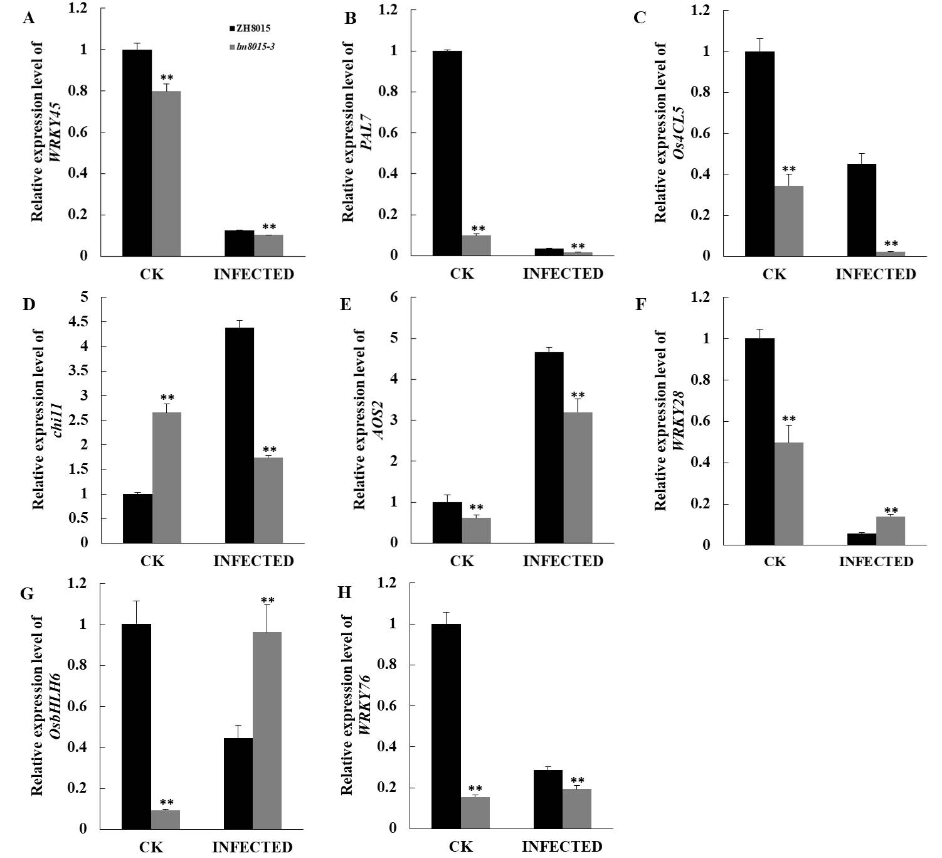
Fig S1 Relative expression analysis of defense genes of lm8015-3 after inoculation at 72 h
A-H: The relative expression analysis of different defense genes of three-week-old ZH8015 and lm8015-3 after inoculation at 72 h. "CK" stands for the leaves without the injection of M. Oryzae; "INJECTED" stands for the leaves with the injection of M. Oryzae. **Significant at P<0.01(t-test); Error bars represent SD (n=3).

