Supplementary Figure 1. The patient enrollment process of the studied cohort.
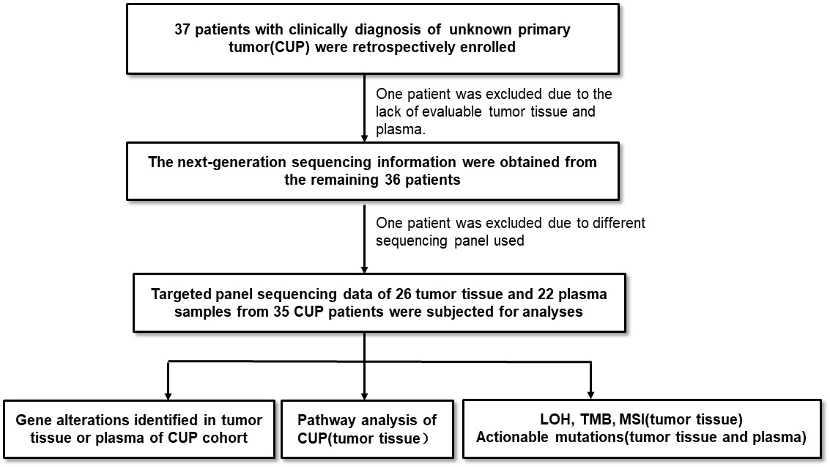
Supplementary Figure 2. Mutation plot of patients with unknown primary using somatic mutations detected in plasma samples. Top mutated genes were shown. The gene alteration types were indicated by the color on the right.
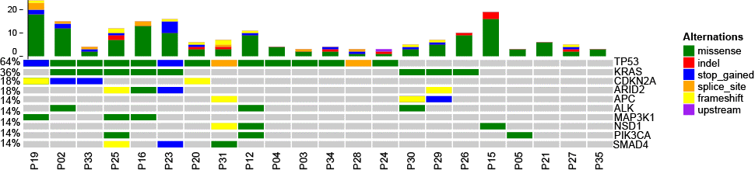

Supplementary Figure 3. The ratio of CUP, ESCC, lung cancer, colorectal cancer patients with different pathway gene alterations. (A) the ratio of CUP, ESCC, lung cancer, colorectal cancer patients with TP53 and RTK-RAS pathway gene alterations. (B) the ratio of CUP, ESCC, lung cancer, colorectal cancer patients with HRR pathway gene alterations. WT: wild type; MUT: mutated ESCC: Esophageal squamous cell cancer. ns: not significant; ***: p˂0.001; * p˂0.05. p value was calculated using Fisher’s exact test.

