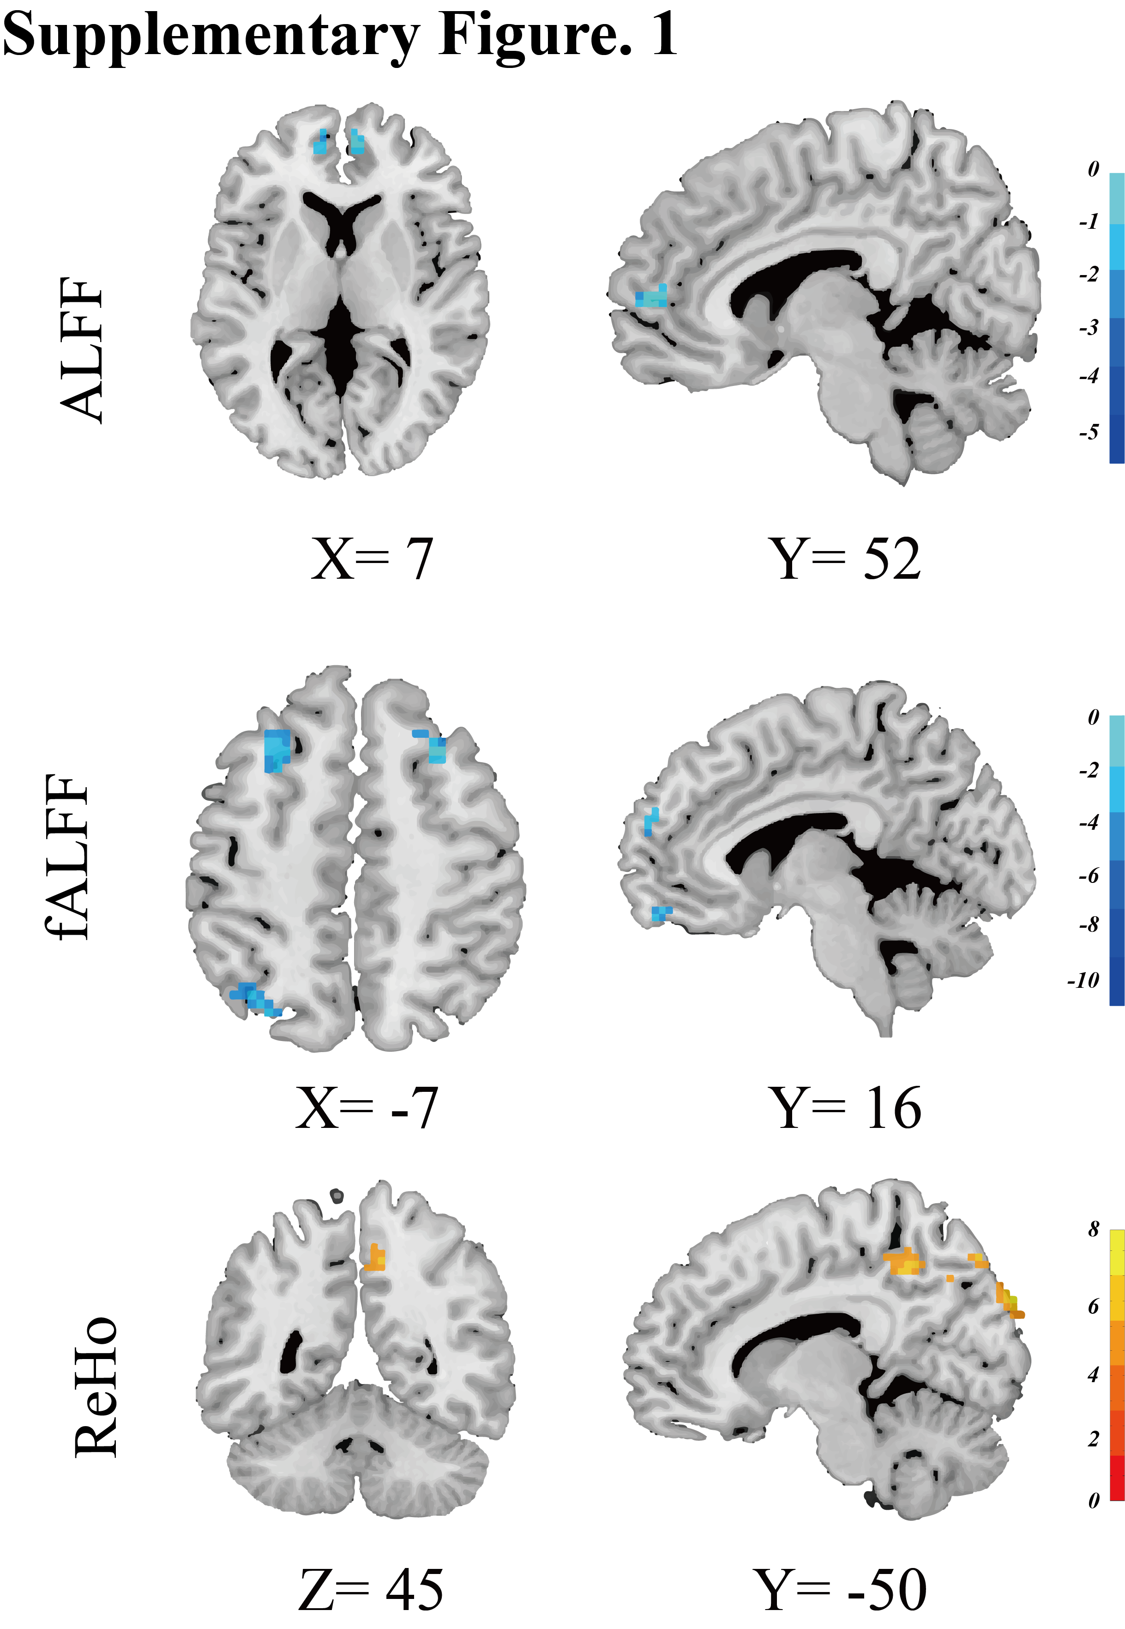Supplementary Material

Legends for Supplementary Figure. 1：
Supplementary Figure. 1 shows the chronic insomnia group show lower ALFF and fALFF in prefrontal regions and higher ReHo in the Precuneus. Abbreviations: ALF, Amplitude of Low frequency fluctuation; fALFF, Fractional ALFF; ReHo, Regional homogeneity.

