Sample  Day/night sampling and location | Coconut database ID of obtained compound | Compound name and  molecular formula | Chemical structure of compound | Molecular weight of obtained compound  [Da] | Bioactivity predictions of obtained compound  (Predicted with Pass) | Possible contribution of compound in thalassotherapy treatment with Nin peloid mud
Day (S4, S8)  Night (S4) | CNP0283907 | N-(tridecan-6-yl)acetamide  C15H31NO | 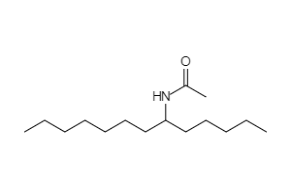 | 241,4133100 | GST A substrate | Alpha-N-acetylglucosaminidase inhibitor | 5 Hydroxytryptamine release stimulant | TNF expression inhibitor | Interleukin agonist | FMO1 substrate | Superoxide dismutase inhibitor | Histamine release inhibitor | Cardiovascular analeptic | Calpain 2 inhibitor | Antiarthritic | Cardiovascular system  Immune response stimulation  Musculoskeletal system  Pain relieves
Day (S4, S8)  Night (S4, S8) | CNP0429766 | Not assigned  C16H31NO | 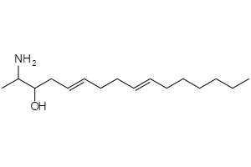 | 253,4240459 | GST A substrate | Caspase 9 stimulant | CYP2C9 substrate | FMO1 substrate | Hypolipemic | CYP1A2 substrate | Cardioprotectant | CYP2C19 substrate | Cholesterol antagonist | Cardiovascular system
Day (S6, S8)  Night (S8) | CNP0079400 | 3-{[hydroxy(octyl)imino]amino}-4-methoxybutan-2-ol  C13H30N2O3 | 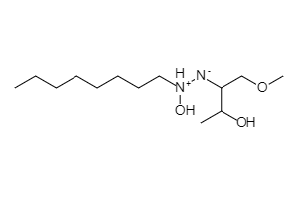 | 262,3894105 | Antifungal | GST A substrate | Antibacterial | Infections
Day (S6, S8)  Night (S4, S8) | CNP0395919 | 2-(octa-2,5-dien-1-yl)-3-octyloxirane  C18H32O | 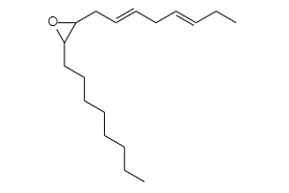 | 264,4467552 | Angiogenesis stimulant | Antiinflammatory | Angiogenesis inhibitor | Cardioprotectant | Platelet adhesion inhibitor | Vasodilator | Atherosclerosis treatment | Antithrombotic | Lipoprotein disorders treatment | Apoptosis agonist | Hypolipemic | Caspase 9 stimulant | Platelet aggregation inhibitor | Peptidyl-prolyl cis-trans isomerase inhibitor | Antiglaucomic | Cyclophilin D inhibitor | Antidiabetic | CYP1A2 substrate | GST A substrate | NOS3 expression inhibitor | Antipsoriatic | Interleukin 4 antagonist | Proliferative diseases treatment | TNF expression inhibitor | Cholesterol antagonist | Hepatic disorders treatment | Antifungal | Antiallergic | Antidiabetic symptomatic | Antiarthritic | Antipruritic, allergic | Lipoxygenase inhibitor | Septic shock treatment | Antidiabetic (type 2) | Antihypertriglyceridemic | Transcription factor NF kappa B inhibitor | Antibacterial | Immunosuppressant | Electron transport complex I inhibitor | FMO1 substrate | Blood sugar level control  Cardiovascular system  Immune response stimulation  Infections  Musculoskeletal system  Pain relieves
Day (S8)  Night (S4) | CNP0262292 | 2-aminooctadeca-5,9,12,15-tetraen-3-ol  C18H31NO | 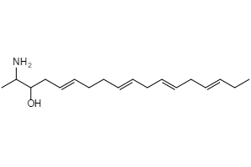 | 277,4455176 | GST A substrate | Caspase 3 stimulant | 5 Hydroxytryptamine release stimulant | TNF expression inhibitor | Caspase 9 stimulant | Antiinflammatory | NOS3 expression inhibitor | Atherosclerosis treatment | Antithrombotic | Apoptosis agonist | Radioprotector | Antidiabetic (type 2) | Cardioprotectant | Lipoprotein disorders treatment | UGT1A6 substrate | Cholesterol antagonist | Antiglaucomic | Hepatic disorders treatment | Cyclophilin D inhibitor | Antidiabetic | UDP-glucuronosyltransferase substrate | Immunostimulant | Peptidyl-prolyl cis-trans isomerase inhibitor | UGT1A9 substrate | UGT2B4 substrate | Apoptosis antagonist | Antifungal | GST P1-1 substrate | Vasodilator | Antipruritic, allergic | Antineoplastic (liver cancer) | Antineoplastic (renal cancer) | Antihypertriglyceridemic | Vasodilator, peripheral | FMO1 substrate | CYP3A4 substrate | Aldehyde oxidase inhibitor | CYP2D6 substrate | UGT1A4 substrate | Spasmolytic | Transcription factor NF kappa B inhibitor | Blood sugar level control  Cancer treatment  Cardiovascular system  Musculoskeletal system  Pain relieves  Radioprotection of tissues
Day (S4, S6, S8)  Night (S4, S6, S8) | CNP0427946 | Not assigned  C18H33NO | 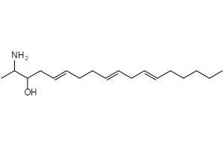 | 279,4613992 | Antiinflammatory | Atherosclerosis treatment | Prostate cancer treatment | Cachexia treatment | Andropause treatment | Respiratory analeptic | Antipsoriatic | CYP2C19 substrate | Immunosuppressant | Apoptosis agonist | Autoimmune disorders treatment | Transcription factor NF kappa B inhibitor | Antiarthritic | UGT1A4 substrate | Analeptic | CYP2C9 substrate | Neurodegenerative diseases treatment | Chemoprotective | TNF expression inhibitor | UGT1A1 substrate | Antihelmintic | Antiparasitic | Analgesic | AR expression inhibitor | Proliferative diseases treatment | Antifungal | Chemopreventive | Antineoplastic (pancreatic cancer) | Antithrombotic | UDP-glucuronosyltransferase substrate | Prostatic (benign) hyperplasia treatment | ICAM1 expression inhibitor | Antiacne | Hepatic disorders treatment | UGT2B7 substrate | Hypogonadism treatment | Antibacterial | Cancer treatment  Infections  Musculoskeletal system  Pain relieves
Night (S4, S6) | CNP0182087 | 3,7,11,15-tetramethylhexadeca-1,4,6,10,14-pentaen-3-ol  C20H32O | 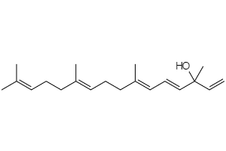 | 288,4682270 | TNF expression inhibitor | Antiinflammatory | Apoptosis agonist | AR expression inhibitor | Antipsoriatic | Caspase 9 stimulant | GST A substrate | UDP-glucuronosyltransferase substrate | Antihypercholesterolemic | Antineoplastic (lung cancer) | Antioxidant | Radioprotector | Prostate cancer treatment | Chemopreventive | CYP2C19 substrate | Lipoprotein disorders treatment | Antineoplastic (brain cancer) | Antiparasitic | Antihelmintic | Hypolipemic | Proliferative diseases treatment | Antifungal | Chemoprotective | Melanin inhibitor | Antiulcerative | Antineoplastic (breast cancer) | Atherosclerosis treatment | Caspase 3 stimulant | Angiogenesis inhibitor | Immunosuppressant | Vasodilator, peripheral | Hepatic disorders treatment | Bone diseases treatment | Antibacterial | Nitric oxide antagonist | Antineoplastic (carcinoma) | CYP2D6 substrate | Vasodilator | Antidiabetic | Cyclophilin D inhibitor | Antiosteoporotic | NOS2 expression inhibitor | Peptidyl-prolyl cis-trans isomerase inhibitor | Antiacne | Lipid peroxidase inhibitor | Transcription factor NF kappa B inhibitor | Antihypertriglyceridemic | Skin whitener | Antithrombotic | Antineoplastic (liver cancer) | Antineoplastic (pancreatic cancer) | UGT1A1 substrate | Alcohol dehydrogenase substrate | Histamine release inhibitor | Antileukemic | Spasmolytic | Immunomodulator | UGT1A9 substrate | 15-Lipoxygenase inhibitor | Blood sugar level control  Cancer treatment  Cardiovascular system  Infections  Musculoskeletal system  Pain relieves  Radioprotection of tissues  Skin diseases
Night (S6) | CNP0138573 | (3R)-3-Hydroxyretinal  C20H28O2 | 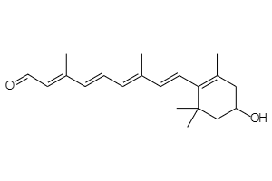 | 300,4358689 | CYP2C19 substrate | CYP1A2 substrate | Antiacne | AR expression inhibitor | GST A substrate | Radioprotector | Antipsoriatic | CYP3A4 substrate | Alcohol dehydrogenase substrate | Transcription factor NF kappa B inhibitor | Glutathione S-transferase substrate | Apoptosis agonist | CYP2C9 substrate | TNF expression inhibitor | Chemoprotective | Chemopreventive | Proliferative diseases treatment | Skin whitener | Retinoic acid receptor agonist | Bone diseases treatment | ABCA1 expression enhancer | CYP2D6 substrate | Antiosteoporotic | Prostate cancer treatment | Antiinflammatory | UDP-glucuronosyltransferase substrate | Caspase 3 stimulant | Liver fibrosis treatment | Antioxidant | Aldehyde dehydrogenase substrate | Ornithine decarboxylase inhibitor | Antipruritic, allergic | Macular degeneration treatment | Antibacterial | Retinoic acid beta receptor agonist | Antileukemic | Antineoplastic (breast cancer) | Hepatic disorders treatment | Lipid peroxidase inhibitor | Antineoplastic (brain cancer) | Neurotrophic factor | Antineoplastic (solid tumors) | Nitric oxide antagonist | UGT1A1 substrate | Immunosuppressant | Keratolytic | Immunostimulant | Antifungal | ICAM1 expression inhibitor | Retinoic acid receptor antagonist | UGT2B7 substrate | Cancer treatment  Infections  Musculoskeletal system  Pain relieves  Radioprotection of tissues  Skin diseases
Day (S6, S8)  Night (S4, S8) | CNP0178821 | 2-methyl-6-(4-methylphenyl)hept-2-en-1-yl 3-methylbutanoate  C20H30O2 | 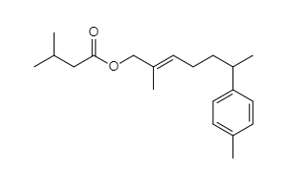 | 302,4517504 | Cholesterol antagonist | Antihypercholesterolemic | TNF expression inhibitor | Antiinflammatory | Antipruritic, allergic | Immunosuppressant | Apoptosis antagonist | Non-steroidal antiinflammatory agent | Hypolipemic | Transcription factor NF kappa B inhibitor | Musculoskeletal system  Pain relieves
Day (S4, S6)  Night (S4, S6, S8) | CNP0419873 | 18-hydroxyoctadeca-7,9,16-trien-11,13-diyn-4-yl acetate  C20H26O3 | 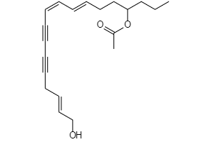 | 314,4193923 | Antiinflammatory | Apoptosis agonist | GST A substrate | Hypolipemic | Caspase 9 stimulant | Alcohol dehydrogenase substrate | TNF expression inhibitor | CYP3A4 substrate | Antifungal | Antipruritic, allergic | Caspase 3 stimulant | Cholesterol antagonist | Nitric oxide antagonist | Antibacterial | Antiulcerative | Antihypercholesterolemic | Lipoprotein disorders treatment | Apoptosis antagonist | Antiprotozoal (Leishmania) | Antiglaucomic | Antithrombotic | Immunosuppressant | Radiosensitizer | Immunostimulant | Bone diseases treatment | Hair growth stimulant | Vasodilator, peripheral | Cardiovascular system  Infections  Musculoskeletal system  Pain relieves
Day (S8) | CNP0278063 | 9-(acetyloxy)octadeca-10,16-dien-12,14-diynoic acid  C20H26O4 | 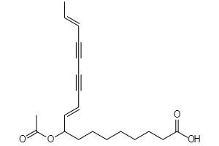 | 330,4187972 | GST A substrate | Antiinflammatory | Hypolipemic | Antihypercholesterolemic | TNF expression inhibitor | CYP3A4 substrate | Antifungal | Apoptosis agonist | Cholesterol antagonist | Apoptosis antagonist | Antipruritic, allergic | Immunosuppressant | Analeptic | Antiallergic | Nitric oxide antagonist | Antibacterial | Antithrombotic | Caspase 9 stimulant | Interleukin 2 agonist | Immunostimulant | Antiglaucomic | Lipoprotein disorders treatment | Caspase 3 stimulant | Peptidyl-prolyl cis-trans isomerase inhibitor | Respiratory analeptic | Immune response stimulation  Infections  Musculoskeletal system  Pain relieves
Night (S6) | CNP0431115 | Not assigned  C20H30O4 | 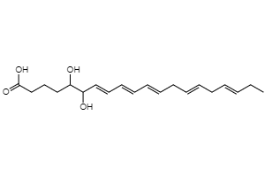 | 334,4505603 | Antiprotozoal (Plasmodium) | Antiprotozoal | Infections
Day (S4, S6, S8)  Night (S4) | CNP0184818 | 1,2-O-(2'-Hydroxyoctadecyl)-Glycerol  C21H42O4 | 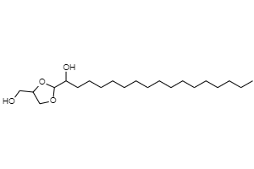 | 358,5565852 | Caspase 9 stimulant | CYP3A4 substrate | Spasmolytic | Vasodilator, peripheral | 5 Hydroxytryptamine release stimulant | Antipruritic, allergic | TNF expression inhibitor | Antifungal | GST T1-1 substrate | Radiosensitizer | Antithrombotic | DNA synthesis inhibitor | Alpha-N-acetylglucosaminidase inhibitor | Cardiovascular system  Radioprotection of tissues
Day (S4) | CNP0322322 | 2,3-dihydroxypropyl tricosa-8,11,14,17,20-pentaenoate  C26H42O4 | 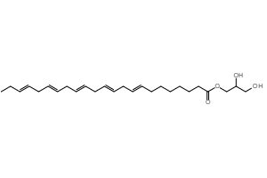 | 418,6102647 | Cholesterol antagonist | Antihypercholesterolemic | Antiinflammatory | GST A substrate | TNF expression inhibitor | Radioprotector | Antithrombotic | Spasmolytic | Antihyperlipoproteinemic | Vasodilator, peripheral | Lipoprotein disorders treatment | Antidiabetic | Cyclophilin D inhibitor | Atherosclerosis treatment | Caspase 9 stimulant | Peptidyl-prolyl cis-trans isomerase inhibitor | NOS3 expression inhibitor | Glutathione S-transferase substrate | Hypolipemic | Antiglaucomic | Antipyretic | Antiseptic | Antidiabetic (type 2) | Hepatic disorders treatment | Vasodilator | Antipruritic, allergic | Histamine release inhibitor | Phospholipase A2 inhibitor | Antihypertriglyceridemic | VCAM1 expression inhibitor | Non-steroidal antiinflammatory agent | Immunostimulant | GST P1-1 substrate | Hair growth stimulant | Cardioprotectant | Antipsoriatic | Radiosensitizer | Endocannabinoid uptake inhibitor | Apoptosis antagonist | Respiratory analeptic | Apoptosis agonist | Antiulcerative | Analeptic | Antidiabetic symptomatic | Diabetic retinopathy treatment | Antiallergic | UGT2B4 substrate | UGT1A9 substrate | Metabolic disease treatment | Immunosuppressant | UGT1A3 substrate | Mediator release inhibitor | Skin whitener | Platelet aggregation inhibitor | Alpha-N-acetylglucosaminidase inhibitor | CYP3A4 substrate | Antihypoxic | Vasodilator, coronary | Blood sugar level control  Cardiovascular system  Musculoskeletal system  Pain relieves  Radioprotection of tissues  Skin diseases
Day (S6) | CNP0163971 | Didrovaltrate  C22H32O8 | 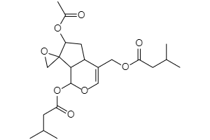 | 424,4855333 | Apoptosis agonist | Antineoplastic (pancreatic cancer) | Antiinflammatory | Antineoplastic (lung cancer) | Antineoplastic (melanoma) | Transcription factor NF kappa B inhibitor | Antiprotozoal | Caspase 9 stimulant | Cholesterol antagonist | Nitric oxide antagonist | Hepatic disorders treatment | Apoptosis antagonist | Antineoplastic (carcinoma) | Antiprotozoal (Plasmodium) | Antiprotozoal (Leishmania) | Immunosuppressant | Antibacterial | Antineoplastic (squamous cell carcinoma) | Antineoplastic (ovarian cancer) | Antineoplastic (breast cancer) | Antiviral (HIV) | Antineoplastic (colorectal cancer) | Cancer treatment  Infections  Musculoskeletal system  Pain relieves
Day (S6, S8) | CNP0169973 | triaconta-3,15,27-trien-1,29-diyn-5-ol  C30H48O | 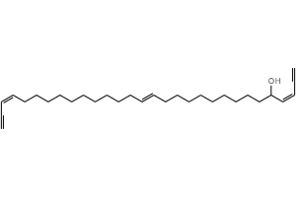 | 424,7026380 | GST A substrate | Antiinflammatory | CYP1A2 substrate | Hypolipemic | Caspase 9 stimulant | CYP3A4 substrate | Antiglaucomic | GST P1-1 substrate | Apoptosis agonist | CYP2C9 substrate | Antifungal | Alcohol dehydrogenase substrate | UGT1A4 substrate | Apoptosis antagonist | Antiulcerative | Alcohol oxidase inhibitor | NOS3 expression inhibitor | UDP-glucuronosyltransferase substrate | Antithrombotic | Vasodilator | Immunosuppressant | UGT2B4 substrate | Cholesterol antagonist | Nitric oxide antagonist | UGT1A9 substrate | Tumour necrosis factor alpha release inhibitor | TNF expression inhibitor | CYP2C19 substrate | Aldehyde oxidase inhibitor | Cardiovascular system  Musculoskeletal system  Pain relieves
Night (S4) | CNP0370344 | 12-cyclohexyl-3-[(1-phenylcyclopentyl)methyl]dodec-9-enoic acid  C30H46O2 | 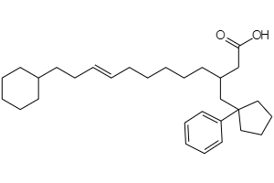 | 438,6861614 | Antihypercholesterolemic | GST A substrate | Antiinflammatory | Cholesterol antagonist | Vasodilator, peripheral | TNF expression inhibitor | Antithrombotic | Antiallergic | Antipruritic, allergic | Immunosuppressant | NOS3 expression inhibitor | Lipoprotein disorders treatment | Antiulcerative | Hypolipemic | Hair growth stimulant | Spasmolytic | Apoptosis agonist | Caspase 9 stimulant | Cardiovascular system  Musculoskeletal system  Pain relieves
Day (S6)  Night (S8) | CNP0213970 | triaconta-4,15,26-trien-1,29-diyne-3,28-diol  C30H48O2 | 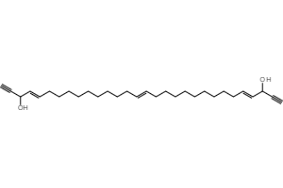 | 440,7020429 | GST A substrate | Antiinflammatory | Antineoplastic (brain cancer) | Alcohol oxidase inhibitor | Apoptosis agonist | Aldehyde oxidase inhibitor | Antileukemic | Neurotrophic factor | GST P1-1 substrate | CYP1A2 substrate | Antidiabetic (type 2) | NOS3 expression inhibitor | Caspase 9 stimulant | CYP3A4 substrate | Antifungal | Nitric oxide antagonist | Bone diseases treatment | GABA C receptor rho-3 antagonist | Antiosteoporotic | Antiglaucomic | Antiparasitic | Apoptosis antagonist | Tumour necrosis factor alpha release inhibitor | CYP2C19 substrate | UGT2B4 substrate | CYP2C9 substrate | Blood sugar level control  Cancer treatment  Musculoskeletal system  Pain relieves
Day (S8) | CNP0350451 | 6-[5-(carbamoylamino)-2-[2-(7-methoxy-4,8-dimethyl-2-oxo-2H-chromen-3-yl)acetamido]pentanamido]hexanoic acid  C26H36N4O8 | 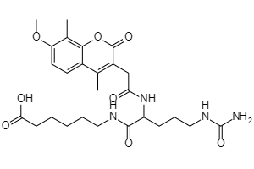 | 532,5870527 | Radioprotector | Antithrombotic | GST A substrate | Histamine release inhibitor | Radioprotection of tissues
Night (S6) | CNP0131985 | 3-(19-{2-hydroxy-2,6,6-trimethyl-7-oxabicyclo[2.2.1]heptan-1-yl}-4,8,13,17-tetramethylnonadeca-2,4,6,8,10,12,14,16,18-nonaenoyl)-3,4,4-trimethylcyclopentan-1-one  C40H54O4 | 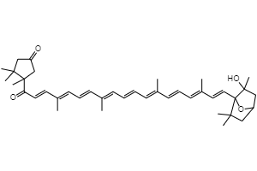 | 598,8558563 | Antipsoriatic | Antiinflammatory | Apoptosis agonist | UDP-glucuronosyltransferase substrate | AR expression inhibitor | Caspase 9 stimulant | Antiacne | Antifungal | Antioxidant | Nitric oxide antagonist | Retinoic acid receptor agonist | TNF expression inhibitor | Chemopreventive | Immunosuppressant | Melanin inhibitor | Transcription factor NF kappa B inhibitor | Antibacterial | Antineoplastic (brain cancer) | Chemoprotective | Antiobesity | Cancer treatment  Infections  Musculoskeletal system  Pain relieves  Skin diseases
Night (S8) | CNP0171673 | 4-Ketomyxol  C40H54O4 | 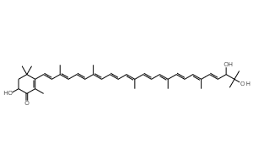 | 598,8558563 | Lipid peroxidase inhibitor | TNF expression inhibitor | Antiinflammatory | UDP-glucuronosyltransferase substrate | Antipsoriatic | Apoptosis agonist | AR expression inhibitor | Radioprotector | GST A substrate | CYP3A4 substrate | CYP1A2 substrate | Antioxidant | CYP2C19 substrate | Transcription factor NF kappa B inhibitor | Glutathione S-transferase substrate | Chemoprotective | Antiacne | Proliferative diseases treatment | Chemopreventive | UGT1A3 substrate | Bone diseases treatment | Skin whitener | Prostate cancer treatment | Hepatic disorders treatment | Caspase 3 stimulant | Antibacterial | Antiulcerative | CYP2C9 substrate | Antipruritic, allergic | Retinoic acid receptor agonist | Antineoplastic (solid tumors) | Nitric oxide antagonist | Antileukemic | Antineoplastic (breast cancer) | UGT2B7 substrate | Antiosteoporotic | Antineoplastic (brain cancer) | Immunosuppressant | ABCA1 expression enhancer | Antifungal | UGT1A1 substrate | Alcohol dehydrogenase substrate | Keratolytic | Caspase 9 stimulant | Liver fibrosis treatment | CYP2D6 substrate | Antineoplastic (lung cancer) | ICAM1 expression inhibitor | Immunostimulant | Cyclophilin D inhibitor | Antidiabetic | Blood sugar level control  Cancer treatment  Infections  Musculoskeletal system  Pain relieves  Radioprotection of tissues  Skin diseases
Day (S4) | CNP0217594 | 4-(18-{4-hydroxy-2,2,6-trimethyl-7-oxabicyclo[4.1.0]heptan-1-yl}-3,7,12,16-tetramethyl-17-oxooctadeca-3,5,7,9,11,13,15-heptaen-1-yn-1-yl)-3,5,5-trimethylcyclohex-3-en-1-yl acetate  C42H56O5 | 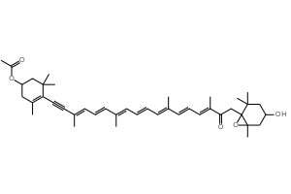 | 640,8926145 | Antiobesity | Chemopreventive | Apoptosis agonist | Antipsoriatic | Proliferative diseases treatment | Antiacne | Transcription factor NF kappa B inhibitor | Antioxidant | Free radical scavenger | AR expression inhibitor | UDP-glucuronosyltransferase substrate | Lipid peroxidase inhibitor | Retinoic acid receptor agonist | Nitric oxide antagonist | Antiinflammatory | Prostate cancer treatment | Chemoprotective | DNA directed RNA polymerase inhibitor | Cancer treatment  Musculoskeletal system  Pain relieves
Day (S6, S8)  Night (S4, S6, S8) | CNP0254150 | 2-(hydroxymethyl)-6-[(3,27,29-trihydroxytriacontyl)oxy]oxane-3,4,5-triol  C36H72O9 | 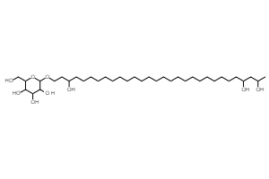 | 648,9528709 | Mannosidase inhibitor | Antihypercholesterolemic | Antidiabetic | Cyclophilin D inhibitor | Cholesterol antagonist | Peptidyl-prolyl cis-trans isomerase inhibitor | Radioprotector | Amylase inhibitor | TNF expression inhibitor | 5 Hydroxytryptamine release stimulant | Hypolipemic | Interleukin agonist | Antiinflammatory | Vasodilator, peripheral | Immunomodulator | Alpha-N-acetylglucosaminidase inhibitor | Angiogenesis stimulant | Antithrombotic | Immunostimulant | Respiratory analeptic | Analeptic | CYP3A4 substrate | Vasodilator, coronary | Caspase 9 stimulant | Antibacterial | Cardioprotectant | Aldose reductase substrate | Alpha-mannosidase inhibitor | Guanylate cyclase inhibitor | Anesthetic general | Antihypertriglyceridemic | NOS3 expression inhibitor | VCAM1 expression inhibitor | Apoptosis agonist | Lipoprotein disorders treatment | Antioxidant | Skin whitener | Transcription factor NF kappa B inhibitor | Spasmolytic | NOS2 expression inhibitor | Antidiabetic (type 2) | Interleukin 2 agonist | Hepatic disorders treatment | Apoptosis antagonist | Antifungal | Tumour necrosis factor alpha release inhibitor | Proliferative diseases treatment | Chemoprotective | Vascular (periferal) disease treatment | GST A substrate | Nitric oxide antagonist | Immunosuppressant | Antipruritic, allergic | UDP-glucuronosyltransferase substrate | Vasodilator | Lipid peroxidase inhibitor | ICAM1 expression inhibitor | Glutathione S-transferase substrate | UGT1A9 substrate | Antihypoxic | Interferon gamma antagonist | Atherosclerosis treatment | UGT2B4 substrate | Antiparasitic | Antineoplastic, alkylator | Triose-phosphate isomerase inhibitor | Chemopreventive | Expectorant | Cyclic AMP phosphodiesterase inhibitor | Antidiabetic (type 1) | NADH dehydrogenase inhibitor | DNA synthesis inhibitor | Cytostatic | Antidiabetic symptomatic | Alkylator | Blood sugar level control  Cancer treatment  Cardiovascular system  Immune response stimulation  Infections  Radioprotection of tissues  Skin diseases

Supplementary Table 3. List of bioactive compounds identified from day/night samples from three Nin peloid mud locations (S4, S6, S8) and their respective bioactivity prediction. Nin peloid mud extracts were analysed using LC-QTOF-MS/MS. Obtained spectra from experimental samples were searched against chemical structures of known natural products deposited in the most recent Collection of Open Natural Products (COCONUT) database in order to identify matching variants.

