Supplementary Materials

Sup. 1. Soil properties used in this study
Term | Amount
Soil texture | Clay Loam
pH | 7.43±0.03
EC (μs/cm) | 221.6±4.7
SOC (g/kg) | 11.44±0.78
Available Nitrogen (mg/kg) | 19.5±1.5
Available Phosphorus (mg/kg) | 13.2±0.4
Exchangeable K (mg/kg) | 487.78±11.15
Exchangeable Na (mg/kg) | 38.0±4.0
Zn(mg/kg) | 2303±139
Pb(mg/kg) | 1262±37

Sup. 2. Growth rate of SHA302 strain at (a); different salinity, (b): temperatures and, (c): pH at 620 nm

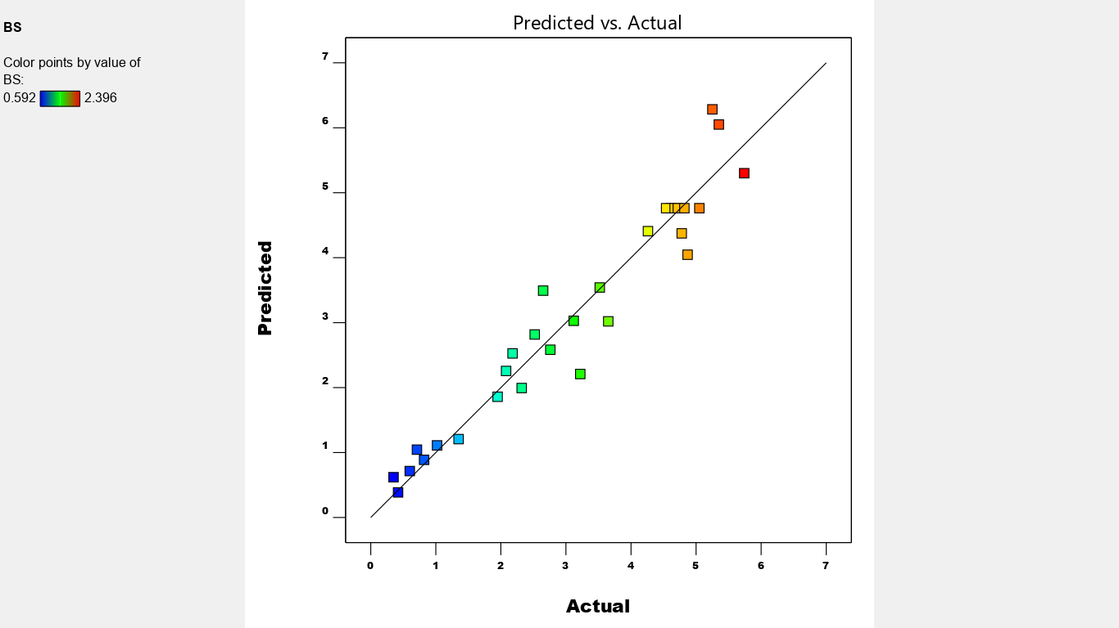
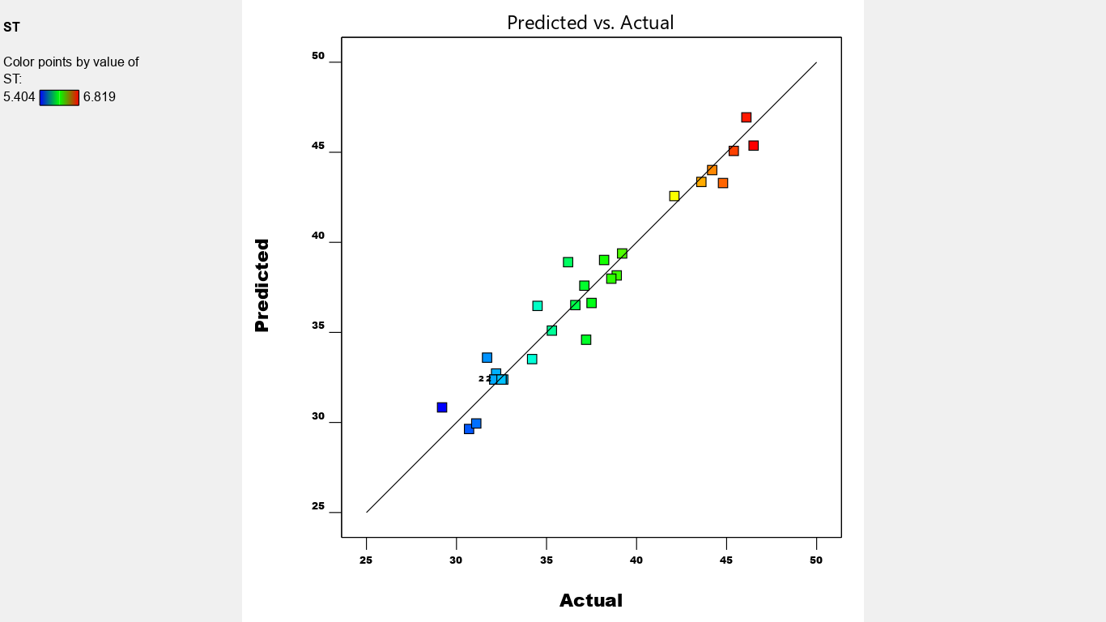
(b)
(a)
Sup. 3. Predicted values versus the actual values of the two response variables (a); Surface Tension, (b): produced biosurfactant from SHA302 strain.

