Supplementary Apendix
Point mutations in the FLT3-ITD region are rare but recurrent alterations in adult AML and associated with concomitant KMT2A-PTD
(Stasik et al.)

Supplementary Methods
DNA preparation and targeted sequencing using NGS
Profiling of FLT3 mutational status and associated co-mutations was performed by targeted resequencing using the TruSight Myeloid assay (Illumina) covering 54 genes frequently mutated in AML: BCOR, BCORL1, CDKN2A, CEBPA, CUX1, DNMT3A, ETV6, EZH2, IKZF1, KDM6A, PHF6, RAD21, RUNX1, STAG2, ZRSR2, ABL1, ASXL1, ATRX, BRAF, CALR, CBL, CBLB, CBLC, CDKN2A, CSF3R, FBXW7, FLT3, GATA1, GATA2, GNAS, HRAS, IDH1, IDH2, JAK2, JAK3, KIT, KRAS, KMT2A, MPL, MYD88, NOTCH1, NPM1, NRAS, PDGFRA, PTEN, PTPN11, SETBP1, SF3B1, SMC1A, SMC3, SRSF2, TET2, TP53, U2AF1 and WT1. For each reaction, 50 ng of genomic DNA was used. Library preparation was done as recommended by the manufacturer (TruSight Myeloid Sequencing Panel Reference Guide 15054779 v02, Illumina). Samples were sequenced paired-end (150bp PE) on a NextSeq NGS-instrument (Illumina). Sequence data alignment of demultiplexed FastQ files, variant calling and filtering was done using the Sequence Pilot software package (JSI medical systems GmbH, Ettenheim, Germany) with default settings and a 5% variant allele frequency (VAF) mutation calling cut-off. Human genome build HG19 was used as reference genome for mapping algorithms. In addition to NGS, conventional fragment analysis was used for profiling of FLT3-ITD mutations in all samples, as described previously [1]. Clonality was determined by the comparison of detected FLT3 allelic ratios with VAFs of co-mutated driver variants, as described previously [2].

Supplementary Data
Table S1: Characteristics of patients with FLT3 non-ITD mutations
Pat | Mutation |  | VAF [%] | Clonality | KMT2A-PTD |  | Karyotype |  |  | ELNRisk
1 | p.Val592Ala |  | 24 | Subclonal | mut |  | 46,XY |  |  | adv
2 | p.Leu576Gln |  | 12 | Dominant | mut |  | 46,XY,?t(X;11)(q2?4;q23),del(9)(q13q22) |  |  | adv
3 | p.Tyr591His |  | 50 | Dominant | wt |  | 46,XX |  |  | int
4 | p.Val592Asp |  | 41 | Subclonal | mut |  | 47,XX,+11 |  |  | int
5 | p.Val592Ala |  | 31 | Dominant | mut |  | 46,XX,t(2;15)(p1?3;q2?2) |  |  | int
6 | p.Tyr599Asn |  | 30 | Subclonal | wt |  | 46,XX |  |  | int
7 | p.Tyr572Cys |  | 10 | Subclonal | mut |  | 46,XX,+mar |  |  | int
8 | p.Val592Ala |  | 7 | Subclonal | wt |  | 46,XX,inv(16)(p13q22),t(16;16)(p13;q22) |  |  | fav
9 | p.Tyr572Cys |  | 19 | Subclonal | n.a. |  | 46,XX |  |  | int
10 | p.Gly583Ser |  | 30 | Subclonal | wt |  | n.a. |  |  | n.a.
11 | p.Tyr572Cys |  | 45 | Subclonal | n.a. |  | 46,XY,t(2;14)(q?2;q32) |  |  | adv
12 | p.Val592Ala |  | 28 | Subclonal | n.a. |  | n.a. |  |  | n.a.
13 | p.Val592Gly |  | 21 | Subclonal | wt |  | 47,XY,+8,t(9;11)(p22;q23) |  |  | int
14 | p.Leu576Pro |  | 30 | Subclonal | wt |  | n.a. |  |  | n.a.
15 | p.Val592Asp |  | 13 | Subclonal | mut |  | 46,XX |  |  | fav
16 | p.Glu598_Tyr599del |  | 38 | Dominant | wt |  | 47,XX,?+i(8)(q10) |  |  | adv
17 | p.Tyr591_Phe594del |  | 6 | Dominant | wt |  | 47,XX,+4 |  |  | int
18 | p.Asp600_Leu601del |  | 36 | Subclonal | wt |  | 47,XY,+4 |  |  | int
19 | p.Phe590_Val592del |  | 8 | Subclonal | wt |  | 46,XY,inv(16)(p13q22) |  |  | fav
Abbreviations: ELN (European LeukemiaNET), adv (adverse), int (intermediate), fav (favorable), OS (Overall survival), RFS (Relapse-free survival), CR (Complete Remission), n.a. (not available)

Table S2: Frequencies of co-mutated variants in AML patients
Gene mut, n/nval (%) |  | FLT3-ITD |  |  |  | FLT3 non-ITD |  | FLT3-ITD wt
ASXL1 |  | 11/324 (3) |  |  |  | 1/19 (5) |  | 111/1196 (9)
BCOR |  | 7/324 (2) |  |  |  | 0/19 (0) |  | 66/1196 (6)
BCORL1 |  | 12/324 (4) |  |  |  | 0/19 (0) |  | 44/1196 (4)
CEBPA |  | 40/313 (13) |  |  |  | 2/19 (11) |  | 211/1156 (18)
EZH2 |  | 7/324 (2) |  |  |  | 1/19 (5) |  | 51/1196 (4)
IDH1 |  | 34/324 (10) |  |  |  | 2/19 (11) |  | 105/1196 (9)
PTPN11 |  | 20/324 (6) |  |  |  | 3/19 (16) |  | 88/1196 (7)
RAD21 |  | 14/324 (4) |  |  |  | 2/19 (11) |  | 34/1196 (3)
RUNX1 |  | 30/324 (9) |  |  |  | 1/19 (5) |  | 106/1196 (9)
SRSF2 |  | 7/324 (2) |  |  |  | 1/19 (5) |  | 94/1196 (8)
TET2 |  | 59/324 (18) |  |  |  | 3/19 (16) |  | 231/1196 (19)
TP53 |  | 3/324 (1) |  |  |  | 1/19 (5) |  | 104/1196 (9)

Table S3: Results of the multivariable analysis
Parameter | OS (HR,  95%-CI) | P-value | RFS (HR,  95%-CI) | P-value | CR1 (OR,  95%-CI) | P-value
age (per 1 yr. increase) | 1.033  (1.027 to 1.038) | <0.001 | 1.023  (1.017 to 1.030) | <0.001 | 0.945  (0.935 to 0.955) | <0.001
sAML | 1.383  (1.135 to 1.686) | 0.001 | 1.184  (0.894 to 1.568) | 0.237 | 0.581  (0.395 to 0.854) | 0.006
tAML | 1.184  (0.832 to 1.685) | 0.348 | 0.84  (0.491 to 1.436) | 0.525 | 0.530  (0.272 to 1.032) | 0.062
ECOGCAT<1 | 0.595  (0.514 to 0.689) | <0.001 | 0.769  (0.635 to 0.930) | 0.007 | 2.193  (1.637 to 2.937) | <0.001
NPM1 mut | 0.564  (0.459 to 0.692) | <0.001 | 0.62  (0.493 to 0.779) | <0.001 | 2.839  (1.878 to 4.294) | <0.001
FLT3-ITD mut | 1.004  (0.782 to 1.287) | 0.975 | 1.177  (0.878 to 1.579) | 0.277 | 1.520  (0.907 to 2.547) | 0.112
FLT3 non-ITD | 0.621  (0.257 to 1.502) | 0.291 | 0.609  (0.227 to 1.637) | 0.326 | 1.823  (0.340 to 9.760) | 0.483
FLT3 non-ITD/ NPM1 mut | 1.886  (0.498 to 7.145) | 0.351 | 2.450  (0.601 to 9.999) | 0.211 | 0.649  (0.041 to 10.30) | 0.760
FLT3 non-ITD / KMT2A-PTD mut | 3.539  (0.231 to 54.12) | 0.364 | 6.646  (0.691 to 63.92) | 0.101 | 1.101  (0.048 to 20.83) | 0.910
Abbreviations: tAML (Therapy-related acute myeloid leukemia), sAML (Secondary acute myeloid leukemia), HR (Hazard ratio), 95%-CI (95% confidence interval), OR (Odds ratio)

Supplementary Figures
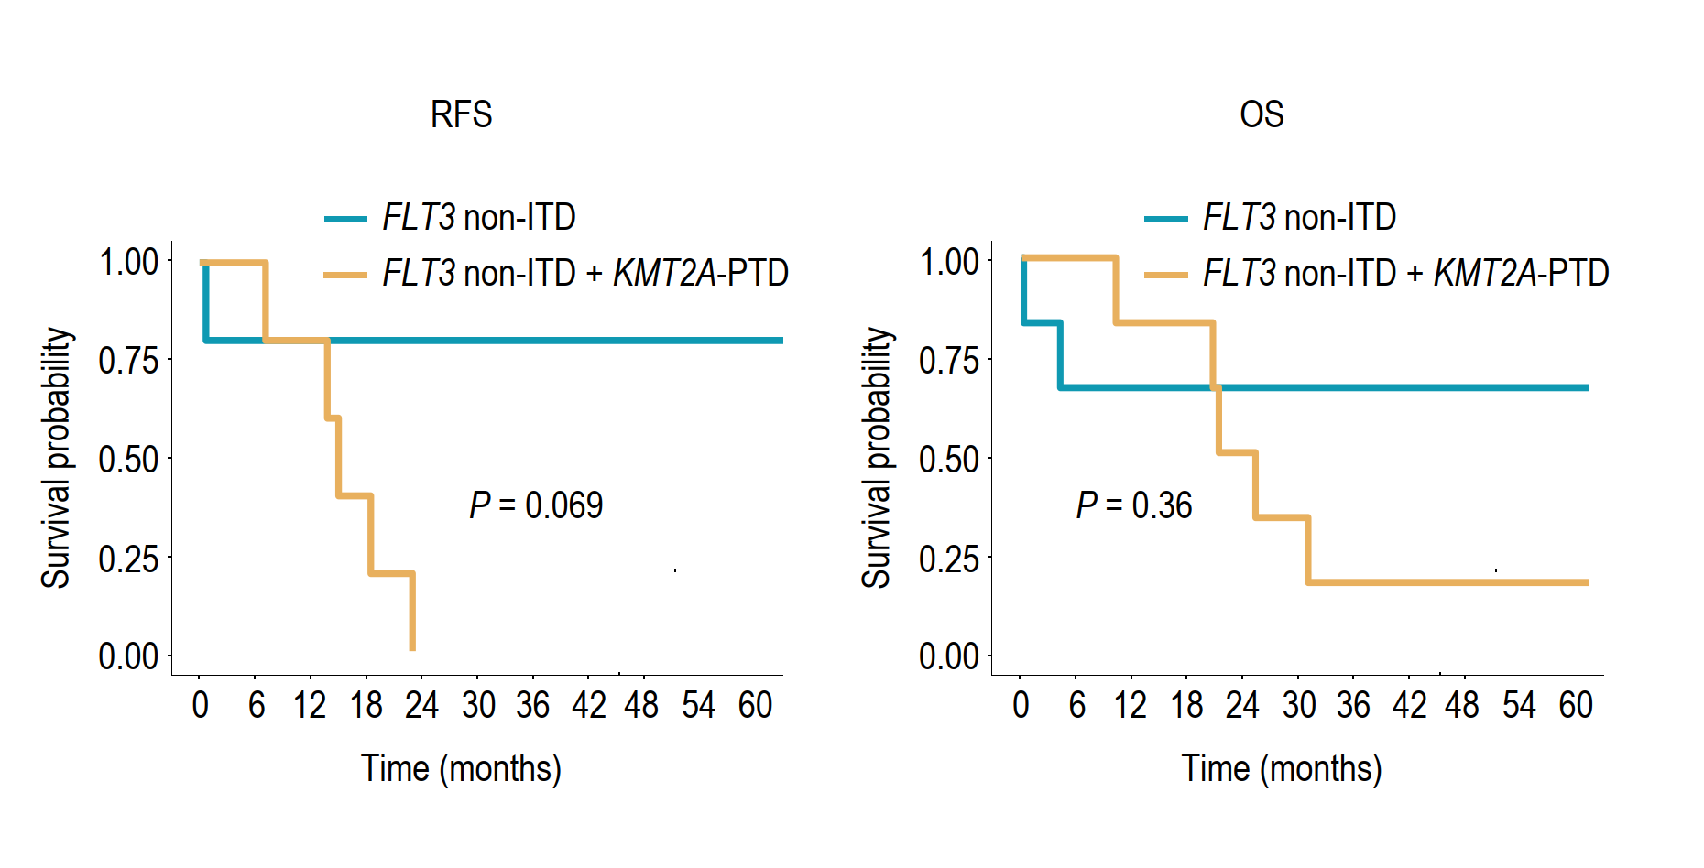
Figure S1
Kaplan-Meier analysis showing the probability of relapse-free survival (RFS) and overall survival (OS) for AML patients with FLT3 non-ITD mutations, with (yellow) or without (blue) concomitant KMT2A-PTD mutation.

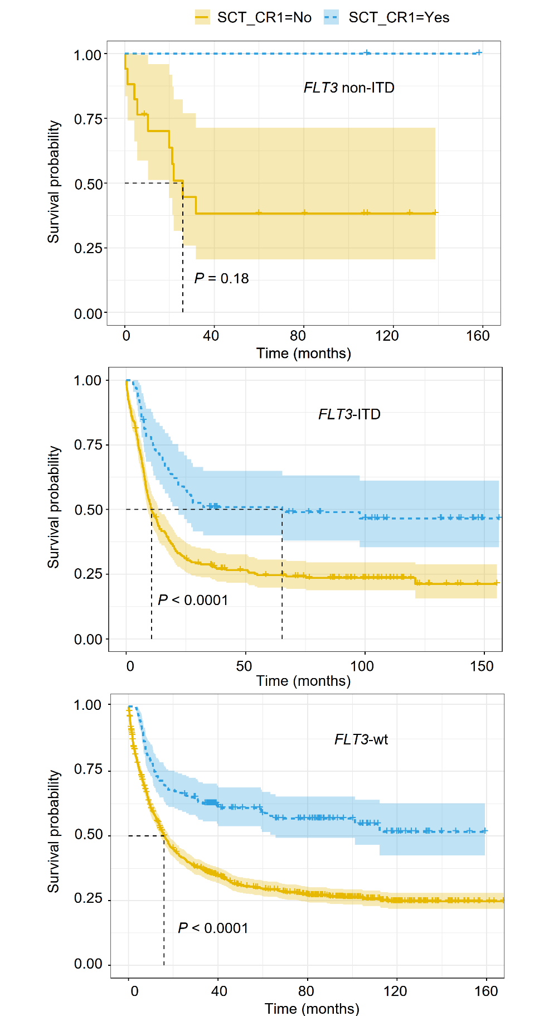
Figure S2
Kaplan-Meier analysis showing the probability of overall survival (OS) for AML patients with or without allogeneic haematopoietic stem cell transplantation (alloHSCT) in CR1. Data are shown for the groups (top to bottom) of FLT3 non-ITD, FLT3-ITD, and FLT3-wt patients.
Supplementary References
[1] Thiede C, Steudel C, Mohr B, Schaich M, Schäkel U, Platzbecker U, Wermke M, Bornhäuser M, Ritter M, Neubauer A, Ehninger G, Illmer T. Analysis of FLT3-activating mutations in 979 patients with acute myelogenous leukemia: association with FAB subtypes and identification of subgroups with poor prognosis. Blood. 2002 Jun 15;99(12):4326-35. doi: 10.1182/blood.v99.12.4326.
[2] Stasik S, Eckardt JN, Kramer M, Röllig C, Krämer A, Scholl S, Hochhaus A, Crysandt M, Brümmendorf TH, Naumann R, Steffen B, Kunzmann V, Einsele H, Schaich M, Burchert A, Neubauer A, Schäfer-Eckart K, Schliemann C, Krause S, Herbst R, Hänel M, Frickhofen N, Noppeney R, Kaiser U, Baldus CD, Kaufmann M, Rácil Z, Platzbecker U, Berdel WE, Mayer J, Serve H, Müller-Tidow C, Ehninger G, Bornhäuser M, Schetelig J, Middeke JM, Thiede C; Study Alliance Leukemia (SAL). Impact of PTPN11 mutations on clinical outcome analyzed in 1529 patients with acute myeloid leukemia. Blood Adv. 2021 Sep 14;5(17):3279-3289. doi: 10.1182/bloodadvances.2021004631.

