Supplementary Material

Appendix 1
Tables A1.1-A1.3 list, in chronological order, all years for which at least one approach indicated the occurrence of a drought event in the UK between 1800 and 2014. For the newspaper material, we provide the relative frequency of the word drought in each year. As the Broadsheet and the Tabloid Corpora cover the same time span, we list all years that emerged in at least one corpus, irrespective of the frequency of the word in the other corpus (Table A1.3). For the rainfall records, all years with a long-lasting extreme drought (SPI-12 < -2) in the EWP time series are included in the tables. This means there is at least one calendar month for which the 12-month SPI accumulation is < -2.
Supporting evidence of (shorter and sharper) droughts in the EWP SPI-3 time series is given in the second to last column in the tables, but only for years that are selected based on the corpus and EWP SPI-12 data, as described above. The last column, titled “Rainfall Record Comments”, only has an entry if the corpus (column 2) disagrees with the EWP SPI-12 and SPI-3 time series (columns 3-4). For these cases, the Comments column discusses the occurrence or absence of droughts in the M2020-EWP time series (for the period up to 1861) or in the more detailed regional HD time series (from 1862 onwards).
Orange colour denotes extreme drought (SPI < -2) and yellow colour denotes severe drought (SPI < -1.5). Years shaded in grey indicate false positives in the corpus data. Lack of reporting of a drought in the corpus material are shown in blue while purple indicates years for which the corpus material suggested the occurrence of a drought that was not captured by the precipitation metric used in this study.

Year | Frequency of drought in the 19th Century Corpus (per one million words) | All months with SPI-12 < -2 (orange) | Months with  SPI-3 < -2  (orange)  or if that is not reached then  SPI-3 < -1.5 (yellow) | Rainfall Record Comments
1803 | 1.4 | Sep-Nov | Sep-Oct | SPI-12 < -2 for Oct and SPI-3 < -2 for Sep-Oct in M2020-EWP
1805 | 0.0 | Nov | Nov-Dec | SPI-3 < -1.5 for Nov in M2020-EWP
1825 | 10.0 |  | Mar
1826 | 23.7 |  | Jun-Jul
1827 | 2.8 | Feb | Jan | SPI-12 < -1.5 for Feb and SPI-3 < -1.5 for Sep in M2020-EWP
1844 | 16.6 | Oct-Dec | Jan, May-Jun
1845 | 7.2 | Feb-Apr | Feb | No severe or extreme drought in M2020-EWP
1846 | 13.3 |  |  | Both SPI-12 and SPI-3 are positive throughout 1846 in M2020-EWP
1852 | 13.4 |  | Apr-May
1854 | 10.3 | Aug-Dec | Jan, Apr
1855 | 7.4 | Jan-Jun | Jan, Mar-Apr | No severe or extreme drought in M2020-EWP
1858 | 7.6 | Sep-Nov | Jan-Mar | SPI-12 < -2 for Apr & Oct and SPI-3 < -2 for Jan-Feb in M2020-EWP
1864 | 13.4 | Oct-Dec | Jan, Aug
1865 | 11.9 |  |  | No severe or extreme droughts in HD, but original EWP SPI-12 < 1.5 for Jan, Mar-Apr, Jun
1868 | 30.1 | Jul | Jul
1869 | 14.9 |  | Aug
1870 | 34.1 | Sep | Jun
1871 | 10.2 |  | Dec
1874 | 27.2 |  | Jan
1875 | 12.3 |  | Apr
1884 | 17.7 |  | Nov
1887 | 27.9 | Dec | Apr
1888 | 11.9 | Jan-Feb | Jan-Feb
1889 | 10.9 |  |  | SPI-12 < -1.5 for Dec in Wales and SPI-3 < -1.5 for Jul in Scotland and Feb in NE England, in HD
1893 | 43.9 | Oct | Jan, May-Jun
1894 | 14.1 |  |  | SPI-12 < -1.5 for Feb in Wales, E and W Midlands and SW England, and SPI-3 < -2 for Nov in Scotland, in HD
1895 | 21.3 |  | Jun
1896 | 22.2 |  | Feb, Jun
1898 | 21.8 | Sep | Mar, Sep
1899 | 16.1 |  |  | SPI-12 < -1.5 for most regions in southern and eastern England at some point, with SPI-12 < -2 throughout southern England in Sep, in HD.
Table A1.1: Years in which drought is mentioned most often in the 19th Century Drought Corpus and the corresponding rainfall record for each year. The table includes, but is not restricted to, all years with extreme drought (SPI-12 <-2) in the full EWP SPI-12 time series. EWP SPI-3 is only given for years selected based on either the corpus data or on EWP SPI-12 <-2. The month refers to the last month in the SPI-3 or SPI-12 accumulation. When the corpus and EWP data differ (columns 2-4), the Rainfall Record Comments column lists any supporting evidence from the M2020-EWP (up to 1861) and HD (from 1862 onwards) time series.

Year | Frequency of drought in the 20th Century Corpus (per one million words) | All  months with SPI-12 < -2 (orange) | Months with  SPI-3 < -2  (orange)  or if that is not reached then  SPI-3 < -1.5 (yellow) | Rainfall Record Comments
1901 | 7.1 |  |  | SPI-12 < -1.5 for Aug & Nov in E Anglia, and for Nov in SE England, in HD. SPI-3 < -1.5 for E Midlands in Nov, in HD.
1902 | 6.4 |  | Mar
1903 | 6.7 |  |  | No severe or extreme droughts in HD, but the original EWP SPI-12 has been continuously negative Jan 1901 – Jun 1903.
1905 | 4.8 | Feb | Jan | SPI-12 < -1.5 at some point for each region in England and Wales, and SPI-12 < -2 for May-Sep in NE England, Feb & May in W Midlands and Feb in Wales, in HD. Situation slightly less severe in the HD SPI-3 time series.
1911 | 11.7 |  | Sep
1912 | 6.7 |  |  | No severe or extreme droughts in the HD SPI-12 and SPI-3 time series.
1913 | 5.9 |  | Aug-Sep
1921 | 9.4 | Jul-Dec | Apr, Jun-Jul
1922 | 4.0 | Jan | Nov | The 1921 drought continues to be severe or extreme in early 1922 in Wales and south and central England in the HD SPI-12 time series. HD SPI-3 < -1.5 for Nov-Dec in northern and western areas of Great Britain and < -2 for Nov in Northern Ireland.
1929 | 8.0 |  | Mar-May
1933 | 5.5 | Dec | Jan | The HD SPI-12 and SPI-3 time series shows severe or extreme drought for most of the UK by the end of 1933. SPI-3 also shows severe or extreme drought for Jan in many eastern and southeastern areas of England.
1934 | 14.1 | Feb-Nov | Jan-Feb
1935 | 6.0 |  |  | The 1934 drought continues into 1935, with HD SPI-12 < -1.5 for Jan in W Midlands, and SPI-3 < -1.5 for Mar in SW England and for May in Northern Ireland.
1938 | 5.4 | May-Jun | Apr-May | The HD SPI-12 time series show severe or extreme drought in most of the UK for much of 1938. SPI-3 < -2 for Apr in all UK except Scotland, with severe to extreme droughts in many parts for May-Jun.
1947 | 6.4 |  | Sep-Oct
1949 | 7.2 | Aug-Sep | Mar
1956 | 3.1 | May-Jun | Apr-May | HD SPI-12 shows severe or extreme drought in most of the UK for the first half of 1956. SPI-3 shows severe or extreme drought in all UK except Scotland for Apr-May. SPI-3 < -1.5 for Dec in Wales and Yorkshire.
1959 | 4.3 | Sep-Oct | Sep | HD SPI-12 shows severe or extreme drought in most of north and west UK during the last half of 1959. SPI-3 shows severe to extreme drought also for Mar-May in some northern areas.
1964 | 2.4 | Nov-Dec | Feb | HD SPI-12 shows severe to extreme drought for most of UK towards the end of the year. In addition, the SPI-3 also shows extreme drought for Feb in all UK regions.
1976 | 20.8 | Jan, Mar-Sep | Jan, Apr, Jun, Aug
1977 | 6.9 |  |  | No severe or extreme droughts in HD SPI-12. HD SPI-3 < -1.5 for Sep in NE England and Yorkshire, and for Jul in Northen Ireland.
1984 | 6.9 |  | Apr, Jun
Table A1.2: Same as Table A1.1 but for the 20th century

Year | Frequency of drought in the Broadsheet Corpus (per 10,000 words) | Frequency of drought in the Tabloid Corpus (per 10,000 words) | All  months with SPI-12 < -2 (orange) | Months with  SPI-3 < -2  (orange)  or if that is not reached then  SPI-3 < -1.5 (yellow) | Rainfall Record Comments
1995 | 15.6 | 19.0 |  | Jun-Aug
1996 | 14.3 | 20.0 | Mar
2003 | 12.9 | 22.7 |  | Apr, Sep-Oct
2004 | 12.1 | 21.6 |  |  | HD SPI-12 < -1.5 for May & Jul in Northern Ireland. No severe or extreme droughts in the HD SPI-3 time series.
2010 | 14.0 | 20.3 |  | Jun
2011 | 15.7 | 18.2 | Nov | Apr-May
2012 | 16.9 | 28.6 |  | Mar
2013 | 17.0 | 18.6 |  |  | No severe or extreme droughts in the HD SPI-12 and SPI-3 time series.
2014 | 13.3 | 20.5 |  |  | No severe or extreme droughts in the HD SPI-12 and SPI-3 time series.
Table A1.3: Same as Table A1.1, but for the Broadsheet (1990-2014) and Tabloid (1992-2014) Corpora

Appendix 2
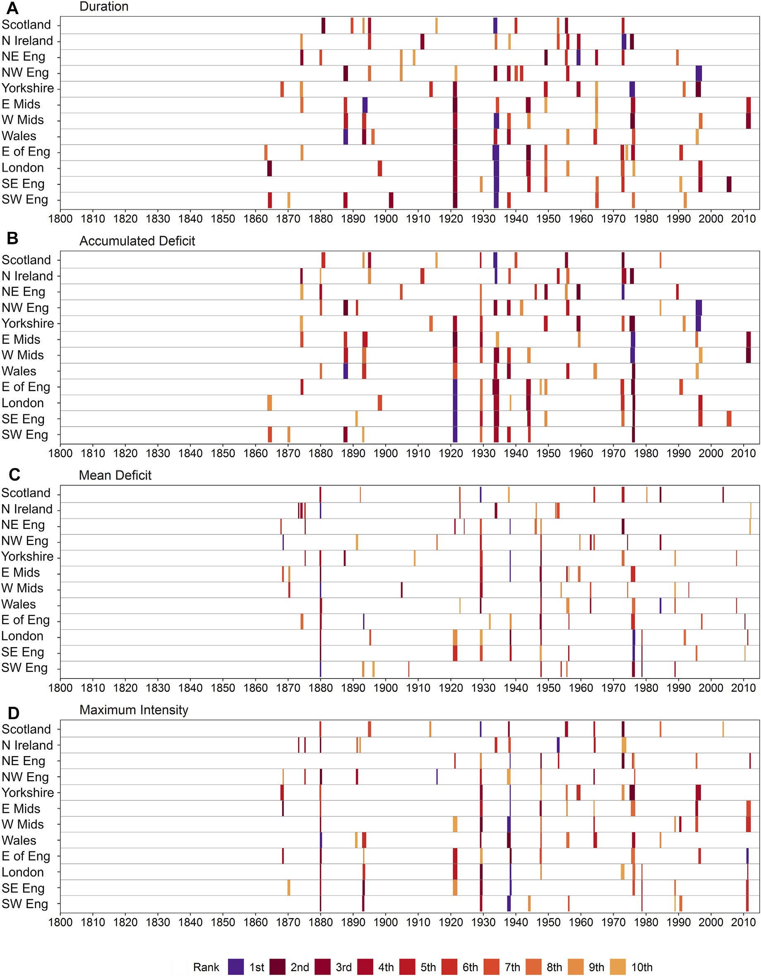
Figure A2.1: Top 10 extracted drought events for the HD SPI-3 series 1862 - 2014 using a threshold of -1.5, for twelve NUTS1 regions which are ordered roughly from north to south on the y-axis. For each region and drought characteristic, the bars are coloured according to the event rank; darker shades represent high-ranking, i.e. more severe, events.

Figure A2.2: Top 15 extracted drought events for SPI-3 derived from the 1800 – 2014 EWP series (top) and the 1800 – 2000 M2020-EWP series (bottom) using a threshold of -1.5. For each of the four drought characteristics, the bars are coloured according to the event rank; darker shades represent high-ranking, i.e. more severe, events.

