Ultrafast and cost-effective pathogen identification and resistance gene detection in a clinical setting using Nanopore Flongle sequencing

Ekaterina Avershina¹, Stephan A. Frye², Jawad Ali¹, Arne M. Taxt², Rafi Ahmad^{1,3,*}

¹Department of Biotechnology, Inland Norway University of Applied Sciences, Holsetgata 22, 2317, Hamar, Norway.
²Department of Microbiology, Division of Laboratory Medicine, Oslo University Hospital, PB 4956, Nydalen, 0424, Oslo, Norway.
³Institute of Clinical Medicine, Faculty of Health Sciences, UiT - The Arctic University of Norway, Hansine Hansens veg 18, 9019, Tromsø, Norway.
*corresponding author: rafi.ahmad@inn.no; +47 62 51 78 45

Supplementary Figures

1
2
5
3
1000 bp
847 bp
4

Supplementary Figure 1. TEM-1 specific PCR. Lane 1: 1KB DNA Ladder, Lane 2: E. coli 101 (Negative control), Lane 3: E. coli 125, Lane 4: E. coli A2-39 (Positive control), Lane 5: PCR control (No DNA).

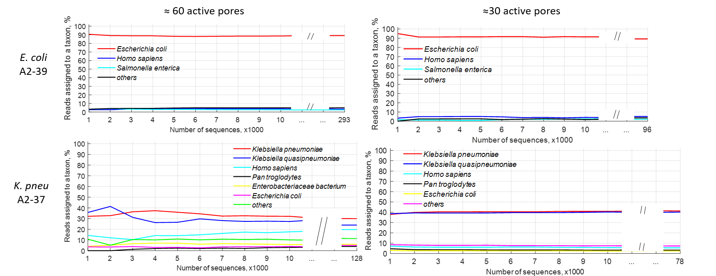
Supplementary Figure 2. Taxonomic assignment of Flongle sequencing reads from spiked blood cultures throughout the runs.

