Figure S1. Venn of soil bacterial during spring (A) and in autumn (B) seasons.
Abbreviations: SR-N0 = straw returning without N fertilizer application; SR-N200 = straw returning with 200 kg ha⁻¹ N fertilizer application; TP-N0 = traditional planting without N fertilizer application; TP-N200 = traditional planting with 200 kg/ha nitrogen fertilizer application.
Figure S2. Venn of soil fungi during spring (A) and in autumn (B) seasons.
Abbreviations: SR-N0 = straw returning without N fertilizer application; SR-N200 = straw returning with 200 kg ha⁻¹ N fertilizer application; TP-N0 = traditional planting without N fertilizer application; TP-N200 = traditional planting with 200 kg/ha nitrogen fertilizer application.
Figure S3. Venn of soil nematode during spring (A) and in autumn (B) seasons.
Abbreviations: SR-N0 = straw returning without N fertilizer application; SR-N200 = straw returning with 200 kg ha⁻¹ N fertilizer application; TP-N0 = traditional planting without N fertilizer application; TP-N200 = traditional planting with 200 kg/ha nitrogen fertilizer application.
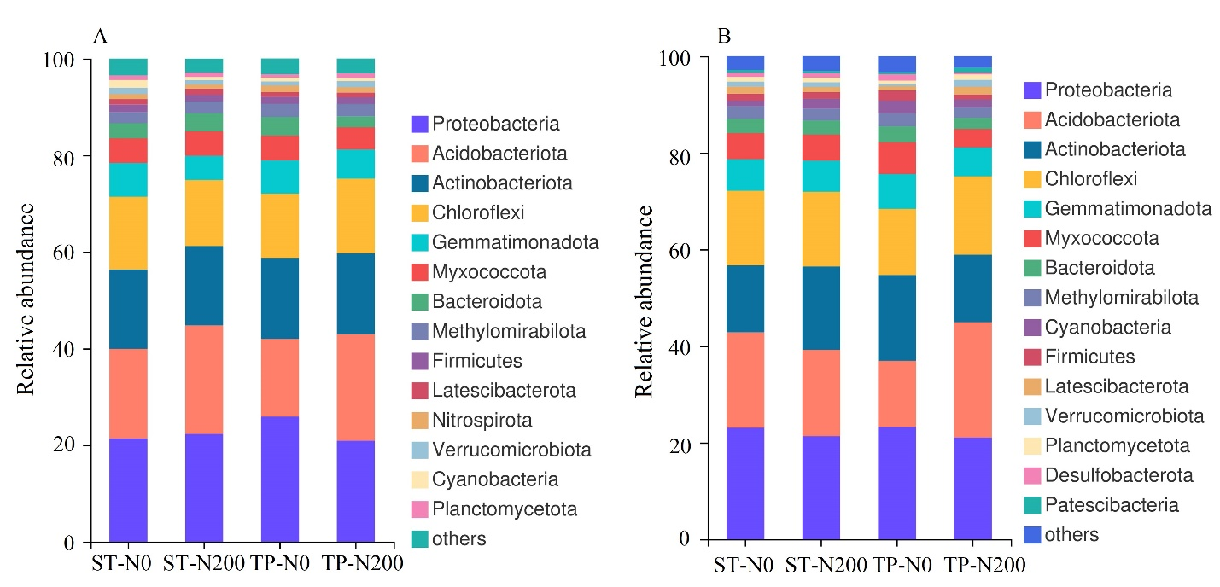
Figure S4. Relative abundance of soil bacterial during spring (A) and in autumn (B) seasons.
Abbreviations: SR-N0 = straw returning without N fertilizer application; SR-N200 = straw returning with 200 kg ha⁻¹ N fertilizer application; TP-N0 = traditional planting without N fertilizer application; TP-N200 = traditional planting with 200 kg/ha nitrogen fertilizer application.
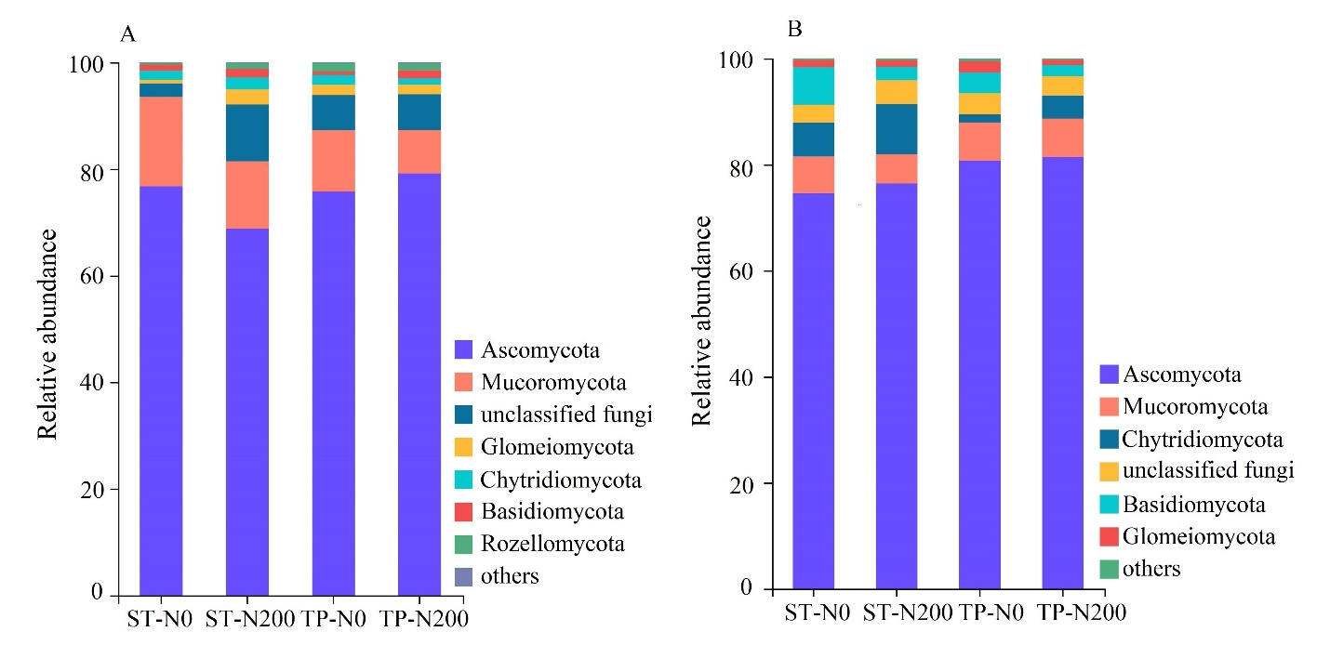
Figure S5. Relative abundance of soil fungi during spring (A) and in autumn (B) seasons.
Abbreviations: SR-N0 = straw returning without N fertilizer application; SR-N200 = straw returning with 200 kg ha⁻¹ N fertilizer application; TP-N0 = traditional planting without N fertilizer application; TP-N200 = traditional planting with 200 kg/ha nitrogen fertilizer application.
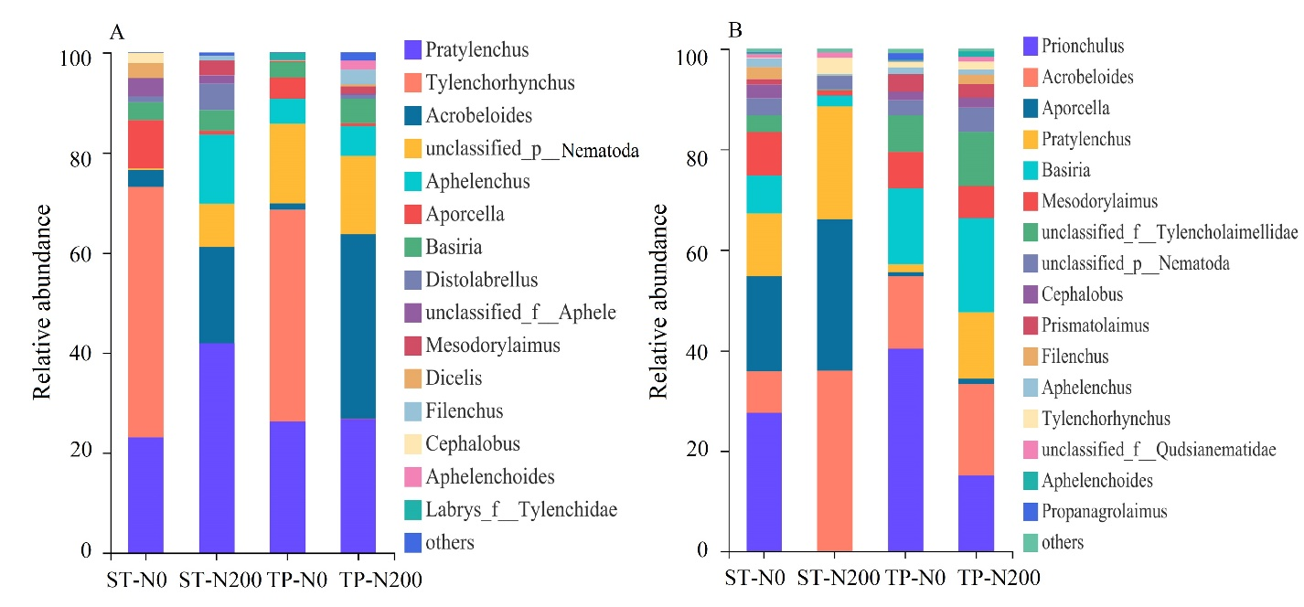
Figure S6. Relative abundance of soil nematode during spring (A) and in autumn (B) seasons.
Abbreviations: SR-N0 = straw returning without N fertilizer application; SR-N200 = straw returning with 200 kg ha⁻¹ N fertilizer application; TP-N0 = traditional planting without N fertilizer application; TP-N200 = traditional planting with 200 kg/ha nitrogen fertilizer application.
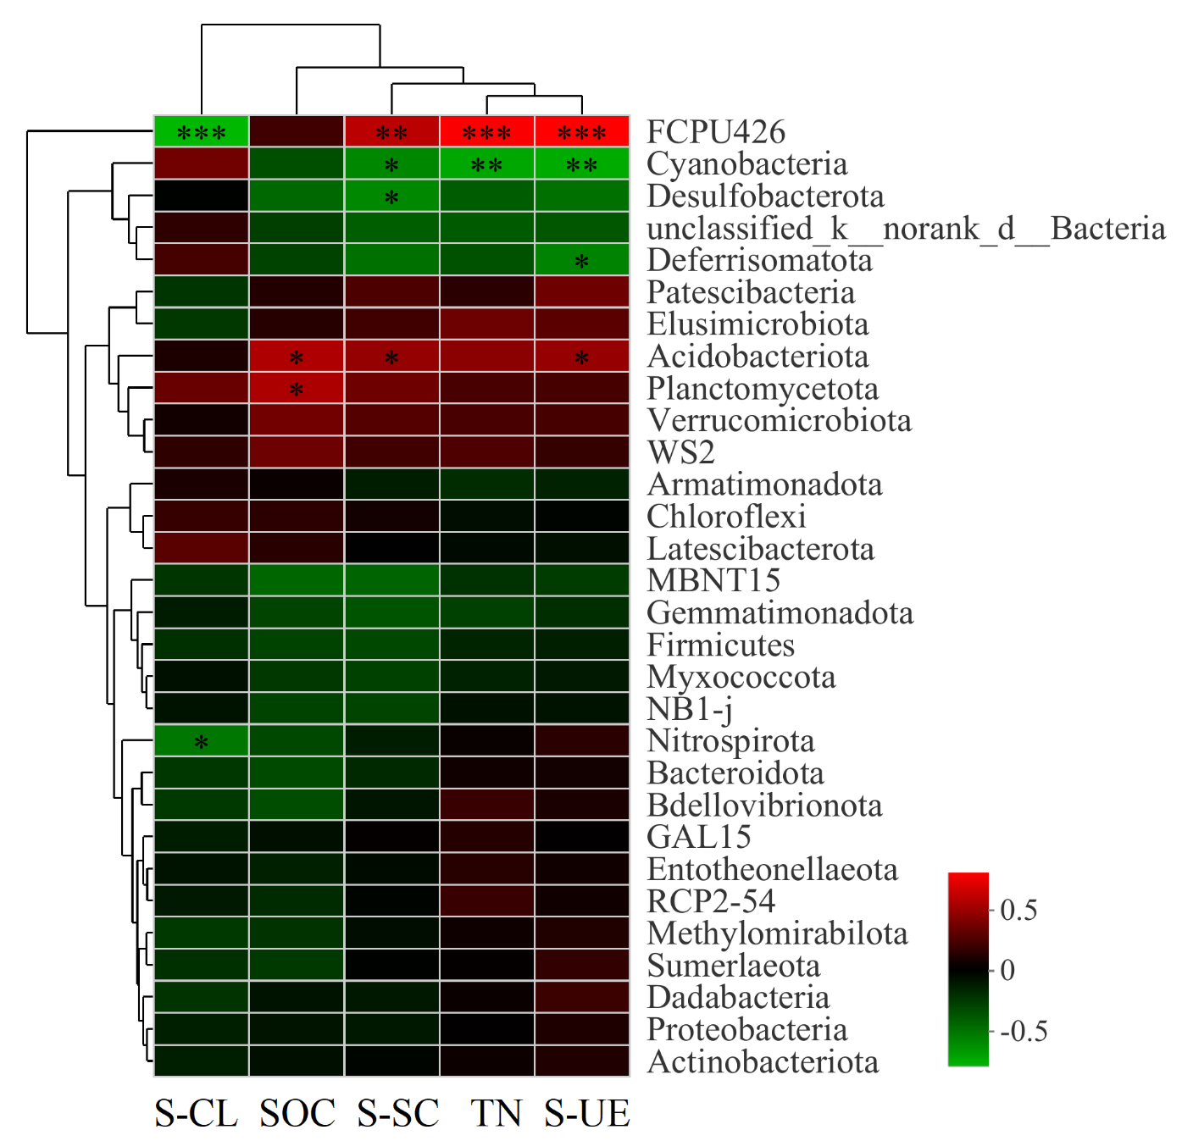
Figure S7. Spearman correlation of soil bacterial during spring (A) and in autumn (B) seasons.
Abbreviations: SR-N0 = straw returning without N fertilizer application; SR-N200 = straw returning with 200 kg ha⁻¹ N fertilizer application; TP-N0 = traditional planting without N fertilizer application; TP-N200 = traditional planting with 200 kg/ha nitrogen fertilizer application.
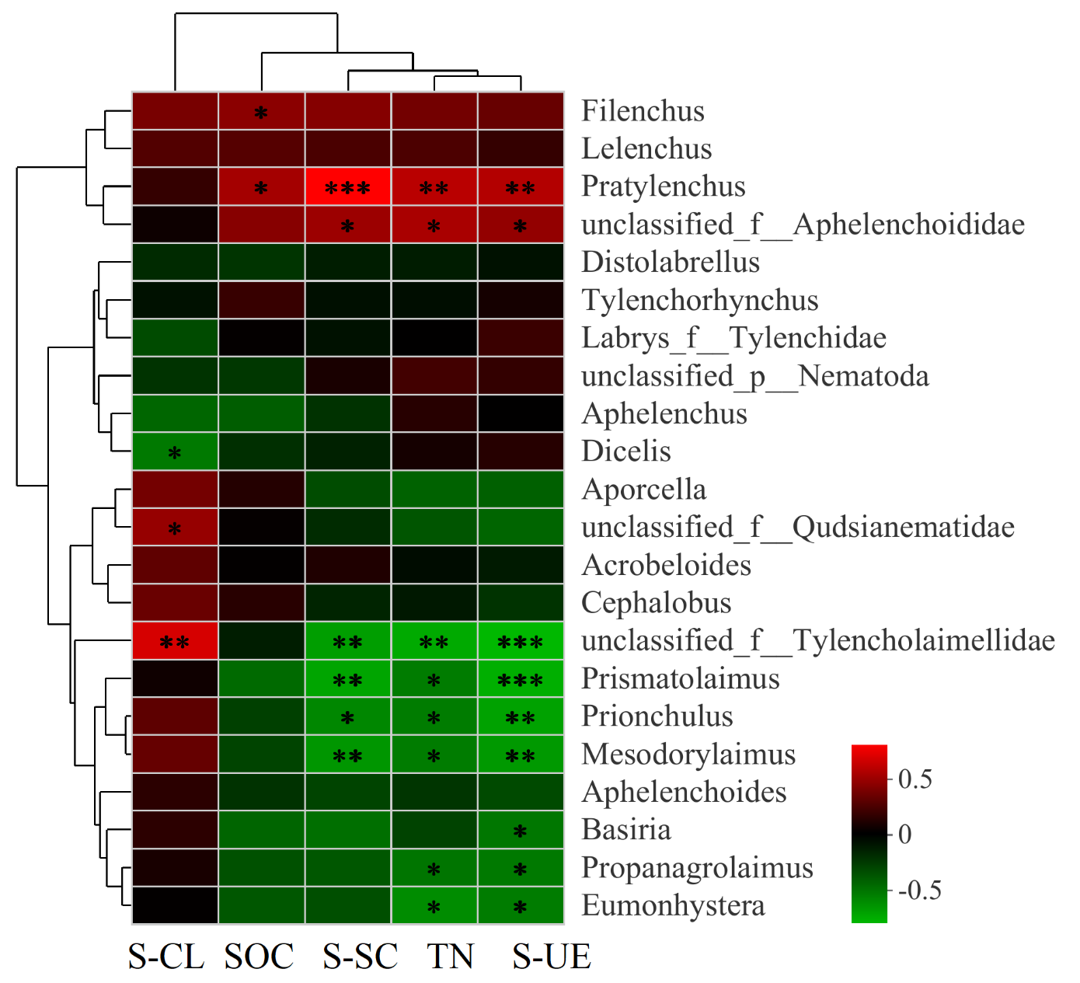
Figure S8. Spearman correlation of soil fungi during spring (A) and in autumn (B) seasons.
Abbreviations: SR-N0 = straw returning without N fertilizer application; SR-N200 = straw returning with 200 kg ha⁻¹ N fertilizer application; TP-N0 = traditional planting without N fertilizer application; TP-N200 = traditional planting with 200 kg/ha nitrogen fertilizer application.
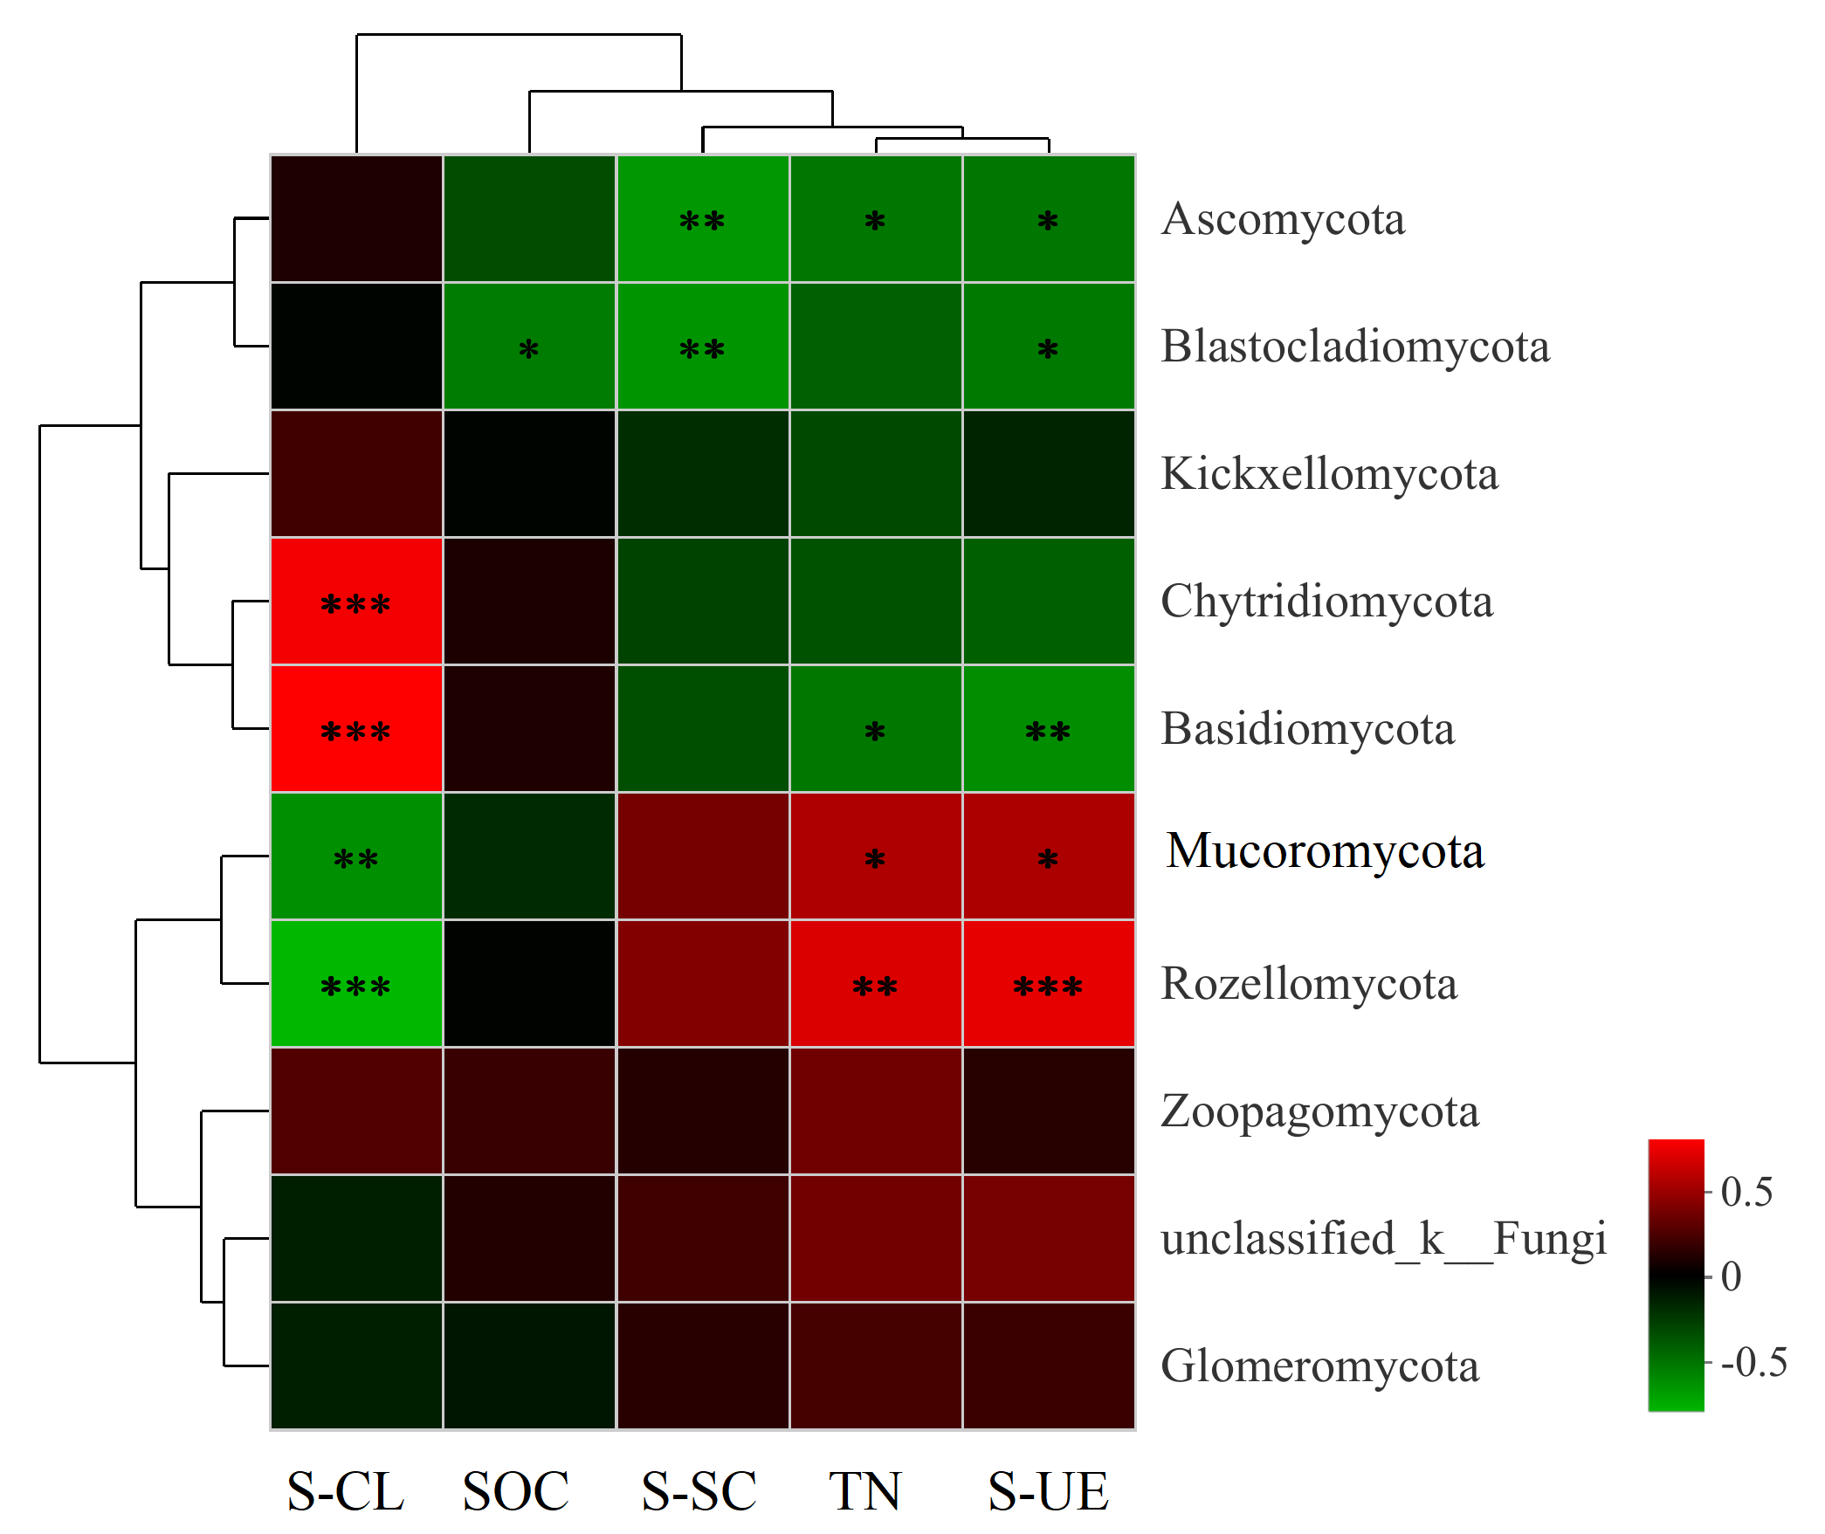
Figure S9. Spearman correlation of soil nematode during spring (A) and in autumn (B) seasons.
Abbreviations: SR-N0 = straw returning without N fertilizer application; SR-N200 = straw returning with 200 kg ha⁻¹ N fertilizer application; TP-N0 = traditional planting without N fertilizer application; TP-N200 = traditional planting with 200 kg/ha nitrogen fertilizer application.

