**Figure S1.** Distribution of extinction risk mapped on the phylogeny of Chinese angiosperm genera. Highly threatened genera which contain more threatened species than that would be expected under the log-normal model at *P* ≤ 0.05 are shown in red.

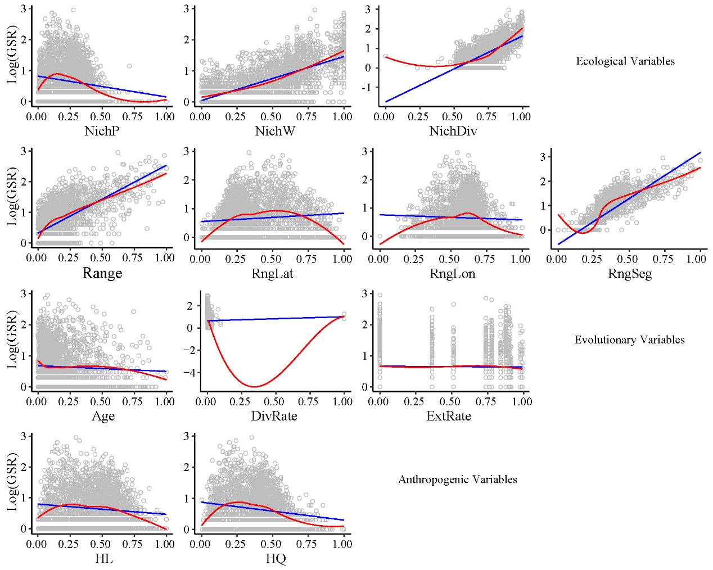

**Figure S2.** Bivariate relationships of ecological, evolutionary and anthropogenic predictors to genus species richness (GSR) (log-transformed). Ordinary least-squares linear regression (blue line) and locally weighted regression (red line) were fitted for all maps. NichP, nich position; NichW, nich width; NichDiv, genus niche divergence; RngLat, range position (latitude); RngLon, range position (longitude); RngSeg, range segregation; ExtRate, relative extinction rate; DivRate, net diversification rate; HL, habitat loss; HQ, habitat quality.



**Figure S3.** Hypothesized model tested via structural equation modeling, indicating the expected pathways (single-headed arrows) for the effects of environment (climatic niche position, NichP; climatic niche width, NichW; climatic niche divergence, NichDiv; range size, Range; range segregation, RngSeg; longitudinal and latitudinal range position, Rnglon and RngLat), evolution history (relative extinction rate, ExtRate; genus age, Age) and human activities (habitat loss, HL; habitat quality, HQ) on the distribution of genus species richness (GSR), threatened species richness (TSR) and relative extinction risk (RER) in Chinese angiosperms. Climate mainly contributes indirectly through its influence on other ecological and evolutionary processes. Most effects of environmental factors on extinction risk are expected to be indirect, mediated by range size (Range) and species richness in each genus (GSR). Black arrows denote hypothesized positive relationships and red arrows negative ones.