Supplementary Material
Eliminating Stubborn Insulated Deposition by Coordination Effect to Boost Zn Electrode Reversibility in Aqueous Electrolyte
Yuzhuo Jiangª, Xinyao Xia^{b}, Siyi Qianª, Jing Zhang^{c}, Pinxin Zhou^{c}, Xuefang Gu^{a,*}, Shu Tianª, Yijin Qian^{d,*}, Haoqing Ji^{b}, Jie Liu^{a,*}, and Tao Qianª
ª School of Chemistry and Chemical Engineering, Nantong University, Nantong 226019, China
^{b} College of Energy, Key Laboratory of Advanced Carbon Materials and Wearable Energy Technologies of Jiangsu Province, Soochow University, Suzhou 215006, Jiangsu, China
^{c} State Key Laboratory of Space Power-sources Technology, Shanghai Institute of Space Power-Sources, 2965 Dongchuan Road, Shanghai 200245, China.
^{d} Deakin University, Institute for Frontier Materials, Waurn Ponds Campus, Locked Bag 20000, Geelong, Victoria 3220, Australia

E-mail: xuefang818@ntu.edu.cn, qianyij@deakin.edu.au and jliu93@ntu.edu.cn

Figure S1. Changes in UV-Vis of EDTA-2Na solution samples with and without Zn₄(OH)₆SO₄·5H₂O.

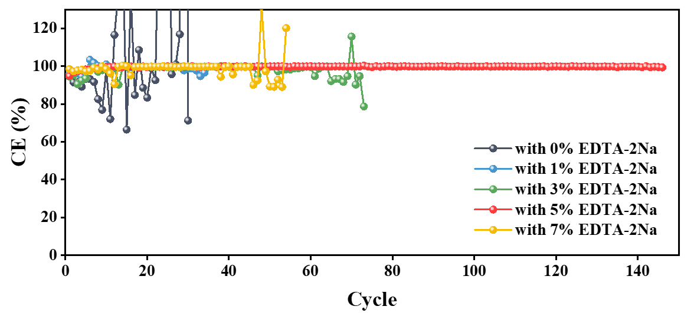
Figure S2. Scheme Caption CE of Zn||Cu cells with different mass ratio of EDTA-2Na in the control electrolyte cycled under 10 mA cm⁻² and 5 mA h cm⁻² conditions.

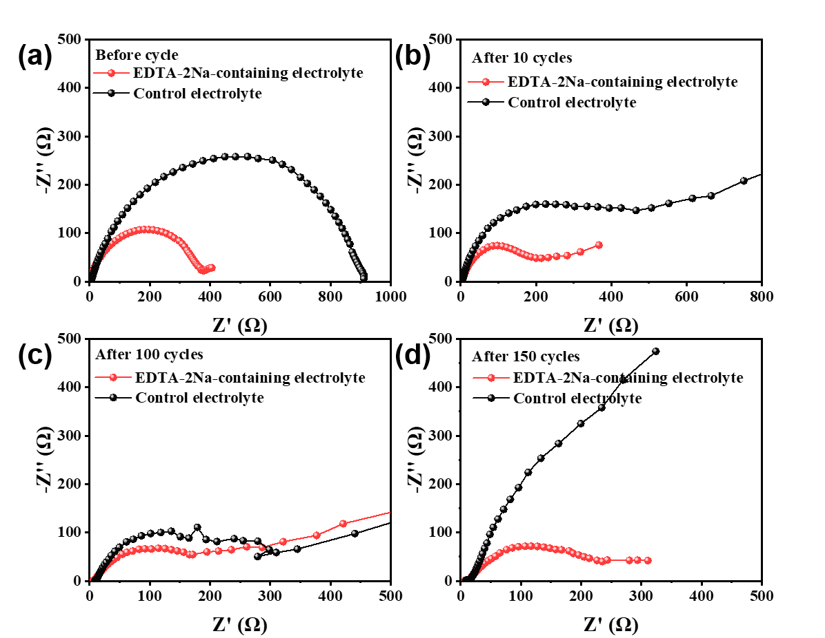
Figure S3. EIS plots of Zn||Cu cells with and without EDTA-2Na after various numbers of cycles.

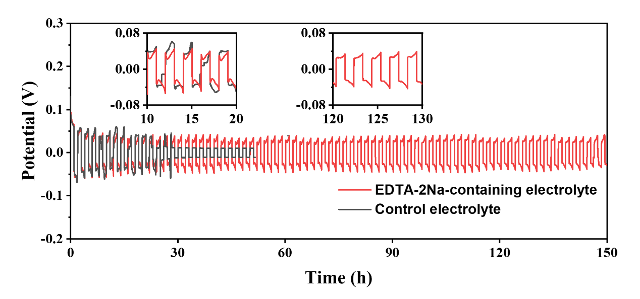
Figure S4. Galvanostatic Zn plating/stripping in Zn||Zn symmetrical cells at 1 mA cm⁻² and 1 mA h cm⁻².

Figure S5. Galvanostatic Zn plating/stripping in Zn||Zn symmetrical cells at 2 mA cm⁻² with different plating/stripping capacity.

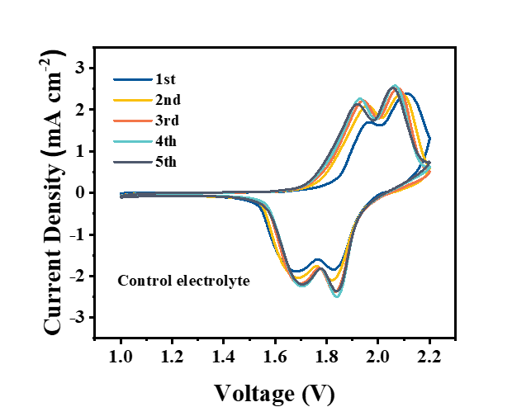
Figure S6. CV curves of Zn||LiMnO₄ battery in the control electrolyte at 0.5 mV s⁻¹.

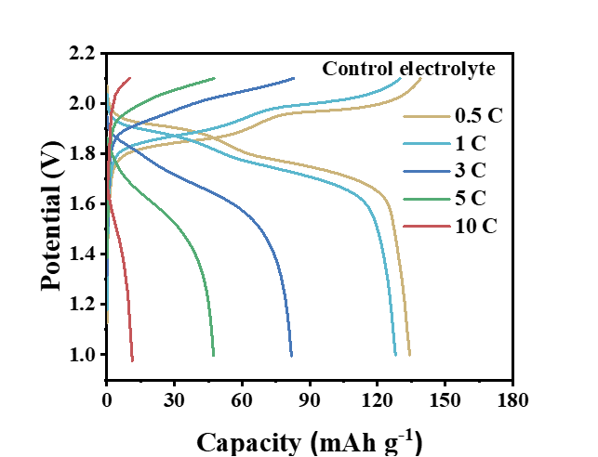
Figure S7. Typical charge/discharge curves for Zn||LiMnO₄ cells in the control electrolyte with current density.

Table S1. The electrochemical performances of aqueous ZIBs using various additives.
Electrolyte | Cathode | Cathode cyclability | Current density | Refs
1.26×10⁻⁸ M PbSO₄ + 5% fumed silica + 1M Li₂SO₄ + 2M ZnSO₄ | LiMn₂O₄ | 74.4% capacity retention after 300 cycles | 1 C | Mater. Today Energy 2017, 4, 34
H₃BO₃ + 1M Li₂SO₄ + 1M ZnSO₄ | LiMn₂O₄ | 78% capacity retention after 1000 cycles | 4 C | Chem. Eur. J. 2018, 24, 1667
PAM/GO/EG | δ-MnO₂ | 95.0% capacity retention after 100 cycles | 0.5 C | Front. Chem. 2020, 8, 603
(NH₄)₆[Mo₇O₂₄]·4H₂O + 1M ZnSO₄ | NaV₃O₈·1.5H₂O | 60% capacity retention after 500 cycles | 5 C | J. Mater. Chem. A 2021, 9, 7025
Polyacrylamide + 0.1M MnSO₄ | MnO₂ | 87.2% capacity retention after 200 cycles | 0.8 C | Angew. Chem. 2019, 131, 15988-15994
5%EDTA-2Na + 1M ZnSO₄ + 3M Li₂SO₄ | LiMn₂O₄ | 90.3% capacity retention after 150 cycles | 4 C | This work

