Supplementary Material Saccò et al.

Supplementary Figures
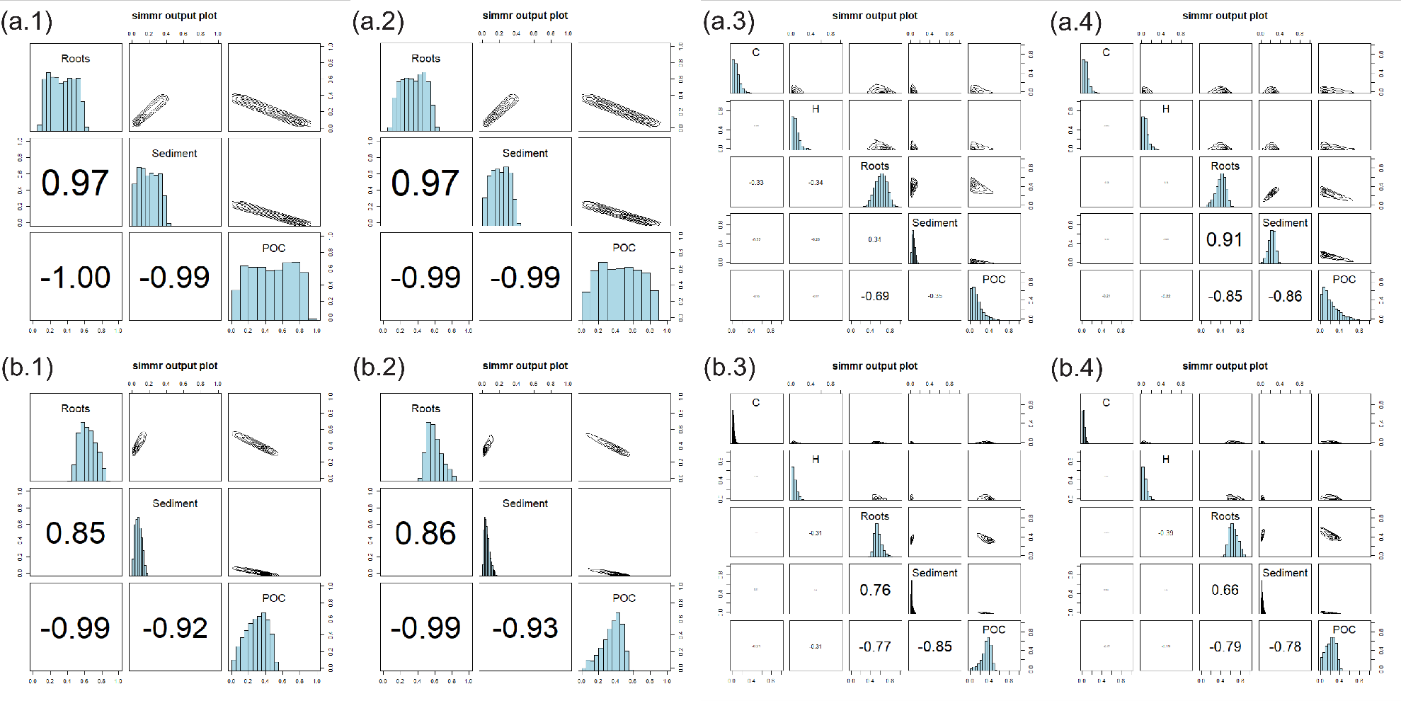
Supplementary Figure 1. SIMM plots on the correlations between sources for C, H, AM1 and AM2 under LR (a.1, a.2, a.3 and a.4, respectively) and HR (b.1, b.2, b.3 and b.4, respectively). Source histograms on the diagonal, contour plots of the relationship between the sources on the upper diagonal, and the correlation between the sources on the lower diagonal are displayed.

Supplementary Tables
Supplementary Table 1. Carbon and nitrogen isotopic ratios for δ¹³C and δ¹⁵N SIA (together with the % of C and N) and Δ¹⁴C values (in ‰) of Copepoda Cyclopoida (C), Copepoda Harpacticoida (H), Amphipoda Scutachiltonia axfordi (AM1), Amphipoda Yilgarniella sturtensis (AM2), Roots (R), Sediment (S) and Particulate Organic Carbon (POC).
Sample | ID | LR |  |  |  |  | HR
 |  | %C | δ¹³C | %N | δ¹⁵N | Δ¹⁴C | %C | δ¹³C | %N | δ¹⁵N | Δ¹⁴C
Cyclopoida | C | 0.11 | -20.45±0.30¹ | 0.11 | 13.90±0.30¹ | -5.60±5.60² | 0.80 | -21.91±0.30¹ | 0.12 | 14.50±0.30¹ | -14.70±6.70²
Harpacticoida | H | 0.10 | -20.60±0.30¹ | 0.10 | 11.90±0.80 | -5.60±5.60² | 0.50 | -23.50±0.30¹ | 0.08 | 15.80±0.80 | -14.70±6.70²
S. axfordi | AM1 | 57.70 | -24.14±0.30¹ | 2.80 | 10.71±0.30¹ | 19.90±4.80 | 64.60 | -26.88±0.05 | 2.30 | 8.81±0.09 | -9.60±9.90
Y. sturtensis | AM2 | 58.30 | -24.55±0.30¹ | 2.80 | 9.99±0.30¹ | -3.70±3.60 | 63.70 | -27.10±0.30¹ | 2.20 | 8.50±0.30¹ | -0.90±8.10
Roots | R | 46.60 | -20.57±0.30¹ | 0.51 | 5.10±2.00 | 27.70±3.00 | 41.30 | -20.90±0.3¹ | 0.92 | 12.10±0.30¹ | 24.90±4.70
Sediment | S | 3.00 | -10.33±0.30¹ | 0.05 | 11.00±1.20 | -780.30±32.10 | 2.40 | -9.65±0.3¹ | 0.02 | 11.40±1.20 | -428.00±51.70
Particulate Organic Carbon | POC | 1.20 | -21.58±0.10 | 0.10 | 10.73±0.10 | -141.70±7.60 | 0.40 | -26.47±0.1 | 0.01 | 8.35±0.10 | -366.70±2.80
¹Accuracy of the CF-iRMS (unique runs)
²Homogeneised values

Supplementary Table 2. Dietary contributions (in %) of copepods C and H and amphipods AM1 and AM2 under LR and HR.

 | Contributions (%)
 | LR |  |  |  |  | HR
 | Roots | Sediment | POC | C | H | Roots | Sediment | POC | C | H
C | 33.7±14.3 | 19.2±10.8 | 47.1±24.9 | / | / | 63.4±9.3 | 7.4±3.8 | 29.2±12.6 | / | /
H | 34.9±13.5 | 20.3±10.2 | 44.8±23.6 | / | / | 59.6±8.8 | 5.4±3.3 | 35±11.8 | / | /
AM1 | 61±11.8 | 5.9±3.1 | 14.5±11.6 | 9.3±7.1 | 9.3±7.3 | 55.1±7.9 | 2.8±2.1 | 32.5±10 | 3±2.1 | 6.6±5.5
AM2 | 39.9±9.8 | 22.2±6.9 | 21.5±16.9 | 8.1±6 | 8.3±6.2 | 65.8±8.9 | 3±1.9 | 21.2±10 | 3.2±2.2 | 6.8±5.5

