SUPPLEMENTARY DATA 3

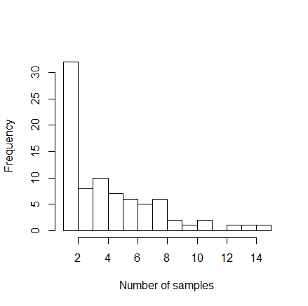
Figure 1 : frequency of the number of samples collected per badger
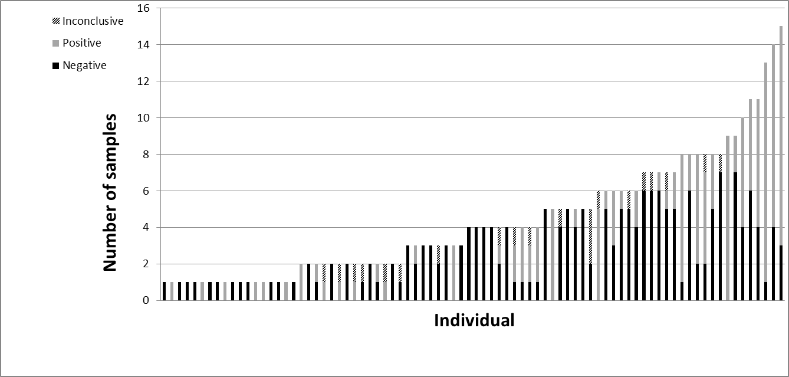
Figure 2 : distribution of the RhB results for the hair samples belonging to each badger (N= 95 individuals)

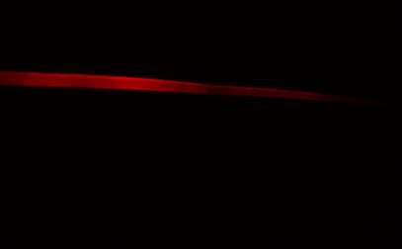
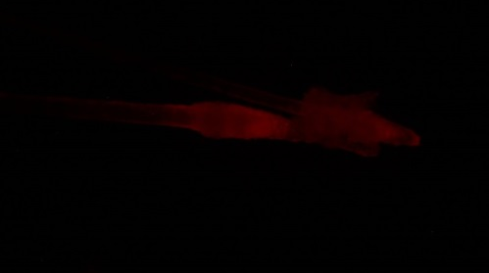
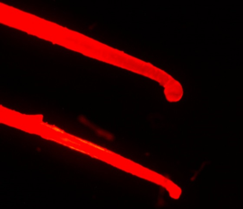
Bulbs, day 2 Bulb day 23 Apex, day 64
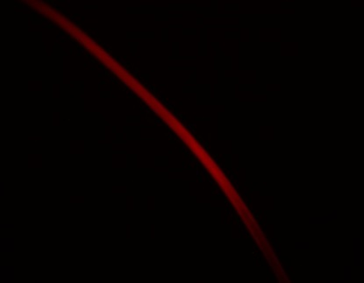
Apex, day 91 Half shaft, day 177

Figure 3 : examples of Rhodamine B fluorescence observed on hairs of badger at different delay of hair capture (the number of day is the delay between delivery of RhB baits and hair collection). Magnification x 4, Olympus fluorescence microscopy system

