Supplementary Material

Supplementary Figures

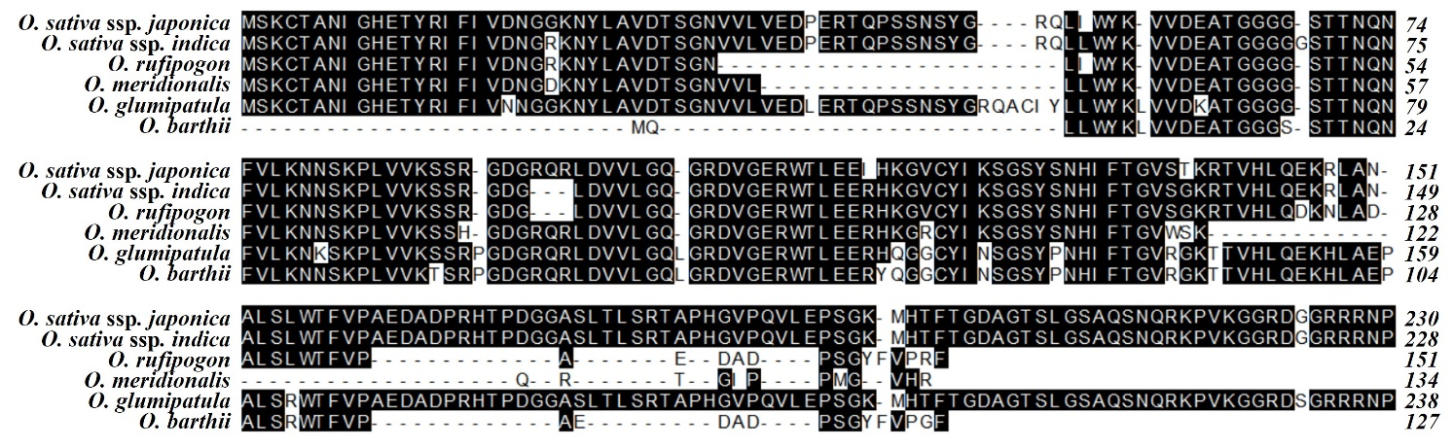
Supplementary Figure 1. Comparison of the predicted amino acid sequences of Xio1 and its homologs from Oryza spp., Oryza sativa ssp. japonica, O. sativa ssp. indica, O. rufipogon, O. meridionalis, O. glumipatula, and O. brathii. DNASTAR MegAlign by ClustalW (weighted) method was used to generate the sequence alignment.

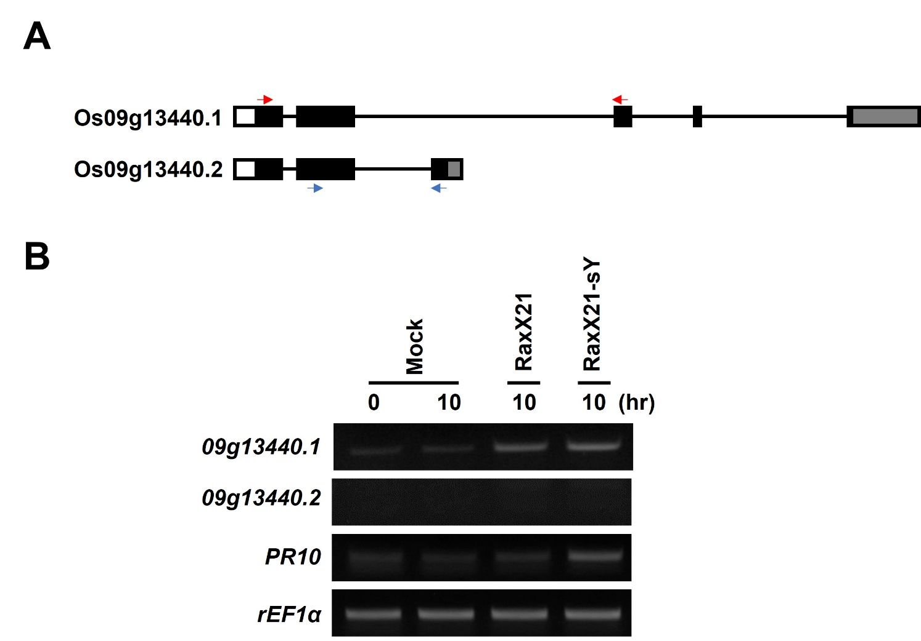
Supplementary Figure 2. Xio1 is the only transcript among predicted alternative splicing forms. (A) The deduced gene structure of Os09g13440.1 (Xio1) and its possible alternative splicing form Os09g13440.2 predicted in Rice Genome Annotation Project (http://rice.uga.edu). Black box, exon; line, intron; white box, 5′ UTR; gray box, 3′ UTR. Specific primer sets to Os09g13440.1 (Xio1) and Os09g13440.2 were indicated with red and blue arrow, respectively. (B) Expression of Os09g13440.1 and Os09g13440.2 genes in XA21/Kit after treatments with a sulfated peptide RaxX (RaxX-sY) or inactive nonsulfated peptide (RaxX). RT-PCR analysis were performed using specific primer sets displayed in (A). rEF1α and pathogenesis-related protein 10 (PR10) were used as an internal control and a positive control for RaxX-sY treatment, respectively. Experiments were repeated at least three times, with similar results.

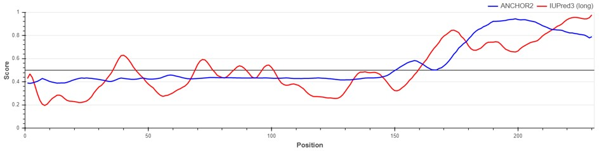
Supplementary Figure 3. Prediction of disordered region and disordered binding site in Xio1 using IUPred3 (https://iupred.elte.hu/) with default parameters.

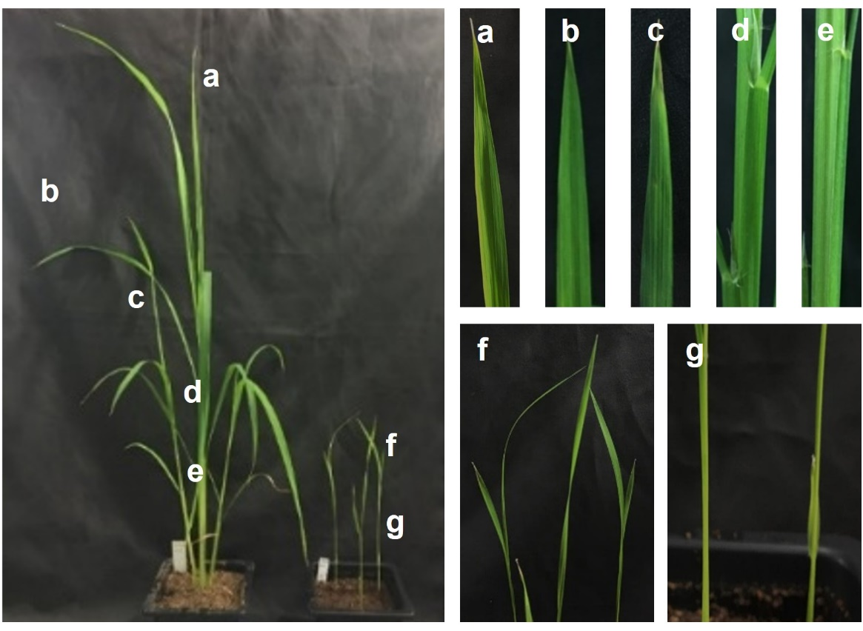
Supplementary Figure 4. Various tissues harvested from 10-week-old and 3-week-old rice plants. 10-week-old Kitaake plants: a, 1st leaf from main tiller; b, 4th leaf from main tiller; c, 1st leaf from sub-tiller; d, upper stem; e, lower stem. 3-week-old Kitaake plants: f, leaf; g, stem.

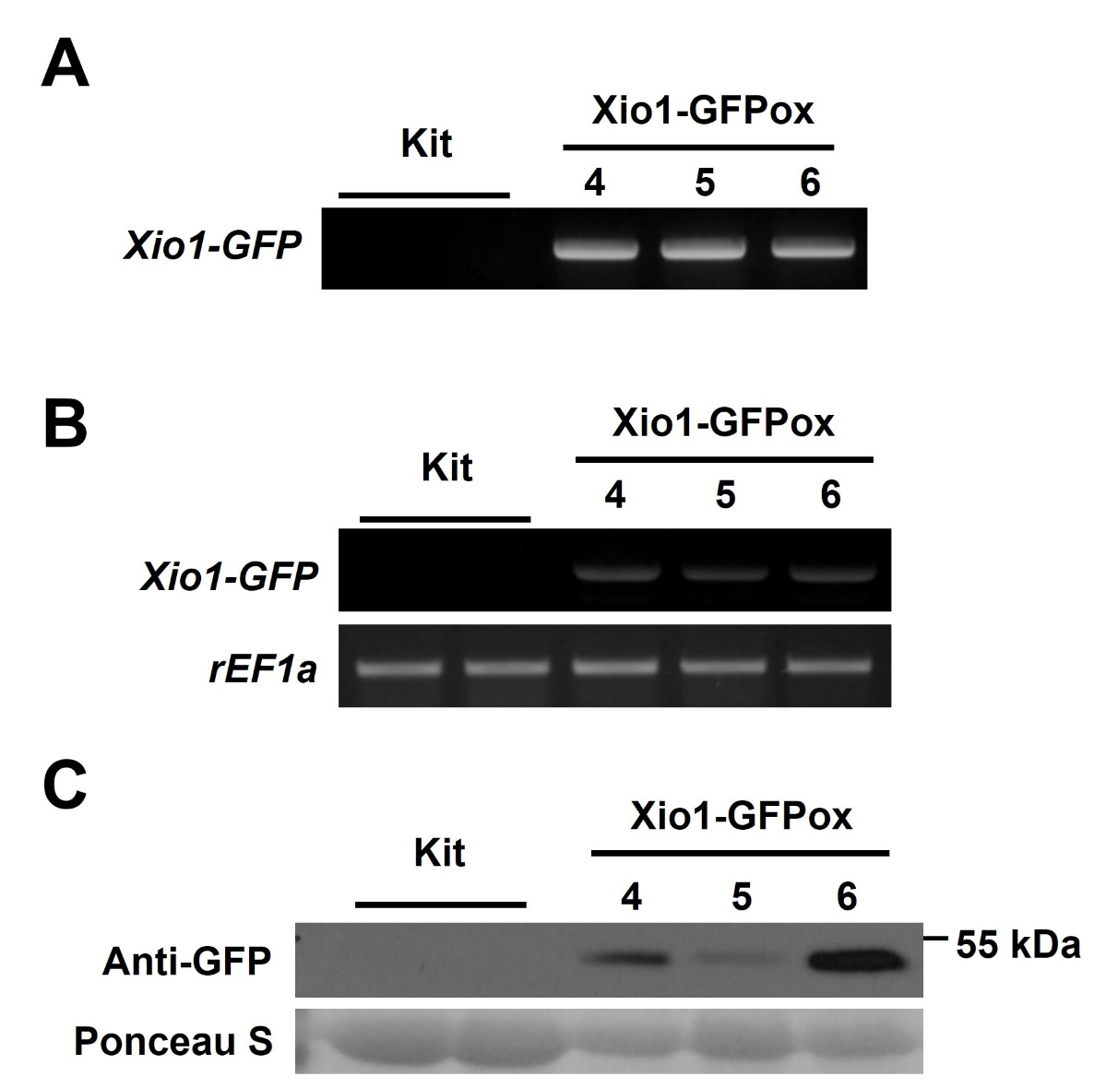
Supplementary Figure 5. Generation of transgenic rice plants overexpressing Xio1-GFP. (A) Genotyping of transgenic Xio1-GFPox (T₀, line 4, 5, and 6). Genotyping was performed using the Xio1-GFP-specific primers from three independently transformed plants (Xio1-GFPox T₀, line 4, 5, and 6). (B) Overexpression of Xio1-GFP in the transgenic Xio1-GFPox (T₀, line 4, 5, and 6). RT-PCR analysis were performed using specific primers for Xio1-GFP. rEF1α was used as an internal control. (C) Accumulation of Xio1-GFP in the transgenic Xio1-GFPox (T₀, line 4, 5, and 6). Western blot analysis was performed with anti-GFP antibody after total protein extracts were extracted from Kitaake and Xio1-GFPox. Rubisco large subunit stained with Ponceau S served as a loading control.

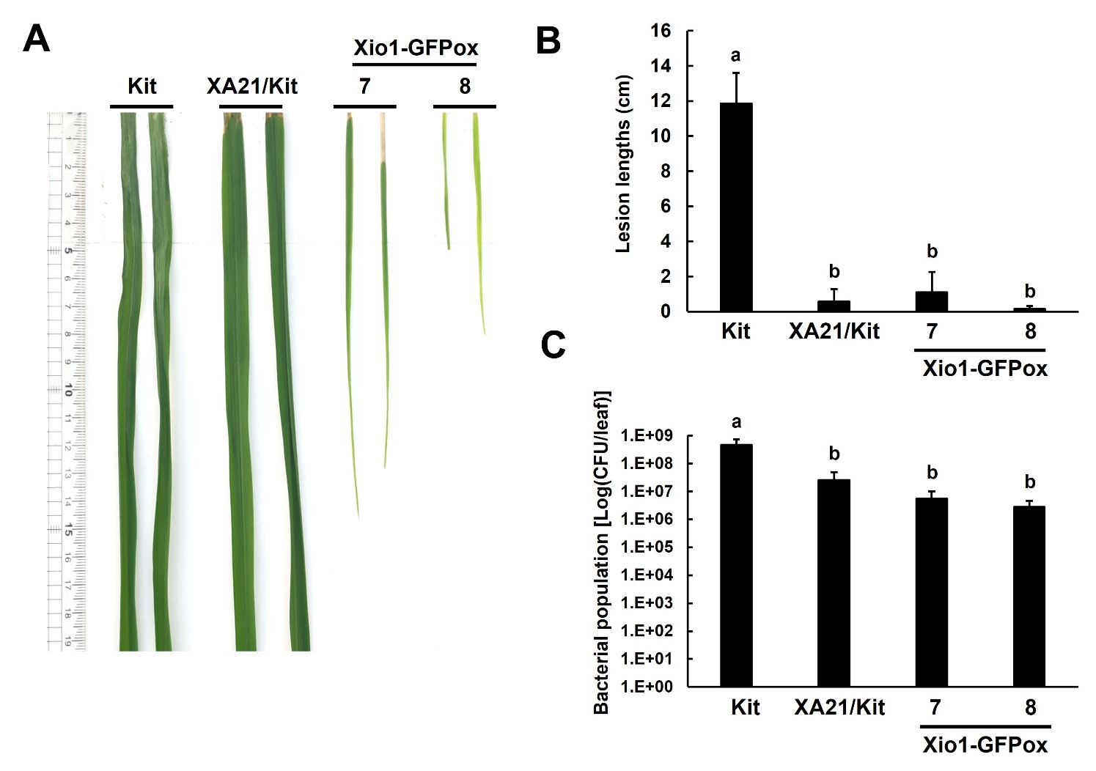
Supplementary Figure 6. Transgenic rice plants overexpressing Xio1-GFP (Xio1-GFPox) exhibit enhanced resistance to Xoo. (A) Picture of representative rice leaves taken at 12 days after Xoo inoculation. From left to right: Kitaake (Kit), transgenic Kitaake overexpressing XA21 (XA21/Kit), transgenic Kitaake overexpressing Xio1-GFP (Xio1-GFPox T₀, line 7 and 8). (B) Lesion lengths were measured in Kitaake, XA21/Kit, and transgenic Xio1-GFPox (T₀, line 7 and 8) 12 days after Xoo inoculation. (C) Xoo populations were determined at 12 days after inoculation in Kitaake, XA21/Kit, and transgenic Xio1-GFPox (T₀, line 7 and 8). The error bars represent standard deviation values obtained from the three samples. Different letters indicate significant differences at p < 0.001.

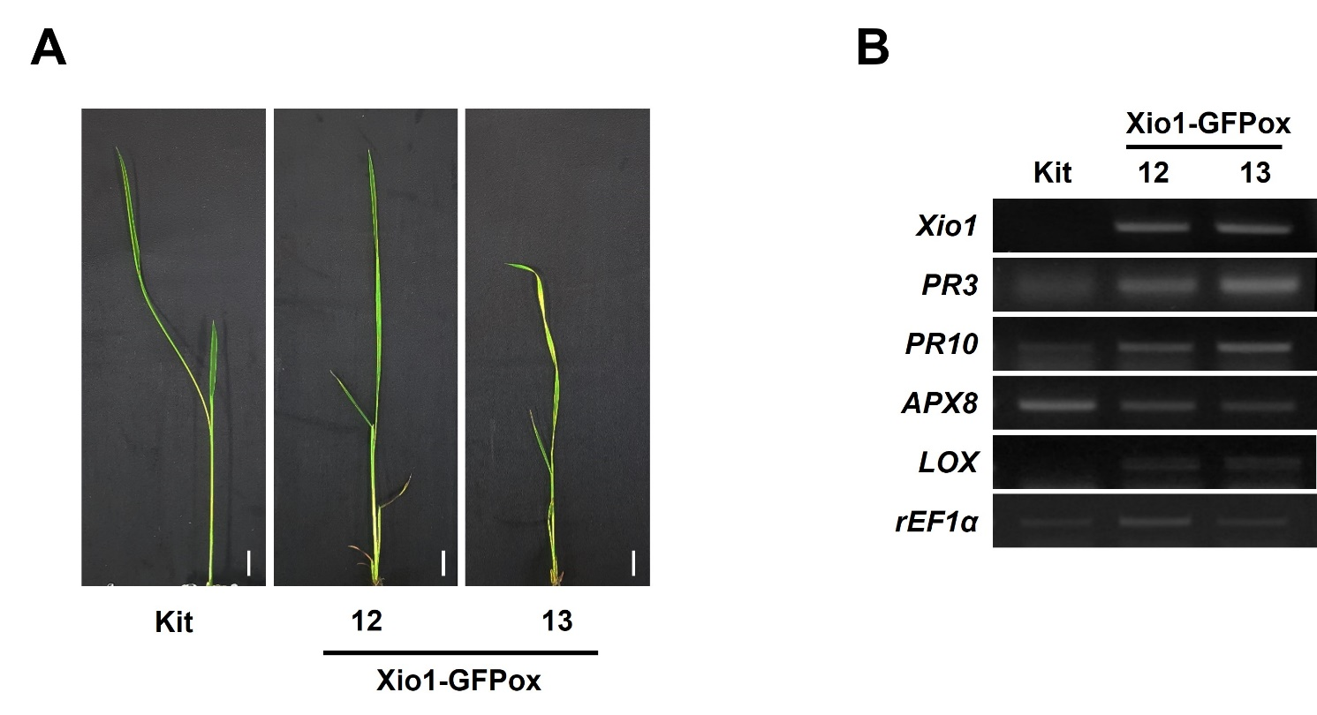
Supplementary Figure 7. Expression analysis of defense-related genes in transgenic Xio1-GFPox grown on MS media. Photograph (A) and expression analysis (B) of defense-related genes of approximately three-week-old Kitaake (Kit) and Xio1-GFPox (T₀, line 12 and 13) grown on MS media in sterilized glass container under growth chamber condition. RT-PCR analysis was performed using specific primers for Xio1, PR3, PR10, lipoxygenase (LOX), and ascorbate peroxidase 8 (APX8) genes. rEF1α gene was used as an internal control. Scale bars, 1 cm.

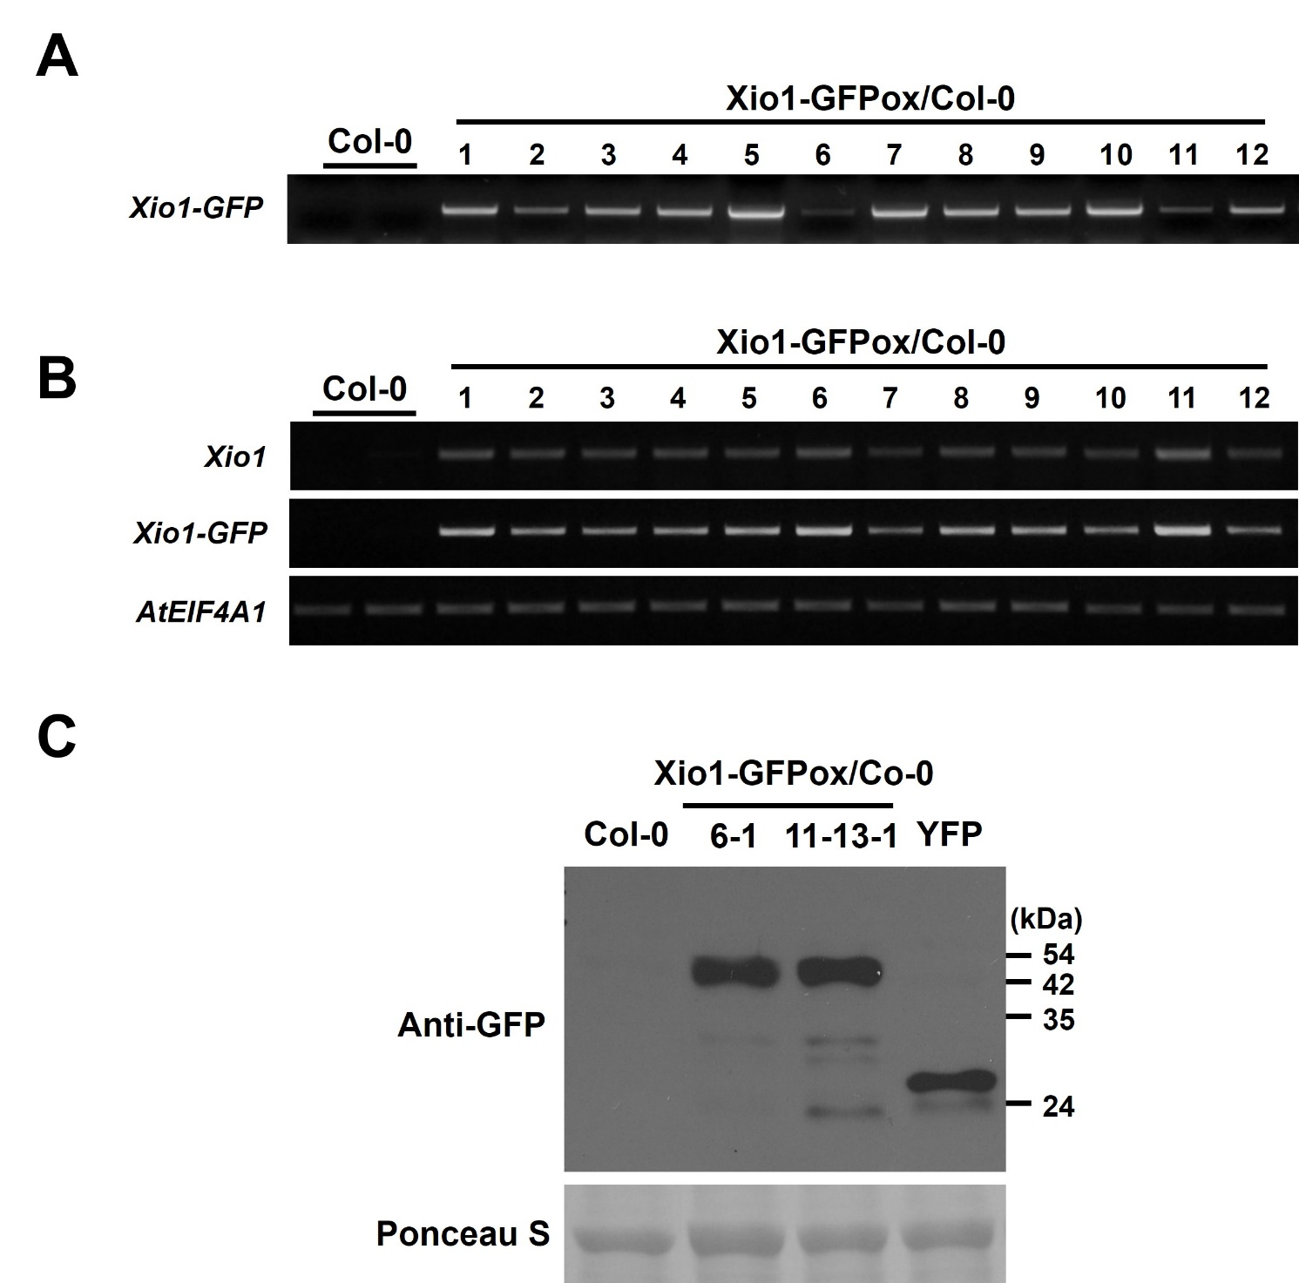
Supplementary Figure 8. Generation of transgenic Arabidopsis plants overexpressing Xio1-GFP. (A) Genotyping of transgenic Arabidopsis Col-0 overexpressing Xio1-GFP (Xio1-GFPox/Col-0). Genotyping was performed using the specific primers for Xio1-GFP from twelve independently transformed plants (Xio1-GFPox/Col-0 T₁, lines 1 to 12). (B) Overexpression of Xio1-GFP in the transgenic Arabidopsis Xio1-GFPox/Col-0 lines. RT-PCR analysis were performed using specific primers for Xio1 and Xio1-GFP. AtEIF4A1 was used as an internal control. (C) Accumulation of Xio1-GFP in the transgenic Arabidopsis Xio1-GFPox/Col-0 lines. Western blot analysis was performed with anti-GFP antibody after total protein extracts were extracted from Col-0, Xio1-GFPox/Col-0, and YFP. Protein gel loading control was done by Ponceau S staining.

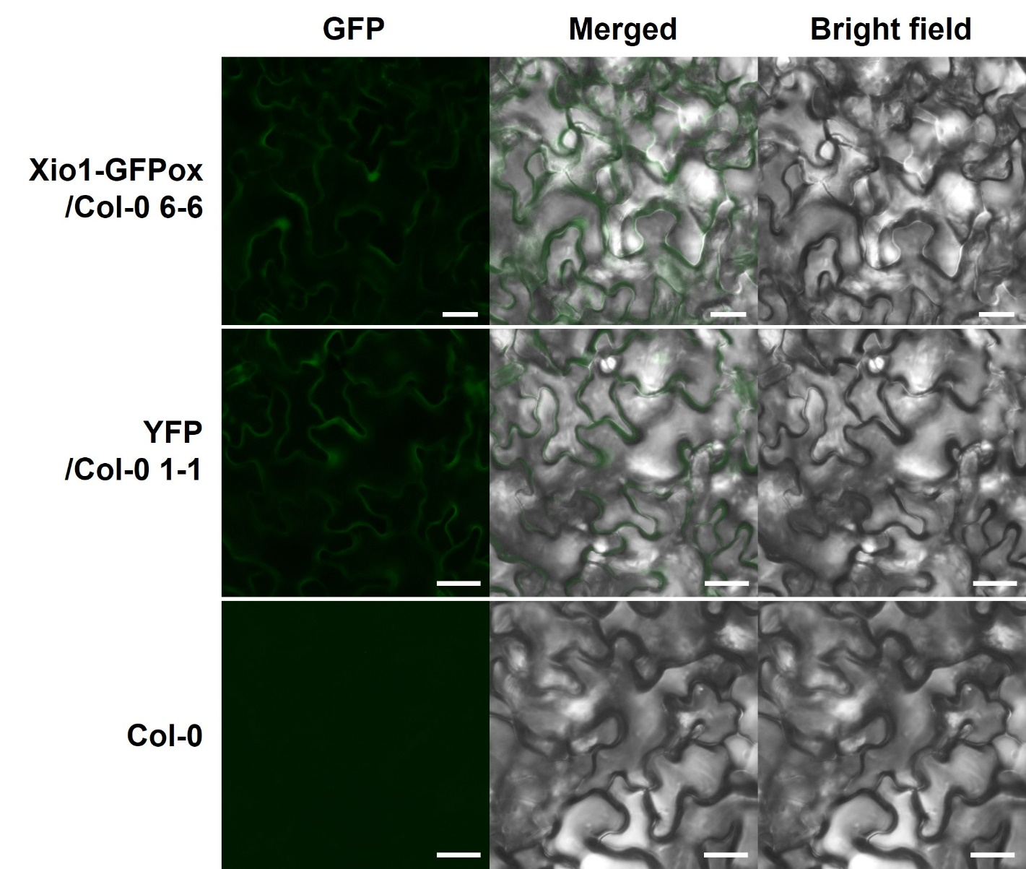
Supplementary Figure 9. Microscopic analysis of Xio1-GFP within the leaf epidermal cells of Arabidopsis. Photographs of Xio1-GFPox/Col-0, YFP/Col-0, and Col-0 were taken using a Nikon fluorescent microscope with a C-FL-C FITC (excitation 465 nm to 495 nm) for GFP and YFP. Scale bar indicates 50 μm. Experiments were repeated three times and shown with representative images.

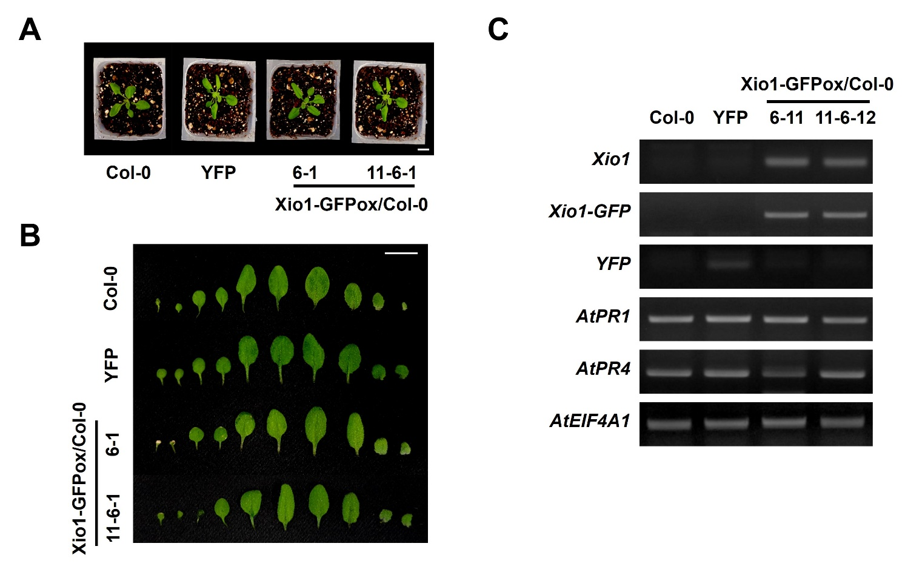
Supplementary Figure 10. Phenotypic analysis of transgenic Arabidopsis plants overexpressing Xio1-GFP. (A) Growth comparison of 3-week-old wild-type Arabidopsis (Col-0), transgenic Col-0 lines overexpressing YFP (YFP), and transgenic Col-0 lines overexpressing Xio1-GFP (Xio1-GFPox/Col-0, lines 6-1 and 11-6-1) grown in soil under normal conditions. Scale bars, 1 cm. (B) Photograph of individual rosette leaves of Col-0, YFP, and Xio1-GFPox/Col-0 (lines 6-1 and 11-6-1). Leaves are placed from the ﬁrst to the latest leaf in that order. Scale bars, 1 cm. (C) Expression analysis of Xio1-GFPox/Col-0 (lines 6-11 and 11-6-12). RT-PCR was performed using specific primers for Xio1, Xio1-GFP, YFP, AtPR1, AtPR4 genes. Eukaryotic translation initiation factor 4A1 (AtEIF4A1) was used as an internal control.

