Supplementary Material

Sulfur-mediated Polycarbonate-polyurethane for Potential Application of Blood-contacting Materials

Peichuang Li^{a,b}, Wanhao Cai^{b,c}, Xin Li^{b,d}, Hong Zhangª, Yuancong Zhao^{b,}*, Jin Wang^{b,}*

ª Heze Branch, Qilu University of Technology (Shandong Academy of Sciences), Biological Engineering Technology Innovation Center of Shandong Province, Heze 274000, China
^{b} Key Laboratory of Advanced Technologies of Materials, Ministry of Education, School of Materials Science and Engineering, Southwest Jiaotong University, 610031, Chengdu, China
^{c} Institute of Physical Chemistry, University of Freiburg, Albertstraße 21a, Freiburg 79104, Germany
^{d} Department of Cardiology, Third People's Hospital of Chengdu Affiliated to Southwest Jiaotong University, Chengdu, 610031, China

∗ Corresponding authors.
E-mail addresses: zhaoyc7320@163.com (Y. Zhao); wangjin@swjtu.edu.cn (J. Wang)

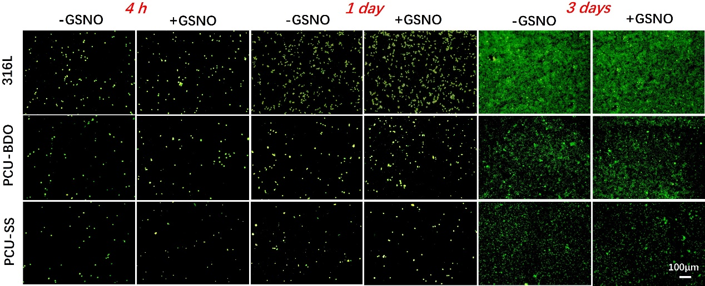
Fig. S1. Cal-AM fluorescence staining of MA on the different samples surface.

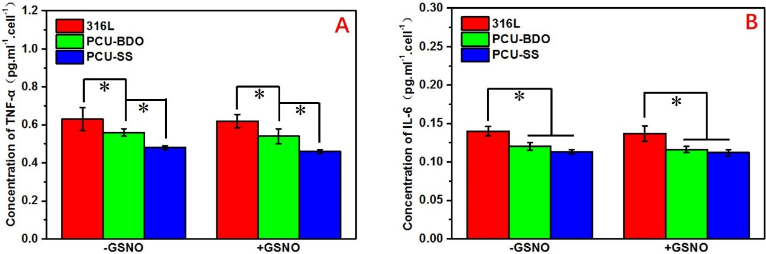
Fig. S2. (A) Quantitative analysis of TNF-α and (B) IL-6 of MA cultured for 3 days.

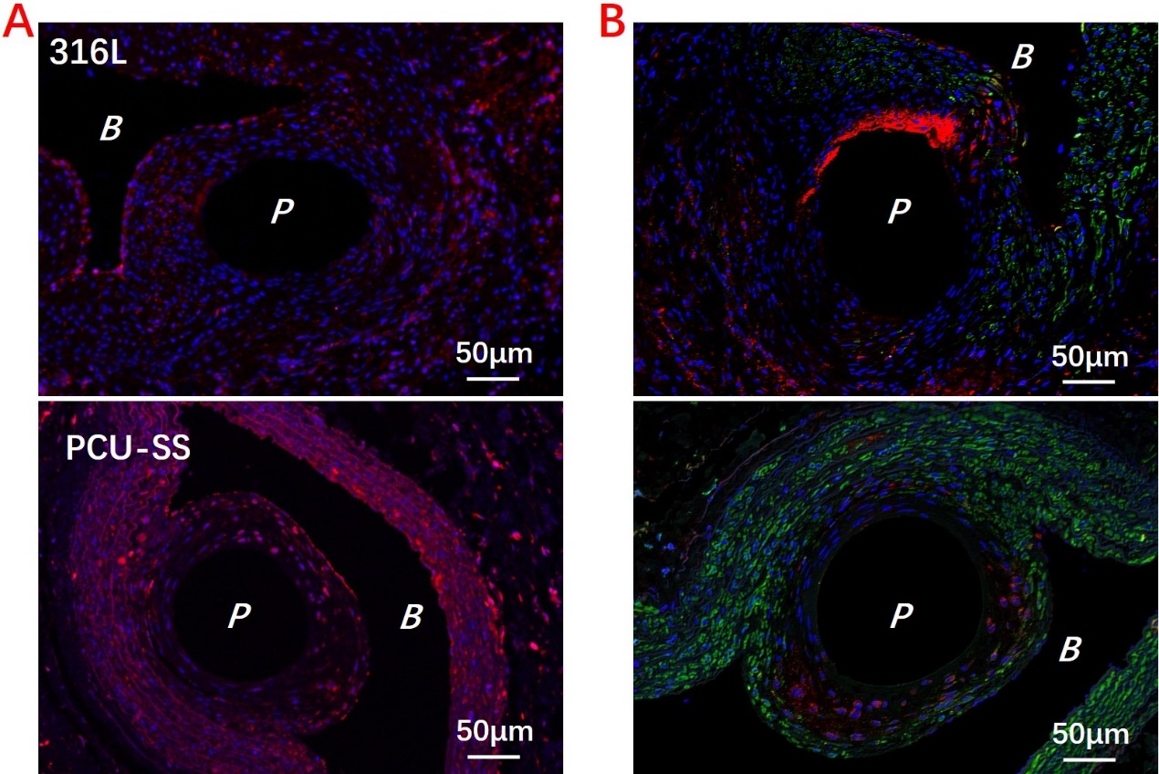
Fig. S3. Immunofluorescence staining results. (A) CD 206 staining of regenerated tissue (red is the positive expression of M2-type macrophage). (B) The results of α-SMA and OPN double staining of regenerated tissue (red is the positive expression of OPN of synthetic SMC, green is the positive expression of α-SMA of contractile SMC, P is the location of sample implantation, B is the location of blood flow).

