Supplementary Table 1：The results of the quality evaluation of the included studies（1）
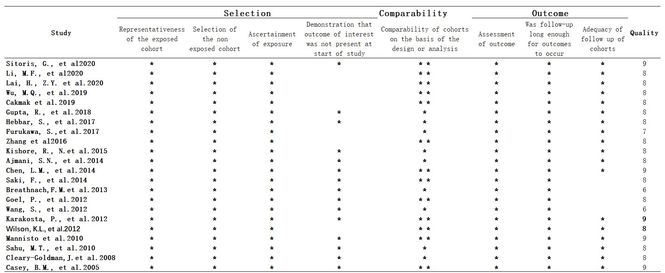
Supplementary Fig 1：model stability was judged by different effect models(2)
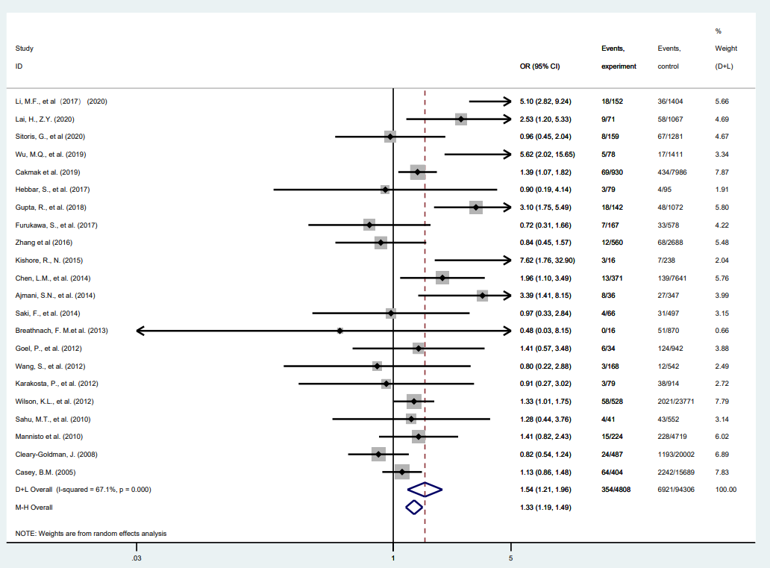

Supplementary Fig2：The results of sensitivity analysis was assessed by investigating the effects of individual studies one by one according to different effect scales.
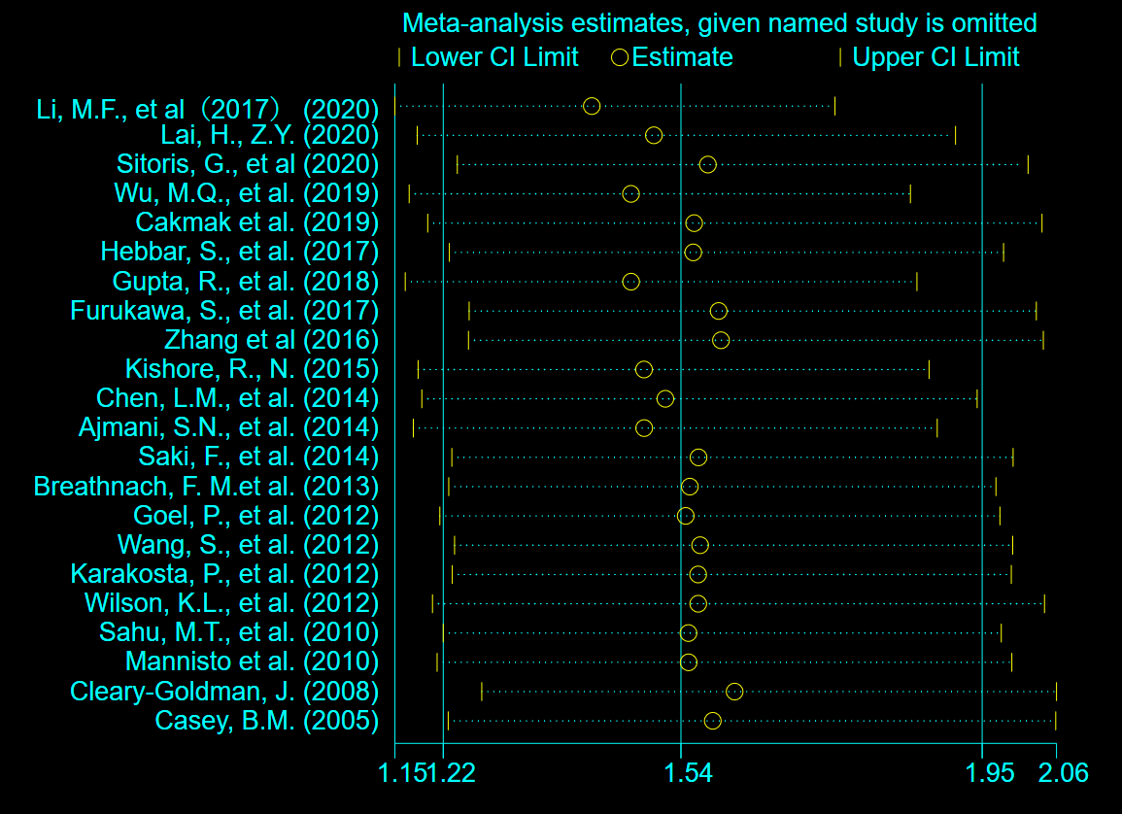
References:
- Wells GA, Shea B, O’Connell D, Peterson J, Welch V, Losos M, et al., The Newcastle-Ottawa Scale (NOS) for assessing the quality of nonrandomized studies in meta-analyses. Available at: www.ohri.ca/programs/clinical_epidemiology/oxford.asp (accessed June 30, 2015)
- DerSimonian R, Laird N 1986 Meta-analysis in clinicaltrials. Control Clin Trials 7:177–188.

