**Optimize the Preparation of Novel Pyrite Tailings Based Non-Sintered Ceramsite (PTNC) by Plackett-Burman Design Combined with Response Surface Method For Phosphorus Removal**

Ruihuan Chen1,2, Zhenlin Pan1, Shuyi Chu3, Jibo Xiao1*, Rengui Weng4, Da Ouyang5, Yunlong Yang1, Xiangting Wu1 and Zhida Huang6*

1College of Life and Environmental Science, Wenzhou University, Wenzhou, China

2Zhejiang Provincial Key Laboratory for Water Environment and Marine Biological Resources Protection, Wenzhou University, Wenzhou, China

3Wenzhou Academy of Agricultural Sciences, Wenzhou, China

4Indoor Environment Engineering Research Center of Fujian Province, Fujian University of Technology, Fuzhou, China

5Key Laboratory of Soil Contamination Bioremediation of Zhejiang Province, School of Environmental and Resource Sciences, Zhejiang Agriculture and Forestry University, Hangzhou, China

6Wenzhou Institute of Industry and Science, Wenzhou, China

*Co-corresponding authors:

Jibo Xiao [(jbxiao@wzu.edu.cn);](mailto:(jbxiao@wzu.edu.cn);)

Zhida Huang [(40098008@qq.com)](mailto:(40098008@qq.com))

**Acknowledgments:** The authorsappreciate all the participants.

**Text S1** Adsorption kinetic models

Nonlinear form pseudo fist-order:

${\text{q}}_{\text{t}}\text{=}{\text{q}}_{\text{e}}\text{(1-}{\text{e}}^{\text{-kt}}\text{)}$ (S1)

where qt is the adsorption amount at time t (mg/g), qe is the equilibrium adsorption amount (mg/g), and k1 is the equilibrium rate constant of the model (min-1).

Nonlinear formula of pseudo second-order model:

${\text{q}}_{\text{t}}\text{=}\frac{{\text{q}}_{\text{e}}^{\text{2}}{\text{k}}_{\text{2}}\text{t}}{\text{1+}{\text{q}}_{\text{e}}{\text{k}}_{\text{2}}\text{t}}$ (S2)

where k2 is the pseudo second-order rate constant (mg/g/min).

**Text S2** Adsorption isotherm models

Langmuir empirical model:

${\text{q}}_{\text{e}}\text{=}\frac{{\text{q}}_{\text{m}}{\text{k}}_{\text{L}}{\text{C}}_{\text{e}}}{\text{1+}{\text{k}}_{\text{L}}{\text{C}}_{\text{e}}}$ (S3)

where Ce (mg/L) is the equilibrium adsorbate concentration in liquid, qm and kL are the Langmuir maximum adsorption capacity and the energy related constant respectively.

The Freundlich isotherm is described as the following equation:

${\text{q}}_{\text{e}}\text{=}{\text{k}}_{\text{F}}{\text{C}}_{\text{e}}^{{\text{1}}/{\text{n}}}$ (S4)

where kF is the Freundlich constant and n is the heterogeneity factor (Freundlich coefficient).

**Text S3** Thermodynamic parameters calculation method

The free energy of adsorption (∆G), enthalpy of adsorption (∆H), and entropy of adsorption (∆S) during the adsorption process by PTNC was be calculated as with following equations:

$\text{∆G=-RT}\text{ln}{\text{K}}$ (S5)

$\text{ln}{\text{K}}\text{=}\frac{\text{∆S}}{\text{R}}\text{-}\frac{\text{∆H}}{\text{RT}}$ (S6)

Where R is the universal gas constant, 8.314 (J/mol/K); T (K) is the absolute solution temperature; K is the dimensionless thermodynamic equilibrium constant. The ΔH and ΔS values are calculated from the slope and intercept of the plot with the plot of lnK versus 1/T. Before the calculation process, the K gained from the best fitted model (Langmuir isotherm) need to be recalculated by multiplying it by 106 to become dimensionless, due to its unit was L/mg.

**Table S1** Chemical composition of original pyrite tailings

|  |  |  |  |  |  |  |
| --- | --- | --- | --- | --- | --- | --- |
| Composition | S | Fe | Si | P | C | Mn |
| Percent (%) | 45.32 | 50 | 2.2 | 0.23 | 0.26 | 0.4 |

**Table S2** Chemical composition of dehydrated sludge

|  |  |  |  |  |  |  |  |
| --- | --- | --- | --- | --- | --- | --- | --- |
| Composition | SiO2 | Al2O3 | Fe2O3 | CaO | MgO | Na2O | K2O |
| Percent (%) | 63.51 | 17.21 | 6.53 | 0.96 | 3.65 | 1.71 | 2.89 |

**Table S3** List of levels and factors of Plackett-Burman experiment

|  |  |  |  |
| --- | --- | --- | --- |
| Factors | Code | Levels | |
| -1 | +1 |
| Cement | A | 10 | 30 |
| Calcium lime | B | 1 | 3 |
| Anhydrous gypsum | C | 1 | 3 |
| Dehydrated sludge | D | 2 | 6 |
| Sodium bicarbonate | E | 0.5 | 1.5 |

**Table S4** Variables and levels in Box-Behnken design response surface method

|  |  |  |  |
| --- | --- | --- | --- |
| Levels | Factors | | |
| X1  Dehydrated sludge (g) | X2  Sodium bicarbonate (g) | X3  Cement (g) |
| -1 | 2 | 0.5 | 10 |
| 0 | 4 | 1 | 20 |
| +1 | 6 | 1.5 | 30 |

**Table S5** Analysis results of specific surface area and pore size with BET method

|  |  |  |  |
| --- | --- | --- | --- |
| Parameters | Units | Original PTNC | PTNC after adsorption |
| Specific surface area | m²·g-1 | 7.21 | 11.39 |
| Average pore volume | cm³·g-1 | 0.024 | 0.029 |
| Average pore aperture | nm | 13.42 | 10.08 |

**Table S6** Physical characteristics of PTNC

|  |  |  |
| --- | --- | --- |
| Indicators | Standard value | PTNC performance |
| Water adsorption (%) | 22 | 25.08 |
| Cylinder compressive strength (MPa) | 1.0 | 1.80 |
| Porosity (%) | ≥40 | 53.90 |
| Solubility in hydrochloric acid (%) | ≤2 | 5.36 |
| Specific surface area (m2/g) | 0.5 | 7.21 |
| Wear rate (%) | ≤6 | 2.08 |
| Silt content (%) | ≤1 | 0.54 |

**Table S7** The concentrations of heavy metals in the PTNC leachate

|  |  |  |  |  |  |  |
| --- | --- | --- | --- | --- | --- | --- |
|  | Cu | Pb | Cr | Zn | Ni | Cd |
| Detected value (mg/L) | 0.096 | 0.003 | 0.007 | 0.258 | 0.002 | 0.012 |
| Standard limitation （mg/L） | 100 | 5 | 5 | 100 | 5 | 1 |

**Table S8** The fitted parameters of two adsorption dynamic models

|  |  |  |  |  |  |
| --- | --- | --- | --- | --- | --- |
| Pseudo first order | | | Pseudo second order | | |
| qe1 (mg/g) | k1 (1/h) | R2 | qe2 (mg/g) | k2 (g/mg/h) | R2 |
| 0.2995 | 0.1661 | 0.9155 | 0.3527 | 0.4691 | 0.9100 |

**Table S9** The isothermal adsorption model parameters of TP adsorption

|  |  |  |  |  |  |  |
| --- | --- | --- | --- | --- | --- | --- |
| T (K) | Langmuir | | | Freundlich | | |
| qm (mg/g) | KL (L/mg) | R2 | KF (L/mg) | n (L/g) | R2 |
| 293 | 6.9603 | 0.8543 | 0.9421 | 3.0483 | 0.2487 | 0.8348 |
| 303 | 6.9824 | 0.8678 | 0.9574 | 3.0880 | 0.2495 | 0.8382 |
| 313 | 6.9978 | 1.1648 | 0.8530 | 3.2436 | 0.2353 | 0.7875 |

**Table S10** Thermodynamic parameters for TP adsorption by PTNC

| T (K) | ∆G (kJ/mol) | ∆H (kJ/mol) | ∆S (J/mol/K) |
| --- | --- | --- | --- |
| 293 | -33.27 | -11.69 | 153.09 |
| 303 | -34.45 |  |  |
| 313 | -36.35 |  |  |



**Fig. S1** XRD pattern of pyrite tailings

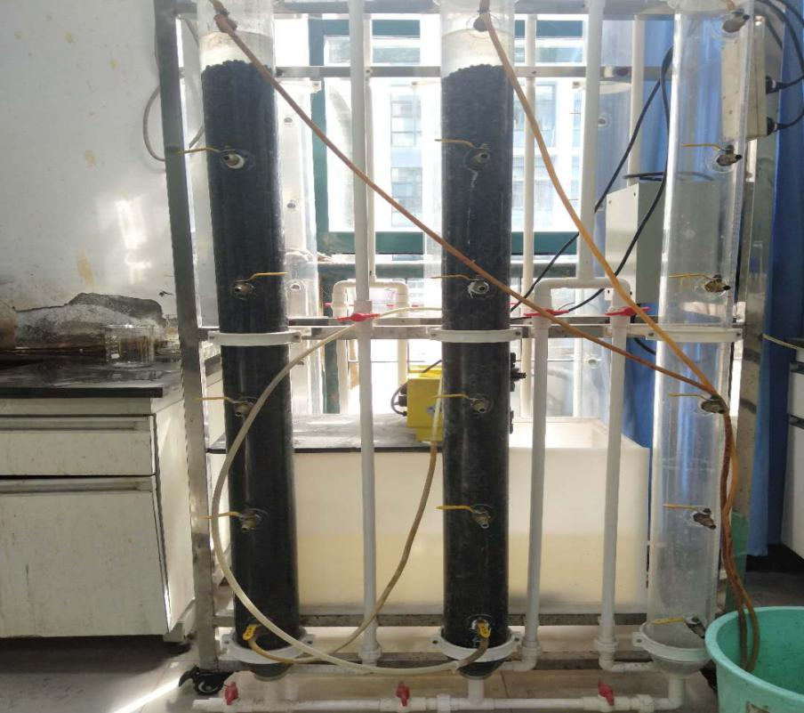

**Fig. S2** Experimental device for dynamic adsorption experiment



**Fig.S3** Comparison analysis of experimental and predicted TP removal rates



**Fig. S4** Comparison XRD analysis of pyrite tailings, PTNC before and after adsorption of TP.

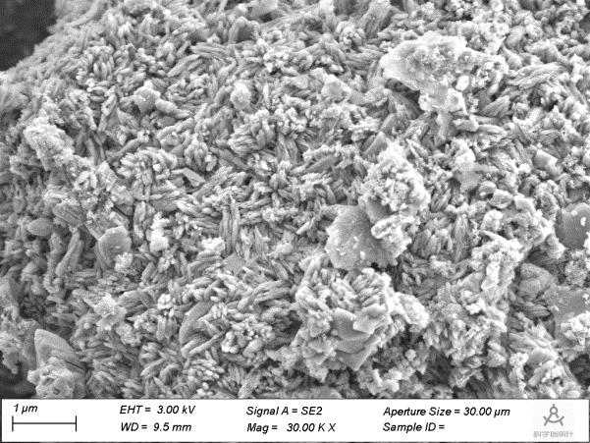

**Fig. S5** SEM image of PTNC after adsorption