SUPPLEMENTARY TABLES

Supplementary Table 1. Summary of the Ion Torrent sequencing output data per examined Culicoides species
Examined Species | Total number of reads | Total length of reads (bp) * | Average read length (bp) * | Total number of ribosomal reads
Culicoides submaritimus | 10,892,044 | 1,444,833,960 | 132.65 | 2,279,102
Culicoides puncticollis | 8,591,840 | 879,408,040 | 102.35 | 2,306,105
Culicoides punctatus | 6,841,815 | 788,228,875 | 115.21 | 2,165,325
Culicoides obsoletus | 8,657,213 | 1,011,616,616 | 116.85 | 2,929,777
Culicoides newsteadi | 8,909,863 | 956,427,876 | 107.34 | 2,436,390
Culicoides univittatus | 9,583,731 | 1,332,632,947 | 139.05 | 2,506,822
Culicoides imicola | 8,487,736 | 932,411,313 | 109.85 | 3,846,669
Culicoides circumscriptus | 7,990,698 | 902,660,195 | 112.96 | 2,138,815
Culicoides haranti | 6,100,232 | 619,211,858 | 101.51 | 1,228,554
Culicoides cataneii | 6,658,220 | 673,846,774 | 101.21 | 1,335,499
- Read lengths post quality trimming
Supplementary Table 2. Summary of the TRINITY assembly program output data. The depicted arithmetic values correspond to the average of 3 TRINITY assembly runs per examined Culicoides species.
Examined Species | Total number of sequences | Total length of sequences (bp) | Average sequence length (bp)
Culicoides submaritimus | 2,048 | 933,569 | 455.80
Culicoides puncticollis | 1,057 | 473,764 | 448.38
Culicoides punctatus | 1,146 | 514,779 | 449.10
Culicoides obsoletus | 1,341 | 604,724 | 450.77
Culicoides newsteadi | 1,178 | 492,306 | 417.95
Culicoides univittatus | 1,735 | 809,768 | 466.64
Culicoides imicola | 777 | 355,404 | 456.95
Culicoides circumscriptus | 1,758 | 848,660 | 482.68
Culicoides haranti | 785 | 355,763 | 453.25
Culicoides cataneii | 829 | 375,822 | 453.26

Supplementary Table 3. Viruses identified in the study with their NCBI GenBank accession number.
Virus | Accession number | Virus | Accession number
Obsoletus Partiti-like virus | MZ771201  MZ771202 | Submaritimus Rhabdo-like virus | MZ771215  MZ771216  MZ771217
Cataneii Bunya-like virus | MZ771203  MZ771204  MZ771205 | Haranti Chuvirus | MZ771218  MZ771219
Cataneii Chu-like virus | MZ771206 | Submaritimus Reo-like virus | MZ771220  MZ771221  MZ771222  MZ771223
Cataneii Rhabdo-like virus | MZ771207  MZ771208 | Obsoletus Rhabdo-like virus | MZ771224  MZ771225  MZ771226
Obsoletus Chaq virus | MZ771209 | Puncticollis Orthomyxo-like virus | MZ771227  MZ771228  MZ771229  MZ771230
Univittatus Rhabdo-like virus | MZ771210 | Punctatus Phasma virus | MZ771231  MZ771232
Circumscriptus Flavi-like virus | MZ771211  MZ771212  MZ771213  MZ771214 | Univittatus Sobemo-like virus | MZ771233  MZ771234

Supplementary Table 4. Total number of viral reads and viral abundance per virus from the studied Culicoides samples.
Virus family | Virus name | Mapped reads* | Viral abundance** | Mapped reads  average length
Solemoviridae | Univittatus sobemo-like virus | 1945 | 203.2 | 149.25
Phasmaviridae | Punctatus phasma virus | 87 | 5.0 | 132.79
Phenuiviridae | Cataneii bunya-like virus | 309 | 46.4 | 111.4
Partitiviridae | Obsoletus partiti-like virus | 7248 | 837.8 | 135.56
Reoviridae | Submaritimus reo-like virus | 1913 | 175.7 | 143.36
Chuviridae | Haranti Chuvirus | 354 | 58.0 | 106.72
 | Cataneii chu-like virus | 56 | 4.4 | 99.1
Orthomyxoviridae | Puncticollis orthomyxo-like virus | 240 | 27.7 | 109.18
Rhabdoviridae | Submaritimus rhabdo-like virus | 1524 | 140.6 | 144.42
 | Obsoletus rhabdo-like virus | 1050 | 121.3 | 129.01
 | Univittatus rhabdo-like virus | 122 | 12.7 | 150.57
 | Cataneii rhabdo-like virus | 119 | 17.9 | 112.61
Flaviviridae | Circumscriptus flavi-like virus | 4952 | 620.3 | 120.97
Unclassified | Obsoletus Chaq virus | 1589 | 183.5 | 125.88

* Number of reads after BWA alignment running with default parameters between each assembled viral sequence and the respective NGS sample which was predominantly used for virus assembly.
** Viral abundances calculated by the RSEM software expressed in transcripts per million (TPM).

Supplementary Table 5. Number of individuals collected per Culicoides species and in total (areas are marked on the Supplementary figure)
Examined Species | Number of individuals | Area 1 | Area 2 | Area 3 | Area 4 | Area 5
Culicoides submaritimus | 19 | 2 | 3 | 2 | 3 | 9
Culicoides puncticollis | 620 | 120 | 65 | 35 | 176 | 224
Culicoides punctatus | 412 | 19 | 12 | 6 | 128 | 247
Culicoides obsoletus | 312 | 23 | 56 | 12 | 176 | 45
Culicoides newsteadi | 664 | 287 | 58 | 78 | 143 | 98
Culicoides univittatus | 124 | 16 | 23 | 12 | 34 | 39
Culicoides imicola | 104 | 25 | 2 | 2 | 28 | 47
Culicoides circumscriptus | 60 | 5 | 12 | 34 | 2 | 7
Culicoides haranti | 32 | 7 | 3 | 2 | 8 | 12
Culicoides cataneii | 17 | 2 | 3 | 3 | 4 | 5
TOTAL | 2364 | 505 | 237 | 187 | 702 | 733

Supplementary Table 6. NCBI GenBank accession number list of cytochrome c oxidase subunit 1 (COI) sequences used for barcoding.
Examined Species | GenBank Accession number
Culicoides submaritimus | MZ695761
Culicoides puncticollis | MZ695762
Culicoides punctatus | MZ695763
Culicoides obsoletus | MZ695764
Culicoides newsteadi | MZ695765
Culicoides univittatus | MZ695766
Culicoides imicola | MZ695767
Culicoides circumscriptus | MZ695768
Culicoides haranti | MZ695769
Culicoides cataneii | MZ695770

Supplementary Table 7. Accession number list of the studied Culicoides species after submission to NCBI SRA database.
Examined Species | SRA Accession number
Culicoides submaritimus | SRR15194102
Culicoides puncticollis | SRR15194470
Culicoides punctatus | SRR15194673
Culicoides obsoletus | SRR15194737
Culicoides newsteadi | SRR15194766
Culicoides univittatus | SRR15194765
Culicoides imicola | SRR15194764
Culicoides circumscriptus | SRR15194763
Culicoides haranti | SRR15194762
Culicoides cataneii | SRR15194761

SUPPLEMENTARY FIGURE
a

b

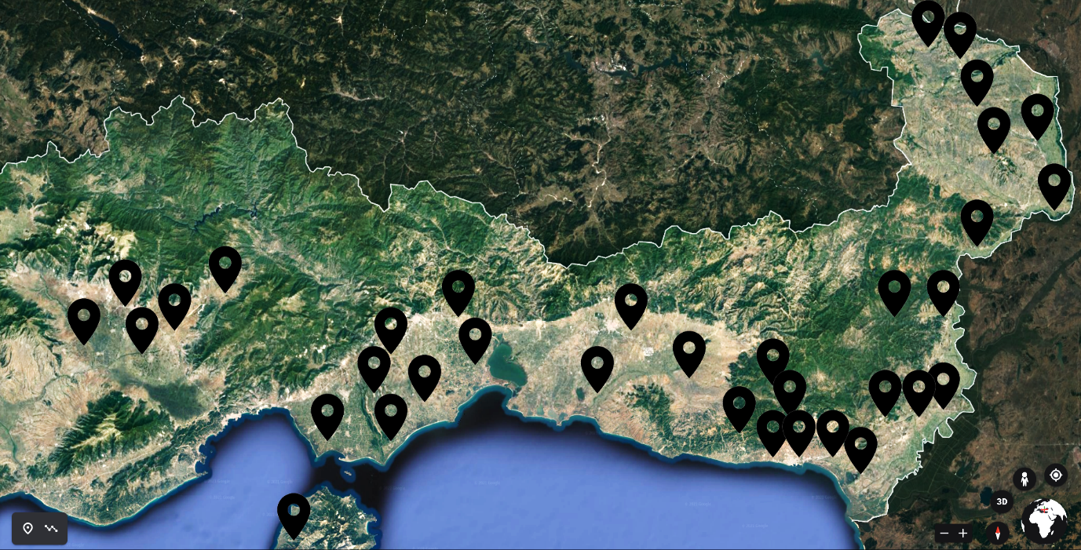
5
4
3
2
1
Supplementary Figure 1. a) Geopolitical map including in red shade the region of Thrace, Greece. b) Physical map of the collection sites in the Thrace region of Greece. The collections were organized into 5 smaller geographical areas Drama (1), Xanthi (2), Rhodopi (3), South Evros (4), North Evros (5). The area is bordered to the north with Bulgaria and to the East with Turkey. Location black marks indicate the collection sites.

