Supplementary Material
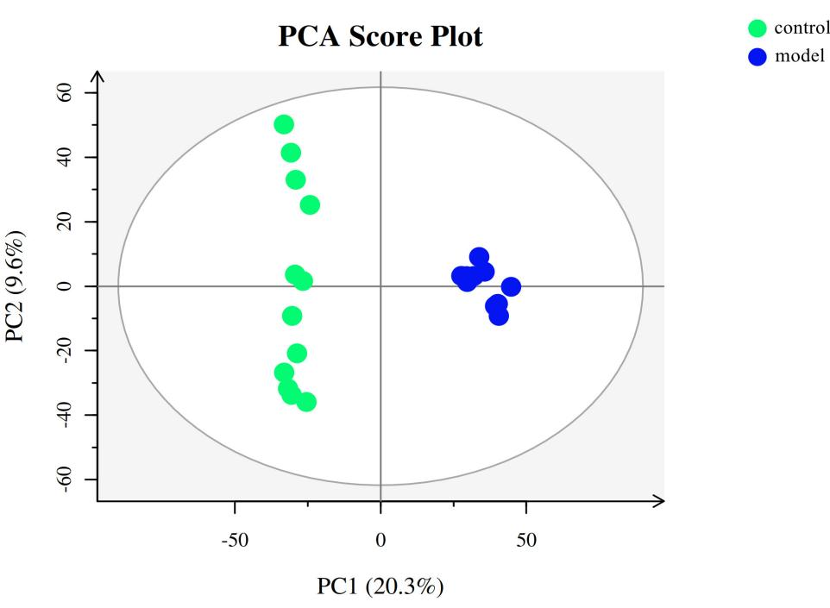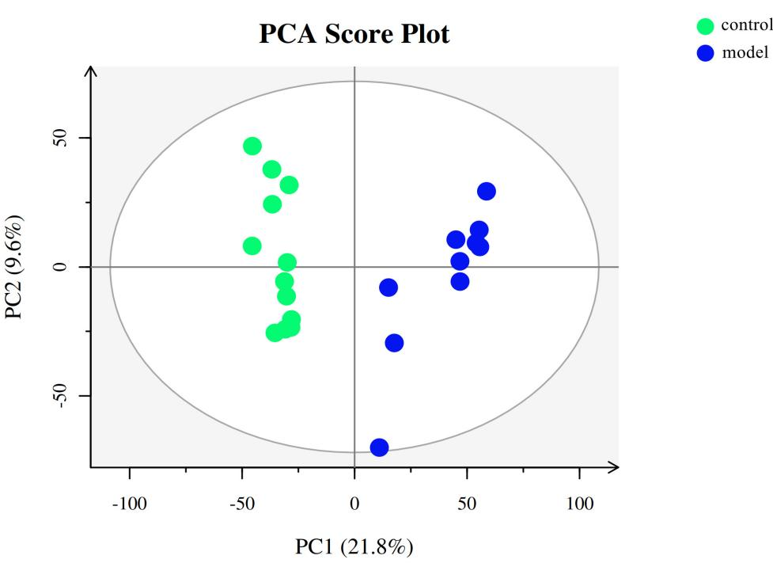
A
B
Supplementary Figure S1. PCA score plot of (A) positive ion mode data and (B) negative ion mode data.

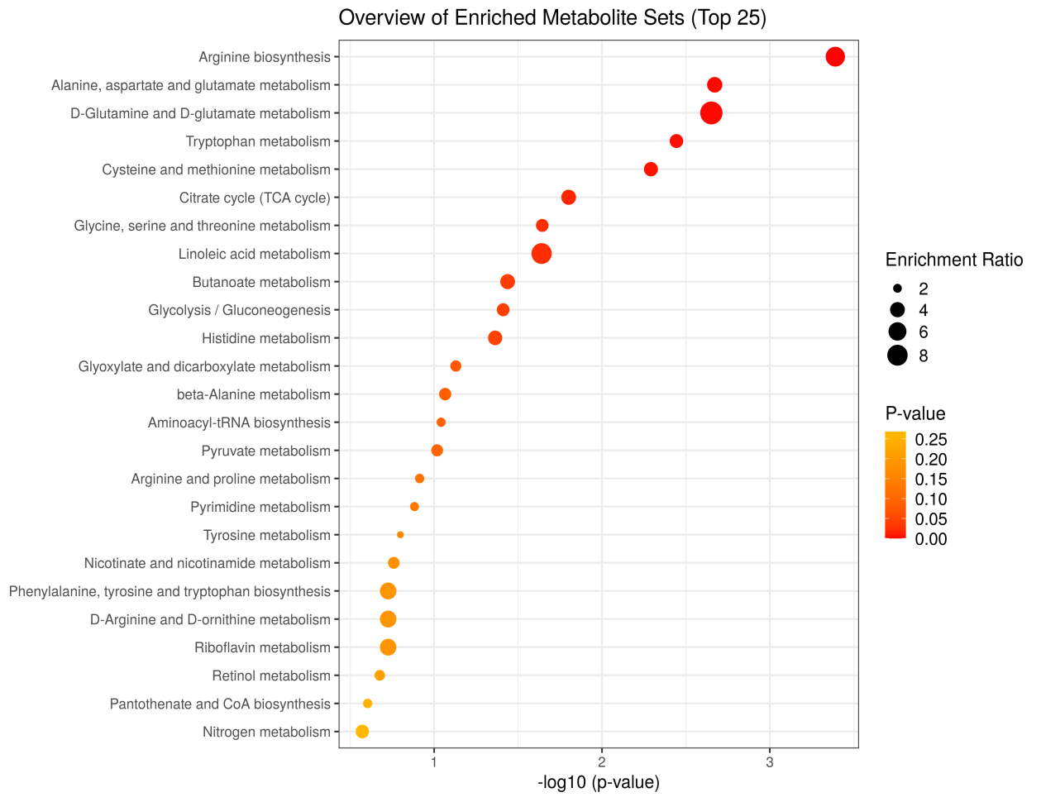
A
B
Supplementary Figure S2. Results of pathway analysis. (A) Bubble chart of pathway analysis. (B) Enrichment analysis.

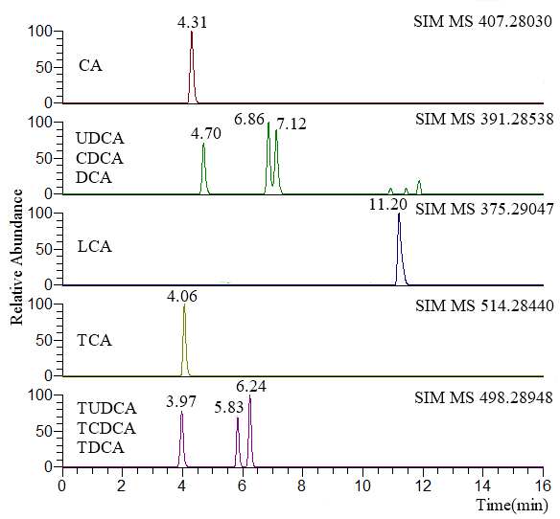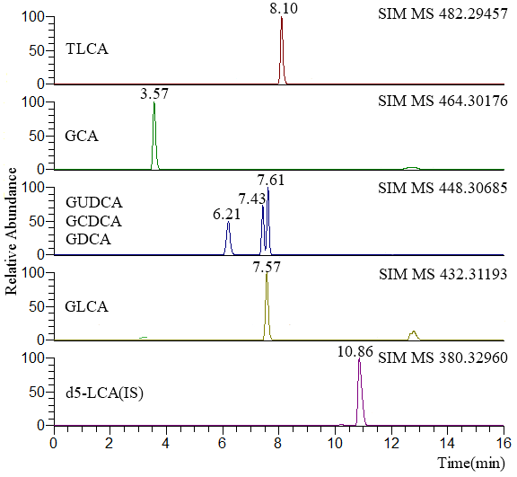
Supplementary Figure S3. Chromatographic separation of 15 bile acids and internal standard.
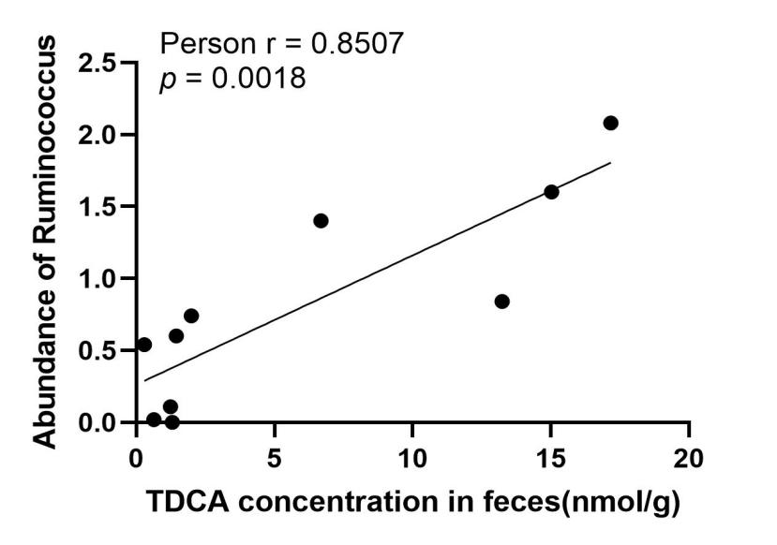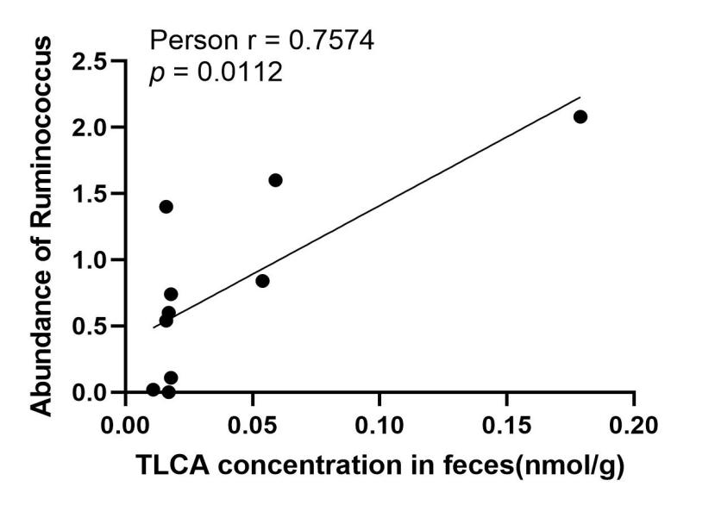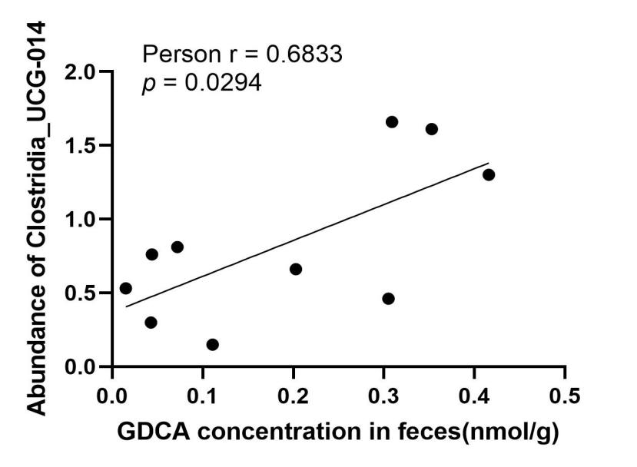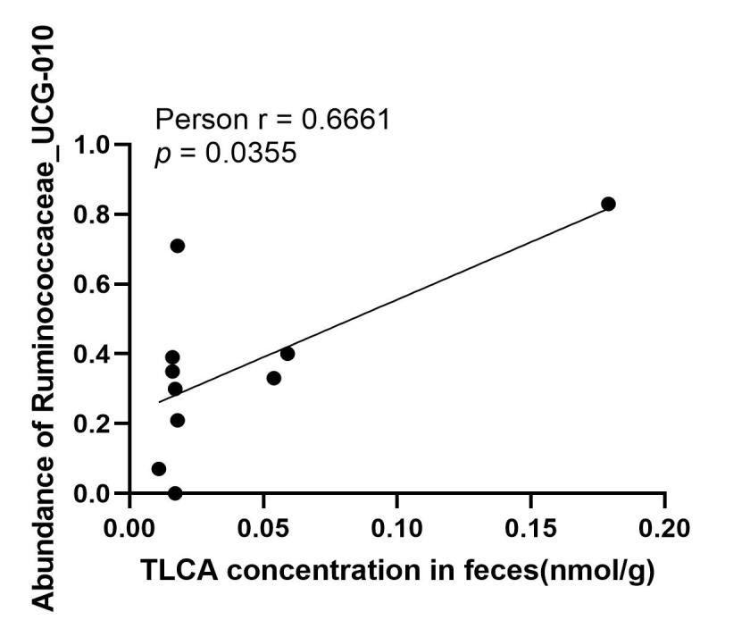
A
B
C
D
Supplementary Figure S4. Pearson’s correlation and linear regression analysis of the identified microbiotic abundance and secondary bile acid concentrations in the feces.

Supplementary Table S1.The proportion of solvent during gradient elution for untargeted metabonomics.FA:formic acid, AF:ammonium formate, ACN:acetonitrile
Time(min) | solvent A(%) | solvent B(%)
 | pos:0.1%FA-water  neg:5mM AF-water | pos:0.1%FA-ACN  neg:ACN
0 | 98 | 2
1 | 98 | 2
9 | 50 | 50
12 | 2 | 98
13.5 | 2 | 98
14 | 98 | 2
20-pos/17-neg | 98 | 2
Supplementary Table S2. Detail KEGG pathway analysis results
Pathway | Total | Hits | p value | FDR | Impact
Arginine biosynthesis | 14 | 5 | 0.0004 | 0.0359 | 0.1929
Alanine, aspartate and glutamate metabolism | 28 | 6 | 0.0022 | 0.0944 | 0.5577
Tryptophan metabolism | 41 | 7 | 0.0038 | 0.1070 | 0.3269
Cysteine and methionine metabolism | 33 | 6 | 0.0054 | 0.1130 | 0.1292
Histidine metabolism | 16 | 4 | 0.0072 | 0.1208 | 0.1393
Citrate cycle (TCA cycle) | 20 | 4 | 0.0164 | 0.2293 | 0.1847
beta-Alanine metabolism | 21 | 4 | 0.0195 | 0.2336 | 0.1605
Linoleic acid metabolism | 5 | 2 | 0.0233 | 0.2451 | 1.0000
Glycine, serine and threonine metabolism | 34 | 5 | 0.0266 | 0.2482 | 0.2556
D-Glutamine and D-glutamate metabolism | 6 | 2 | 0.0339 | 0.2805 | 0.5000
Butanoate metabolism | 15 | 3 | 0.0375 | 0.2805 | 0.0000
Glycolysis / Gluconeogenesis | 26 | 4 | 0.0401 | 0.2805 | 0.2078
Tyrosine metabolism | 42 | 5 | 0.0592 | 0.3826 | 0.1151
Glyoxylate and dicarboxylate metabolism | 32 | 4 | 0.0766 | 0.4596 | 0.0661
Aminoacyl-tRNA biosynthesis | 48 | 5 | 0.0941 | 0.5167 | 0.1667
Pyruvate metabolism | 22 | 3 | 0.0984 | 0.5167 | 0.2068
Arginine and proline metabolism | 38 | 4 | 0.1253 | 0.6190 | 0.2217
Pyrimidine metabolism | 39 | 4 | 0.1344 | 0.6274 | 0.0957
Nicotinate and nicotinamide metabolism | 15 | 2 | 0.1765 | 0.7136 | 0.0316
Phenylalanine, tyrosine and tryptophan biosynthesis | 4 | 1 | 0.1895 | 0.7136 | 0.0000
D-Arginine and D-ornithine metabolism | 4 | 1 | 0.1895 | 0.7136 | 0.0000
Riboflavin metabolism | 4 | 1 | 0.1895 | 0.7136 | 0.5000
Retinol metabolism | 16 | 2 | 0.1954 | 0.7136 | 0.4790
Fructose and mannose metabolism | 18 | 2 | 0.2338 | 0.8183 | 0.2736
Pantothenate and CoA biosynthesis | 19 | 2 | 0.2532 | 0.8507 | 0.0286
Nitrogen metabolism | 6 | 1 | 0.2705 | 0.8660 | 0.0000
Arachidonic acid metabolism | 36 | 3 | 0.2784 | 0.8660 | 0.3192
Pentose phosphate pathway | 22 | 2 | 0.3114 | 0.9342 | 0.1356
Valine, leucine and isoleucine biosynthesis | 8 | 1 | 0.3435 | 0.9619 | 0.0000
Taurine and hypotaurine metabolism | 8 | 1 | 0.3435 | 0.9619 | 0.0000
Ubiquinone and other terpenoid-quinone biosynthesis | 9 | 1 | 0.3773 | 1.0000 | 1.0000
Ascorbate and aldarate metabolism | 10 | 1 | 0.4093 | 1.0000 | 0.0000
Glutathione metabolism | 28 | 2 | 0.4242 | 1.0000 | 0.0268
Phenylalanine metabolism | 12 | 1 | 0.4686 | 1.0000 | 0.2381
alpha-Linolenic acid metabolism | 13 | 1 | 0.4960 | 1.0000 | 0.0000
Starch and sucrose metabolism | 15 | 1 | 0.5466 | 1.0000 | 0.0068
Sphingolipid metabolism | 21 | 1 | 0.6704 | 1.0000 | 0.0000
Primary bile acid biosynthesis | 46 | 2 | 0.6935 | 1.0000 | 0.0229
Propanoate metabolism | 23 | 1 | 0.7037 | 1.0000 | 0.0406
Lysine degradation | 25 | 1 | 0.7336 | 1.0000 | 0.0470
Galactose metabolism | 27 | 1 | 0.7606 | 1.0000 | 0.0000
Porphyrin and chlorophyll metabolism | 30 | 1 | 0.7961 | 1.0000 | 0.0000
Biosynthesis of unsaturated fatty acids | 36 | 1 | 0.8523 | 1.0000 | 0.0000
Amino sugar and nucleotide sugar metabolism | 37 | 1 | 0.8600 | 1.0000 | 0.0873
Purine metabolism | 66 | 1 | 0.9711 | 1.0000 | 0.0046

