Supplementary Material

Supplementary Figures
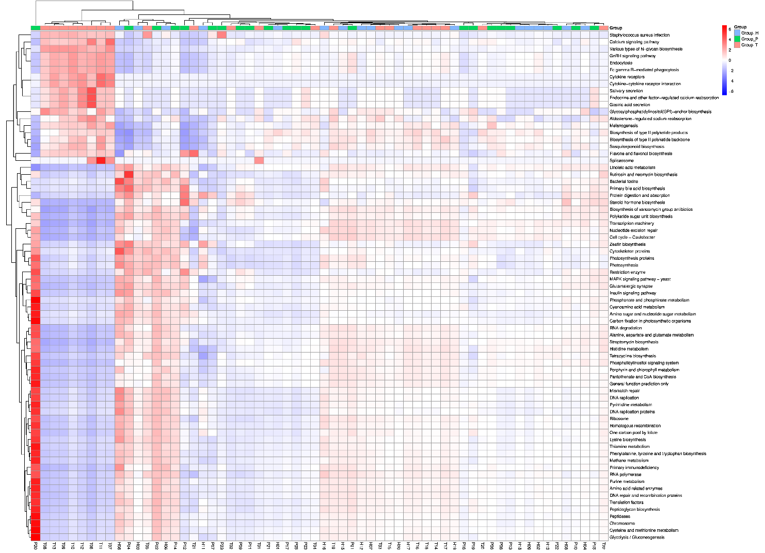
Supplementary Figure 1. Kyoto Encyclopedia of Genes and Genomes (KEGG) function prediction based on 16S rRNA sequencing.

Supplementary Figure 2. Relative expression of β-catenin (A) and E-cadherin (B) in tissues of healthy people and CRC patients (COAD, colon cancer; RECD, rectal cancer; T, Tumor patients; N, normal people).

