Supplementary material
Figure S1: Evaluation of the NorKyst800 model outputs into the Porsanger for (A) inner, (B) central, and (C) outer fjord.
The data used for the ground-truthing were collected by R. Mankettikkara and colleagues and were retrieved from the Arctic University of Tromsø database: https://dataverse.no/dataverse/uit?q=Mankettikkara&types=datasets&sort=score&order=desc&page=1. Those data are publicly available and contain values of salinity, temperature, and depth, collected into the Porsanger from the end of the 1970s until 2013. The sampling sites are not the same from one year to another and the time of the year it was collected also varies. Corresponding values were extracted from the NorKyst800 model outputs. Mean absolute error was computed in each area (sampling sites were grouped into an area corresponding to the ones used in this study, i.e. inner, central, outer).

Temporal trends are not significant, except for surface salinity in the central fjord (B) where the mean difference between model and observation significantly decreases.
A

C
B

Spatial bias was tested investigating whether there were significant differences in the mean difference across areas. This was done with a non-parametric multiple pairwise Kruskal-Wallis test, with the function kruskalmc from the pgirmess r package. In the results below, the “TRUE” difference shows a significant difference in the mean difference between the two areas.
Surface temperature | obs.dif | critical.dif | difference
central-inner | 11.22778 | 43.12029 | FALSE
central-outer | 42.80020 | 40.74757 | TRUE
inner-outer | 54.02798 | 51.59029 | TRUE

Bottom temperature | obs.dif | critical.dif | difference
central-inner | 83.015657 | 43.12029 | TRUE
central-outer | 7.339592 | 40.74757 | FALSE
inner-outer | 90.355248 | 51.59029 | TRUE

Surface salinity | obs.dif | critical.dif | difference
central-inner | 79.634848 | 43.12029 | TRUE
central-outer | 4.185968 | 40.74757 | FALSE
inner-outer | 75.448880 | 51.59029 | TRUE

Bottom salinity | obs.dif | critical.dif | difference
central-inner | 79.04141 | 43.12029 | TRUE
central-outer | 15.77036 | 40.74757 | FALSE
inner-outer | 63.27106 | 51.59029 | TRUE

Table S1: Megabenthic taxa grouping and full list of species
Explanations of the groupings of certain taxa due to phylogenic nesting.

(1) Taxa that had a lower taxonomic level also present in the dataset (for instance ophiura
sarsii grouped with ophiuroidea) were grouped together.
(2) Nevertheless, when the taxonomic level was too high (class for instance, such as bivalvia), the
taxa were deleted because it would have led to group too many different taxa (including boreal
and arctic taxa) together. For each grouping, a check of the spatial distribution was done (i.e. atlantic or arctic) to prevent from grouping boreal and arctic taxa together which could have weakened the trends of the biomass facing climate change.

For (1) I grouped:
• Nicomache and Maldanidae (both Atlantic+Arctic distribution) in Maldanidae
• Terebellidae, Thelepus (both Atlantic+Arctic distribution) in Terebellidae
• Gammarus, Liljeborgidae, Amphipoda, Arrhis phyllonyx , Anonyx (all Atlantic+Arctic distribution)
in Amphipoda
• Nymphon, Pycnogonida (both Atlantic+Arctic distribution) in Pycnogonida
• Terebratulida, Brachiopoda (both large distribution) in Brachiopoda
• Bryozoa, Reteporella (both large distribution) in Bryozoa
• Polycitoridae, Ascidiacea, Molgulidae, Styelidae (both large distribution) in Ascidiacea
• Edwardsiidae, Hormathiidae, Metridiidae, Actiniaria (all large distribution) in Actiniaria
• Haleciidae, Lafoeidae, Hydrozoa (all large distribution) in Hydrozoa
• Diplopteraster multipes, Pterasteridae (both Atlantic+Arctic distribution) in Pterasteridae
• Myriotrochidae, Cucumaria frondosa, Thyonidium, Psolus, Eupyrgus scaber, Holothuroidea (all large
or Atlantic + Arctic distribution) in Holothuroidea
• Ophiuridae, Ophiura robusta, Ophiura sarsii (all Atlantic+Arctic distribution) in Ophiuridae
• Euspira pallida, Naticidae (both Atlantic+Arctic distribution) in Naticidae
• Colus, Buccinidae, Neptunea (all Atlantic+Arctic distribution) in Buccinidae
• Polymastiidae, Tentorium semisuberites (all Atlantic+Arctic distribution) in Polymastiidae
• Golfingia, Nephasoma, Phascolion, Sipunculidea (all large distribution) in Sipunculidea
• Pandalus borealis and Pandalus montagui (both Atlantic+Arctic distribution) in Pandalidae

For (2) the following taxa were removed:
• Polychaeta that encompasses 22 other taxa in the database
• Asteroidea that encompasses 7 other taxa in the database
• Bivalvia that encompasses 23 other taxa in the database, notably the arctic chlamys islandica
• Pectinidae that encompasses 5 other taxa in the database, notably the arctic chlamys islandica
• Gastropoda that encompasses 18 other taxa in the database
• Porifera that encompasses 10 other taxa in the database

Dataset | Latin name | Phylum | Class | Order | Family
Benthos | Actiniaria | Cnidaria | Anthozoa | Actiniaria
Benthos | Ampharetidae | Annelida | Polychaeta | Terebellida | Ampharetidae
Benthos | Amphipoda | Arthropoda | Malacostraca | Amphipoda
Benthos | Anomiidae | Mollusca | Bivalvia | Pectinida | Anomiidae
Benthos | Ascidiacea | Chordata | Ascidiacea
Benthos | Astarte | Mollusca | Bivalvia | Carditida | Astartidae
Benthos | Axinellida | Porifera | Demospongiae | Axinellida
Benthos | Bathyarca glacialis | Mollusca | Bivalvia | Arcida | Arcidae
Benthos | Boreotrophon | Mollusca | Gastropoda | Neogastropoda | Muricidae
Benthos | Brachiopoda | Brachiopoda
Benthos | Brada | Annelida | Polychaeta | Terebellida | Flabelligeridae
Benthos | Bryozoa | Bryozoa
Benthos | Buccinidae | Mollusca | Gastropoda | Neogastropoda | Buccinidae
Benthos | Chlamys | Mollusca | Bivalvia | Pectinida | Pectinidae
Benthos | Chlamys islandica | Mollusca | Bivalvia | Pectinida | Pectinidae
Benthos | Ciliatocardium ciliatum | Mollusca | Bivalvia | Cardiida | Cardiidae
Benthos | Cirripedia | Arthropoda | Hexanauplia
Benthos | Cryptonatica affinis | Mollusca | Gastropoda | Littorinimorpha | Naticidae
Benthos | Ctenodiscus crispatus | Echinodermata | Asteroidea | Paxillosida | Ctenodiscidae
Benthos | Cylichna alba | Mollusca | Gastropoda | Cephalaspidea | Cylichnidae
Benthos | Diastylidae | Arthropoda | Malacostraca | Cumacea | Diastylidae
Benthos | Echinus | Echinodermata | Echinoidea | Camarodonta | Echinidae
Benthos | Epizoanthidae | Cnidaria | Anthozoa | Zoantharia | Epizoanthidae
Benthos | Euphausiidae | Arthropoda | Malacostraca | Euphausiacea | Euphausiidae
Benthos | Gorgonocephalus | Echinodermata | Ophiuroidea | Euryalida | Gorgonocephalidae
Benthos | Henricia | Echinodermata | Asteroidea | Spinulosida | Echinasteridae
Benthos | Hiatella | Mollusca | Bivalvia | Adapedonta | Hiatellidae
Benthos | Holothuroidea | Echinodermata | Holothuroidea
Benthos | Hyas | Arthropoda | Malacostraca | Decapoda | Oregoniidae
Benthos | Hydrozoa | Cnidaria | Hydrozoa
Benthos | Lebbeus polaris | Arthropoda | Malacostraca | Decapoda | Thoridae
Benthos | Lepetidae | Mollusca | Gastropoda |  | Lepetidae
Benthos | Lithodes maja | Arthropoda | Malacostraca | Decapoda | Lithodidae
Benthos | Maldanidae | Annelida | Polychaeta |  | Maldanidae
Benthos | Margaritidae | Mollusca | Gastropoda | Trochida | Margaritidae
Benthos | Munida sarsi | Arthropoda | Malacostraca | Decapoda | Munididae
Benthos | Mysidae | Arthropoda | Malacostraca | Mysida | Mysidae
Benthos | Mytilus | Mollusca | Bivalvia | Mytilida | Mytilidae
Benthos | Naticidae | Mollusca | Gastropoda | Littorinimorpha | Naticidae
Benthos | Nematoda | Nematoda
Benthos | Nephtheidae | Cnidaria | Anthozoa | Alcyonacea | Nephtheidae
Benthos | Nephtyidae | Annelida | Polychaeta | Phyllodocida | Nephtyidae
Benthos | Nuculana | Mollusca | Bivalvia | Nuculanida | Nuculanidae
Benthos | Nudibranchia | Mollusca | Gastropoda | Nudibranchia
Benthos | Ophiacantha | Echinodermata | Ophiuroidea | Ophiacanthida | Ophiacanthidae
Benthos | Ophiopholis aculeata | Echinodermata | Ophiuroidea | Amphilepidida | Ophiopholidae
Benthos | Ophiuridae | Echinodermata | Ophiuroidea | Ophiurida | Ophiuridae
Benthos | Oweniidae | Annelida | Polychaeta |  | Oweniidae
Benthos | Pagurus | Arthropoda | Malacostraca | Decapoda | Paguridae
Benthos | Pandalidae | Arthropoda | Malacostraca | Decapoda | Pandalidae
Benthos | Paralithodes camtschaticus | Arthropoda | Malacostraca | Decapoda | Lithodidae
Benthos | Pectinariidae | Annelida | Polychaeta | Terebellida | Pectinariidae
Benthos | Polymastiidae | Porifera | Demospongiae | Polymastiida | Polymastiidae
Benthos | Polynoidae | Annelida | Polychaeta | Phyllodocida | Polynoidae
Benthos | Polyplacophora | Mollusca | Polyplacophora
Benthos | Pontophilus norvegicus | Arthropoda | Malacostraca | Decapoda | Crangonidae
Benthos | Pterasteridae | Echinodermata | Asteroidea | Velatida | Pterasteridae
Benthos | Pycnogonida | Arthropoda | Pycnogonida
Benthos | Rossia | Mollusca | Cephalopoda | Sepiida | Sepiolidae
Benthos | Sabellidae | Annelida | Polychaeta | Sabellida | Sabellidae
Benthos | Sabinea septemcarinata | Arthropoda | Malacostraca | Decapoda | Crangonidae
Benthos | Scaphopoda | Mollusca | Scaphopoda
Benthos | Sclerocrangon boreas | Arthropoda | Malacostraca | Decapoda | Crangonidae
Benthos | Similipecten greenlandicus | Mollusca | Bivalvia | Pectinida | Propeamussiidae
Benthos | Sipunculidea | Sipuncula | Sipunculidea
Benthos | Spiochaetopterus typicus | Annelida | Polychaeta |  | Chaetopteridae
Benthos | Spirontocaris | Arthropoda | Malacostraca | Decapoda | Thoridae
Benthos | Strongylocentrotus | Echinodermata | Echinoidea | Camarodonta | Strongylocentrotidae
Benthos | Terebellidae | Annelida | Polychaeta | Terebellida | Terebellidae
Benthos | Yoldia hyperborea | Mollusca | Bivalvia | Nuculanida | Yoldiidae
Benthos | Yoldiella | Mollusca | Bivalvia | Nuculanida | Yoldiidae
Fish | Amblyraja radiata | Vertebrata | Elasmobranchii | Rajiformes | Rajidae
Fish | Anarhichas lupus | Vertebrata | Actinopteri | Perciforms | Anarhichadidae
Fish | Argentina | Vertebrata | Actinopteri | Argentiniformes | Argentinidae
Fish | Artediellus atlanticus | Vertebrata | Actinopteri | Perciformes | Cottidae
Fish | Clupea harengus | Vertebrata | Actinopteri | Clupeiformes | Clupeidae
Fish | Enchelyopus cimbrius | Vertebrata | Actinopteri | Gadiformes | Lotidae
Fish | Gadiculus argenteus | Vertebrata | Actinopteri | Gadiformes | Gadidae
Fish | Gadus morhua | Vertebrata | Actinopteri | Gadiformes | Gadidae
Fish | Glyptocephalus cynoglossus | Vertebrata | Actinopteri | Pleuronectiformes | Pleuronectidae
Fish | Hippoglossoides platessoides | Vertebrata | Actinopteri | Pleuronectiformes | Pleuronectidae
Fish | Hippoglossus hippoglossus | Vertebrata | Actinopteri | Pleuronectiformes | Pleuronectidae
Fish | Leptoclinus maculatus | Vertebrata | Actinopteri | Perciformes | Stichaeidae
Fish | Lycodes gracilis | Vertebrata | Actinopteri | Perciformes | Zoarcidae
Fish | Mallotus villosus | Vertebrata | Actinopteri | Osmeridae | Osmeridae
Fish | Melanogrammus aeglefinus | Vertebrata | Actinopteri | Gadiformes | Gadidae
Fish | Merlangius merlangus | Vertebrata | Actinopteri | Gadiformes | Gadidae
Fish | Micromesistius poutassou | Vertebrata | Actinopteri | Gadiformes | Gadidae
Fish | Microstomus kitt | Vertebrata | Actinopteri | Pleuronectiformes | Pleuronectidae
Fish | Myctophiformes | Vertebrata | Actinopteri | Myctophiformes
Fish | Pleuronectes platessa | Vertebrata | Actinopteri | Pleuronectiformes | Pleuronectidae
Fish | Pollachius virens | Vertebrata | Actinopteri | Gadiformes | Gadidae
Fish | Rajella fyllae | Vertebrata | Elasmobranchii | Rajiformes | Rajidae
Fish | Sebastes | Vertebrata | Actinopteri | Perciformes | Sebastidae
Fish | Trisopterus esmarkii | Vertebrata | Actinopteri | Gadiformes | Gadidae

Fig. S2: Yearly distribution of the sampling sites amongst the areas of the fjord (inner, central, outer for megabenthos data set (A) and central and outer for fish data set (B)). Yearly distribution of sediment types amongst the sampling sites (for megabenthos data set (C) and fish data set (D)).
A
B
C
D

Fig. S3: Stratified biomass in the inner fjord. Only the 5 taxa with the largest biomass each year have their name printed.
Fig. S4: Regression plot corresponding to Table 1 and Table 2 of the manuscript.
Fig. S5: (A) Linear regression of the log(x+1) transformed stratified biomass of megabenthic warm-water and cold-water taxa (from the K-means clustering on the score of the two first axis of the compromise) over time. Equation of the regression, its r², and its p-value are printed for each group in each area of the fjord.
A

(B) Linear regression of the log(x+1) transformed stratified biomass of megabenthic cold-water taxa without red king crab Paralithodes camtschaticus.
B

Fig S6: Intrastructure plots for megabenthos: (A) yearly average position of environmental variables, (B) score of the environmental variables on axis 1 of the compromise, (C) yearly average position of the group of taxa from the Kmeans clustering, (D) score of the taxa on axis 1 of the compromise. Intrastructure plots for fish: (E) yearly average position of the group of taxa from the Kmeans clustering (F) score of the taxa on axis 1 of the compromise.
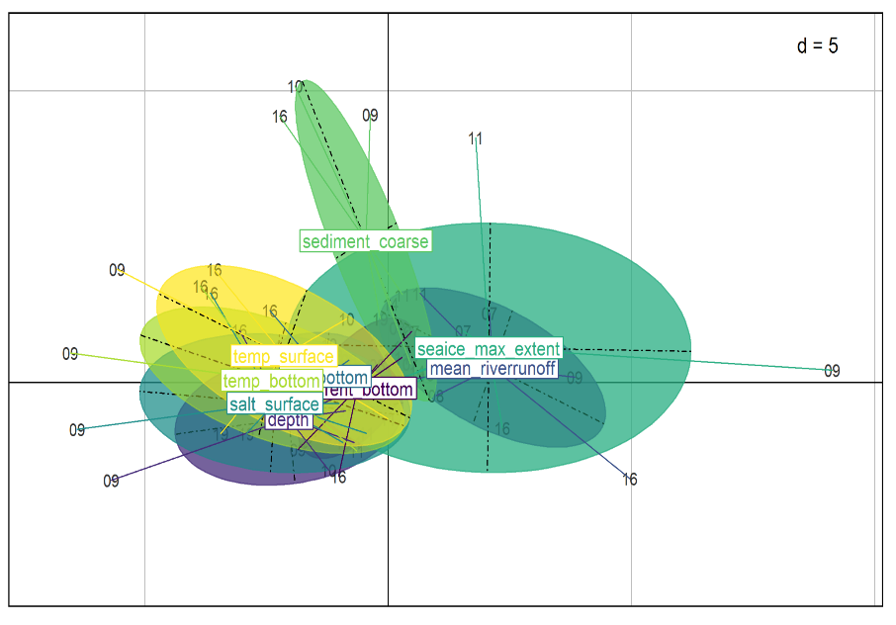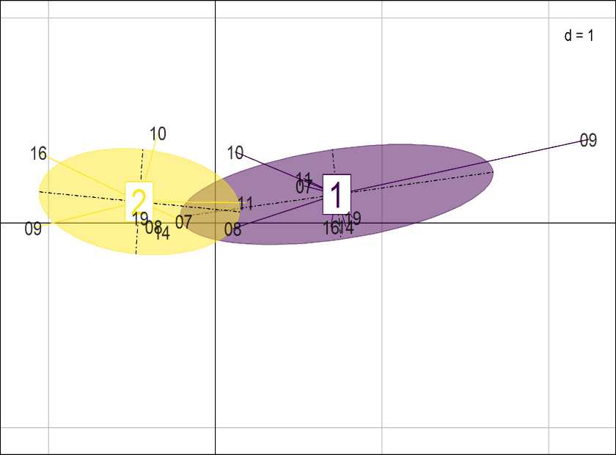
D
C
B
A

F
E

Fig S7: Yearly log(x+1) transformed stratified biomass (kg/km²) of fish taxa into the Porsanger.
