Supplementary Material

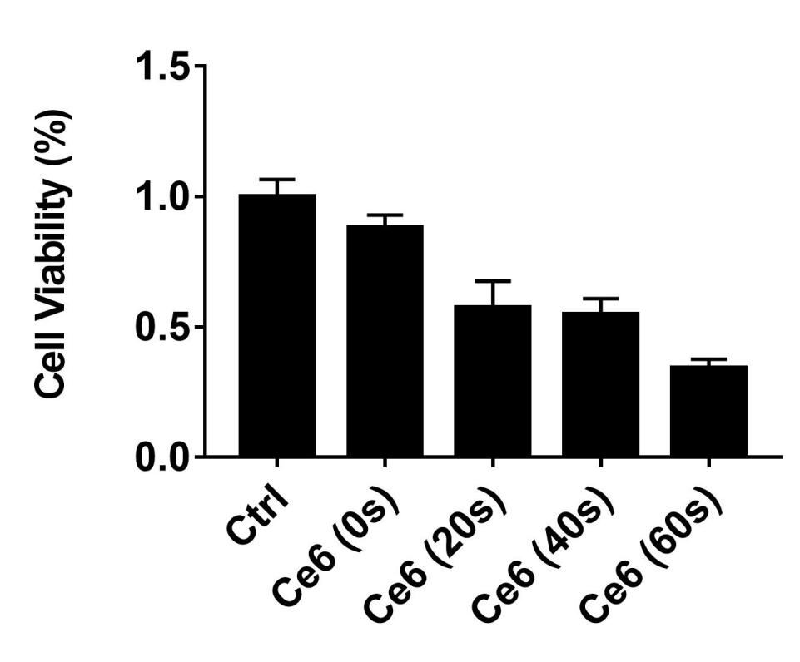
Fig. S1. Viability of macrophages at different laser irradiation time.

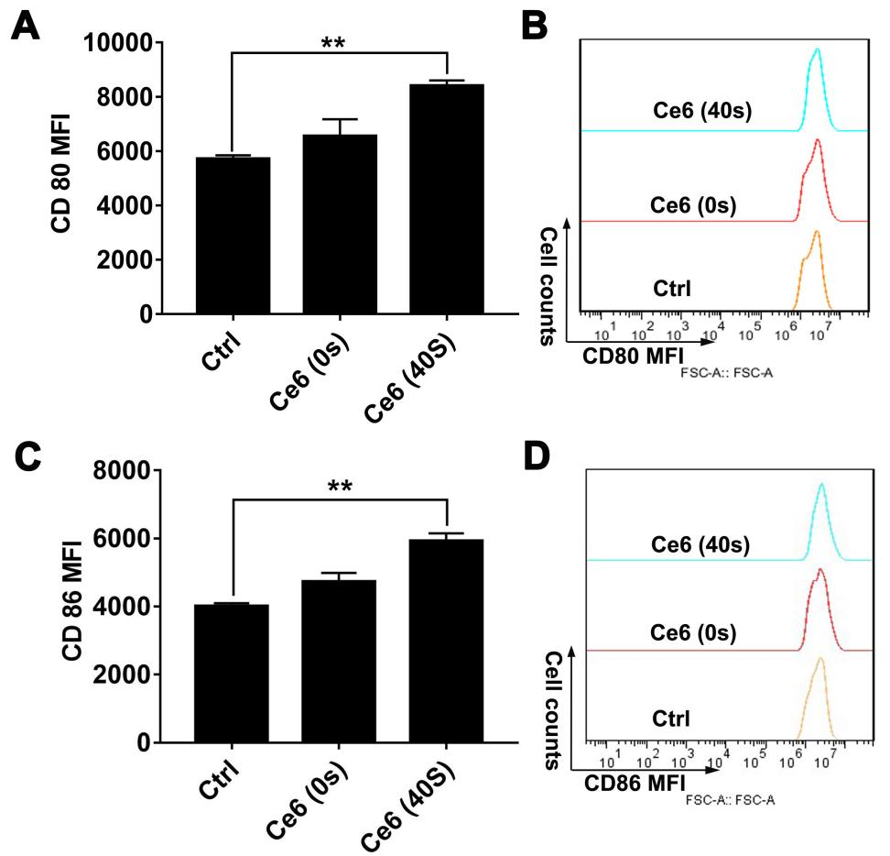
Fig. S2. Ce6 PDT up-regulated the surface expression of CD80 and CD86 in mouse bone marrow derived macrophages (mBMDMs).

