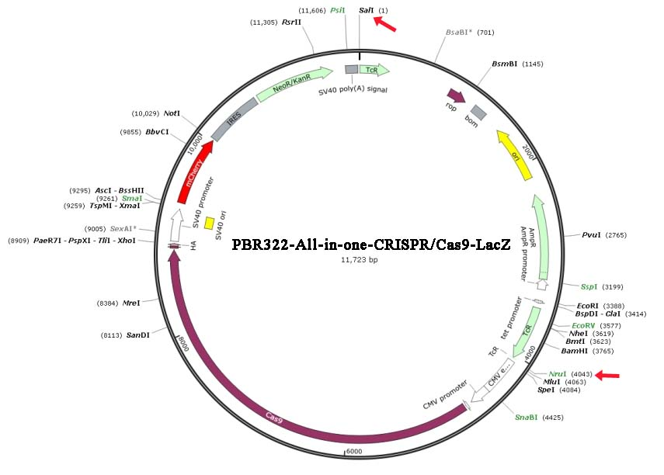
FIGURE S1 PBR322-All-in-one-CRISPR/Cas9-LacZ vector map. Red arrows represent enzyme cut sites.

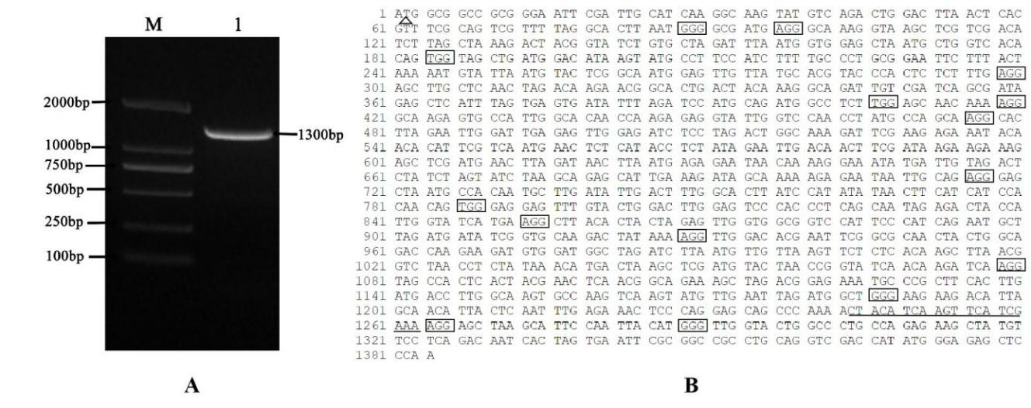
FIGURE S2 Identification of S. lemnae Adss gene. (A) Electrophoresis of full-length target gene RT-PCR product. M, DL2000 DNA Marker; 1, Adss amplified by primers Adss-F/Adss-R. (B) S. lemnae Adss cDNA sequencing result. The horizontal line shows the sgRNA; the triangle shows the initiation codon ATG; the boxes show PAM sites.

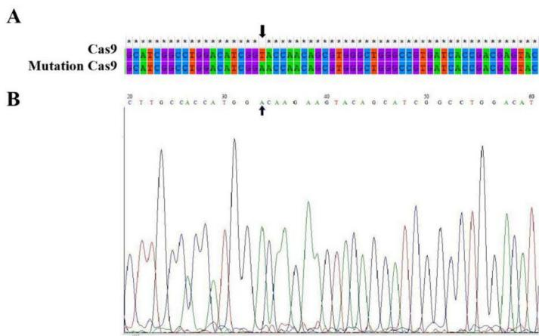
FIGURE S3 The mutation result of all-in-one CRISPR/Cas9-LacZ vector. (A) MEGA sequence blast. Black arrows indicate the mutated base. (B) Next-Generation sequencing peaks figure of mutation vector sequence.

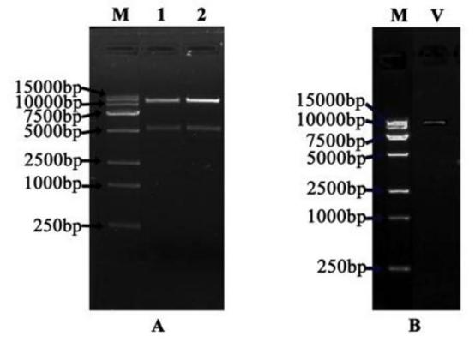
FIGURE S4 Identification of restriction enzyme digestion of two vectors and the recombinant vector PCR product. (A) Two vectors digested by SalI and NruI. (B) Identification of the recombinant expression vector. M, DL15000 DNA Marker; 1, Original vector; 2, Optimized vector; V, Recombinant vector.

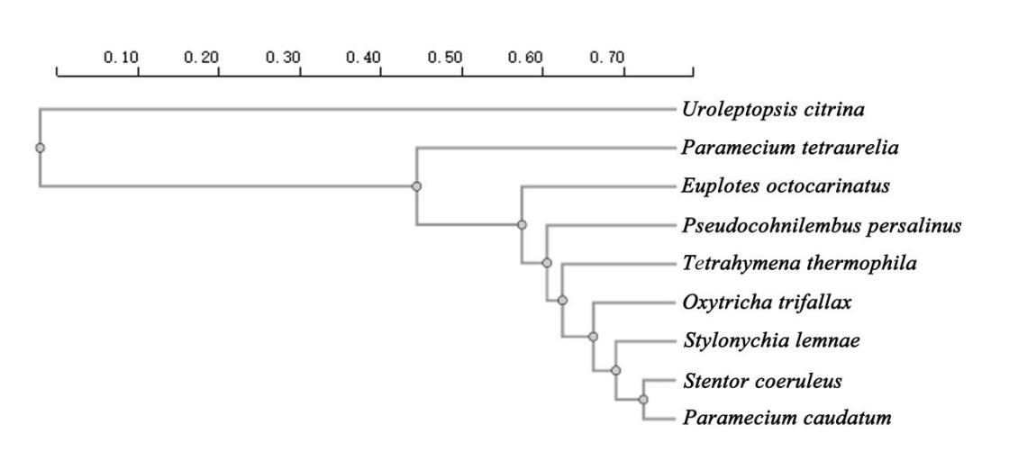
FIGURE S5 Phylogenetic tree based on RSCU.

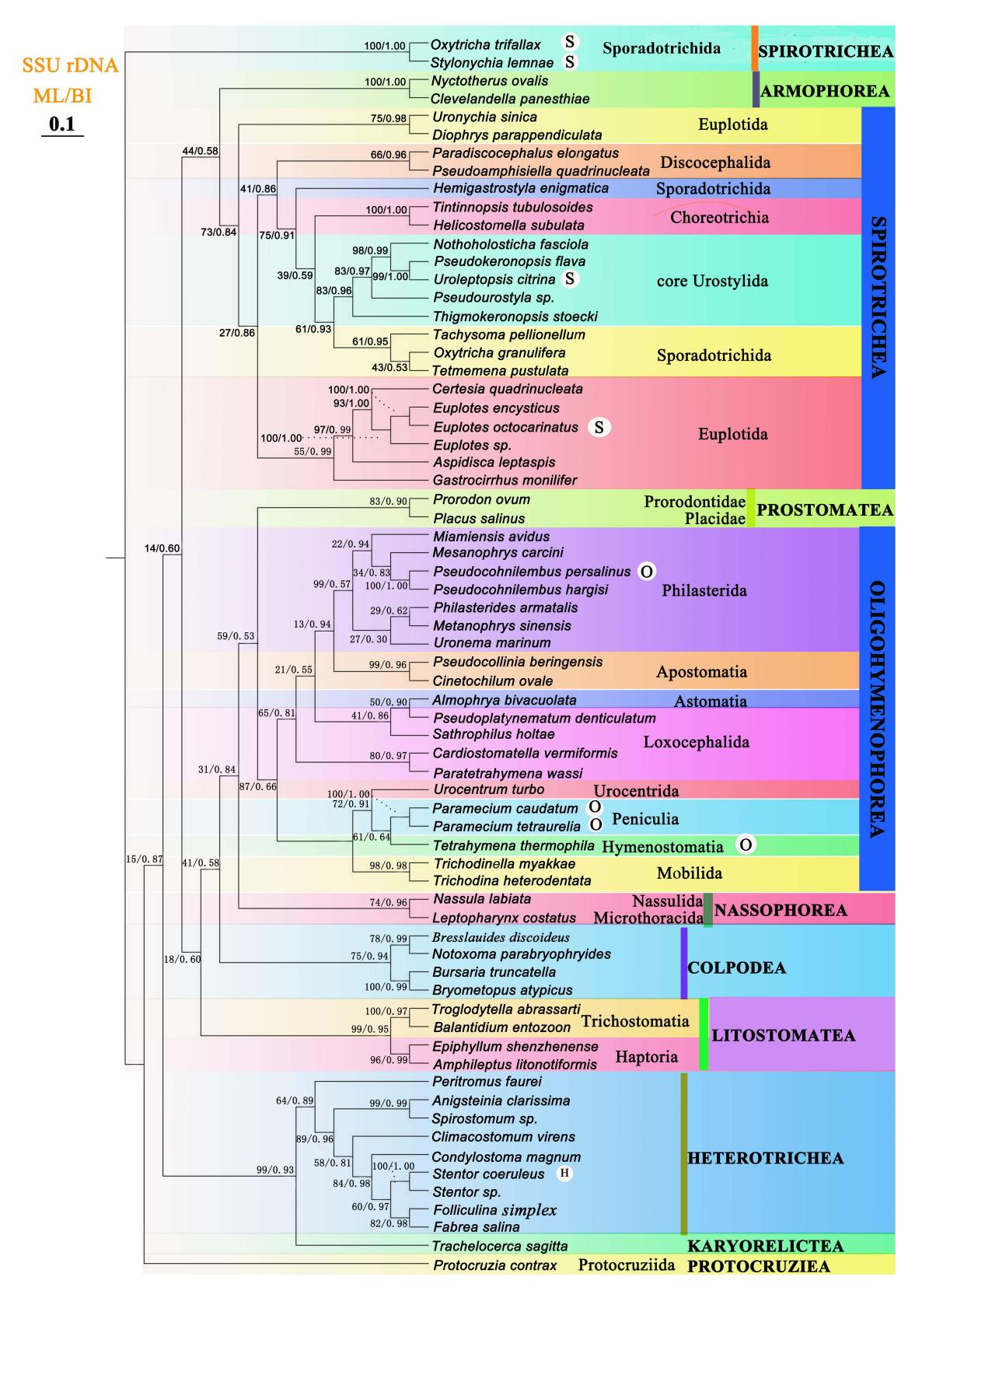
FIGURE S6 Maximum likelihood (ML) phylogenetic tree of the phylum Ciliophora based on the SSU rDNA (68 taxa). Numbers at nodes represent the bootstrap values of maximum likelihood (ML) out of 1000 replicates and the posterior probability of Bayesian analysis (BI). The letters in the white circle represent different taxa:
H, Heterotrichea; O, Oligohymenophorea; R, Spirotrichea.

TABLE S1 Primers used in this study.
Primer name | Sequence information
Adss-F(RT-PCR) | GTCTGAGGAACATAGCT
Adss-R(RT-PCR) | GCATCAAGGCAAGTA
18s-F(qRT-PCR) | AAGAACGGCCATGCACCACC
18s-R(qRT-PCR) | TTCAGCATCTTCCGAGAAATCAAAGT
Adss-F(qRT-PCR) | GGGAGCGAATGCTACAATGC
Adss-R(qRT-PCR) | TTCTGATGGGAATGGACCGC
Mutation-S | GACATCGGAACCAACAGCGTGGGCT
Mutation-A | GTTGGTTCCGATGTCCAGGCCGATG
sgRNA-F | GCAGGCTTTAAAGGAACCAATTCAGTCGACTGGATCCGGTA
sgRNA-R | GTAGAGAGGTACCTCGAGCGGCCCAAGCTTAAAAAAAGCACCGACTCGG

TABLE S2 ENC ratio of nine ciliates.
Species | Class boundary | Median | Amount | Frequency
S. lemnae | -23.0～-5.0 | -14 | 1781 | 0.087
 | -5.0～5.0 | 0 | 16605 | 0.813
 | 5.0～17.0 | 11 | 2036 | 0.100
T. thermophila | -17.0～-5.0 | -11 | 2105 | 0.082
 | -5.0～5.0 | 0 | 21460 | 0.837
 | 5.0～23.0 | 14 | 2081 | 0.081
O. trifallax | -19.0～-5.0 | -12 | 130 | 0.088
 | -5.0～5.0 | 0 | 1197 | 0.810
 | 5.0～15.0 | 10 | 150 | 0.102
P. tetraurelia | -17.0～-5.0 | -11 | 85 | 0.117
 | -5.0～5.0 | 0 | 553 | 0.762
 | 5.0～17.0 | 11 | 88 | 0.121
- caudatum | -17.0~-5.0 | -11 | 107 | 0.138
 | -5.0～5.0 | 0 | 571 | 0.736
 | 5.0～17.0 | 11 | 98 | 0.126
E. octocarinatus | -11.0～-5.0 | -8 | 11 | 0.108
 | -5.0～5.0 | 0 | 85 | 0.833
 | 5.0～11.0 | 8 | 6 | 0.059
S. coeruleus | -17.0～-5.0 | -11 | 107 | 0.041
 | -5.0～5.0 | 0 | 2475 | 0.942
 | 5.0～13.0 | 9 | 46 | 0.018
U. citrina | -29～-5.0 | -17 | 8257 | 0.195
 | -5.0～5.0 | 0 | 25098 | 0.592
 | 5.0～11.0 | 8 | 9045 | 0.213
P. persalinus | -9.0～-3.00 | -6.0 | 15 | 0.053
 | -3.00～3.00 | 0 | 254 | 0.904
 | 3.00～9.0 | 6.0 | 12 | 0.043

TABLE S3 ENC values of nine ciliates.
Species | Class boundary | Amount | Frequency
S. lemnae | 20～35 | 175 | 0.009
 | 35～45 | 8105 | 0.397
 | 45～61 | 12142 | 0.594
T. thermophila | 20～35 | 2300 | 0.090
 | 35～45 | 21414 | 0.935
 | 45～61 | 1932 | 0.075
O. trifallax | 20～35 | 16 | 0.011
 | 35～45 | 434 | 0.234
 | 45～61 | 1027 | 0.695
P. tetraurelia | 20～35 | 18 | 0.025
 | 35～45 | 335 | 0.461
 | 45～61 | 373 | 0.514
P. caudatum | 20～35 | 23 | 0.030
 | 35～45 | 286 | 0.369
 | 45～61 | 467 | 0.602
E. octocarinatus | 20～35 | 0 | 0
 | 35～45 | 10 | 0.098
 | 45～61 | 92 | 0.902
S. coeruleus | 20～35 | 2 | 0.0008
 | 35～45 | 169 | 0.0643
 | 45～61 | 2457 | 0.9350
U. citrina | 20～35 | 425 | 0.010
 | 35～45 | 5481 | 0.129
 | 45～61 | 36494 | 0.861
P. persalinus | 20～35 | 1 | 0.004
 | 35～45 | 261 | 0.929
 | 45～61 | 19 | 0.068

TABLE S4 RSCU values of nine ciliates.
Animo acid | Codon | U. citrina | E. octocarinatus | S. lemnae | O. trifallax | S. coeruleus | T. thermophila | P. tetraurelia | P. caudatum | P. persalinus
Ter | UGA | 1.00 | 1.00 | 1.00 | 1.00 | 1.00 | 1.00 | 1.00 | 1.00 | 1.00
Trp | UGG | 1.00 | 1.00 | 1.00 | 1.00 | 1.00 | 1.00 | 1.00 | 1.00 | 1.00
Met | AUG | 1.00 | 1.00 | 1.00 | 1.00 | 1.00 | 1.00 | 1.00 | 1.00 | 1.00
Phe | UUU*** | 1.83 | 1.10 | 1.17 | 1.35 | 1.46 | 1.50 | 1.30 | 1.38 | 1.68
 | UUC | 0.73 | 0.90 | 0.83 | 0.65 | 0.54 | 0.50 | 0.70 | 0.62 | 0.32
Tyr | UAU*** | 1.11 | 1.16 | 1.31 | 1.42 | 1.53 | 1.61 | 1.33 | 1.48 | 1.69
 | UAC | 0.64 | 0.84 | 0.69 | 0.58 | 0.47 | 0.39 | 0.67 | 0.52 | 0.31
Lys | AAA* | 1.10 | 0.86 | 1.17 | 1.24 | 1.43 | 1.24 | 1.71 | 1.40 | 1.57
 | AAG | 0.90 | 1.14 | 0.83 | 0.76 | 0.57 | 0.76 | 0.29 | 0.60 | 0.43
Asp | GAU* | 0.89 | 1.24 | 1.51 | 1.47 | 1.52 | 1.56 | 1.64 | 1.59 | 1.54
 | GAC | 0.41 | 0.76 | 0.49 | 0.53 | 0.48 | 0.44 | 0.36 | 0.41 | 0.46
His | CAU* | 0.77 | 1.25 | 1.44 | 1.60 | 1.44 | 2.00 | 1.60 | 1.48 | 1.63
 | CAC | 1.23 | 0.75 | 0.56 | 0.40 | 0.56 | 0.67 | 0.40 | 0.52 | 0.38
Cys | UGU | 1.60 | 0.88 | 0.94 | 1.20 | 1.23 | 1.14 | 1.67 | 1.25 | 1.00
 | UGC | 0.17 | 1.13 | 1.06 | 0.80 | 0.77 | 0.86 | 0.33 | 0.75 | 0.45
Asn | AAU* | 0.71 | 1.24 | 1.42 | 1.45 | 1.22 | 1.43 | 1.77 | 1.50 | 1.75
 | AAC | 1.29 | 0.76 | 0.58 | 0.55 | 0.63 | 0.57 | 0.23 | 0.50 | 0.25
Glu | GAA* | 0.98 | 1.20 | 1.24 | 1.26 | 1.42 | 1.60 | 1.89 | 1.40 | 1.44
 | GAG | 0.77 | 0.80 | 0.76 | 0.74 | 0.58 | 0.40 | 0.11 | 0.60 | 0.56
Ile | AUU** | 1.64 | 1.20 | 1.4 | 1.15 | 1.22 | 1.35 | 0.93 | 1.38 | 1.59
 | AUC | 0.75 | 0.71 | 0.63 | 0.71 | 0.59 | 0.31 | 0.53 | 0.54 | 0.23
 | AUA* | 1.25 | 1.09 | 0.96 | 1.15 | 1.19 | 1.35 | 1.53 | 1.08 | 1.19
Gln | UAA** | 1.14 | 1.45 | 1.55 | 1.76 | 1.70 | 0.89 | 0.78 | 2.01 | 2.52
 | UAG | 0.07 | 0.58 | 0.87 | 0.48 | 0.72 | 0.65 | 0.72 | 0.70 | 0.77
 | CAA** | 1.41 | 1.33 | 1.08 | 1.28 | 1.10 | 1.00 | 1.63 | 0.93 | 0.47
 | CAG | 1.51 | 0.64 | 0.50 | 0.48 | 0.48 | 1.00 | 0.22 | 0.36 | 0.23
Gly | GGU | 0.47 | 1.14 | 1.15 | 0.67 | 1.13 | 0.47 | 1.00 | 1.16 | 1.20
 | GGC | 0.71 | 0.86 | 0.69 | 1.17 | 0.51 | 0.47 | 0.26 | 0.57 | 0.46
 | GGA* | 1.41 | 0.86 | 1.76 | 1.83 | 1.53 | 3.06 | 3.00 | 1.71 | 1.50
 | GGG | 0.10 | 1.14 | 0.4 | 0.33 | 0.83 | 0.62 | 0.77 | 0.56 | 0.83
Val | GUU*** | 1.52 | 1.17 | 1.53 | 1.14 | 1.63 | 2.13 | 1.67 | 1.56 | 1.90
 | GUC | 0.95 | 0.50 | 0.67 | 0.57 | 0.53 | 0.50 | 0.67 | 0.48 | 0.54
 | GUA | 0.95 | 1.50 | 1.19 | 1.14 | 1.18 | 0.88 | 1.00 | 1.24 | 1.11
 | GUG | 0.57 | 0.83 | 0.62 | 1.14 | 0.66 | 0.50 | 0.67 | 0.71 | 0.45
Pro | CCU*** | 1.68 | 1.45 | 1.58 | 1.50 | 1.46 | 1.67 | 1.60 | 1.51 | 1.59
 | CCC | 0.65 | 0.43 | 0.43 | 0.50 | 0.80 | 0.33 | 2.00 | 0.53 | 0.50
 | CCA*** | 1.55 | 1.09 | 1.82 | 2.00 | 1.52 | 2.00 | 2.00 | 1.81 | 1.42
 | CCG | 0.13 | 0.36 | 0.17 | 0.02 | 0.23 | 0.57 | 0.50 | 0.15 | 0.49
Thr | ACU | 0.64 | 1.68 | 1.95 | 1.33 | 1.53 | 2.00 | 1.54 | 1.49 | 0.50
 | ACC | 0.29 | 0.52 | 0.54 | 0.89 | 0.75 | 0.38 | 0.62 | 0.67 | 0.50
 | ACA* | 0.07 | 1.68 | 1.35 | 1.33 | 1.47 | 1.63 | 1.54 | 1.66 | 1.35
 | ACG | 0.65 | 0.13 | 0.16 | 0.44 | 0.25 | 0.10 | 0.31 | 0.19 | 0.34
Ala | GCU* | 0.57 | 2.10 | 1.86 | 1.41 | 1.73 | 2.25 | 1.71 | 1.44 | 1.56
 | GCC | 1.71 | 0.57 | 0.55 | 0.86 | 0.57 | 0.43 | 0.57 | 0.59 | 0.63
 | GCA*** | 1.14 | 1.33 | 1.43 | 1.62 | 1.39 | 1.50 | 1.14 | 1.80 | 1.27
 | GCG | 0.80 | 0.21 | 0.16 | 0.11 | 0.32 | 0.25 | 0.57 | 0.17 | 0.54
Arg | AGA*** | 1.31 | 3.63 | 4.40 | 4.74 | 2.90 | 3.75 | 3.00 | 3.46 | 2.87
 | AGG* | 2.44 | 1.74 | 0.95 | 0.32 | 1.42 | 1.50 | 2.00 | 1.48 | 1.48
 | CGU | 0.38 | 0.16 | 0.19 | 0.49 | 0.47 | 0.75 | 1.00 | 0.30 | 0.47
 | CGC | 0.56 | 0.12 | 0.12 | 0.16 | 0.29 | 0.44 | 0.14 | 0.12 | 0.22
 | CGA | 0.75 | 0.35 | 0.29 | 0.07 | 0.69 | 0.27 | 0.58 | 0.52 | 0.66
 | CGG | 0.56 | 0.18 | 0.05 | 0.01 | 0.23 | 0.29 | 0.13 | 0.12 | 0.29
Leu | UUA* | 0.58 | 1.27 | 1.55 | 1.50 | 2.01 | 2.34 | 2.18 | 2.24 | 3.10
 | UUG | 1.55 | 0.64 | 1.06 | 1.63 | 1.08 | 1.32 | 0.91 | 1.16 | 1.10
 | CUU** | 1.74 | 1.36 | 1.39 | 1.25 | 1.27 | 0.92 | 1.82 | 1.03 | 0.77
 | CUC | 0.58 | 0.73 | 0.57 | 0.38 | 0.43 | 0.41 | 0.91 | 0.42 | 0.15
 | CUA | 0.97 | 0.91 | 0.99 | 0.75 | 0.77 | 0.81 | 0.91 | 0.72 | 0.60
 | CUG | 0.58 | 1.09 | 0.44 | 0.50 | 0.43 | 0.20 | 0.18 | 0.42 | 0.30
Ser | UCU* | 1.04 | 1.63 | 1.48 | 0.97 | 1.48 | 1.71 | 1.45 | 1.51 | 1.25
 | UCC | 0.91 | 0.41 | 0.42 | 0.39 | 0.71 | 0.21 | 0.41 | 0.76 | 0.61
 | UCA | 1.43 | 0.92 | 1.76 | 2.32 | 1.58 | 0.86 | 2.07 | 1.51 | 0.84
 | UCG | 0.91 | 0.61 | 0.22 | 0.39 | 0.31 | 0.21 | 0.15 | 0.25 | 0.42
 | AGU*** | 1.76 | 1.33 | 1.32 | 1.55 | 1.10 | 1.61 | 1.66 | 1.28 | 2.19
 | AGC | 1.24 | 1.20 | 0.80 | 0.55 | 0.81 | 1.39 | 0.41 | 0.69 | 0.69
Note: RSCU, the relative synonymous codon usage；
*** represents the codon commonly preferred by nine ciliates;
** represents the codon commonly preferred by the four ciliates of Spirotrichea;
* represents the codon commonly preferred by the four ciliates of Oligohymenophorea;

TABLE S5-1 Correlation coefficients of CUB indices in E. octocarinatus.
 | T3s | C3s | A3s | G3s | ENC | GC3s | GC12 | L-sym | L-aa
T3s
C3s | -0.261**
A3s | -0.330** | -0.177
G3s | -0.414** | -0.199* | -0.329**
ENC | -0.147 | 0.002 | -0.385** | 0.506**
GC3s | -0.603** | 0.588** | -0.464** | 0.636** | 0.429**
GC12 | -0.269** | 0.326** | -0.258** | 0.110 | 0.224* | 0.445**
L-sym | -0.004 | -0.054 | -0.220* | 0.158 | 0.209* | 0.119 | 0.027
L-aa | -0.013 | -0.055 | -0.225* | 0.171 | 0.211* | 0.130 | 0.027 | 1.000**

Note: **means extremely significant correlation (P＜0.01)；*means significant correlation (P＜0.05).

TABLE S5-2 Correlation coefficients of CUB indices in S. lemnae.
 | T3s | C3s | A3s | G3s | ENC | GC3s | GC12 | L-sym | L-aa
T3s
C3s | -0.720**
A3s | 0.292** | -0.620**
G3s | -0.238** | 0.127** | -0.372**
ENC | -0.008 | -0.001 | 0.003 | -0.007
GC3s | -0.008 | 0.019** | -0.020** | -0.001 | 0.009
GC12 | -0.009 | 0.011 | -0.01 | -0.001 | 0.018* | 0.711**
L-sym | -0.007 | 0.004 | 0.007 | -0.004 | -0.008 | -0.056** | -0.093**
L-aa | -0.007 | 0.005 | 0.007 | -0.004 | -0.008 | -0.054** | -0.091** | 1.000**

Note: **means extremely significant correlation (P＜0.01)；*means significant correlation (P＜0.05).

TABLE S5-3 Correlation coefficients of CUB indices in T. thermophila.
 | T3s | C3s | A3s | G3s | ENC | GC3s | GC12 | L-sym | L-aa
T3s
C3s | -0.402**
A3s | -0.121** | -0.564**
G3s | -0.322** | -0.019** | 0.016**
ENC | -0.268** | 0.074** | 0.047** | 0.358**
GC3s | -0.534** | 0.880** | -0.593** | 0.420** | 0.217**
GC12 | -0.151** | 0.583** | -0.676** | -0.186** | -0.065** | 0.533**
L-sym | 0.096** | -0.087** | 0.059** | -0.049** | 0.027** | -0.069** | -0.040**
L-aa | 0.086** | -0.067** | 0.053** | -0.060** | 0.037** | -0.089** | -0.050** | 1.000**

Note: **means extremely significant correlation (P＜0.01)；*means significant correlation (P＜0.05).

TABLE S5-4 Correlation coefficients of CUB indices in O. trifallax.
 | T3s | C3s | A3s | G3s | ENC | GC3s | GC12 | L-sym | L-aa
T3s
C3s | -0.760**
A3s | 0.419** | -0.685**
G3s | -0.238** | 0.147** | -0.309**
ENC | -0.083** | -0.03 | -0.057* | 0.380**
GC3s | -0.786** | -0.905** | -0.782** | 0.515** | 0.131**
GC12 | -0.666** | 0.728** | -0.746** | 0.113** | -0.004 | 0.750**
L-sym | 0.161** | -0.133** | 0.080** | -0.081** | -0.035 | -0.153** | -0.155**
L-aa | 0.160** | -0.132** | 0.078** | -0.081** | -0.035 | -0.152** | -0.154** | 1.000**

Note: **means extremely significant correlation (P＜0.01)；*means significant correlation (P＜0.05).

TABLE S5-5 Correlation coefficients of CUB indices in P. tetraurelia.
 | T3s | C3s | A3s | G3s | ENC | GC3s | GC12 | L-sym | L-aa
T3s
C3s | -0.607**
A3s | -0.152** | -0.293**
G3s | -0.195** | 0.007 | -0.461**
ENC | -0.202** | 0.383** | -0.488** | 0.471**
GC3s | -0.656** | 0.784** | -0.539** | 0.599** | 0.588**
GC12 | -0.436** | 0.353** | -0.343** | 0.197** | 0.376** | 0.506**
L-sym | -0.032 | 0.056 | -0.09 | 0.027 | 0.049 | 0.062 | 0.101**
L-aa | -0.052 | 0.066 | -0.07 | 0.022 | 0.045 | 0.072 | 0.101** | 1.000**

Note: **means extremely significant correlation (P＜0.01)；*means significant correlation (P＜0.05).

TABLE S5-6 Correlation coefficients of CUB indices in P. caudatum.
 | T3s | C3s | A3s | G3s | ENC | GC3s | GC12 | L-sym | L-aa
T3s
C3s | -0.601**
A3s | -0.140** | -0.265**
G3s | -0.182** | -0.014 | -0.490**
ENC | -0.193** | 0.343** | -0.503** | 0.489**
GC3s | -0.619** | 0.738** | -0.579** | 0.636** | 0.591**
GC12 | -0.402** | 0.361** | -0.454** | 0.222** | 0.391** | 0.538**
L-sym | -0.03 | 0.09 | -0.067 | 0.027 | 0.071* | 0.075 | 0.089*
L-aa | -0.08 | 0.06 | -0.058 | 0.035 | 0.062* | 0.069 | 0.079* | 1.000**

Note: **means extremely significant correlation (P＜0.01)；*means significant correlation (P＜0.05).

TABLE S5-7 Correlation coefficients of CUB indices in S. coeruleus.
 | T3s | C3s | A3s | G3s | ENC | GC3s | GC12 | L-sym | L-aa
T3s
C3s | -0.006
A3s | 0.103** | -0.01
G3s | -0.259** | -0.245** | -0.357**
ENC | -0.300** | -0.083** | -0.392** | 0.480**
GC3s | -0.025 | 0.249** | -0.041* | -0.466** | 0.094**
GC12 | -0.029 | 0.223** | -0.045* | -0.069** | 0.180** | 0.781**
L-sym | -0.340** | -0.026 | -0.468** | -0.049** | 0.142** | -0.085** | -0.052**
L-aa | -0.220** | -0.017 | -0.248** | -0.052** | 0.143** | -0.065** | -0.073** | 1.000**

Note: **means extremely significant correlation (P＜0.01)；*means significant correlation (P＜0.05).

TABLE S5-8 Correlation coefficients of CUB indices in U. citrina.
 | T3s | C3s | A3s | G3s | ENC | GC3s | GC12 | L-sym | L-aa
T3s
C3s | -0.458**
A3s | -0.219** | -0.321**
G3s | -0.345** | -0.111** | -0.305**
ENC | -0.218** | 0.252** | -0.166** | 0.189**
GC3s | -0.640** | 0.689** | -0.546** | 0.604** | 0.328**
GC12 | -0.399** | 0.284** | -0.377** | 0.238** | 0.270** | 0.513**
L-sym | -0.056** | 0.051** | -0.059** | 0.038** | 0.275** | 0.079** | 0.147**
L-aa | -0.062** | 0.049** | -0.060** | 0.047** | 0.277** | 0.085** | 0.150** | 1.000**

Note: **means extremely significant correlation (P＜0.01)；*means significant correlation (P＜0.05).

TABLE S5-9 Correlation coefficients of CUB indices in P. persalinus.
 | T3s | C3s | A3s | G3s | ENC | GC3s | GC12 | L-sym | L-aa
T3s
C3s | -0.774**
A3s | -0.273** | -0.025
G3s | 0.140* | -0.344** | -0.600**
ENC | -0.367** | 0.563** | -0.398** | 0.088
GC3s | -0.646** | 0.717** | -0.507** | 0.397** | 0.610**
GC12 | -0.398** | 0.444** | -0.564** | 0.366** | 0.521** | 0.762**
L-sym | 0.045 | -0.028 | -0.005 | 0.002 | 0.004 | -0.033 | -0.066
L-aa | 0.040 | -0.029 | -0.005 | 0.004 | 0.003 | -0.033 | -0.066 | 1.000**

Note: **means extremely significant correlation (P＜0.01)；*means significant correlation (P＜0.05).

TABLE S6 List of species for phylogeny analysis based on SSU rDNA.
Number | Class | Subclass | Order | Family | Taxon | GenBank accession numbers
1 | ARMOPHOREA |  | Clevelandellida | Clevelandellidae | Clevelandella panesthiae | KC139719
2 | ARMOPHOREA |  | Clevelandellida | Nyctotheridae | Nyctotherus ovalis | AJ222678
3 | COLPODEA |  | Bryometopida | Bryometopida | Bryometopus atypicus | EU039886
4 | COLPODEA |  | Bryophryida | Bryophryidae | Notoxoma parabryophryides | EU039903
5 | COLPODEA |  | Bursariomorphida | Bursariidae | Bursaria truncatella | U82204
6 | COLPODEA |  | Colpodida | Hausmanniellidae | Bresslauides discoideus | HM140394
7 | HETEROTRICHEA |  | Heterotrichida | Climacostomidae | Climacostomum virens | EU583990
8 | HETEROTRICHEA |  | Heterotrichida | Climacostomidae | Fabrea salina | KM222110
9 | HETEROTRICHEA |  | Heterotrichida | Condylostomatidae | Condylostoma magnum | KM222108
10 | HETEROTRICHEA |  | Heterotrichida | Folliculinidae | Folliculina simplex | EU583992
11 | HETEROTRICHEA |  | Heterotrichida | Peritromidae | Peritromus faurei | EU583993
12 | HETEROTRICHEA |  | Heterotrichida | Spirostomidae | Anigsteinia clarissima | KM222109
13 | HETEROTRICHEA |  | Heterotrichida | Spirostomidae | Spirostomum sp. | FJ998027
14 | HETEROTRICHEA |  | Heterotrichida | Stentoridae | Stentor sp. | KM222111
15 | HETEROTRICHEA |  | Heterotrichida | Stentoridae | Stentor coeruleus | LT628482
16 | KARYORELICTEA |  | Protostomatida | Trachelocercidae | Trachelocerca sagitta | KC542935
17 | LITOSTOMATEA | Haptoria | Pleurostomatida | Amphileptidae | Amphileptus songi | FJ876974
18 | LITOSTOMATEA | Haptoria | Pleurostomatida | Amphileptidae | Epiphyllum shenzhenense | GU574809
19 | LITOSTOMATEA | Trichostomatia | Entodiniomorphida | Troglodytellidae | Troglodytella abrassarti | AB437346
20 | LITOSTOMATEA | Trichostomatia | Vestibuliferida | Balantidiidae | Balantidium entozoon | EU581716
21 | NASSOPHOREA |  | Microthoracida | Leptopharyngidae | Leptopharynx costatus | EU286811
22 | NASSOPHOREA |  | Nassulida | Nassulidae | Nassula labiata | KC832949
23 | OLIGOHYMENOPHOREA | Apostomatia | Apostomatida | Colliniidae | Pseudocollinia beringensis | HQ591474
24 | OLIGOHYMENOPHOREA | Astomatia | Astomatida | Anoplophryidae | Almophrya bivacuolata | HQ446281
25 | OLIGOHYMENOPHOREA | Hymenostomatia | Ophryoglenida | Ichthyophthiriidae | Ichthyophthirius multifiliis | U17354
26 | OLIGOHYMENOPHOREA | Hymenostomatia | Tetrahymenida | Tetrahymenidae | Tetrahymena thermophila | X56165
27 | OLIGOHYMENOPHOREA | Peniculia | Peniculida | Parameciidae | Paramecium tetraurelia | AY102613
28 | OLIGOHYMENOPHOREA | Peniculia | Urocentrida | Urocentridae | Urocentrum turbo | AF255357
29 | OLIGOHYMENOPHOREA | Peritrichia | Mobilida | Trichodinidae | Trichodina heterodentata | AY788099
30 | OLIGOHYMENOPHOREA | Peritrichia | Mobilida | Trichodinidae | Trichodinella myakkae | AY102176
31 | OLIGOHYMENOPHOREA | Scuticociliatia | Loxocephalida | Cinetochilidae | Cinetochilum ovale | FJ870103
32 | OLIGOHYMENOPHOREA | Scuticociliatia | Loxocephalida | Cinetochilidae | Pseudoplatynematum denticulatum | JX310020
33 | OLIGOHYMENOPHOREA | Scuticociliatia | Loxocephalida | Cinetochilidae | Sathrophilus holtae | FJ868188
34 | OLIGOHYMENOPHOREA | Scuticociliatia | Loxocephalida | Loxocephalidae | Cardiostomatella vermiformis | AY881632
35 | OLIGOHYMENOPHOREA | Scuticociliatia | Loxocephalida | Loxocephalidae | Paratetrahymena wassi | GQ292767
36 | OLIGOHYMENOPHOREA | Scuticociliatia | Philasterida | Orchitophryidae | Metanophrys sinensis | HM236336
37 | OLIGOHYMENOPHOREA | Scuticociliatia | Philasterida | Parauronematidae | Miamiensis avidus | JN885091
38 | OLIGOHYMENOPHOREA | Scuticociliatia | Philasterida | Philasteridae | Philasterides armatalis | FJ848877
39 | OLIGOHYMENOPHOREA | Scuticociliatia | Philasterida | Pseudocohnilembidae | Pseudocohnilembus hargisi | JN885090
40 | OLIGOHYMENOPHOREA | Scuticociliatia | Philasterida | Uronematidae | Uronema marinum | GQ465466
41 | OLIGOHYMENOPHOREA | Scuticociliatia | Philasterida | Orchitophryidae | Mesanophrys carcini | JN885086
42 | OLIGOHYMENOPHOREA | Scuticociliatia | Philasterida | Pseudocohnilembidae | Pseudocohnilembus persalinus | GU584096
43 | PROSTOMATEA |  | Prorodontida | Placidae | Placus salinus | KC832954
44 | PROSTOMATEA |  | Prorodontida | Prorodontidae | Prorodon ovum | KM222104
45 | PROTOCRUZIEA |  | Protocruziida | Protocruziidae | Protocruzia contrax | DQ190467
46 | SPIROTRICHEA | Choreotrichia | Tintinnida | Codonellidae | Tintinnopsis tubulosoides | AF399111
47 | SPIROTRICHEA | Choreotrichia | Tintinnida | Metacylididae | Helicostomella subulata | JQ716991
48 | SPIROTRICHEA | Hypotrichia | Discocephalida | Discocephalidae | Paradiscocephalus elongatus | EU684746
49 | SPIROTRICHEA | Hypotrichia | Discocephalida | Discocephalidae | Pseudoamphisiella quadrinucleata | EU518416
50 | SPIROTRICHEA | Hypotrichia | Euplotida | Aspidiscidae | Aspidisca leptaspis | EU880597
51 | SPIROTRICHEA | Hypotrichia | Euplotida | Certesiidae | Certesia quadrinucleta | KM222097
52 | SPIROTRICHEA | Hypotrichia | Euplotida | Euplotidae | Euplotes encysticus | FJ346569
53 | SPIROTRICHEA | Hypotrichia | Euplotida | Euplotidae | Euplotes sinicus | FJ876980
54 | SPIROTRICHEA | Hypotrichia | Euplotida | Gastrocirrhidae | Gastrocirrhus monilifer | DQ864734
55 | SPIROTRICHEA | Hypotrichia | Euplotida | Uronychiidae | Diophrys parappendiculata | EU267928
56 | SPIROTRICHEA | Hypotrichia | Euplotida | Uronychiidae | Uronychia sinica | FJ876982
57 | SPIROTRICHEA | Stichotrichia | Sporadotrichida | Oxytrichidae | Hemigastrostyla enigmatica | FJ870096
58 | SPIROTRICHEA | Stichotrichia | Sporadotrichida | Oxytrichidae | Oxytricha granulifera | AF508762
59 | SPIROTRICHEA | Stichotrichia | Sporadotrichida | Oxytrichidae | Tachysoma pellionellum | KM222096
60 | SPIROTRICHEA | Stichotrichia | Sporadotrichida | Oxytrichidae | Tetmemena puslata | KM222092
61 | SPIROTRICHEA | Stichotrichia | Sporadotrichida | Oxytrichidae | Oxytricha trifallax | AF198110
62 | SPIROTRICHEA | Stichotrichia | Urostylida | Pseudokeronopsidae | Nothoholosticha fasciola | FJ377548
63 | SPIROTRICHEA | Stichotrichia | Urostylida | Pseudokeronopsidae | Pseudokeronopsis flava | DQ227798
64 | SPIROTRICHEA | Stichotrichia | Urostylida | Pseudokeronopsidae | Thigmokeronopsis stoecki | EU220226
65 | SPIROTRICHEA | Stichotrichia | Urostylida | Pseudokeronopsidae | Uroleptopsis citrina | FJ870094
66 | SPIROTRICHEA | Stichotrichia | Urostylida | Pseudourostylidae | Pseudourostyla sp. | FJ775725
67 | SPIROTRICHEA | Stichotrichia | Sporadotrichida | Oxytrichidae | Stylonychia lemnae | HQ432920
68 | SPIROTRICHEA | Hypotrichia | Euplotida | Euplotidae | Euplotes octocarinatus | LT623905

S1 Perl scripts

Perl 1: Remove the newline characters in the sequence;
#!/usr/bin/env perl
#===============================================================================
#
# FILE: 11.pl
#
# USAGE:./11.pl
#
#DESCRIPTION: Remove the newline characters in the sequence
#
# OPTIONS: ---
# REQUIREMENTS: ---
# BUGS: ---
# NOTES: ---
# AUTHOR: YAN BAI (YanB), baiyan789@163.com
# ORGANIZATION:
# VERSION: 1.0
# CREATED: 2019/6/20 13:47:51
# REVISION: ---
#===============================================================================

while(<>){
chomp;
if(/>/){
print "\n$_\n";
}else{
print $_;}}

Perl 2: Retain sequences with a sequence length> 300bp; remove repeated sequences; remove reverse complementary sequences;
#!/usr/bin/env perl
#===============================================================================
#
# FILE: 1.pl
#
# USAGE: ./1.pl
#
# DESCRIPTION: Retain sequences with a sequence length> 300bp; remove repeated sequences; remove reverse complementary sequences
#
#
# OPTIONS: ---
# REQUIREMENTS: ---
# BUGS: ---
# NOTES: ---
# AUTHOR: YOUR NAME (),
# ORGANIZATION:
# VERSION: 1.0
# CREATED: 2019/6/17 23:05:33
# REVISION: ---
#===============================================================================

while(<>){
chomp;
if(/>/){
$a = $_;}
else{
$m = reverse $_;
$m=~tr/ATGC/TACG/;
$re{$m} = 1;
if($re{$_}){}else{

$ha{$_} = $a;}}}

foreach (keys %ha){
$n = length($_);

if($n>=300){
print "$ha{$_}\n$_\n";}
}
#print %ha;

Perl 3: The sequence is incomplete and there is a stop codon in the middle of the sequence is deleted, and the CDS containing the start codon ATG and the end stop codons UAA, UAG, UGA is retained;
#!/usr/bin/perl

while ( <> ) {
chomp;
if(/>/){
$a=$_;
}else{$m = $_;
@p = $m =~ /(.{3})/g;
@b = grep s/ATG|TGG|TAA|TAG|TGA//,@p;
$z = join ('',@p);
$ha{$a} =$z;}}
foreach (keys %ha){
print"$_\n$ha{$_}\n";}

