Supplementary Information:
Succinate is a natural suppressor of antiviral immune response by targeting MAVS

Yue Xiao¹, Xinyi Chen¹, Zhun Wang ², Jiazheng Quan¹, Xibao Zhao¹, Haimei Tang¹, Han Wu¹, Qianqian Di¹, Zherui Wu¹, Weilin Chen^{1,}*

¹Department of Immunology, School of Medicine, Shenzhen University, Shenzhen, 518055, China.
²Technological Center, Changchun Customs 1301 Puyang Street, Changchun, Jilin, 130062, China,

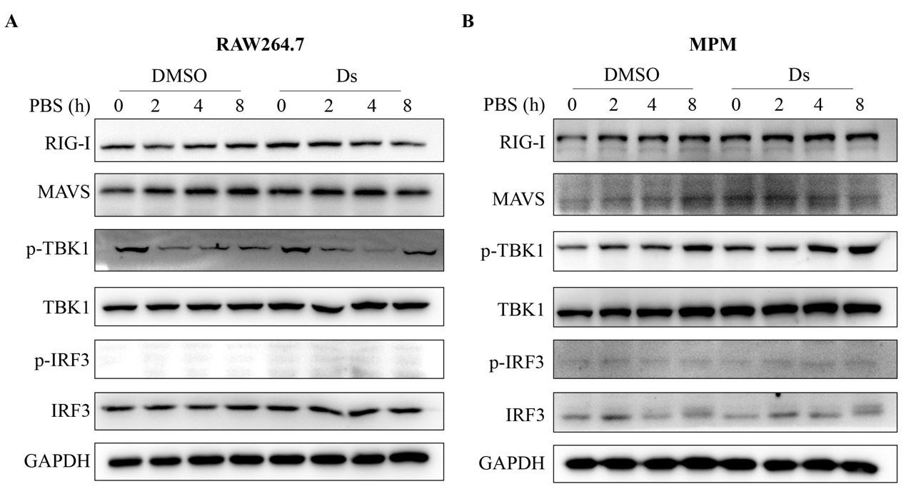
Figure S1. The expression levels of MAVS-IRF3 signaling proteins in the mice macrophages treated with succinatee. (A) RAW264.7 cells and (B) MPM were pretreated with 5 mM Ds or DMSO for 3 h followed treatment with PBS the indicated times. Cell lysates were immunoblotted with the indicated antibodies.

