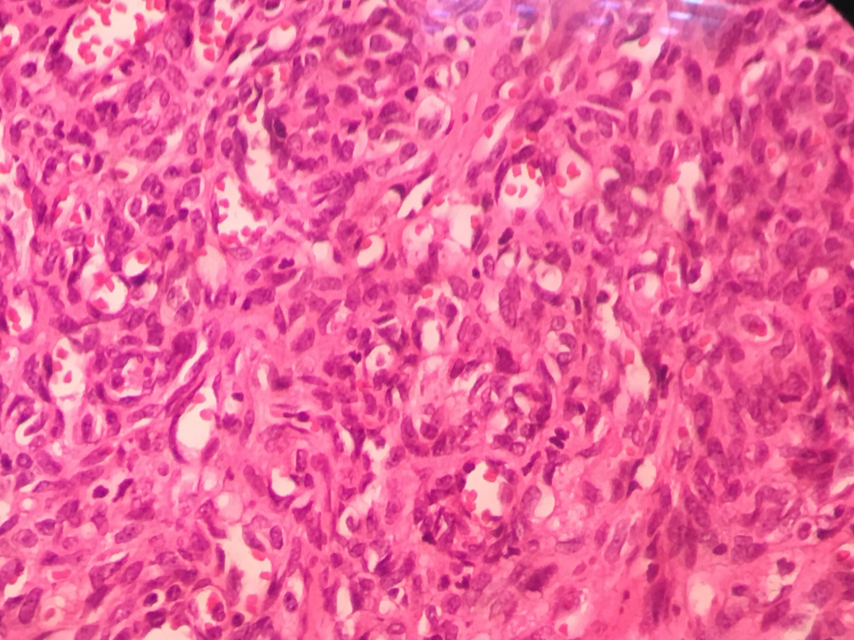

Figure supp: Proliferation of vascular nodules composed of numerous small sized vascular channels containing Red blood cells .

