Supplementary Material
The following 28 tables and 7 figures complement those included in the article.

1 Supplementary Tables

Supplementary Table 1. Ages of the piedmont fault terraces in Sertengshan.
Sample location | Terrace | Method | Age (ka) | Data source
Northern Wujiahe | T1 | OSL | 9.29±1.11 | This paper
Northern Shuiquan | T2 | OSL | 22.42±2.56 | This paper
Eastern Fanrong | T2 | OSL | 33.01±1.99 | This paper
Western Langshankou | T2 | OSL | 23.97±3.45 | This paper
Western Liushuquanzi | T3 | OSL | 72.05±9.76 | This paper
Northern Shuiquan | T3 | OSL | 60.34±7.94 | This paper
Eastern Dashetai | T3 | OSL | 71.38±9.76 | This paper
Wulan | T3 | OSL | 79.50±9.67 | This paper

Supplementary Table 2. Terrace height distribution for Sertengshan Mountain piedmont faults.
Segment | Sample location | Terrace height(m) |  |  |  | Data source  (This paper)
 |  | T1 | T2 | T3 | T4
 | Fanrong | 7.5 | 14 | 27.5 | 42
 | Langshankou |  | 12 | 26 | 41
Wujiahe segment | Eastern Langshankou | 7 | 14 | 24 | 38
 | Wujiahe | 5.5 | 11.3 | 24.2 | 34
 | Dahoudian |  | 12 | 26
 | Hongqicun | 4 | 15 | 21
Hongqicun segment | Liguigedan | 3.3 | 11.7 | 23
 | Wubulangkou |  | 14
Kuluebulong segment | Kuluebulong | 7.8
 | Wayaotan | 7 | 16 | 25
 | Northern Mabuzi | 7 |  | 21
Dashetai segment | Eastern Xishuidao | 9 | 15
 | Dashetai | 8 | 13 | 23
 | Wulan | 7.8

Supplementary Table 3. Dating data for the piedmont terraces in Wulashan.
No. | Sample location | Terrace | Method | Age (a) | Data source
1 | Western Tehanqi | T1 | TL | 7770±610 | This paper
2 | Northern Gongmiaozi | T1 | TL | 9520±810 | This paper
3 | Northern Baiyanhua | T1 | TL | 10150±860 | This paper
4 | Western Hademengou | T1 | OSL | 13830±1430 | This paper
5 | Aguigou | T1 | OSL | 5880±540 | This paper
6 | Xishanzui | T2 | TL | 39920±3110 | Previous study*
7 | Hayehutong | T2 | TL | 27410±2280 | Previous study*
8 | Northern Gongmiaozi | T2 | TL | 42760±3630 | Previous study*
9 | Northern Hayehutong | T2 | TL | 53800±4580 | Previous study*
*Institute of Crustal and Dynamics and China Earthquake Administration (2013).

Supplementary Table 4. Terrace heights in Wulashan.
Segment | Location | Terrace height (m) |  |  | Data source  (This paper)
 |  | T1 | T2 | T3
 | Wulashandianchang |  | 75
Wulateqianqi segment | Wulashan |  | 60
 | Wulanbulage |  | 40
 | Northern Gongmiaozi |  | 23
 | Huhebulage |  | 24 | 53
Gongmiaozi segment | Dabagou |  | 27 | 39
 | Daligai |  | 27
 | Northern Heshunzhuang | 9 | 35
 | Northern Heshunzhuang |  | 47 | 72
 | Wubulagou |  | 58 | 73
Baotou segment | Nailingou | 10 | 42 | 72
 | Meiligenggou | 6 | 21 | 41
 | Northern Hayehutong | 6 | 19
 | Sandaobagou | 10 |  | 40
 | Hademen | 3 | 15

Supplementary Table 5. Elevations of Daqingshan piedmont terraces.
Segment | Location | T1 elevation (m) | T2 elevation (m) | T3 elevation (m) | Data source
Tuyouxi segment | Maoqilai  Adulai  Shamujia  Maliu  Shabingya | 1040  1030  1049.4  1039  1038 | 1070  1060  1066  1100 | 1100  1120  1136  1128  1140 | Liang et al. (1997)  Liang et al. (1997)  Liang et al. (1997)  Liang et al. (1997)  Liang et al. (1997)
Tuzuoxi segment | Guyangou  Shangdalai | 1054  1056 | 1107  1079 | 1145  1120 | Liang et al. (1997)  Liang et al. (1997)
Bikeqi segment | Zhuergou  Daqi  Shuimogou  Shibaoqi | 1083  1052  1110  1058 | 1111  1116  1126 | 1154  1143  1145  1150 | Liang et al. (1997)  Previous study*  Liang et al. (1997)  Liang et al. (1997)
Huhehaote segment | Goumen  Yaojiawan |  |  | 1157  1170 | Previous study*  Previous study*
*Institute of Crustal and Dynamics and China Earthquake Administration (1994).

Supplementary Table 6. Relationship between the fault tensile stress axis and fault strike on the northern margin of the Hetao Basin.
Faults | Langshan fault | Sertengshan fault | Wulashan fault | Daqingshan fault
Fault strike | Approximately 50° | Approximately 90–120° | Approximately 90° | Approximately 75°
Angle between the extensional stress axis and the fault strike | 83° | 18–48° | 48° | 63°
Maximum vertical slip rate of late Pleistocene (mm/a) | 3.2 | 1.81 | 3.11 | 3.88

Supplementary Table 7. Lithologies in borehole VI-3.
Stratum number | Depth of the stratum bottom (m) | Thickness (m) | Lithologic description
1 | 15 | 15 | Topsoil, brownish-yellow clay, containing plant roots and no water
2 | 88.13 | 73.13 | Yellowish-green silty sand, relatively loose, good permeability, top 15–20 m containing a small amount of clay
3 | 97.51 | 9.38 | Brownish-yellow clay layer with a small amount of fine sand at the bottom, approximately 5%, no water
4 | 116.26 | 18.75 | Fine sand, greenish-yellow, grey-green, very loose, containing a small amount of water
5 | 122.51 | 6.25 | Brown-yellow clay layer, no water, no sand
6 | 138.76 | 16.25 | Coarse sand, medium sand, grey-yellow, loose, good water
7 | 148.76 | 10 | Brown-yellow clay layer, no bedding, no sand
8 | 152.51 | 3.75 | Coarse sand, medium sand, no bedding, no water
9 | 170.64 | 18.13 | Brownish-yellow clay layer with a small amount of fine sand at the bottom, approximately 5%, no water
10 | 174.39 | 3.75 | Greenish-grey fine sand, unbedded, containing little water and no clay
11 | 176.89 | 2.5 | Brown-yellow clay layer, no bedding, no water, no sand
12 | 180.2 | 3.13 | Grey-brown sandy silt layer, saturated, unstratified
13 | 189.4 | 9.38 | Greenish-yellow fine sand, unbedded, containing little water and no clay
14 | 194.4 | 5 | Brown-yellow clay layer, gravel-free, unstratified
15 | 203.78 | 9.38 | Light yellow silty sand, unbedded, free of clay and containing little water
16 | 209.41 | 5.63 | Clay sandy soil, containing little water, unstratified, silt content approximately 40%
17 | 233.16 | 23.75 | Yellowish-green silty sand layer, no bedding, large water content, no clay
Supplementary Table 8. Lithologies in borehole Ⅵ-1.
Stratum number | Depth of stratum bottom(m) | Thickness  (m) | Lithologic description
1 | 94.45 | 94.45 | Dark brown sandy gravel, with plant roots at the top, gravel normally 20-40 mm in diameter, greyish white in section and fine sand at the bottom
2 | 217.24 | 122.79 | Blackish-green silt layer, large water content at the bottom, fine sand content of approximately 15%, no gravel, no bedding
3 | 220.28 | 3.04 | A brownish-yellow clay layer with fine sand at the top, no gravel, horizontal bedding
4 | 238.91 | 18.63 | Brown sandy gravel, gravel content of approximately 30%, coarse sand content of approximately 15%, no water

Supplementary Table 9. Lithologies in borehole Ⅶ-1.
Stratum number | Depth of stratum bottom(m) | Thickness  (m) | Lithologic description
1 | 7.14 | 7.14 | Brownish-yellow clay sandy soil with plant roots and fine gravel at the top, no bedding
2 | 19.23 | 12.09 | Yellowish-green fine sand layer, with fine gravel in the middle, no water
3 | 23.36 | 4.13 | Brownish-yellow clay sandy soil, no sand, no gravel, no bedding
4 | 43.27 | 19.91 | Light yellow fine sand with a small amount of clay at the top and no gravel
5 | 53.03 | 9.76 | Brownish-yellow clay sandy soil, no obvious bedding, no water, a small amount of fine gravel at the bottom
6 | 70.2 | 17.17 | Yellowish-green fine sand, with a small amount of fine gravel at the bottom, 10-20 mm in diameter, approximately 10% content
7 | 74.62 | 4.42 | A dark brown layer of sand and gravel, approximately 30% gravel, 20-35 mm in diameter, with greyish-white sections and no water
8 | 77.85 | 3.23 | Brownish-yellow clay layer, containing medium fine sand, approximately 20%
9 | 87.27 | 9.42 | Light yellow fine sand, containing a small amount of clay, approximately 10%
10 | 97.37 | 10.1 | Brownish-yellow sandy clay layer, medium coarse sand content of approximately 15%, no gravel
11 | 102.73 | 5.36 | Light grey fine sand, no gravel, no water, no bedding
12 | 107.76 | 5.03 | Brownish-yellow sandy clay layer, approximately 20% fine sand, no gravel
13 | 117.57 | 9.81 | Light yellow medium fine sand, containing a small amount of fine gravel, no water, relatively loose
14 | 144.06 | 26.49 | Brownish-yellow clay sandy soil, relatively loose, no gravel, no water
15 | 149.57 | 5.51 | Yellowish-green fine sand with a small amount of clay at the bottom, relatively loose
16 | 155.38 | 5.81 | Light yellow sandy clay layer, medium coarse sand content of approximately 15%, no water
17 | 199.12 | 43.74 | Yellowish-green fine sand layer, relatively loose, no water

Supplementary Table 10. Lithologies in borehole VIII-1.
Stratum number | Depth of stratum bottom(m) | Thickness  (m) | Lithologic description
1 | 33.56 | 33.56 | Brownish-yellow fine sand layer, loose, no gravel, no bedding
2 | 56.22 | 22.66 | Dark brown sandy gravel, 15-35 mm in diameter, containing no water
3 | 64.3 | 8.08 | Brownish-yellow clay layer, well - stratified, containing fine gravel, no water
4 | 76.08 | 11.78 | Light grey fine sand layer, no bedding, no water
5 | 79.55 | 3.47 | Brown gravel layer, gravel diameter is small, no water, no bedding
6 | 88.59 | 9.04 | Light yellow coarse sand, containing fine gravel, no bedding
7 | 105.52 | 16.93 | Blackish-green silt layer, containing little water, local carbon chips, no bedding
8 | 110.98 | 5.46 | Light yellow fine sand, no gravel, no water, no bedding
9 | 129.2 | 18.22 | Brownish-black silt with fine sand at the top, no gravel, no bedding and little water
10 | 132.81 | 3.61 | Brown sandy gravel, small amount of water, gravel 10-20 mm in diameter, greyish-white in section
11 | 146.7 | 13.89 | Blackish-green silt, containing water, no gravel, no bedding
12 | 169.07 | 22.37 | Light yellow fine sand, containing a little water, no bedding
13 | 174.41 | 5.34 | Brown gravel layer, gravel diameter 10-30 mm, the section is grey, containing a little water, no bedding
14 | 180.94 | 6.53 | Brownish-yellow fine sand, containing a little water, with fine gravel at the top, no bedding
15 | 188.98 | 8.04 | Dark brown sandy gravel, approximately 35% gravel, 15-30 mm in diameter, no bedding
16 | 208.46 | 19.52 | Dark green silt, containing little water, no gravel, no bedding

Supplementary Table 11. Lithologies in borehole H125.
Stratum number | Depth of stratum bottom(m) | Thickness  (m) | Lithologic description
1 | 111.66 | 111.66 | Brown sandy gravel, loose at the top, 20-40 mm in diameter, with a small amount of clay at the bottom, no water, no bedding
2 | 126.72 | 15.06 | Brownish-yellow clay sandy soil with a small amount of fine gravel at the top, no water, no bedding
3 | 131.79 | 5.07 | Light yellow fine sand, with a small amount of fine gravel at the bottom, no water
4 | 153.04 | 21.25 | Dark brown sandy gravel, relatively loose, no water, no bedding
5 | 162.66 | 9.62 | Light yellow fine sand, containing little water, no gravel, no bedding
6 | 184.25 | 21.59 | Yellowish-brown clay with a small amount of black clay at the bottom, approximately 5 cm in diameter

Supplementary Table 12. Lithologies in borehole H141.
Stratum number | Depth of stratum bottom(m) | Thickness  (m) | Lithologic description
1 | 88.26 | 88.26 | Brown sandy gravel, loose, approximately 30% gravel, 10-35 mm in diameter, with coarse sand at the bottom, no bedding
2 | 112.38 | 24.12 | Brownish-yellow clay sandy soil, loose, no bedding, no gravel
3 | 131.49 | 19.11 | Dark brown gravel, approximately 30% gravel, no clay and bedding
4 | 142.8 | 11.31 | Light yellow clay sandy soil with a small amount of gravel at the top and no water
5 | 151.66 | 8.86 | Dark brown silt, containing little water, no gravel, no bedding
6 | 190.23 | 38.57 | Brown sandy gravel, with a little water at the top, gravel diameter in 10-30 mm, well rounded and sorted
7 | 192.63 | 2.4 | Brownish-yellow clay sandy soil with little water and no bedding
8 | 199.65 | 7.02 | Dark brown sandy gravel, containing little water, well rounded and sorted, no bedding
9 | 218.32 | 18.67 | Blackish-green silt layer, large water content, no gravel, no bedding
10 | 235.73 | 17.41 | Brownish-yellow clay sandy soil with little water at the top, no gravel, no bedding

Supplementary Table 13. Lithologies in borehole ZH18.
Stratum number | Depth of stratum bottom(m) | Thickness  (m) | Lithologic description
1 | 9.03 | 9.03 | Light yellow clay sand, dense, poor permeability, no gravel
2 | 34.45 | 25.42 | Greyish-brown sandy gravel, with a small amount of clay at the top, poorly rounded and sorted, with a content of approximately 35%
3 | 42.66 | 8.21 | Brownish-yellow sandy clay with a small amount of fine gravel at the bottom, no water and bedding
4 | 56.67 | 14.01 | Dark brown sandy gravel with a small amount of fine sand at the bottom, no water, no bedding, gravel approximately 50 mm in diameter
5 | 63.73 | 7.06 | Yellowish-green fine sand layer, no bedding, no water, relatively loose
6 | 66.84 | 3.11 | Light yellow clay layer, no gravel and bedding
7 | 87.87 | 21.03 | Yellowish-green fine sand, no gravel, no water, loose, no bedding
8 | 150.28 | 62.41 | Blackish-green silt layer, large water content, no bedding, no gravel

Supplementary Table 14. Lithologies in borehole ZK3.
Stratum number | Depth of stratum bottom(m) | Thickness  (m) | Lithologic description
1 | 3.7 | 3.7 | Silt, yellow and brown, loose, poor water permeability
2 | 18.9 | 15.2 | Sandy gravel, red to green–grey, loose. Gravel diameter 5-15 mm, maximum gravel diameter 20-50 mm
3 | 19.6 | 0.7 | Brownish-yellow sandy clay, 25% fine sand and medium-coarse sand
4 | 48.05 | 28.35 | Red to yellow sandy gravel, maximum gravel diameter 30-70 mm, 40% gravel, 25% medium-coarse sand, sandy clay in the middle
5 | 54.8 | 6.75 | Greyish-green silty clay, partial cementation, 35% silt, occasional calcium nodules
6 | 67.5 | 9.7 | Grey silty fine sand, loose, good water permeability
7 | 69.4 | 1.9 | Greenish-grey silty sand, poor water permeability, chemical odour
8 | 77.4 | 8 | Greyish-green intermediate fine sand, loose, good water permeability
9 | 82.9 | 5.5 | Greyish-green silt, partial cementation
10 | 105.3 | 22.4 | Greyish-green silty clay, weak stratification, strong chemical odour
11 | 108 | 2.7 | Greyish-green silty fine sand, loose
12 | 109.3 | 1.3 | Greyish-green compact silty sand
13 | 141.8 | 32.5 | Greenish-grey fine sand, very loose, containing gravels with diameters of 5-10 mm, good water permeability
14 | 153.7 | 11.9 | Greenish-grey silt, good stratification, chemical odour
15 | 167.6 | 12.9 | Greyish-green sandy gravel, very loose, with gravel 5-10 mm in diameter, maximum gravel diameter 150 mm
16 | 172 | 4.4 | Greyish-green silt
17 | 188.4 | 16.4 | Greyish-green sandy gravel normally 5-10 mm in diameter, maximum gravel diameter 70 mm, good water permeability

Supplementary Table 15. Lithologies in borehole ZK6.
Stratum number | Depth of stratum bottom(m) | Thickness  (m) | Lithologic description
1 | 10.4 | 10.4 | Yellowish-green fine sand, relatively loose, containing little water, no gravel, no bedding
2 | 16.69 | 6.29 | Brown sandy gravel, approximately 20% gravel, no bedding, no water
3 | 19.75 | 3.06 | Light yellow sandy clay, no gravel, no bedding
4 | 28.78 | 9.03 | Dark brown sandy gravel, well rounded and sorted, no bedding, gravel approximately 10 mm in diameter
5 | 35.07 | 6.29 | Brownish-yellow silty clay, no water, no gravel and bedding
6 | 47.68 | 12.61 | Brown sandy gravel, gravel content of approximately 35%, gravel well rounded, poor sorting, no bedding
7 | 50.88 | 3.2 | Yellowish-green clay silt, loose, no water, no bedding
8 | 74.48 | 23.6 | Brown sandy gravel, gravel poorly rounded and sorted, no bedding, no water
9 | 77.61 | 3.13 | Sandy clay, well cemented, no gravel, no bedding
10 | 93.17 | 15.56 | Greyish-brown sandy gravel, gravel content of approximately 30%, gravel approximately 20 mm in diameter, sorting and grinding is good
11 | 98.77 | 5.6 | Dark green silt layer, no bedding, with a small amount of fine sand at the top, no gravel
12 | 107.88 | 9.11 | Light yellow fine sand, containing little water, no bedding, no gravel
13 | 112.71 | 4.83 | Dark brown silt, containing a small amount of fine sand, good permeability, no bedding, no gravel
14 | 120.89 | 8.18 | Brownish-yellow fine sand with fine gravel at the top, no bedding and a little water
15 | 128.41 | 7.52 | Dark brown sandy gravel, approximately 20% gravel, with little water, no bedding
16 | 137.32 | 8.91 | Light yellow fine sand, containing little water, no gravel
17 | 139.73 | 2.41 | Black-green silt layer, good permeability, no bedding, top 1 m containing fine sand, no gravel
18 | 143.81 | 4.08 | Yellowish-green sandy clay layer, no bedding, poor permeability, no gravel
19 | 165.57 | 21.76 | A dark green silt layer with a small amount of clay at the top, no gravel and a small amount of water

Supplementary Table 16. Lithologies in borehole ZK7.
Stratum number | Depth of stratum bottom(m) | Thickness  (m) | Lithologic description
1 | 5.95 | 5.95 | Greyish-yellow sandy gravel, 40-50% gravel, gravel normally 2-8 mm in diameter, clayey sandy soil in the upper 0.7 m
2 | 18.5 | 12.55 | Greyish-black and yellow sandy clay containing mica and shells, silty sand and fine sand in the bottom layer
3 | 22.59 | 4.09 | Yellowish-green sandy gravel with gravel normally 2-5 mm in diameter
4 | 25 | 2.41 | Brown and greyish-black sandy clay occasionally containing gravely and medium-fine sand
5 | 31.03 | 6.03 | Greenish-grey sandy gravel, loose, containing a silt layer, good water permeability
6 | 59.68 | 28.65 | Greenish-grey fine sand, occasionally containing medium sand and gravel
7 | 64.71 | 5.03 | Greyish-black silty sand, loose, well sorted
8 | 75 | 10.29 | Greyish-white sand gravel, loose, with gravel normally 2-8 mm in diameter, subrounded, containing calcareous sands and sandy clay
9 | 86 | 11 | Greyish-black and greyish-green clayey silty sand and some silty fine sand
10 | 90 | 4 | Grey silt, poor stratification, containing gravel and silty sand at the bottom
11 | 93.52 | 3.52 | Greenish-grey fine sand, loose, primarily quartz grains, containing a thin calcareous medium-coarse sand layer at the bottom
12 | 115.19 | 21.67 | Greyish-black compact silt with horizontal bedding, some silty sand
13 | 129 | 13.81 | Sandy gravel, grey at the top and yellowish-green at the bottom, loose, with gravel normally 2-6 mm in diameter
14 | 159.66 | 30.66 | Yellowish-green and brown fine sand, loose, partial stratification, occasionally containing medium sand and gravel
15 | 183.05 | 23.39 | Brownish-yellow silty sand, occasionally containing medium sand gravel
16 | 200.11 | 16.06 | Yellowish-green silty sands, loose, containing fine sand and some clay as well as medium sand and gravel at the bottom
17 | 241.4 | 41.73 | Brownish-yellow sandy gravel, loose, with gravel normally 3-5 mm in diameter containing 20-30% medium sand

Supplementary Table 17. Lithologies in borehole C11.
Stratum number | Depth of the stratum bottom (m) | Thickness (m) | Lithologic description
1 | 16.25 | 16.25 | Grey-yellow coarse sand layer, no bedding, no water
2 | 22.5 | 6.25 | Brownish-yellow clay layer, no bedding, no gravel, no water
3 | 30 | 7.5 | Greyish-brown sand and gravel layer, gravel section is greyish white, gravel diameter 2–4 mm, good water permeability
4 | 43.13 | 23.13 | Greyish-yellow clay sand layer, top 35–36 m with little gravel, 2–3 mm in diameter, bottom 40–42 m with a little water
5 | 53.13 | 10 | Greyish-brown gravel layer, top 45–46 m containing a small amount of fine sand, gravel 3–5 mm in diameter
6 | 61.26 | 8.13 | Brown clay silt, approximately 70% silt, 30% clay, unstratified, with little water
7 | 68.51 | 7.25 | Brown-yellow silty clay, approximately 20% silty clay, unbedded, no water
8 | 84.76 | 16.25 | Brown sandy silt layer, low silt and fine sand content, approximately 15%, developed horizontal bedding
9 | 112.26 | 27.5 | Grey-yellow clay sandy soil, low clay content, mainly silt, no bedding, containing a small amount of water

Supplementary Table 18. Lithologies in borehole C02.
Stratum number | Depth of stratum bottom(m) | Thickness  (m) | Lithologic description
1 | 9 | 9 | Brown sandy gravel, gravel content approximately 35%, coarse sand content approximately 20%, gravel diameter in 20-40 mm, relatively loose
2 | 17.35 | 8.35 | Brownish-yellow clay layer with fine gravel at the top, horizontal bedding, no water
3 | 22.91 | 5.56 | Dark brown sandy gravel, 15-30 mm in diameter, with greyish-white sections, no bedding
4 | 31 | 8.09 | Light yellow clay sandy soil, no gravel and bedding
5 | 36.56 | 5.56 | Brown sandy gravel, gravel content of approximately 30%, the section is grey, no water
6 | 48.38 | 11.82 | Pale yellow clay sandy soil with a small amount of fine gravel at the top, no water, no bedding
7 | 62.66 | 14.28 | Dark brown sandy gravel layer, no water, no bedding
8 | 71.09 | 8.43 | Orange clay layer, no gravel, horizontal bedding, dense
9 | 84.2 | 13.11 | Dark brown sandy gravel layer, gravel content approximately 30%, well rounded and sorted, no bedding
10 | 89.2 | 5 | Light yellow coarse sand, containing a small amount of fine gravel, no water
11 | 120.74 | 31.54 | Greyish-brown silt, containing little water, no gravel, horizontal bedding

Supplementary Table 19. Lithologies in borehole CKB33.
Stratum number | Depth of stratum bottom(m) | Thickness  (m) | Lithologic description
1 | 16.86 | 16.86 | Brownish-yellow clay sandy soil with plant roots at the top, no gravel, no bedding
2 | 23.3 | 6.44 | Orange coarse sand, containing a small amount of fine gravel, no water
3 | 28.69 | 5.39 | Brown clay sandy soil, no gravel, loose, and no bedding
4 | 39.83 | 11.14 | Pale yellow clay layer, no gravel, horizontal bedding
5 | 46.24 | 6.41 | Yellowish-green fine sand, containing little clay, no gravel
6 | 54.64 | 8.4 | Brownish-yellow clay sandy soil with a small amount of water at the base and no gravel
7 | 87.93 | 33.29 | Dark green silt layer, containing little water, no gravel, horizontal bedding

Supplementary Table 20. Lithologies in borehole Bao6.
Stratum number | Depth of stratum bottom(m) | Thickness  (m) | Lithologic description
1 | 10.97 | 10.97 | Dark brown sandy gravel, gravel 15-40 mm in diameter, 35%, no water, no bedding
2 | 16.37 | 6.12 | Brownish-yellow clay sandy soil, no gravel, no water, and no bedding
3 | 22.49 | 6.12 | Brown sandy gravel layer, gravel diameter 10-20 mm, the section is grey, no water
4 | 27.93 | 5.44 | Brownish-green silt layer, containing fine sand, horizontal bedding
5 | 33.27 | 5.34 | Light yellow medium sand, containing a small amount of fine gravel, no water
6 | 4636 | 13.09 | Dark green sandy silt layer, containing little water, no gravel, horizontal bedding
7 | 54.74 | 8.38 | Brownish-yellow fine sand, with little water, no gravel, no bedding
8 | 102.65 | 47.91 | Dark green silt layer, no gravel, containing little water, horizontal bedding
9 | 138.01 | 35.36 | Pale yellow sandy clay layer with a small amount of gravel at the top, no water, no bedding

Supplementary Table 21. Lithologies in borehole VIII-3.
Stratum number | Depth of the stratum bottom (m) | Thickness (m) | Lithologic description
1 | 21.88 | 21.88 | Brown-yellow silty clay with a silt content of approximately 20%, no bedding, no water
2 | 39.38 | 17.5 | Greyish-brown gravel layer, 2–3 mm diameter gravel, 37–38 m bottom with a small amount of clay, good water permeability
3 | 45.63 | 6.25 | Light yellow silty clay with a small amount of gravel at the bottom (43–44 m), gravel 2–3 mm in diameter, unstratified and free of water
4 | 69.38 | 23.75 | Greyish-brown gravel layer, 3–4 mm diameter gravel, 68–69 m bottom with a small amount of silt, no water, no bedding
5 | 76.26 | 6.88 | Dark brown sandy silt, free of gravel, developed in horizontal bedding
6 | 98.76 | 22.5 | Light yellow fine sand, no gravel, no bedding, containing a small of amount of water
7 | 136.26 | 37.5 | Dark brown sandy silt, free of gravel, with black bands and horizontal bedding at bottom
8 | 145.01 | 8.75 | Brown silt layer, dense, lower part yellow green, with fine sand
9 | 201.26 | 56.25 | Dark brown sandy silt, yellowish-green at the top, horizontal bedding, with a small number of pebbles at the bottom, pebbles 2–3 mm in diameter

Supplementary Table 22. Lithologies in borehole Sa4.
Stratum number | Depth of stratum bottom(m) | Thickness  (m) | Lithologic description
1 | 3.77 | 3.77 | Clay sandy soil with plant roots at the top, no gravel, no bedding
2 | 8.43 | 4.66 | Brown sandy gravel layer, gravel diameter 5-25 mm, coarse sand at the bottom, no water
3 | 16.98 | 8.55 | Brownish-yellow medium sand, containing a small amount of fine gravel, no water, no bedding
4 | 29.36 | 12.38 | Dark brown gravel bed, 30% gravel content, loose, no water
5 | 40.72 | 11.36 | Light yellow silty sand layer, relatively loose, no water
6 | 51.69 | 10.97 | Brown sandy gravel layer, relatively loose, gravel content of approximately 30%, the section is grey
7 | 73.23 | 21.54 | Brownish-yellow silty sand layer, loose, no bedding, no water
8 | 87.39 | 14.16 | Light yellow fine sand, containing a small amount of medium sand, no gravel
9 | 98.92 | 11.53 | Dark green silt layer, containing little water, no gravel, horizontal bedding
10 | 103.7 | 4.78 | Light yellow silt, containing little water, no clay
11 | 109.17 | 5.47 | Dark green silt layer, containing little water, no gravel, horizontal bedding
12 | 121.94 | 12.77 | Pale yellow fine sand with a small amount of fine gravel and a small amount of water
13 | 140.32 | 18.38 | Dark green silt layer, containing little water, no gravel
14 | 146.05 | 5.73 | Brownish-yellow silt, with little water, gravel 20 mm in diameter
15 | 153.02 | 6.97 | Dark green silt layer, no gravel, horizontal bedding, containing a small amount of water

Supplementary Table 23. Lithologies in borehole TK7.
Stratum number | Depth of stratum bottom(m) | Thickness  (m) | Lithologic description
1 | 8.65 | 8.65 | Dark brown sandy gravel, 15-30 mm in diameter, approximately 25% gravel, with approximately 15% coarse sand at the bottom
2 | 15.01 | 6.36 | Light yellow medium coarse sand, coarse sand content of approximately 20%, no water
3 | 29.17 | 14.16 | Dark green sandy silt layer, no water, dense
4 | 35.41 | 6.24 | Brownish-yellow sandy clay layer, no gravel, with horizontal bedding at the top
5 | 67.97 | 32.56 | Light yellow medium and fine sand layer, mainly fine sand, medium sand content of approximately 20%
6 | 78.37 | 10.4 | Brown sandy gravel, gravel section is grey, content of approximately 30%, no water
7 | 83.37 | 5 | Light yellow medium fine sand, no gravel, no bedding
8 | 130.49 | 47.12 | Dark green sandy silt layer, containing little water, no gravel, horizontal bedding
9 | 144.77 | 14.28 | Brownish-yellow medium coarse sand, coarse sand content of approximately 20%, containing a little water, relatively loose
10 | 159.39 | 14.62 | Yellowish-green silty sand layer, relatively loose, no bedding

Supplementary Table 24. Lithologies in borehole TS19.
Stratum number | Depth of stratum bottom(m) | Thickness  (m) | Lithologic description
1 | 20.08 | 20.08 | Brown sandy gravel layer, gravel content of approximately 25%, coarse sand content of approximately 15%, the rest is medium fine sand
2 | 27.66 | 7.58 | Pale yellow clay sandy soil, no gravel and bedding
3 | 42.62 | 14.96 | Brown sandy gravel layer, gravel 10-30 mm in diameter, the section is grey, no water
4 | 65.33 | 22.71 | Brownish-yellow sandy clay layer with a small amount of fine gravel at the top, no water, no bedding
5 | 80.46 | 15.13 | Yellow medium and fine sand layer, medium sand content of approximately 30%, no water
6 | 85.24 | 4.78 | Dark brown sandy gravel layer, no water, well rounded and sorted
7 | 90.7 | 5.46 | Pale yellow clay sandy soil, no gravel and bedding
8 | 97.5 | 6.8 | Brown sandy gravel layer, gravel grinding round sorting is good, diameter in 20-30 mm
9 | 103.55 | 6.05 | Light yellow clay sandy soil, no gravel and bedding
10 | 123.39 | 19.84 | Brown sandy gravel, no water, gravel content of approximately 30%, the section is grey, no bedding
11 | 168.47 | 45.08 | Dark green sandy silt layer, approximately 10% fine sand content, little water, no bedding
12 | 182.02 | 13.55 | Brownish-yellow sandy clay layer, no gravel, and no bedding
13 | 216.48 | 34.46 | Dark green sandy silt layer, containing little water, no gravel, horizontal bedding

Supplementary Table 25. Lithologies in borehole Ⅶ-1.
Stratum number | Depth of stratum bottom(m) | Thickness  (m) | Lithologic description
1 | 33.71 | 37.11 | Brown sandy gravel, gravel content of approximately 40%, 15-35 mm in diameter, the section is grey, no water, no bedding
2 | 45.07 | 11.36 | Grey–green silt layer, no gravel, and no bedding
3 | 53.79 | 8.72 | Dark green sandy silt layer, fine sand content of approximately 15%, no gravel, horizontal bedding
4 | 68.79 | 15 | Greyish-brown gravel layer, gravel diameter in 10-30 mm, the section is greyish-white
5 | 77.39 | 8.86 | Dark green sandy silt layer, approximately 15% fine sand, no gravel, little water
6 | 91.14 | 13.75 | Brown sandy gravel layer, approximately 25% gravel, 10-20 mm in diameter, no water
7 | 125.04 | 33.9 | Dark green sandy silt layer, containing little water, no gravel, horizontal bedding
8 | 177.14 | 52.1 | Greyish-brown sandy gravel, containing water at the top, coarse sand content of approximately 20%, no bedding

Supplementary Table 26. Lithologies in borehole TK27.
Stratum number | Depth of stratum bottom(m) | Thickness  (m) | Lithologic description
1 | 50.93 | 50.93 | Dark brown sandy gravel, approximately 35% gravel content, 10-30 mm in diameter, greyish-white section, poor gravel sorting
2 | 57.17 | 6.24 | Brownish-yellow medium coarse sand, coarse sand content of approximately 30%, no water
3 | 64.02 | 6.85 | Greyish-green sandy silt, approximately 20% fine sand content, horizontal bedding
4 | 72.79 | 8.77 | Brown sandy gravel, gravel content of approximately 30%, no water, no bedding
5 | 87.53 | 14.74 | Light yellow silty sand, no gravel and bedding
6 | 102.37 | 14.84 | Yellowish-brown medium fine sand, with a small amount of fine gravel at the bottom, no water
7 | 132.12 | 29.75 | Dark green sandy silt layer, containing little water, no gravel
8 | 138.61 | 6.49 | Yellowish-green fine sand, no clay, and no bedding
9 | 142.66 | 4.05 | Dark green sandy silt layer, containing little water, no gravel, horizontal bedding
10 | 157.5 | 14.84 | Yellowish-brown medium fine sand, no gravel, with clay clumps in the middle
11 | 194.22 | 36.72 | Light yellow sandy clay layer, no gravel, approximately 15% sand content, horizontal bedding

Supplementary Table 27. Lithologies in borehole TS67.
Stratum number | Depth of stratum bottom(m) | Thickness  (m) | Lithologic description
1 | 21.98 | 21.98 | Brown sandy gravel layer, gravel 10-30 mm in diameter, approximately 35%, top containing plant roots, no water
2 | 28.25 | 6.27 | Brownish-yellow clay sandy soil, loose, no gravel
3 | 47.31 | 19.06 | Dark brown sandy gravel, gravel sorting is poorly rounded, no water, no bedding
4 | 56.2 | 8.89 | Greyish-green sandy silt layer with a small amount of clay at the top, no gravel, no bedding
5 | 91.08 | 34.88 | Brown sandy gravel layer, gravel content of approximately 30%, 10-40 mm in diameter, the section is grey
6 | 106.94 | 15.86 | Light yellow sandy clay layer, approximately 15% fine sand, no gravel
7 | 125.9 | 18.96 | Brown sandy gravel, coarse sand content of approximately 20%, gravel diameter in 10-30 mm, no bedding, no water
8 | 138.28 | 12.38 | Brownish-yellow clay sandy soil, relatively loose, no water, no bedding
9 | 172.98 | 34.7 | Greyish-brown gravel layer, gravel diameter in 10-30 mm, good sorting and grinding, no water
10 | 179.95 | 6.97 | Light yellow clay sandy soil, relatively loose, no water, no bedding
11 | 199.01 | 19.06 | Greyish-brown sandy gravel, gravel content of approximately 30%, poor sorting and grinding, no water
12 | 211.15 | 12.14 | Light yellow sandy clay layer, fine sand content of approximately 15%, no water
13 | 248.92 | 37.77 | Dark brown sandy gravel, gravel diameter in 10-30 mm, good sorting and grinding, no bedding

Supplementary Table 28. Lithologies in borehole Ⅱ-1.
Stratum number | Depth of stratum bottom(m) | Thickness  (m) | Lithologic description
1 | 10 | 10 | Brownish-yellow fine sand layer, top containing plant roots, no water
2 | 13.26 | 3.26 | Brown sandy gravel, gravel diameter in 10-20 mm, poor sorting and grinding
3 | 18.55 | 5.29 | Light yellow clay sandy soil, loose, no gravel, no bedding
4 | 43.68 | 25.13 | Dark brown sandy gravel, approximately 30% gravel, no water and bedding
5 | 69.18 | 25.5 | Light yellow sandy clay layer, approximately 15% fine sand content, no gravel, relatively loose
6 | 85.48 | 16.3 | Greyish-brown sandy gravel layer, coarse sand content is approximately 20%, gravel sorting is better rounded
7 | 94.08 | 8.6 | Brownish-yellow sandy soil, no gravel, relatively loose
8 | 110.38 | 16.3 | Brown sandy gravel, approximately 35% gravel content, 10-30 mm in diameter
9 | 114.88 | 4.5 | Light yellow clay sandy soil, containing little water, no gravel, relatively loose
10 | 134.23 | 19.35 | Dark brown sandy gravel, gravel diameter in 10-30 mm, poor sorting and grinding
11 | 141.03 | 6.8 | Orange-yellow sandy clay layer, approximately 15% fine sand content, with greyish-black clay clumps at the bottom
12 | 147.41 | 6.38 | Greyish-brown sandy gravel, approximately 25% gravel, 15-35 mm in diameter, no water and bedding
13 | 154.21 | 6.8 | Yellowish-green clay sandy soil, relatively loose, no water
14 | 157.98 | 3.77 | Pale yellow sandy clay, dense, no bedding
15 | 166.14 | 8.16 | Greyish-brown sandy gravel, gravel sorting is poorly rounded, diameter in 20-30 mm
16 | 170.64 | 4.5 | Light yellow sandy clay layer, no water, relatively loose
17 | 29534 | 124.7 | Orange yellow clay sandy soil, relatively loose, no water, no bedding

2 Supplementary Figures
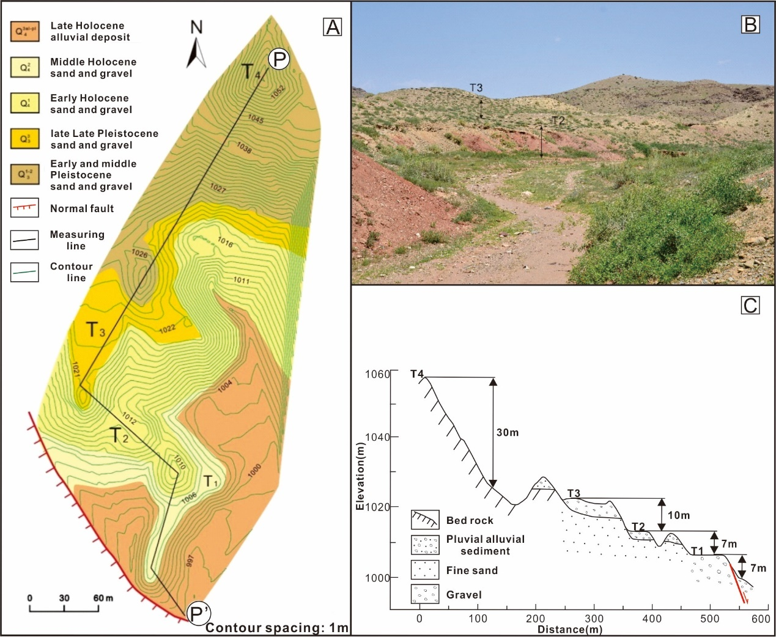
Supplementary Fig. 1. (A) Geological and geomorphological map of eastern Langshankou; (B) geomorphological photograph; (C) A-A’ section
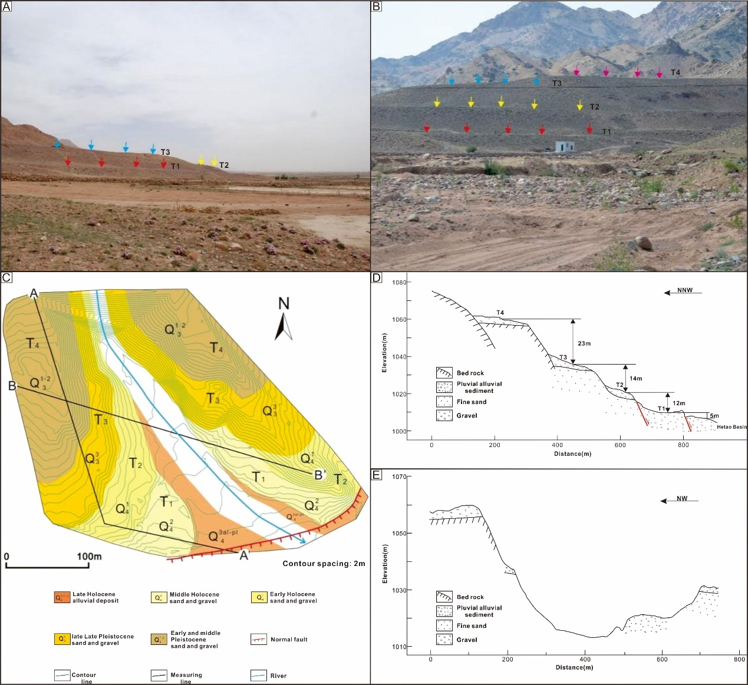
Supplementary Fig. 2. (A) Geomorphological photograph of eastern Yaoliangwan; (B) Geomorphological photograph of western Yaoliangwan; (C) Geological and geomorphological map of the Yaoliangwan; (D) A-A’ section; (E) B-B’ section.

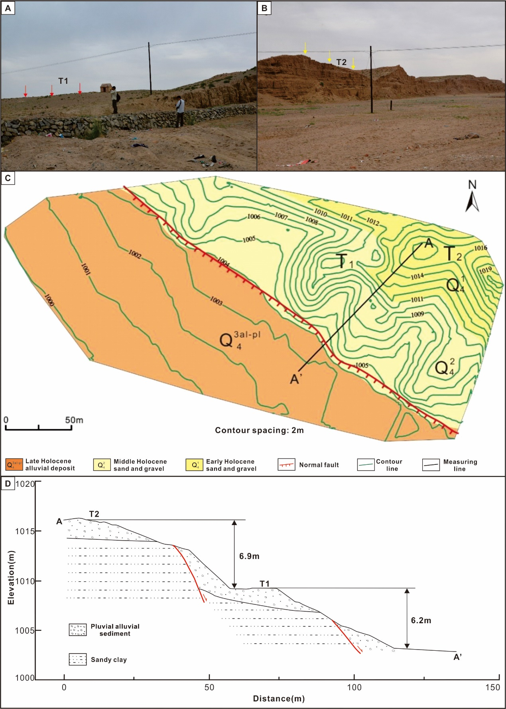
Supplementary Fig. 3. (A) T1 terrace landform; (B) T2 terrace landform; (C) Geological and geomorphological map of northeast Wulanganggangou; (D) A-A’ section
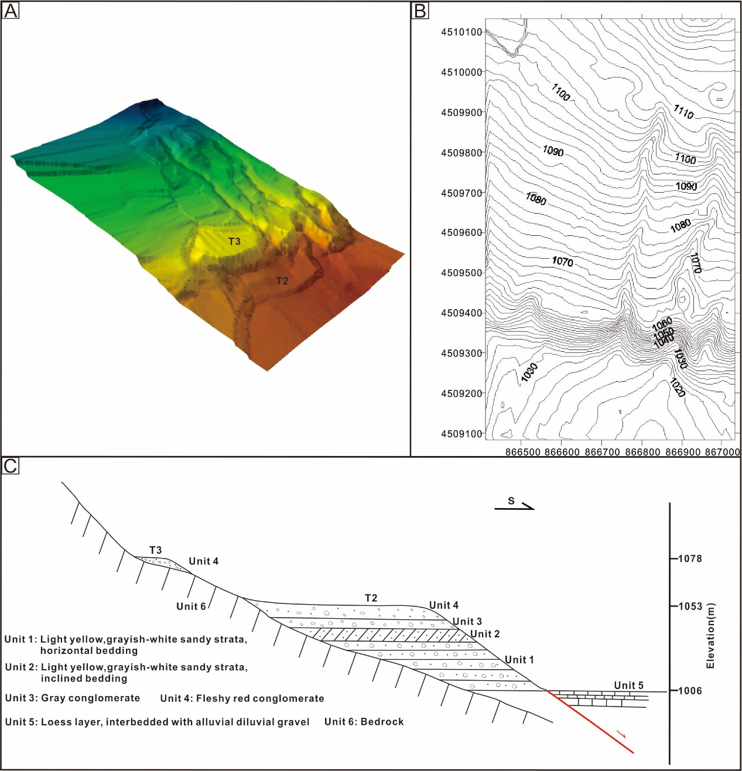
Supplementary Fig. 4. (A) DEM of the terrace; (B) Topographic map of the terrace; (C) Schematic diagram of the terrace near Heshunzhuang
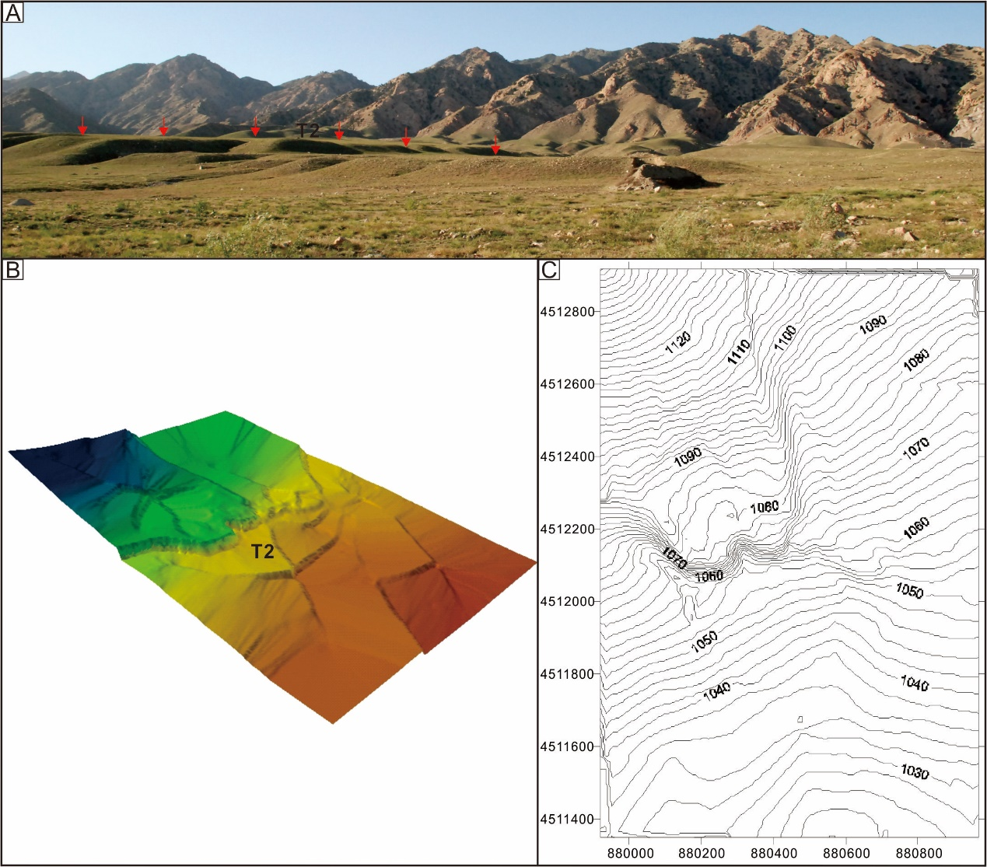
Supplementary Fig. 5. (A) T2 terrace landform; (B) DEM of the terrace; (C) Schematic diagram of the terrace near Hayehutong
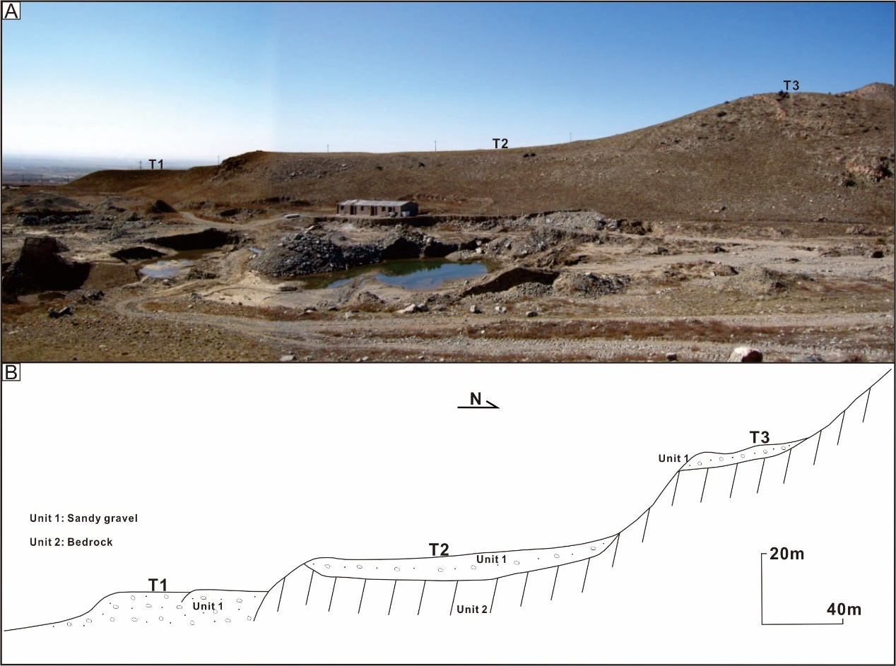
Supplementary Fig. 6. (A) Geomorphological photograph of Dabagou; (B) Schematic diagram of the terrace near Dabagou
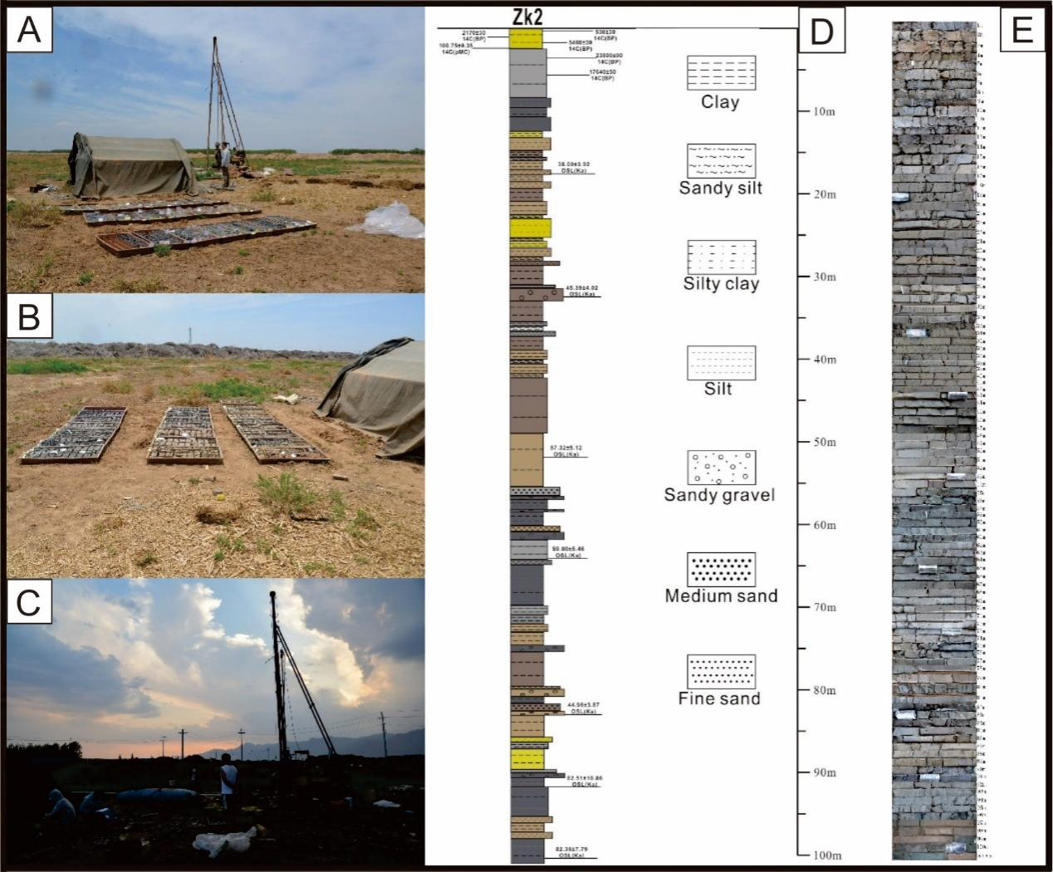
Supplementary Fig. 7. (A) (B) (C) Field photographs; (D) Zk2 bar chart of the borehole; (E) Photo of the Zk2 core from the borehole.

