Major Expansion of Marine Forests in a Warmer Arctic
Supplementary Information
Jorge Assis, Ester A. Serrão, Carlos M. Duarte, Eliza ﻿Fragkopoulou and Dorte Krause-Jensen

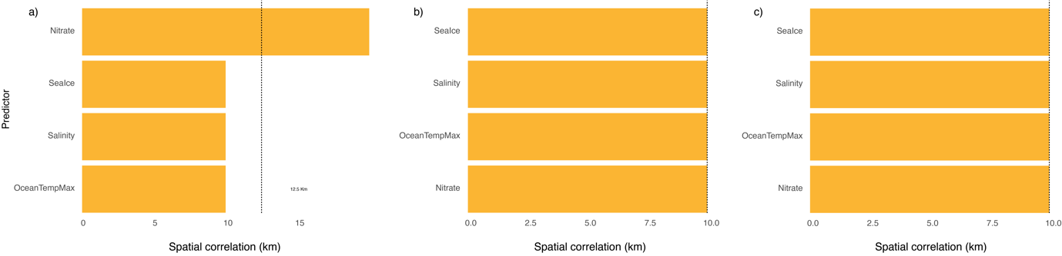
Figure S1. Significant spatial autocorrelation of each environmental predictor used in the niche models developed for (a) intertidal and (b) subtidal macroalgae and for (c) eelgrass.

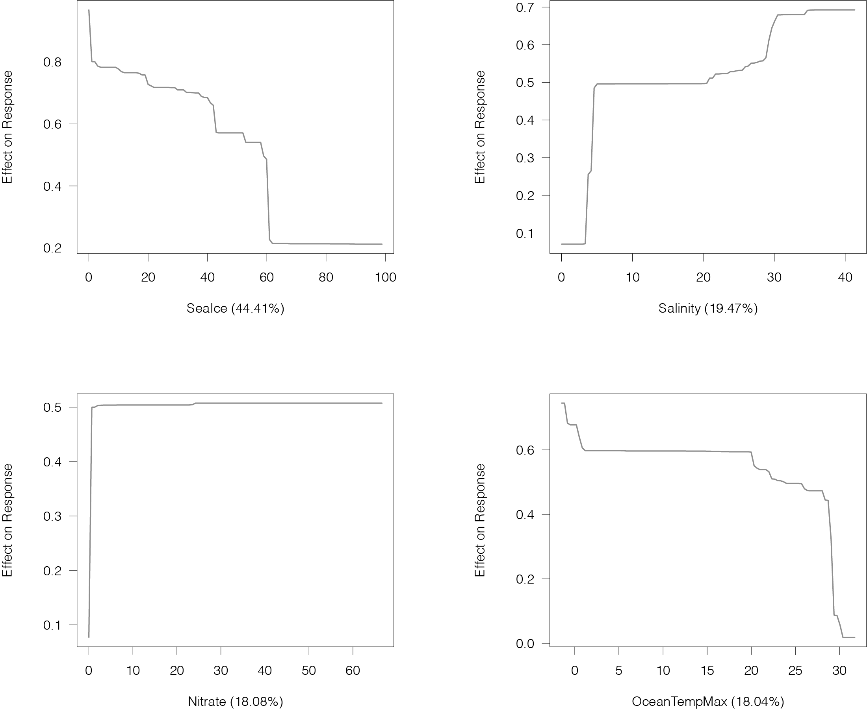
Figure S2. Partial dependency functions depicting the effect of each environmental predictor on the response of the species distribution modelling developed for subtidal macroalgae.

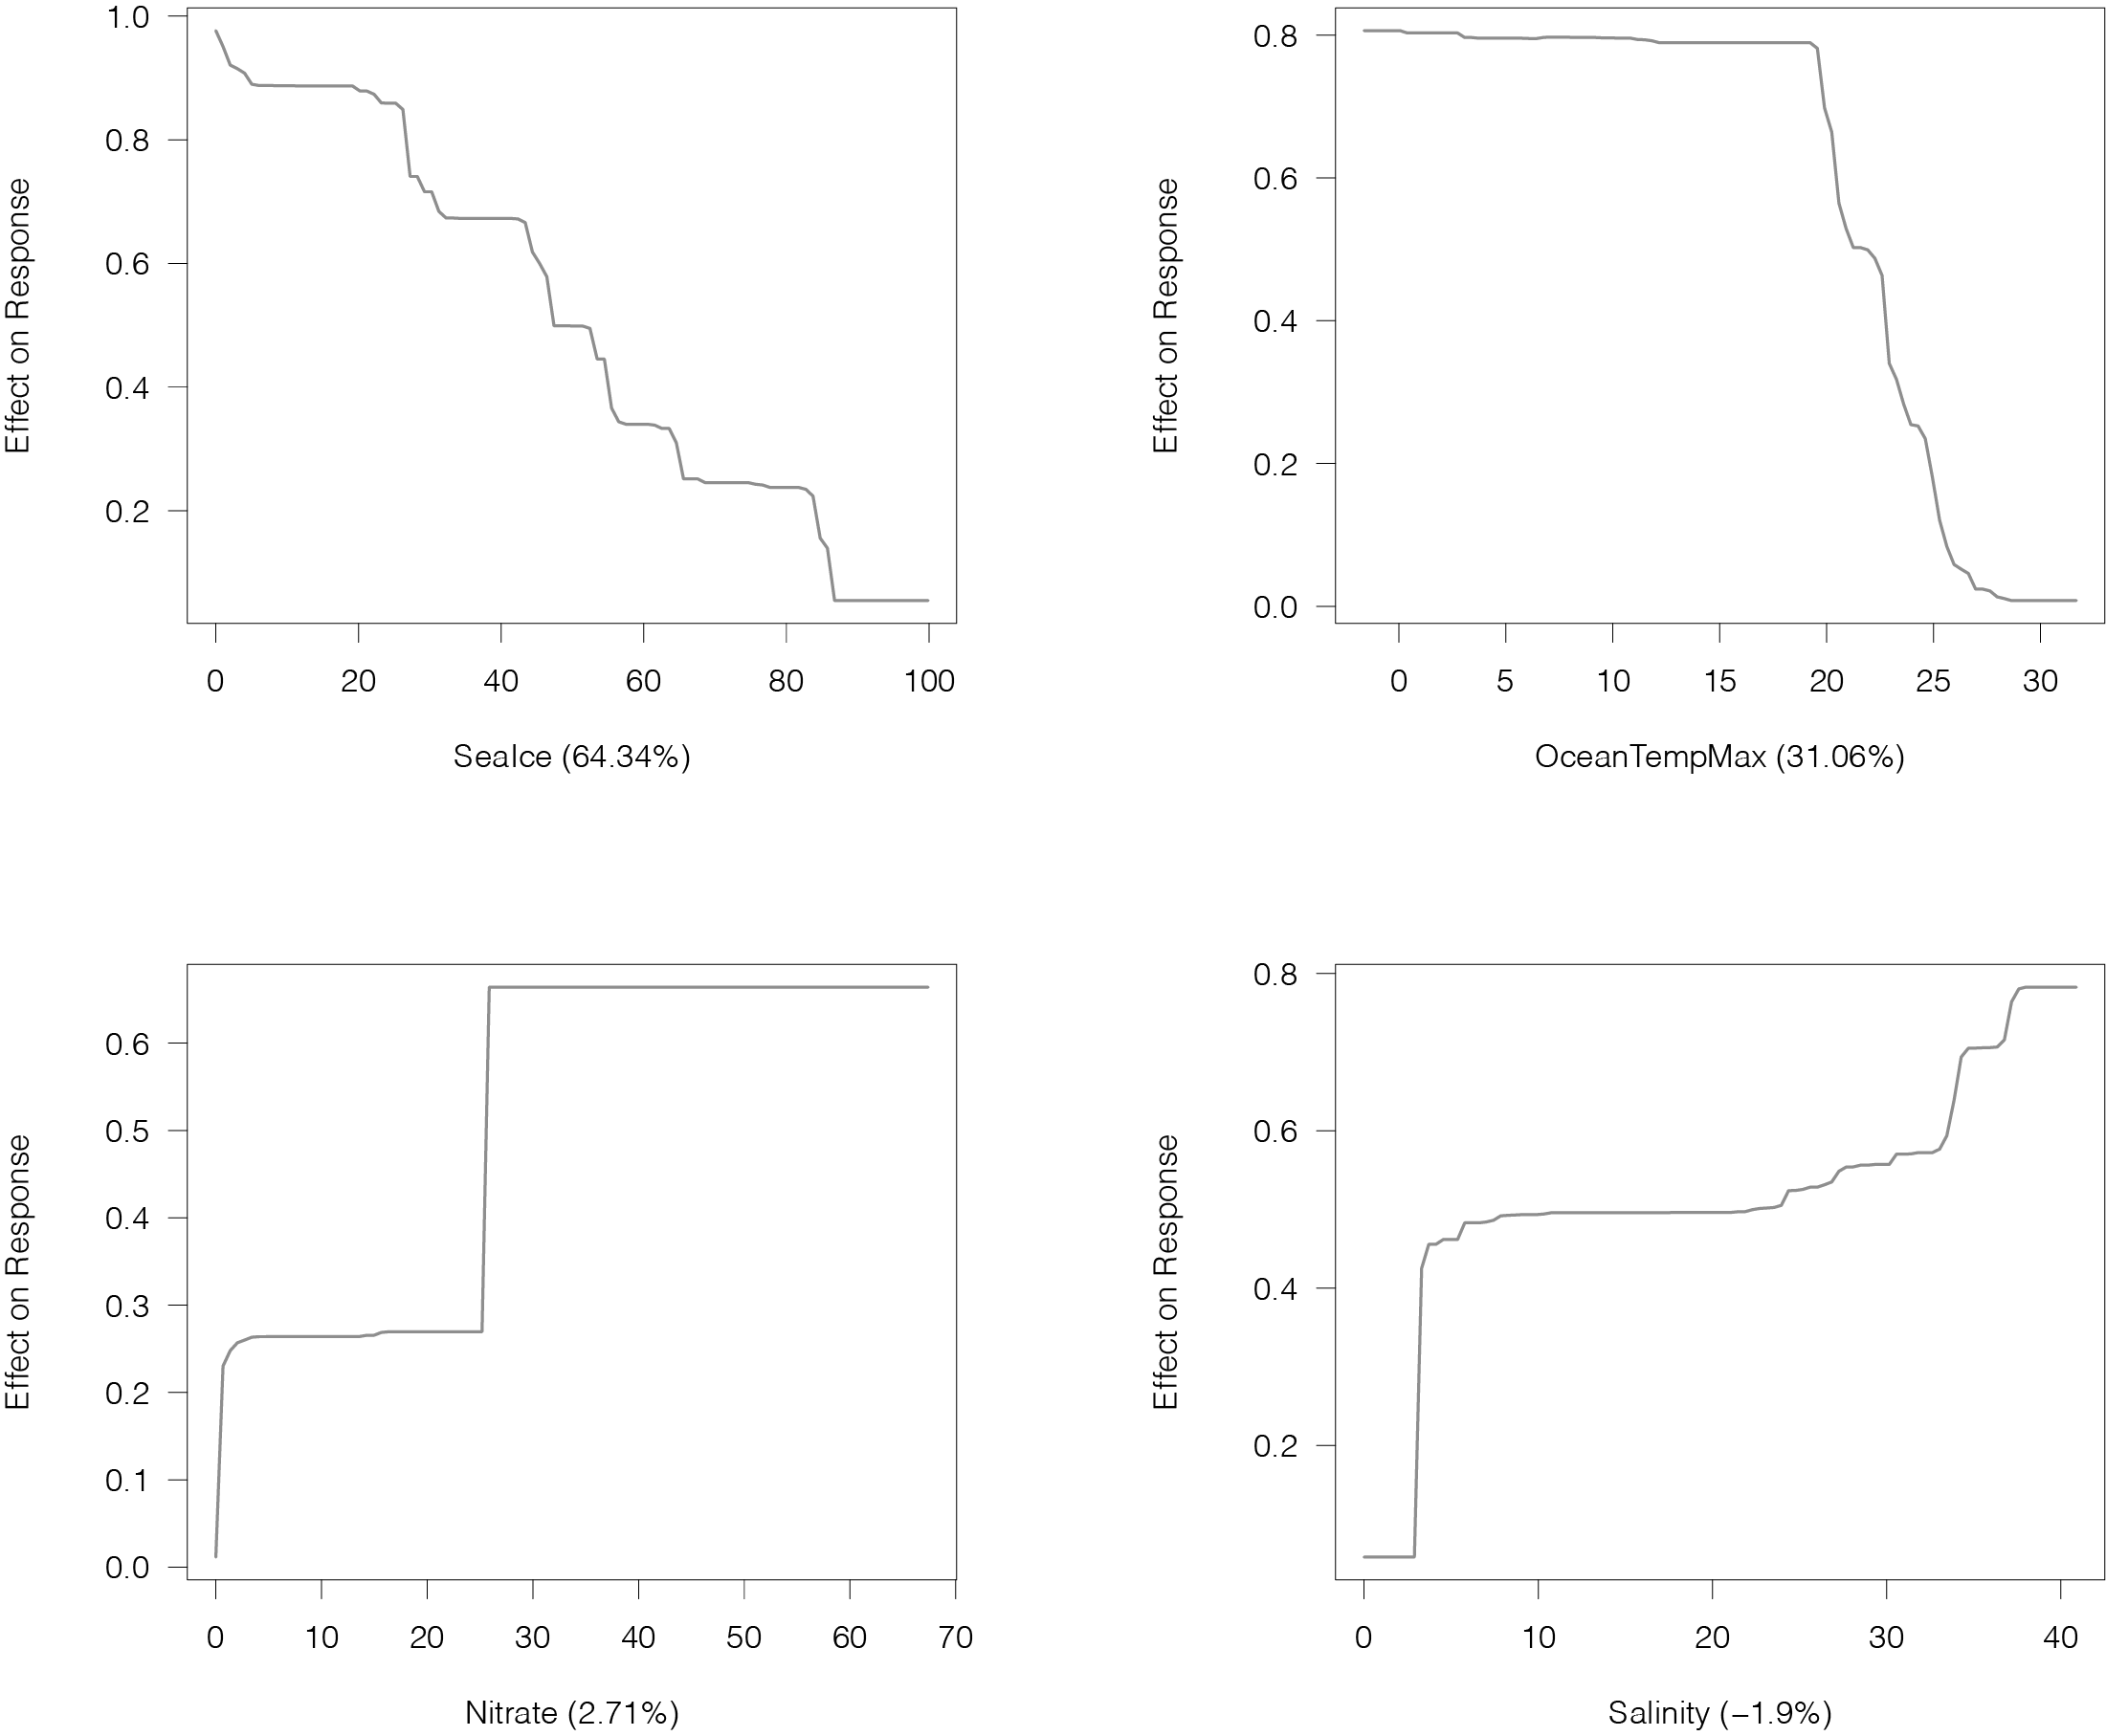
Figure S3. Partial dependency functions depicting the effect of each environmental predictor on the response of the species distribution modelling developed for intertidal macroalgae.

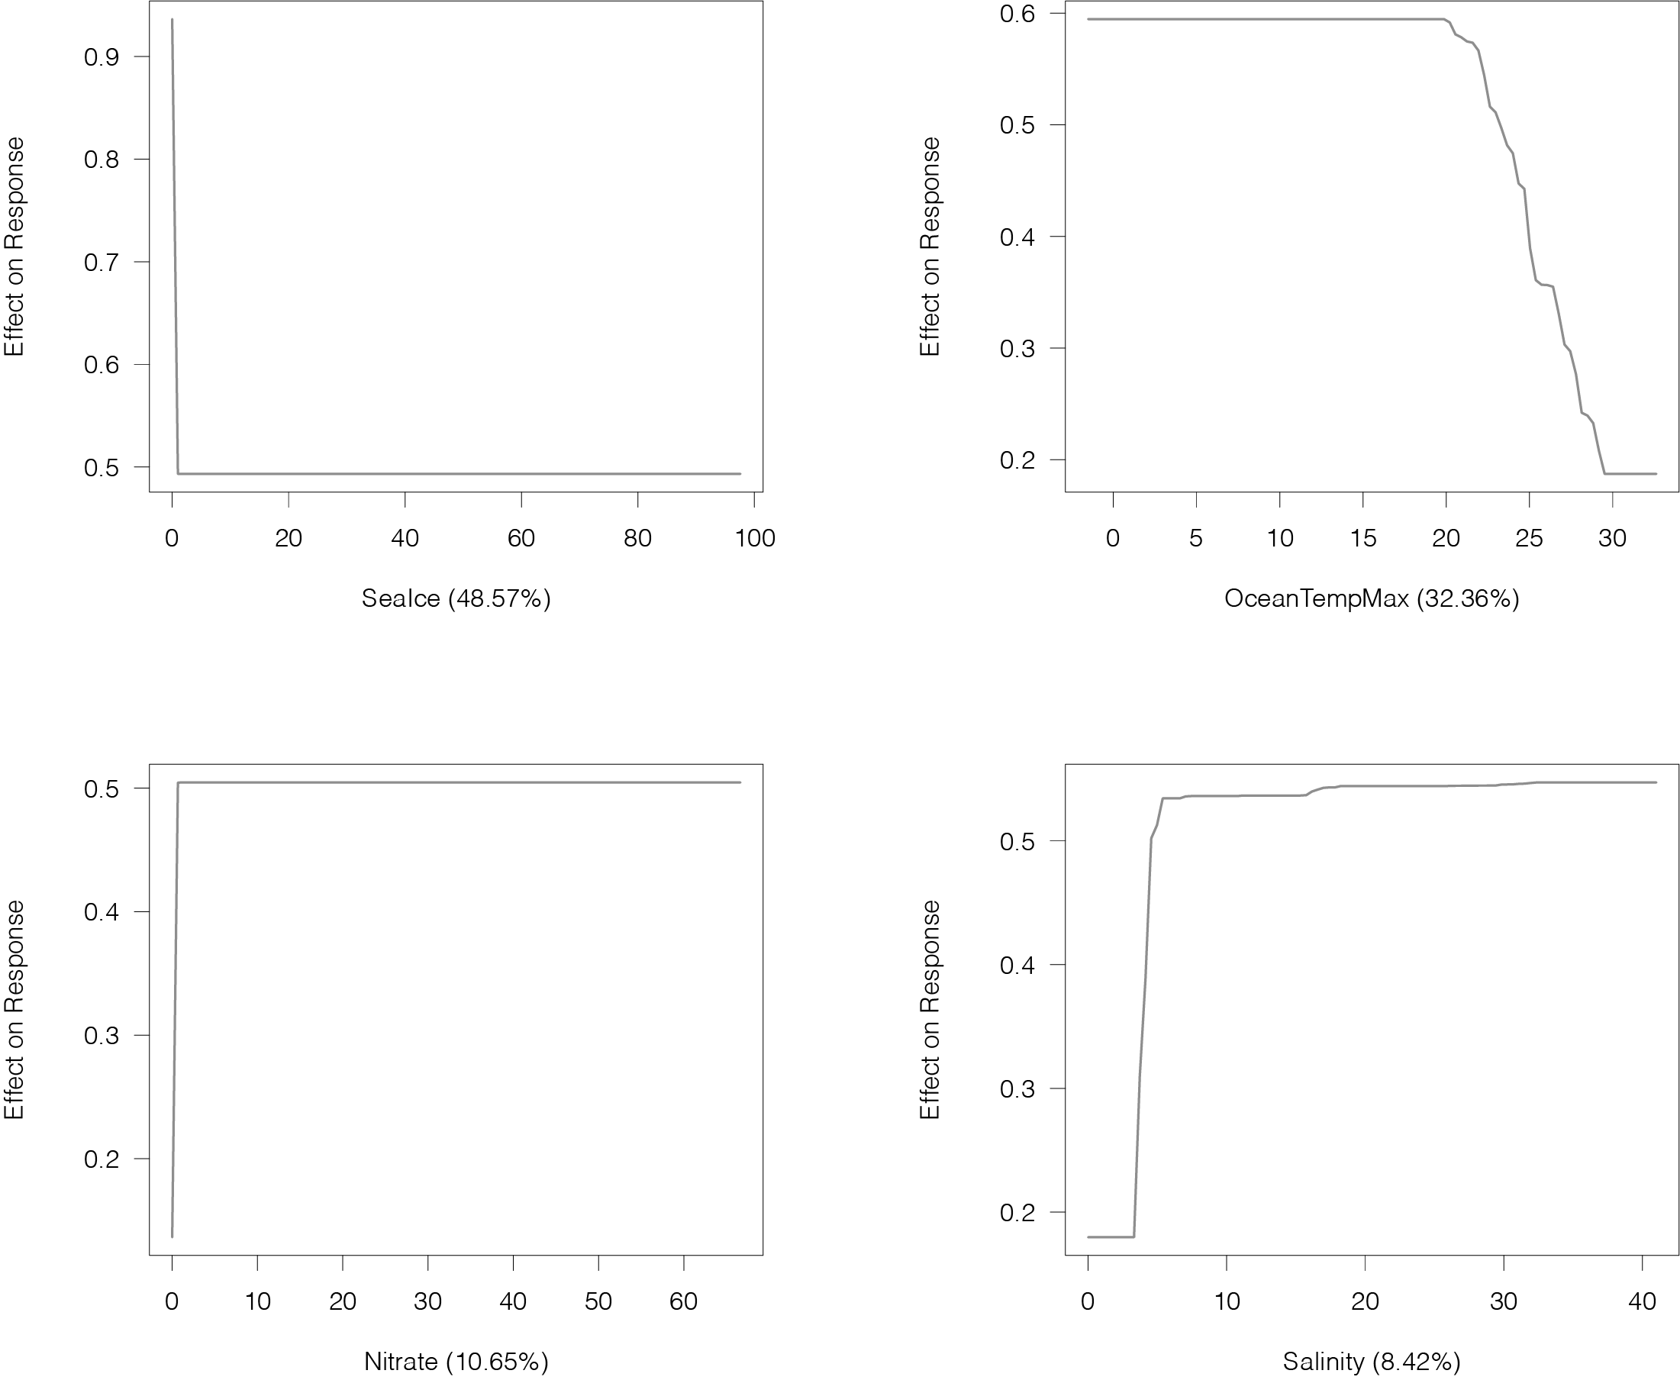
Figure S4. Partial dependency functions depicting the effect of each environmental predictor on the response of the species distribution modelling developed for eelgrass.

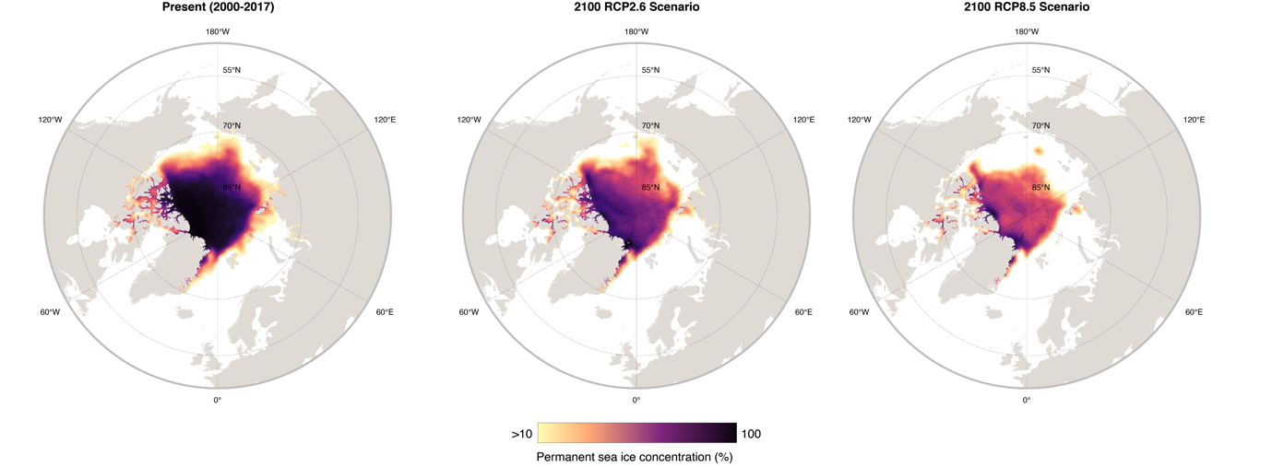
Figure S5. Permanent sea ice concentration for the present and future times (2090-2100) under contrasting scenarios of greenhouse gas emissions (RCP2.6 and RCP 8.5). Ensemble of multiple atmospheric-ocean general circulation models from the Climate Model Intercomparison Project: CCSM4, GFDL-ESM2G, HadGEM2-ES, IPSL-CM5A-LR, MIROC-ESM.

Table S1. Warming rate (ºC decade⁻¹) and permanent sea ice loss (km² decade⁻¹) projected for the pan-Arctic region and by Arctic sector for future times (2090-2100) under contrasting scenarios of greenhouse gas emissions (RCP2.6 and RCP 8.5). Ensemble of multiple atmospheric-ocean general circulation models from the Climate Model Intercomparison Project: CCSM4, GFDL-ESM2G, HadGEM2-ES, IPSL-CM5A-LR, MIROC-ESM.
 | RCP26 |  | RCP85
Region | Warming (ºC decade⁻¹) | Ice loss (km² decade⁻¹) | Warming (ºC decade⁻¹) | Ice loss (km² decade⁻¹)
﻿Pan-Arctic | 0.17 | 217.08 | 0.75 | 464.71
E.Greenland | 0.20 | 14.06 | 0.70 | 27.98
W.Greenland | 0.08 | 0.84 | 0.49 | 1.08
Iceland | 0.09 |  | 0.49
Svalbard | 0.29 | 16.32 | 0.84 | 22.38
N.Norway | 0.25 |  | 0.70
Russia | 0.24 | 117.82 | 0.84 | 241.76
Alaska | 0.18 | 19.46 | 0.77 | 65.47
Canada | 0.10 | 34.78 | 0.76 | 70.48
Faroe Islands | 0.10 |  | 0.42

