Supplementary Material

Supplementary Table 1. Primer sequences of selected miRNAs in the study
miRNA ID | Primer sequence
hsa-miR-210-3p | 5’-AACAAGCTGTGCGTGTGACA-3’
hsa-mir-155-5p | 5’-AAGCGACCTTAATGCTAATCGTGA-3’
hsa-miR-133a-3p | 5’-AACACGCTTTGGTCCCCTTC-3’
hsa-miR-15a-3p | 5’-AACACGCCAGGCCATATTGTG-3’
hsa-miR-181a-5p | 5’-AACACGCAACATTCAACGCTG-3’
hsa-miR-181b-5p | 5’-AAGCGACCAACATTCATTGCTGT-3’
hsa-miR-30e-5p | 5’-AGCCAGCGTGTAAACATCCTTG-3’
hsa-miR-18a-5p | 5’-AAGCGACCTAAGGTGCATCTAGT-3’
hsa-miR-26a-5p | 5’-AGCCAGCGTTCAAGTAATCCAG-3’
hsa-miR-20a-5p | 5’-ATGCGCGCTAAAGTGCTTATAGT-3’
hsa-miR-19a-3p | 5’-AACACGCTGTGCAAATCTATGC-3’
hsa-miR-301a-3p | 5’-AAGCGACCCAGTGCAATAGTATT-3’
hsa-miR-92a-2-5p | 5’-AACAGTGGGGTGGGGATTTGT-3’

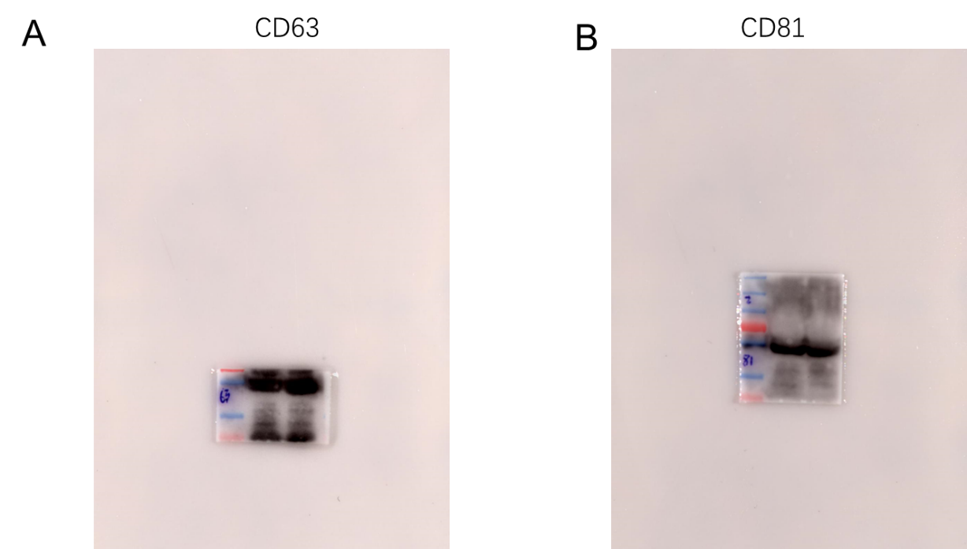
Supplementary Figure 1. Full western blot gels of extracellular vesicle (EV)/exosomal markers CD63 and CD81 in plasma-derived EVs.

